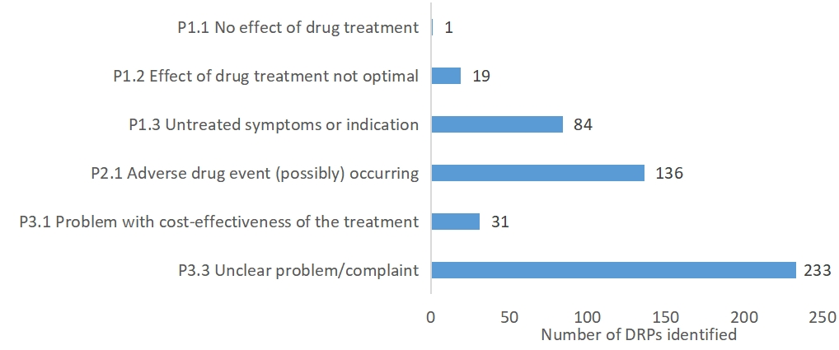
Supplementary Figure S1. Number of Causes of DRPs Identified during Pharmacy consultation

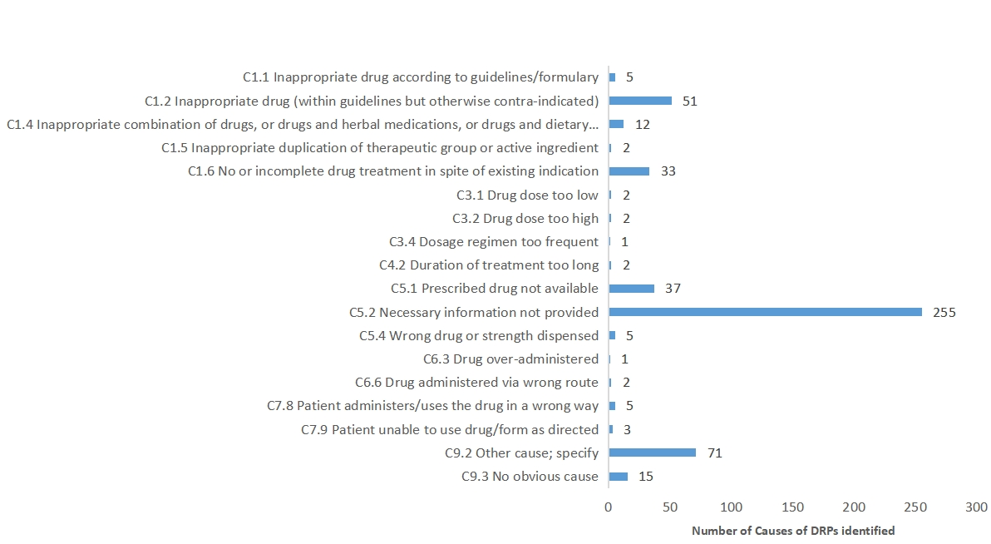
Supplementary Figure S2. Number of Causes of DRPs Identified during Pharmacy consultation

Supplementary Table S1. Top3 Medicines’ Drug Related Problems and Causes of Pharmacy Intervention
Problem | Cause | N
Cardiovascular system |  | 69
P1.2 Effect of drug treatment not optimal | C9.2 Other cause;specify | 2
P1.3 Untreated symptoms or indication | C5.2 Necessary information not provided  C5.4 Wrong drug or strength dispensed  C9.2 Other cause | 8  1  2
P2.1 Adverse drug event (possibly) occurring | C1.2 Inappropriate drug (within guidelines but otherwise contraindicated)  C1.4 Inappropriate combination of drugs, or drugs and herbal medications, or drugs and dietary supplements  C5.1 Prescribed drug not available  C5.2 Necessary information not provided  C6.3 Drug over-administered  C7.8 Patient administers/uses the drug in a wrong way  C9.2 Other cause | 6  4  2  4  1  1  4
P3.1 Problem with cost-effectiveness of the treatment | C5.1 Prescribed drug not available  C5.2 Necessary information not provided  C5.4 Wrong drug or strength dispensed  C9.2 Other cause | 1  2  1  5
P3.3 Unclear problem/complaint. Further clarification  necessary (please use as escape only) | C1.6 No or incomplete drug treatment in spite of existing indication  C5.1 Prescribed drug not available  C5.2 Necessary information not provided  C9.2 Other cause  C9.3 No obvious cause | 2  3  15  4  1
Traditional Chinese medicine |  | 63
P1.3 Untreated symptoms or indication | C1.1 Inappropriate drug according to guidelines/formulary  C1.6 No or incomplete drug treatment in spite of existing indication  C5.2 Necessary information not provided | 1  2  9
P2.1 Adverse drug event (possibly) occurring | C1.1 Inappropriate drug according to guidelines/formulary  C1.2 Inappropriate drug (within guidelines but otherwise contraindicated)  C1.4 Inappropriate combination of drugs, or drugs and herbal medications, or drugs and dietary supplements  C1.5 Inappropriate duplication of therapeutic group or active ingredient  C1.6 No or incomplete drug treatment in spite of existing indication  C5.2 Necessary information not provided  C7.8 Patient administers/uses the drug in a wrong way  C9.2 Other cause | 1  15  3  1  1  4  1  1
P3.1 Problem with cost-effectiveness of the treatment | C9.2 Other cause | 1
P3.3 Unclear problem/complaint. Further clarification  necessary (please use as escape only) | C5.1 Prescribed drug not available  C5.2 Necessary information not provided  C9.2 Other cause  C9.3 No obvious cause | 1  18  2  2
Alimentary tract and metabolism |  | 68
P1.2 Effect of drug treatment not optimal | C9.2 Other cause | 1
P1.3 Untreated symptoms or indication | C1.6 No or incomplete drug treatment in spite of existing indication  C5.2 Necessary information not provided | 2  12
P2.1 Adverse drug event (possibly) occurring | C1.2 Inappropriate drug (within guidelines but otherwise contraindicated)  C1.4 Inappropriate combination of drugs, or drugs and herbal medications, or drugs and dietary supplements  C7.3 Patient abuses drug (unregulated overuse)  C9.2 Other cause | 3  2  1  3
P3.3 Unclear problem/complaint. Further clarification  necessary (please use as escape only) | C1.5 Inappropriate duplication of therapeutic group or active ingredient  C1.6 No or incomplete drug treatment in spite of existing indication  C5.1 Prescribed drug not available  C5.2 Necessary information not provided  C7.9 Patient unable to use drug/form as directed  C9.3 No obvious cause | 1  2  3  36  1  1

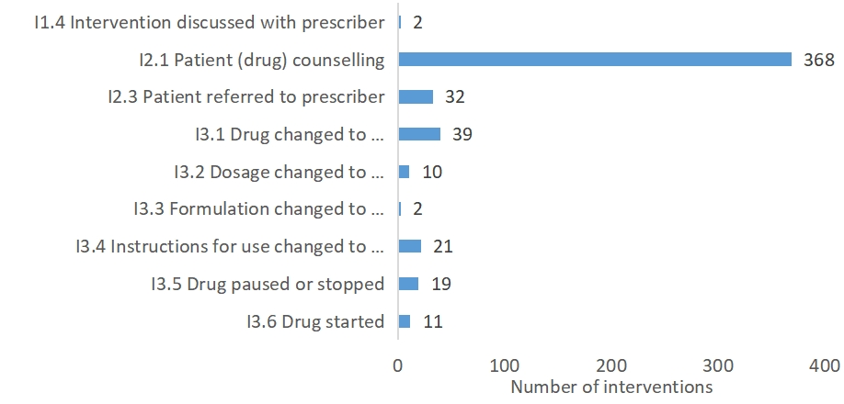
Supplementary Figure S3. Number of Intervention during Pharmacy consultation

