Table 1 – Information on analyzed bartenders’ videos
Bartender Name | Number of followers on TikTok© (C1) | Ex. of alcohol brands displayed on videos (C2) | Ex. of sweetened products in cocktails with alcohol (C3) | Ex. of young people cues displayed on videos (C4) | Screenshots  (C5) | Number of views of the analyzed videos (C6)
@realtipsybartender | 4.9M | Malibu, Kahlùa | Ice cream, candies, chocolate | Scooby Doo, Cocktail presented in a jar that refers to the movie « the Grinch », Cocktail inspired by the butter beer in Harry Potter | 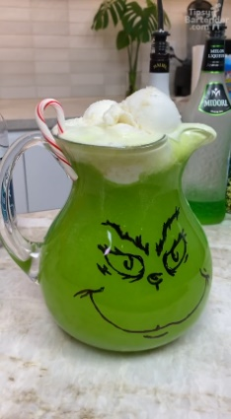 | 89,258,500
@michellebellexo | 2.9M | New Amsterdam | Candies, caffeinated soda | Never |  | 22,113,500
@theparadise.bartender | 2.6M | Smirnoff, Hendrick’s | Ice cream | The Polar Express |  | 1,292,000
@drinkowithrico | 2.6M | Captain morgan, Tito’s | Chocolate, screenshot on the right : Nesquik, caffeinated soda | Never | 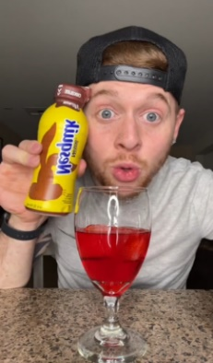 | 15,447,500
@johnrondi | 2.3M | St-Germain, DrumShambo | Ice cream | Never |  | 30,910,900
@timthetank | 2.1M | DeKuyper, Pinnacle | Ice cream, chocolate, candies, caffeinated soda | The Grinch, The Mad Scientist – nerdsbomb |  | 8,954,400
@bartenderis | 2.1M | Gunpowder | Never | Never |  | 74,700
@barchemistry | 1.8M | Rum chata, jaggermeister… | Ice cream | Butterbeer from Harry Potter |  | 2,893,200
@barrisstaelba | 1.4M | Unspecified | Ice cream | Never |  | 823,800
@courtneyshae_ | 1.3M | Borghetti | Never | Never |  | 14,202,000
@nic.hamilton | 1.3M | Cointreau, Tito’s | Never | Never |  | 34,029,200
@sincitybartender | 1.3M | Bacardi, Absolut Vodka | Ice cream, candies | Video games, screenshot on the right : Sonic – level city escape | 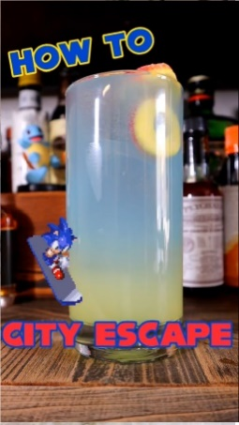 | 16,547,100
@lasvegas.bartender | 1.1M | Smirnoff, Malibu | Candies – screenshot on the right : Skittles | The Grinch | 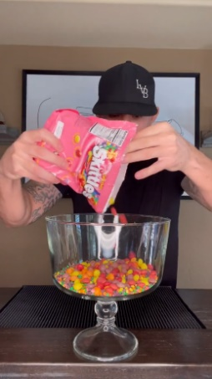 | 5,218,000
@cdbartending | 1M | Disaronno, Jack Daniels | Never | Never |  | 1,422,500
@thewhyteelephant | 1M | Snowfox, Chambord | Candies | The Grinch |  | 27,138,300
 |  |  | Total number of views for all analyzed videos: |  |  | 270,325,600

