Picture 1
Functional subtotal in-stent obstruction of the venous RCA graft

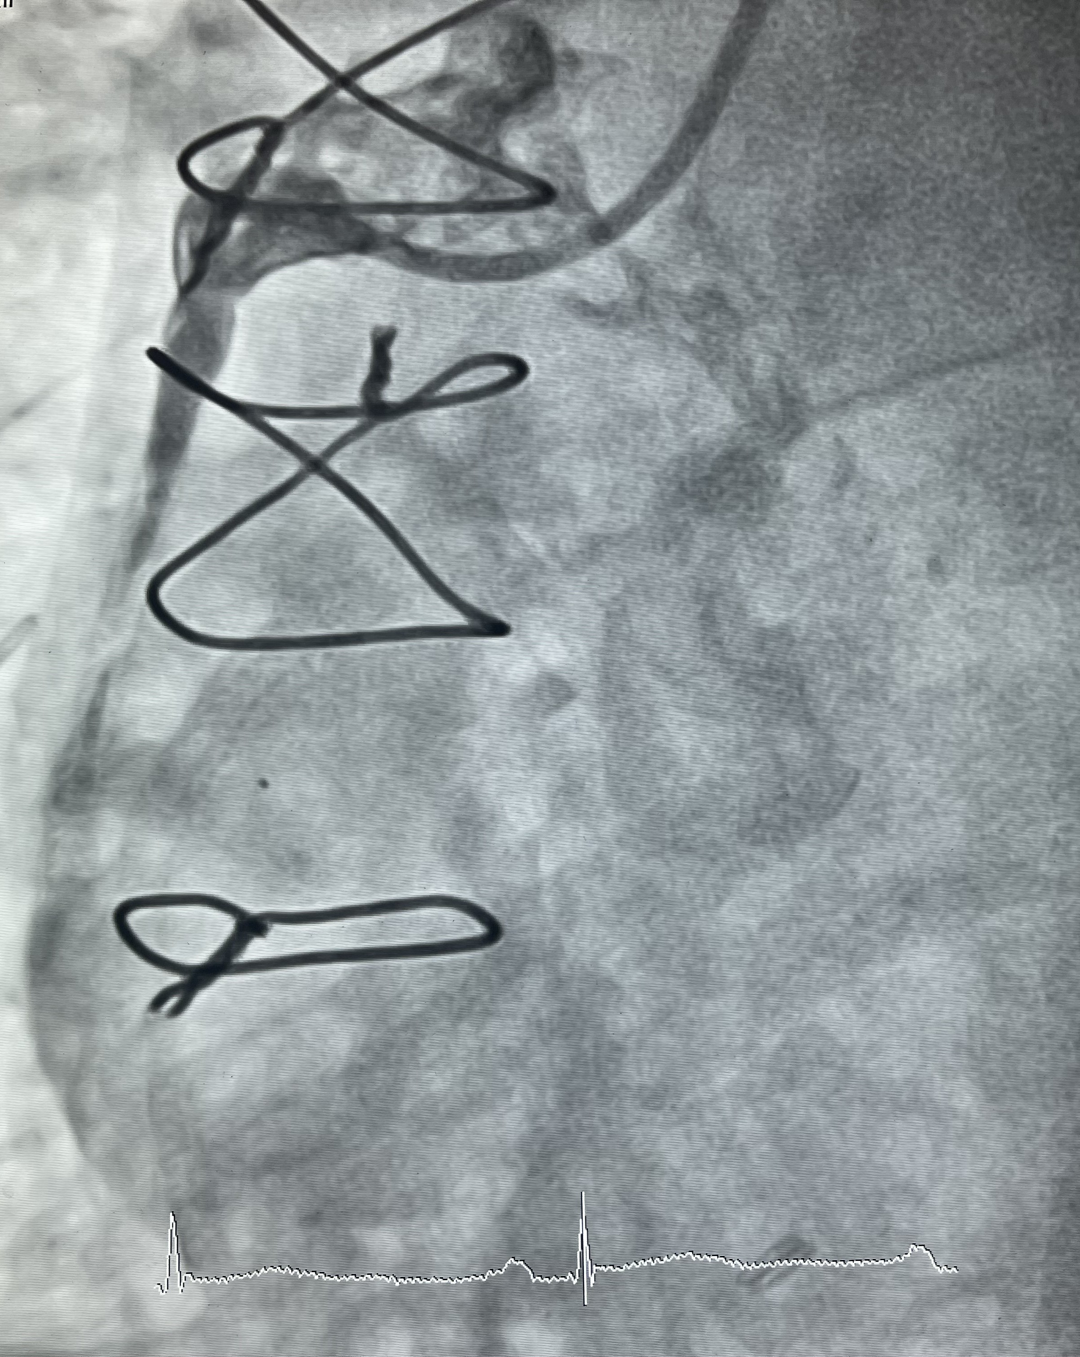
Picture 2
IVUS revealing a mixture of underexpansion and neoatherosceloris
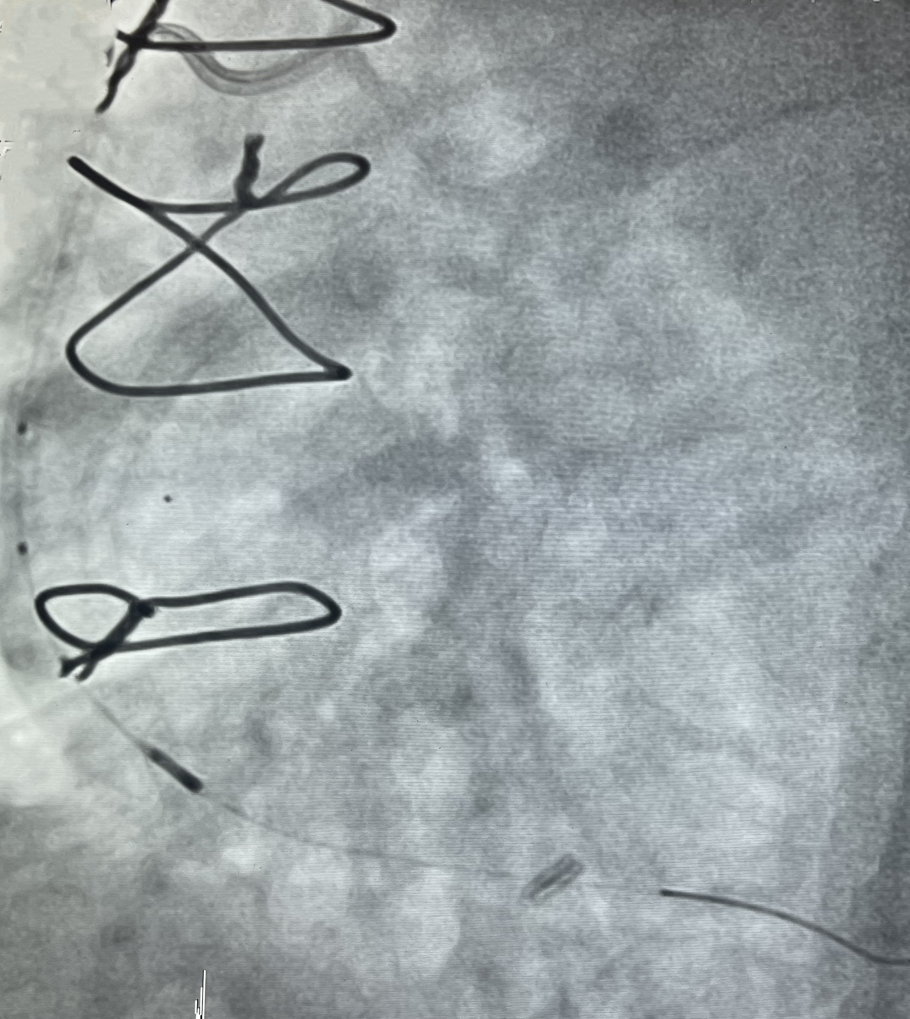
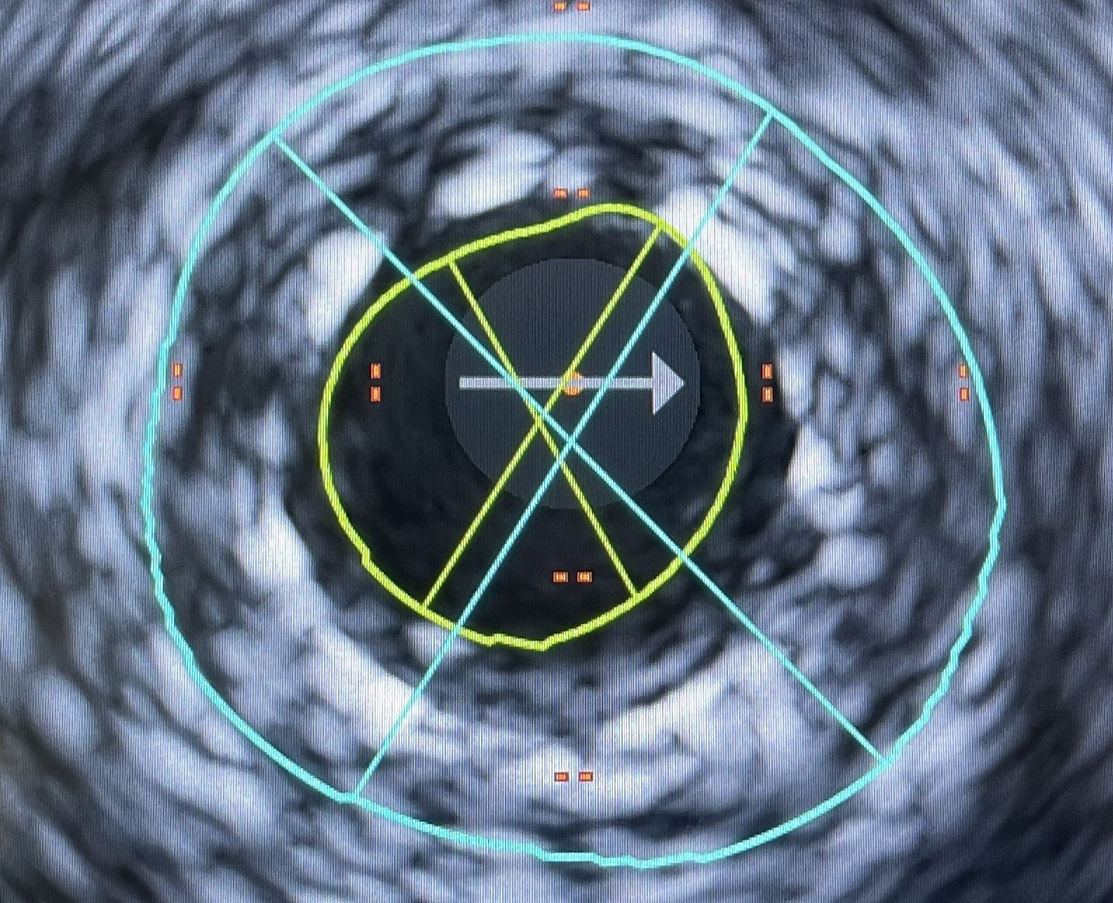

MLA1 3.6 mm² (diameter 2.0-2.3 mm)
ML2 14.3 mm² (diameter 4.1-4.5 mm)
Plaque burden 74.8%
Picture 3
The primary result of DEB (angiography and IVUS)
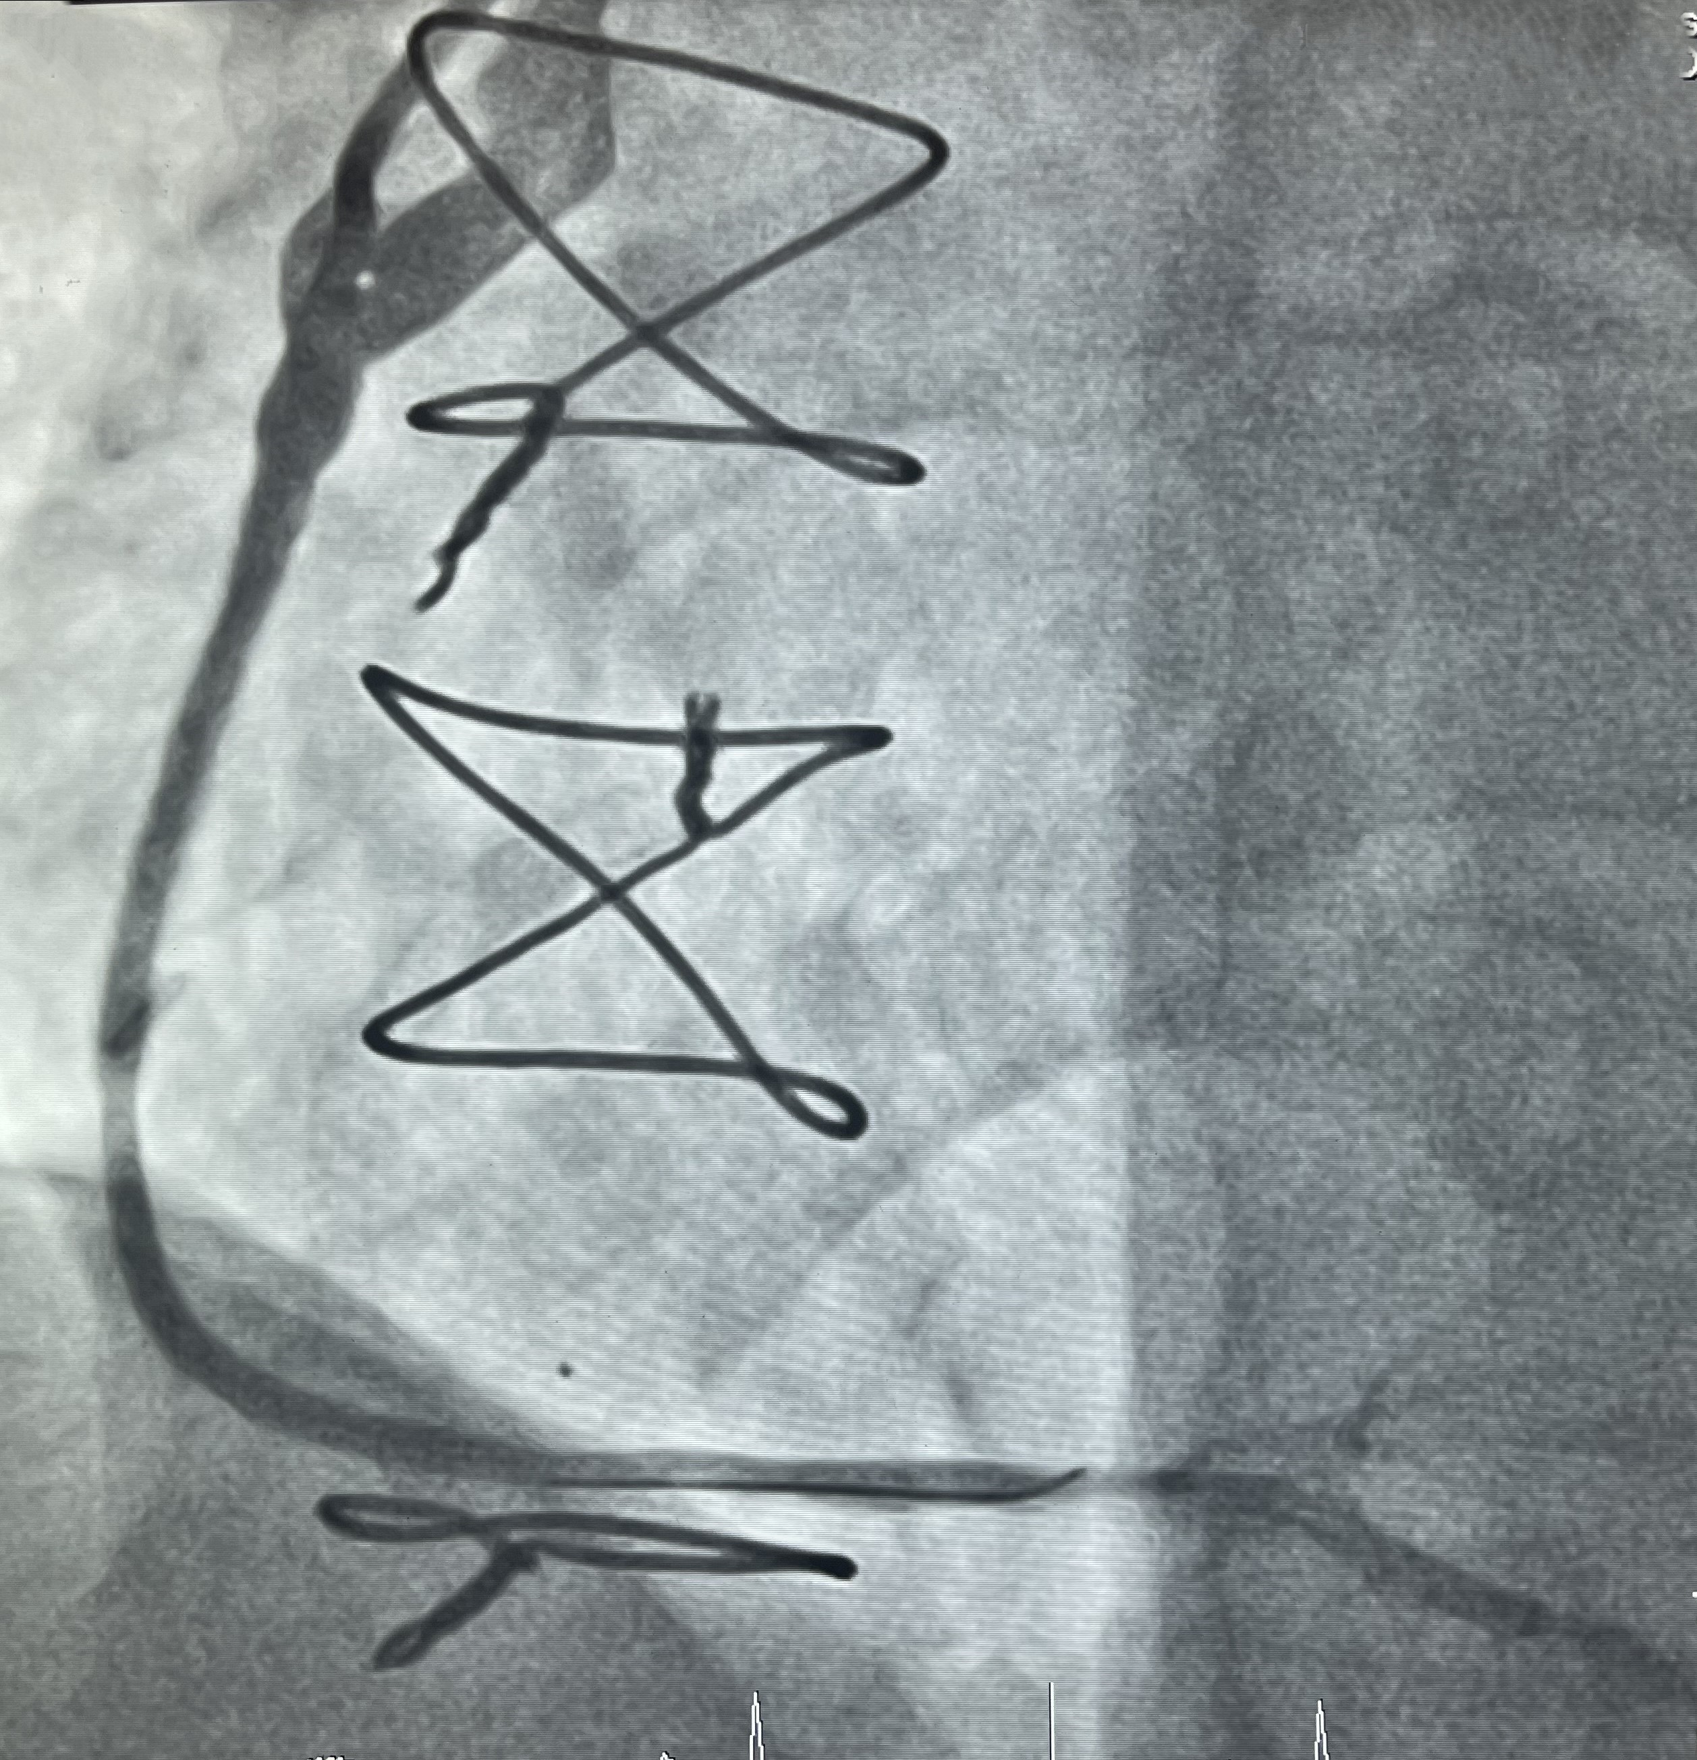
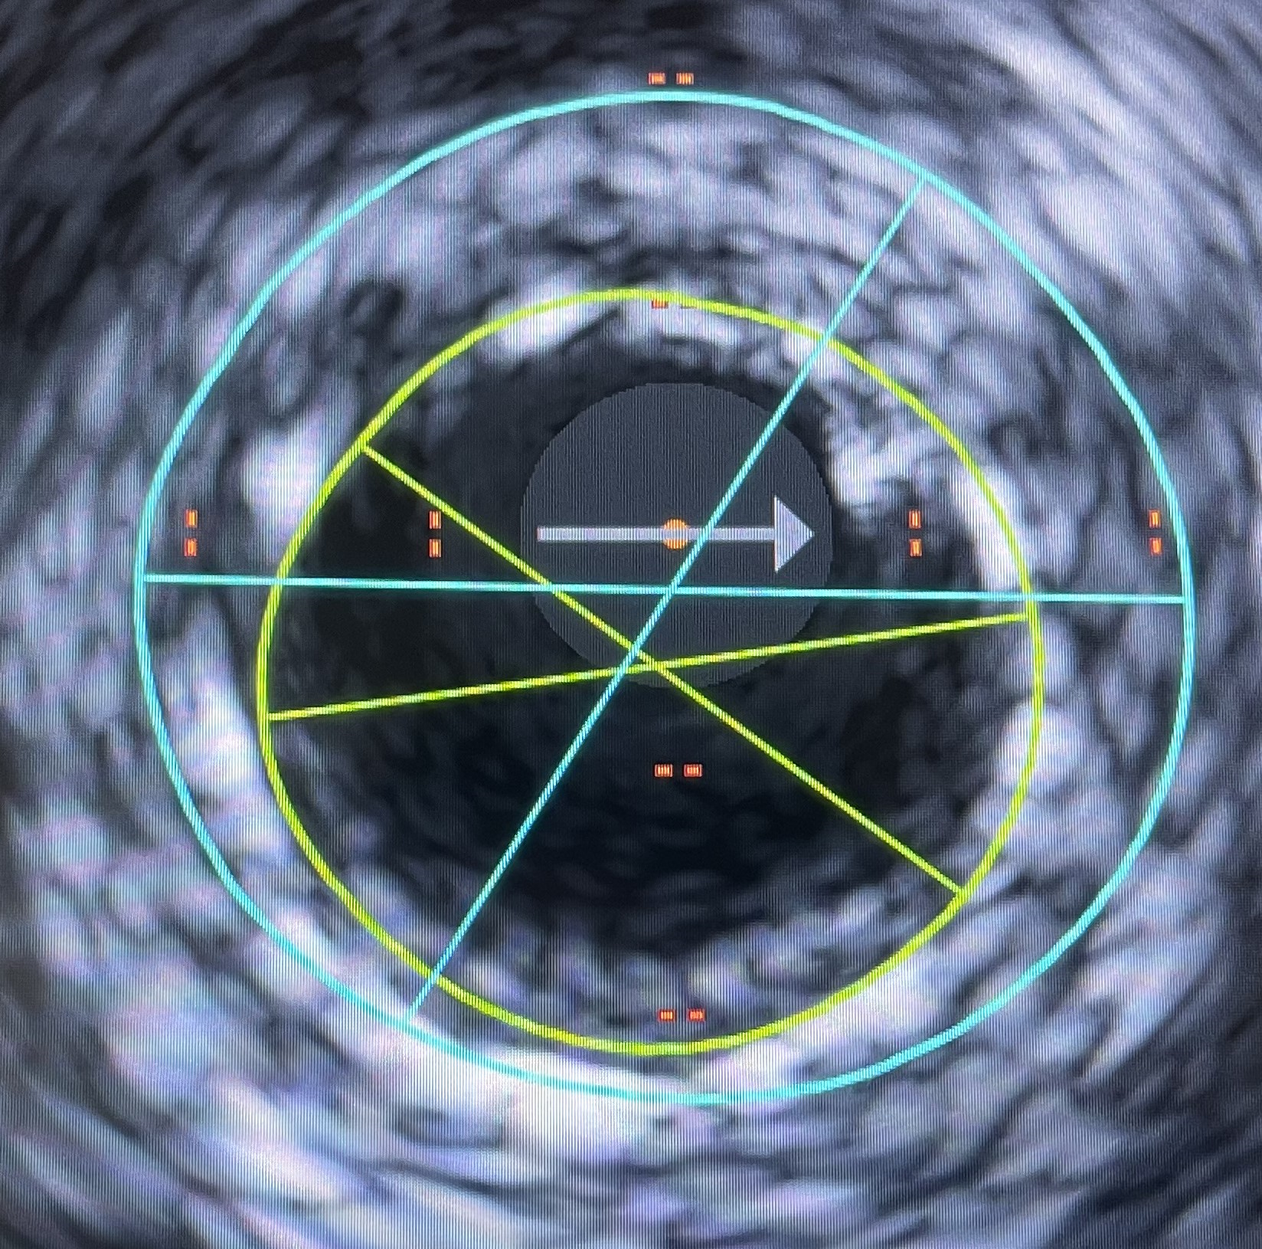
MLA1 7.8 mm² (diameter 3.1-3.2 mm)
MLA 2 14.2 mm² (diameter 4.2-.4.3 mm)
Plaque burden 45%

