Supporting Information
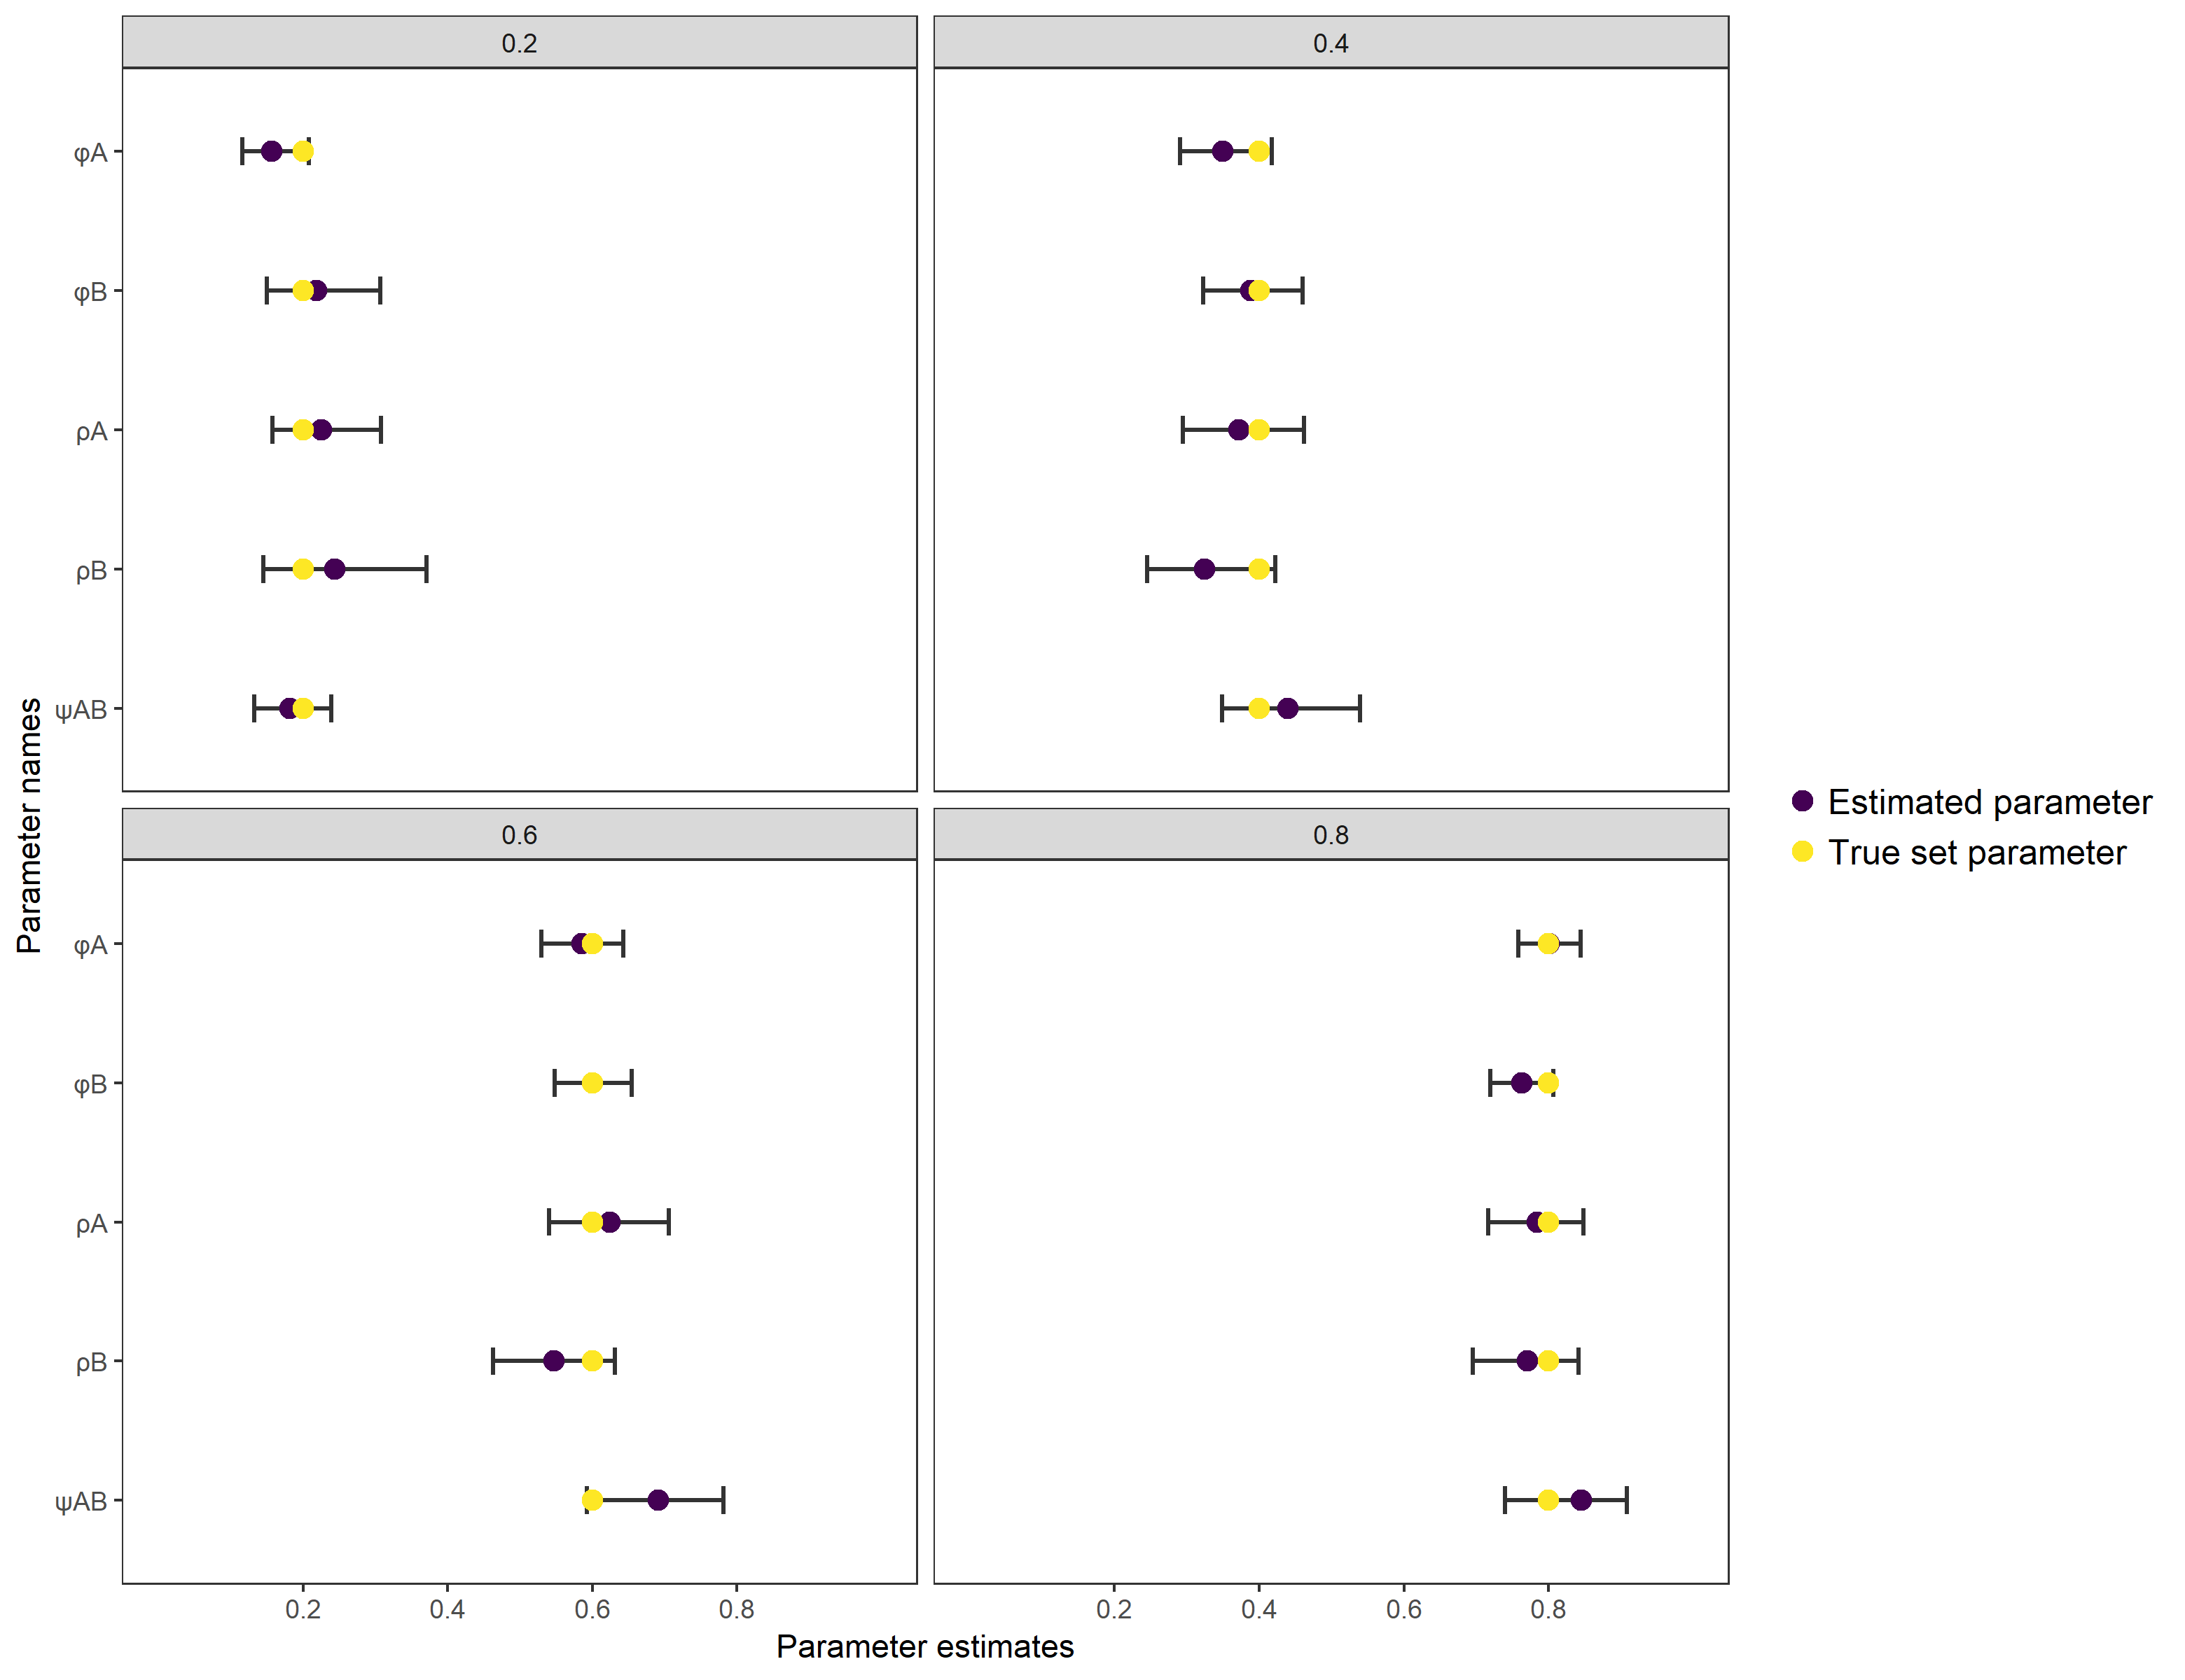
Fig. S1: Sensitivity test of all parameters of interest of the non-spatial CR model. Every parameter of interest (transition, survival and detection) was set to be 0.2, 0.4, 0.6 or 0.8 in the simulated dataset which are corresponding to the four different graphs. Parameter estimations are made for every simulated data set whereby the true set parameter (yellow) can be compared to the estimated parameter (purple).
Table S2: Bias and precision calculated from the simulated models for survival (φ), detection (ρ) and dispersal variance (σ) for the non-spatial, partially spatial (grouped according to maximal movement distance) and fully spatial (not grouped by serostate in the simulation model). No estimates for ρ for the non-spatial model are available due to the inclusion of a fixed effect for time.
Model | Parameter | Bias | Precision
Non spatial | φ_{A} | -0.005 | 0.030
Non spatial | φ_{B} | 0.001 | 0.032
Non spatial | ψ_{AB} | 0.007 | 0.028
Non spatial | ρ_{A} | NA | NA
Non spatial | ρ_{B} | NA | NA
Partially spatial | φ_{A} | -0.002 | 0.027
Partially spatial | φ_{B} | 0.002 | 0.030
Partially spatial | ψ_{AB} | 0.006 | 0.027
Partially spatial | ρ_{A} | 0.008 | 0.043
Partially spatial | ρ_{B} | -0.005 | 0.049
Fully spatial | φ | -0.001 | 0.022
Fully spatial | ρ | 0.002 | 0.032
Fully spatial | σ | 0.210 | 0.029

