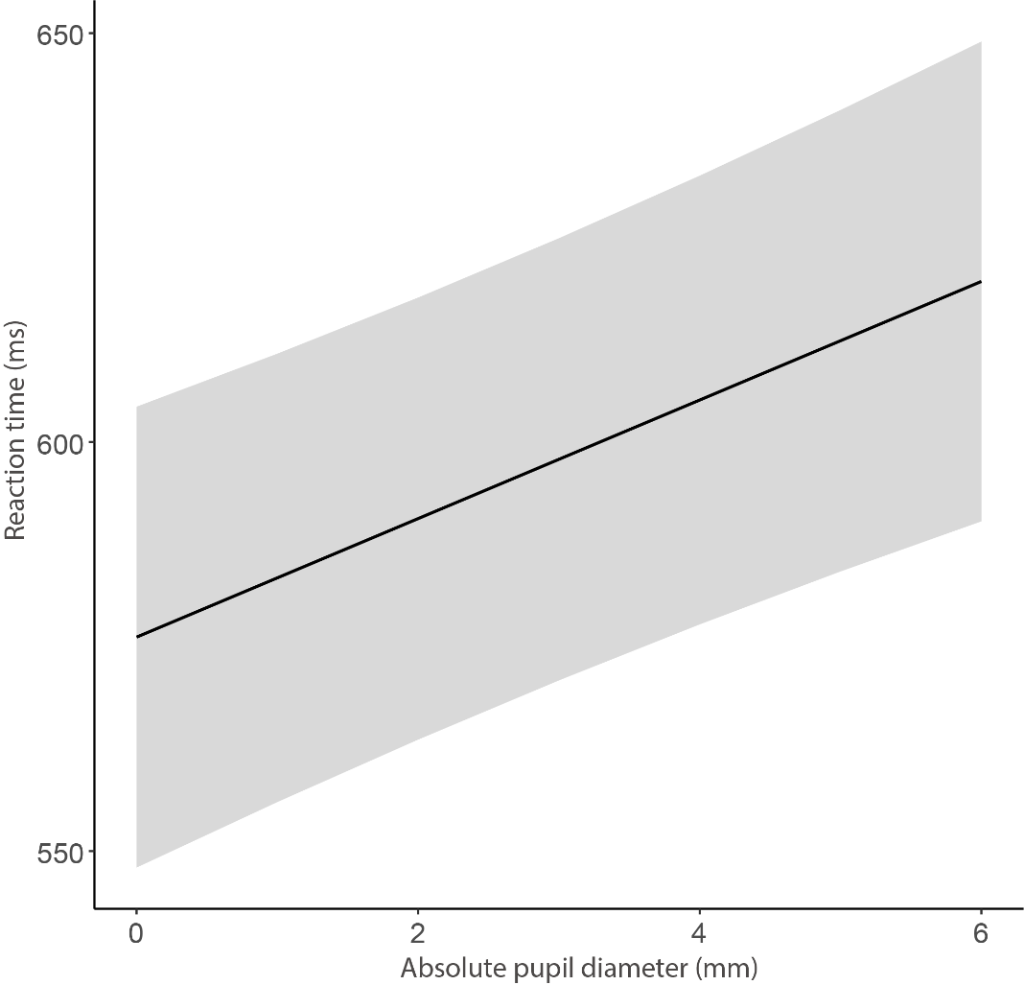
Supplementary Figure 1. Model predicted best fit line for the effect of absolute pupil size on reaction times (Model 1). The shaded colored region surrounding the predicted line represents the ± 95% confidence interval. Absolute pupil diameter: absolute pupil size at the target epoch.

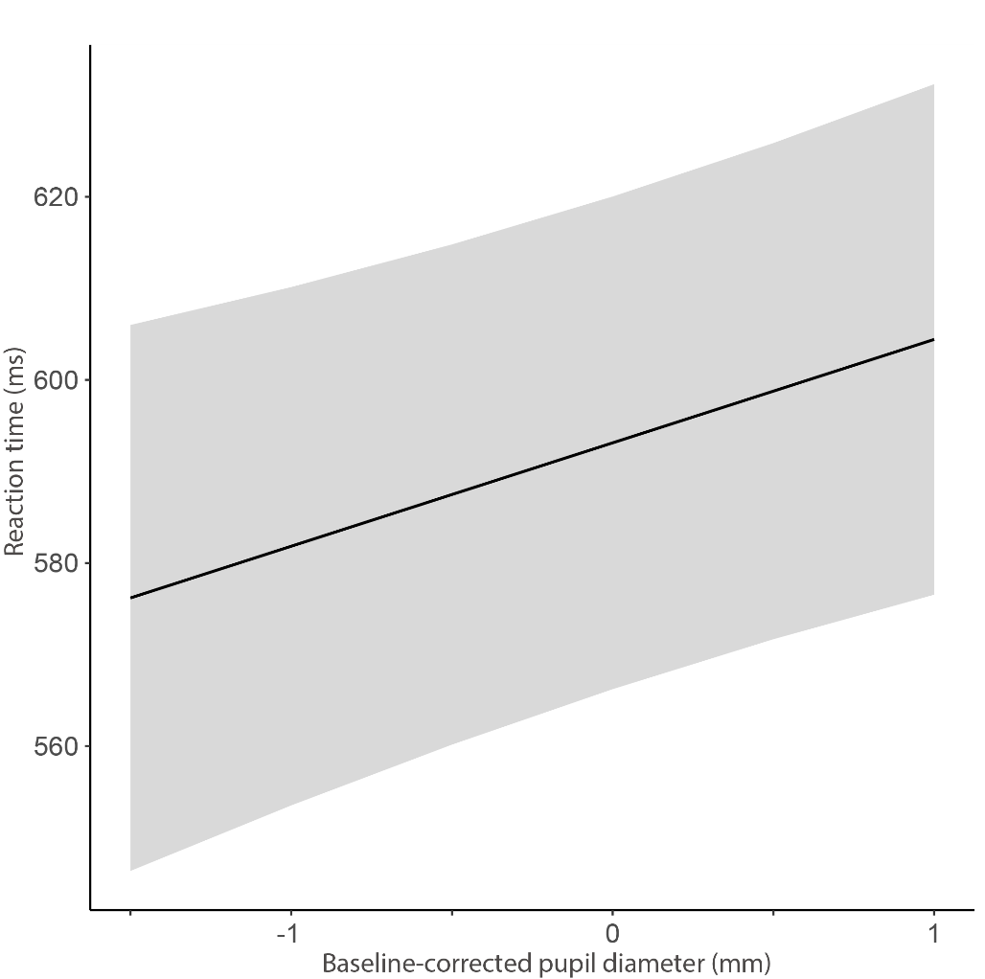
Supplementary Figure 2. Model predicted best fit line for the effect of baseline-corrected pupil dilation responses on reaction times (Model 2). The shaded colored region surrounding the predicted line represents the ± 95% confidence interval. Baseline-corrected pupil diameter: baseline-corrected pupil dilation responses at the target epoch.

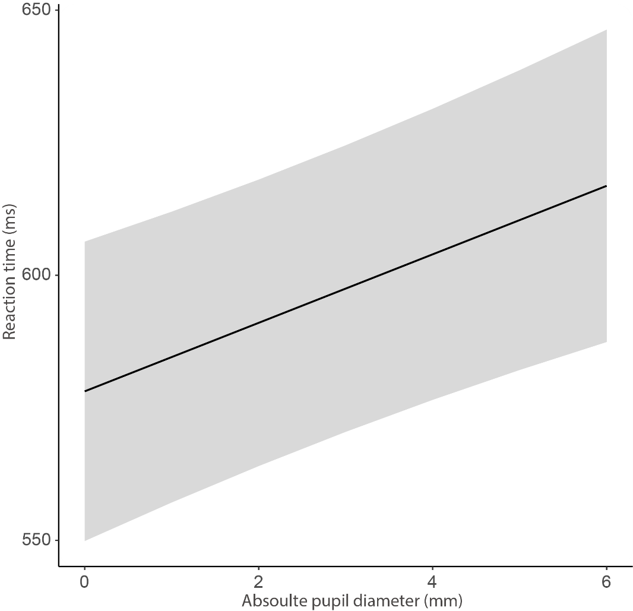
Supplementary Figure 3. Model predicted best fit line for the effect of absolute pupil size on reaction times (Model 3). The shaded colored region surrounding the predicted line represents the ± 95% confidence interval. Absolute pupil diameter: absolute pupil size at the target epoch.

