Unraveling the surface marker signature of cell-derived vesicles via proteome analysis and nanoparticle flow cytometry

Hui-Chong Lau¹, Ilaria Passalacqua², Jik-Han Jung¹, Yerim Kwon¹, Davide Zocco², Sung-Soo Park¹, and Seung Wook Oh^{1,3,*}

¹ BioDrone Research Institute, MDimune Inc., Seoul, Korea

² Lonza Siena., Siena, Italy

³ BioDrone Therapeutics Inc., Seattle, USA

* Correspondence should be addressed to swoh@mdimune.com

No | Protein Name | Gene name | CDV (Abundance) | EV (Abundance) | CDV/EV | CDV/Cell | EV/Cell
1 | Lysosome-associated membrane glycoprotein 1 | LAMP1 | 625,753,223 | 18,317,643 | 34.16 | 41.69 | 1.22
2 | Lysosome-associated membrane glycoprotein 2 | LAMP2 | 618,379,380 | 15,638,189 | 39.54 | 36.38 | 0.92
3 | Basigin | BSG/CD147 | 578,831,342 | 356,519,809 | 1.62 | 19.18 | 11.81
4 | Kinectin | KTN1 | 502,081,461 | 179,452910 | 2.79 | 7.82 | 2.81
5 | Integrin beta-1 | ITGB1 | 407,439,475 | 304,557,675 | 1.34 | 14.28 | 10.68
6 | Ras-related protein Rab-7a | RAB7A | 387,167,648 | 59,032,236 | 6.56 | 11.42 | 1.74
7 | Sodium/potassium-transporting ATPase subunit beta-3 | ATP1B3 | 368,836,860 | 150,996,699 | 2.44 | 14.48 | 5.93
8 | Nicastrin | NCSTN | 333,029,841 | 38,070,235 | 8.75 | 8.28 | 0.95
9 | Lysosome membrane protein 2 | SCARB2 | 325,954,252 | 8,133,431 | 40.1 | 21.41 | 0.53
10 | Tetraspanin CD63 | CD63 | 274,787,551 | 49,466,431 | 5.55 | 29.24 | 5.26
11 | Tetraspanin CD81 | CD81 | 131,259,149 | 525,212,037 | 0.25 | 16.10 | 64.44
12 | Tetraspanin CD9 | CD9 | 94,886,099 | 257,505,787 | 0.37 | 5.04 | 13.67
13 | Prostaglandin F2 receptor negative regulator | PTGFRN | 381,966,809 | 1136,219,822 | 0.34 | 3.94 | 11.73
Supplementary Table S1. The nine most differentially expressed membrane protein markers in CDVs. The respective protein and gene names are based on the accession ID. The measurable abundance values of the membrane protein markers in CDVs (fourth column) were compared to those in EVs (fifth column). The relative abundance levels of CDV membrane proteins were compared to both EVs and parental cells. The protein abundance values of EVs relative to cells were also included in the analysis. Tetraspanin markers and PTGFRN were used as controls.

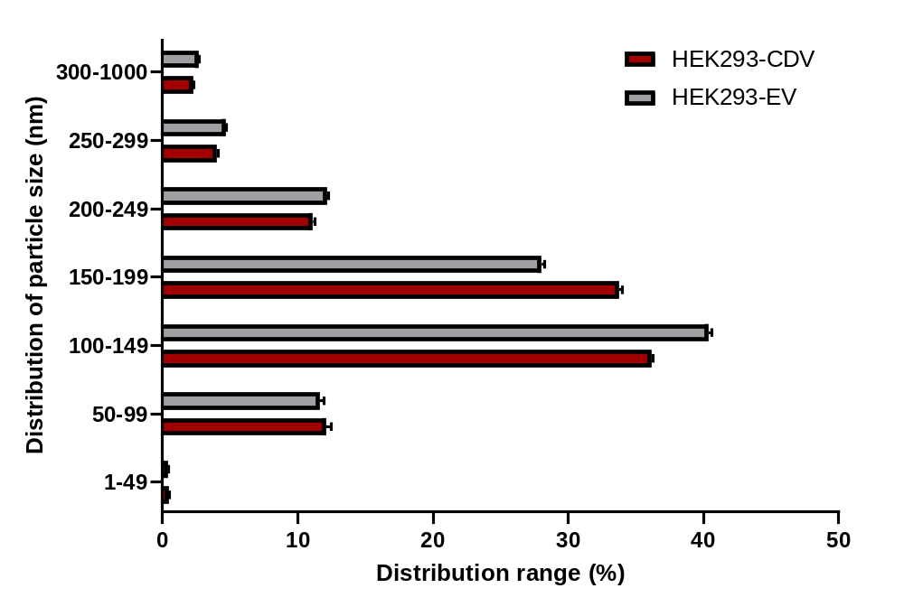

Supplementary Figure S1. Size distribution of CDVs and EVs. Data represent the mean ± SD (N=5).

(a)
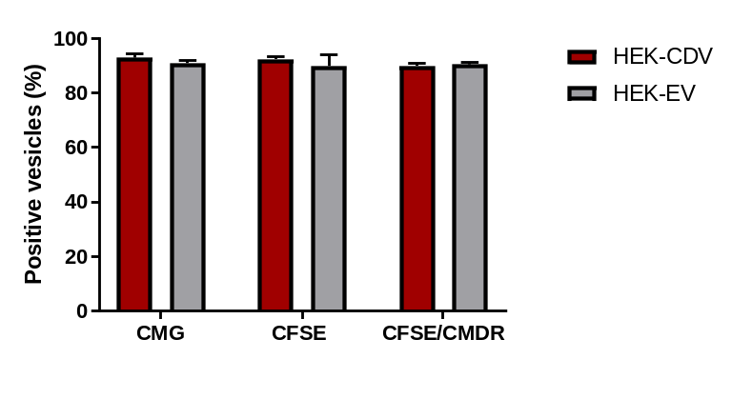
(b)
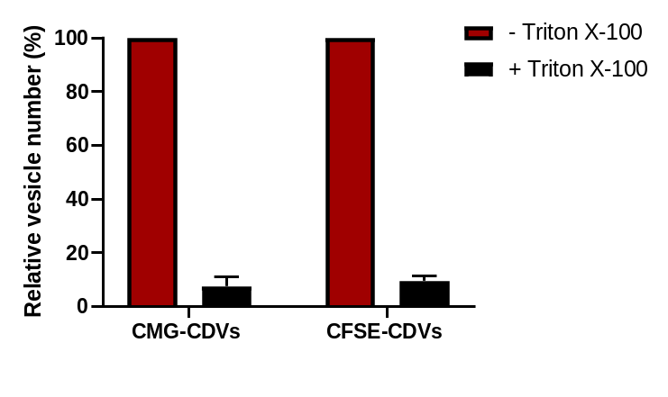
(c)
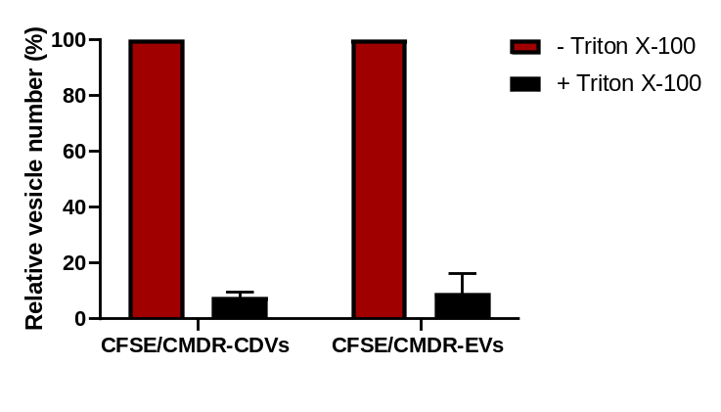
Supplementary Figure S2. (a) Membrane and luminal staining CDVs. CDVs were labeled with single (CMG or CFSE) or double (CMDR and CFSE) fluorescent dyes. Labeled CDVs were analyzed by nFCM. The positive vesicles indicate the fluorescent vesicles in the population. EVs were used as the control group. Data represent the mean ± SD (N=3). Purity assessment of CDVs using nFCM. The relative particle number of CDVs was determined after Triton X-100 treatment. (b) CDVs labeled with single fluorescent dye, (CMG or CFSE), and (c) both different fluorescent dyes (CFSE and CMDR) were analyzed before (red) and after (black) addition of Triton X-100. EVs were used as the control group for double labeling. The untreated CDVs were used to normalize each data for comparative analysis. Data represent the mean ± SD (N=3).

