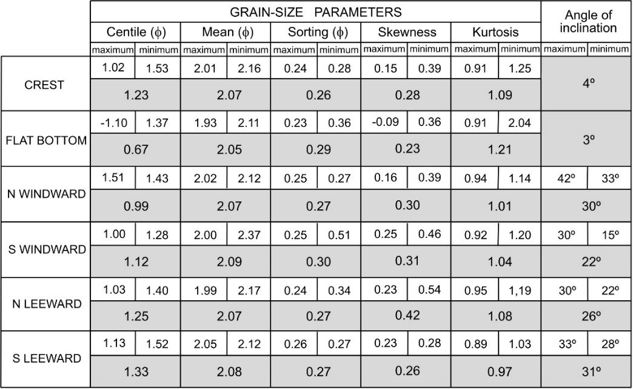

Table 1. Maximum, minimum and average values of the grain-size parameters and angles of inclination for each particular morphology of the saucer blowout of Frouxeira.

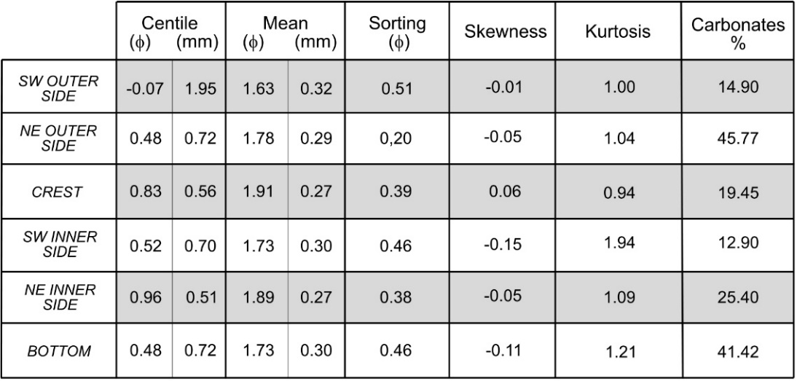

Table 2. Averages of the grain-size parameters and the biogenic carbonate percents for each particular morphology in the blowout of El Puntal of Somo.

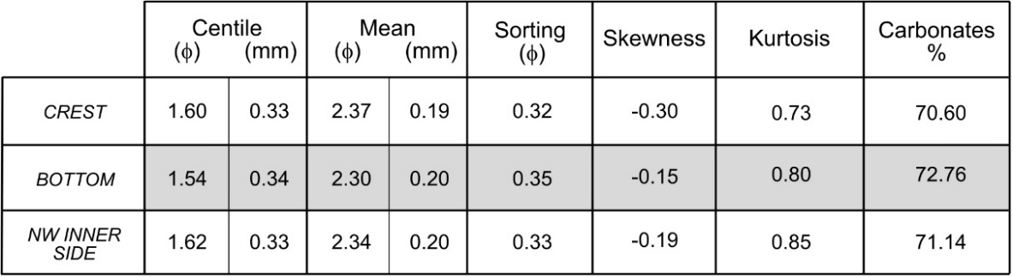

Table 3. Averages of grain-size parameters and biogenic carbonate percents for each particular morphology in the blowout of Sonabia.

