SUPPLEMENTARY MATERIALS
New pyranoxanthones from the stem bark of Calophyllum soulattri Burm. F.
Mas Atikah Lizazman¹, Vivien Jong Yi Mian^{1,*}
¹Faculty of Applied Sciences, Universiti Teknologi MARA, Kota Samarahan, Sarawak, Malaysia
*E-mail: vivien@uitm.edu.my

Abstract: Five new pyranoxanthones (1-5), together with eight known xanthones were isolated from hexane extract of C. soulattri stem bark. Among the new compounds, xanthones 1-3 are structural isomers. The structures of compounds 1-13 were determined by 1D and 2D NMR analysis.

Keywords: Calophyllaceae, Calophyllum soulattri, hexane extract, xanthone.

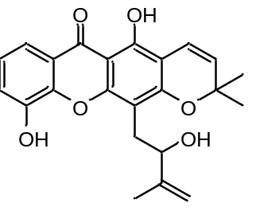 | 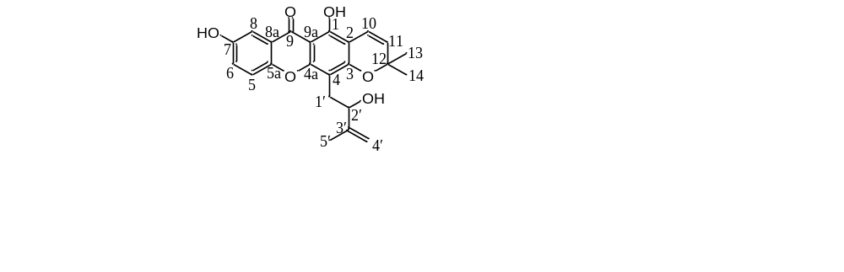
1 | 2
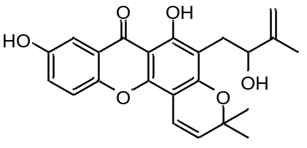 | 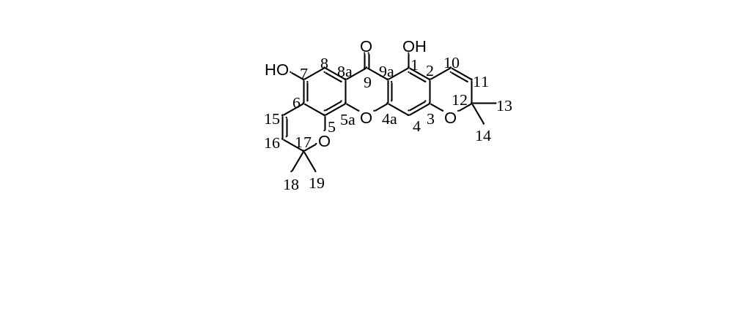
3 | 4
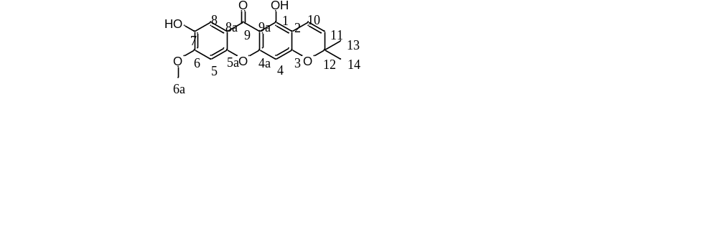
5

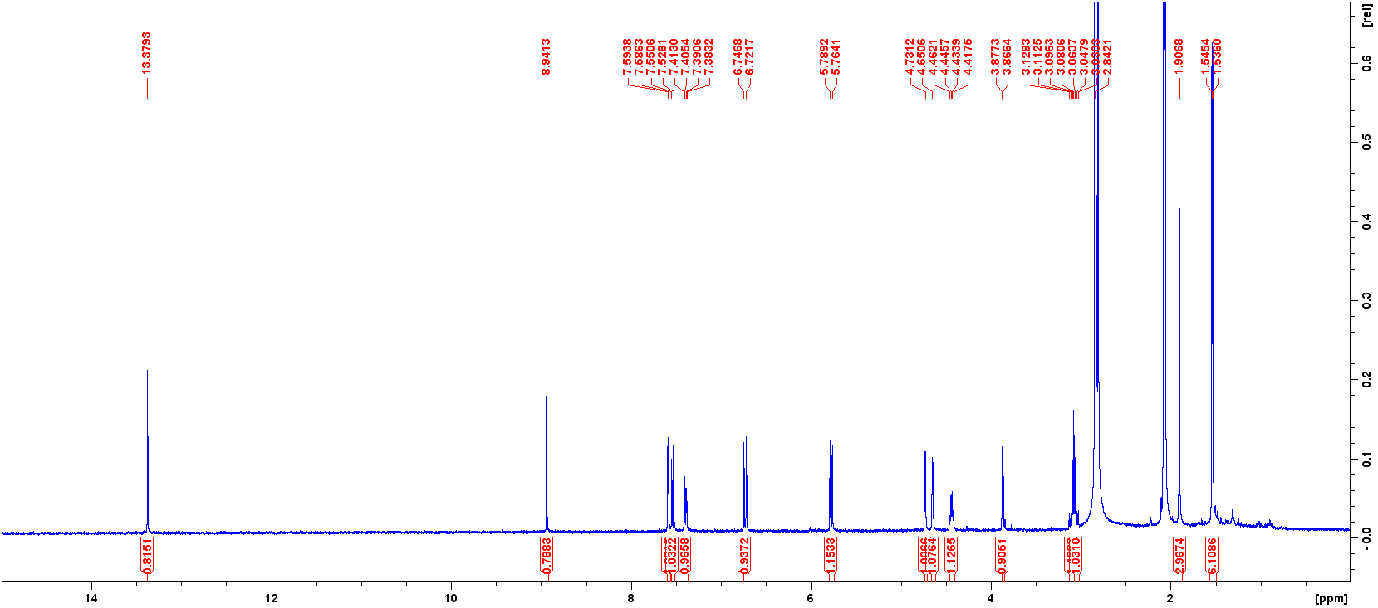
Figure S1. 1D (¹H) NMR spectrum (400 MHz, acetone-d₆) of compound 1.

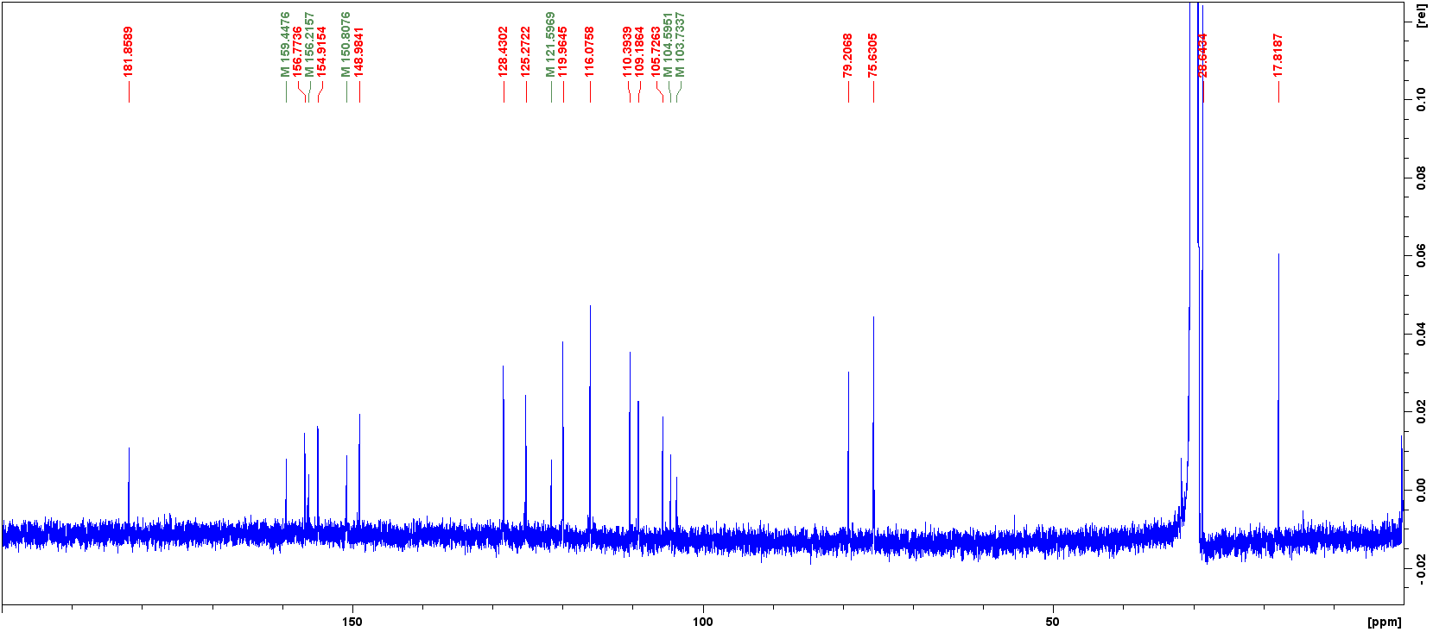
Figure S2. 1D (¹³C) NMR spectrum (100 MHz, acetone-d₆) of compound 1.

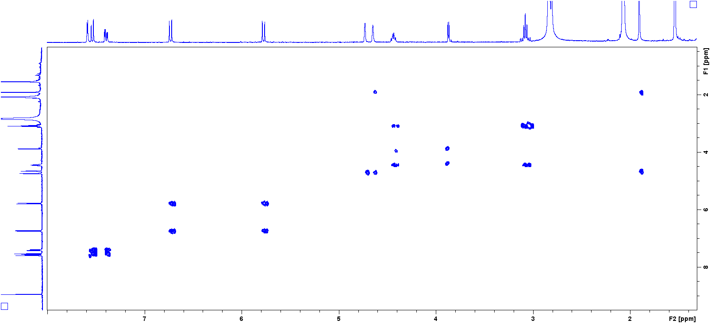
Figure S3. 2D (COSY) NMR spectrum of compound 1.

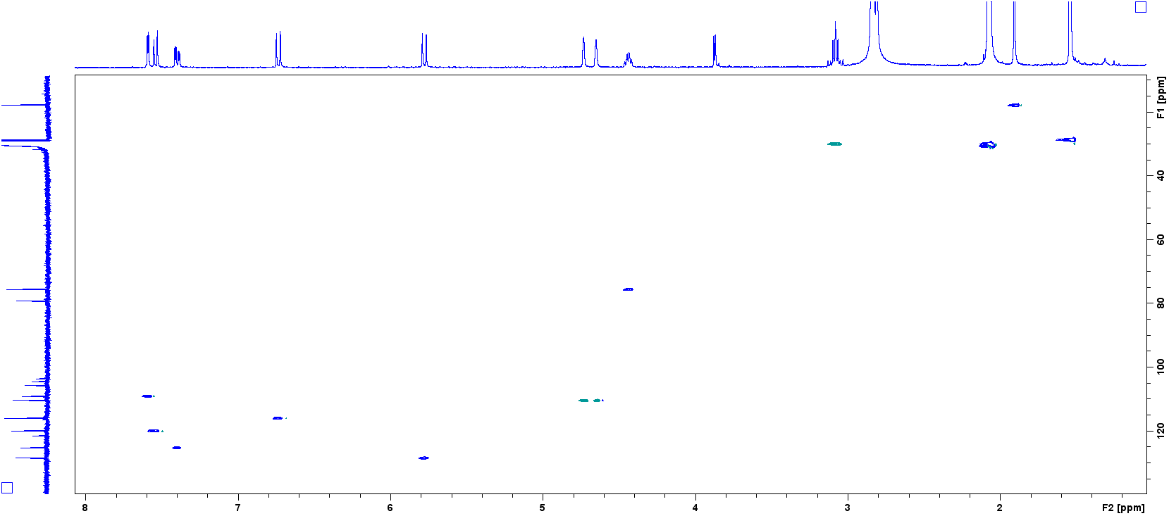
Figure S4. 2D (HSQC) NMR spectrum of compound 1.

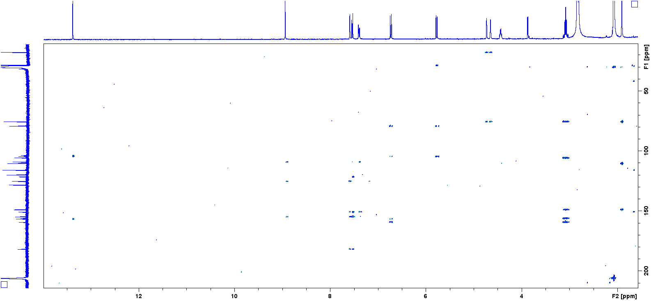
Figure S5. 2D (HMBC) NMR spectrum of compound 1.

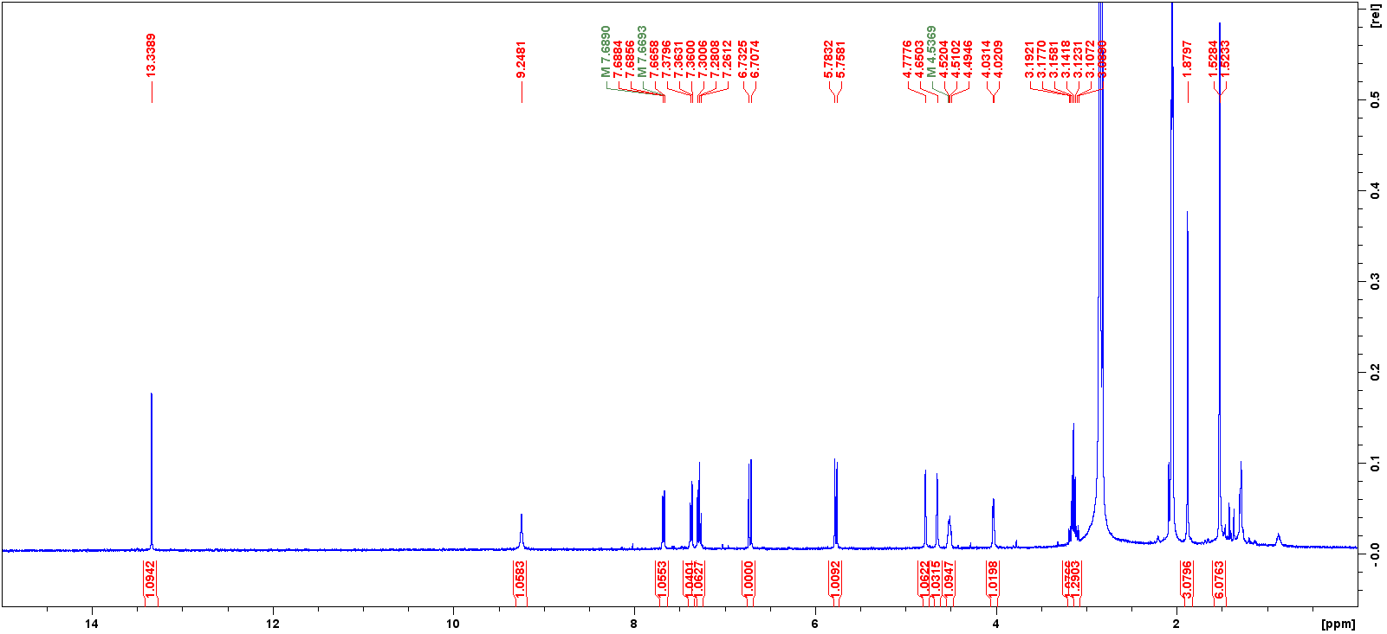
Figure S6. 1D (¹H) NMR spectrum (400 MHz, acetone-d₆) of compound 2.

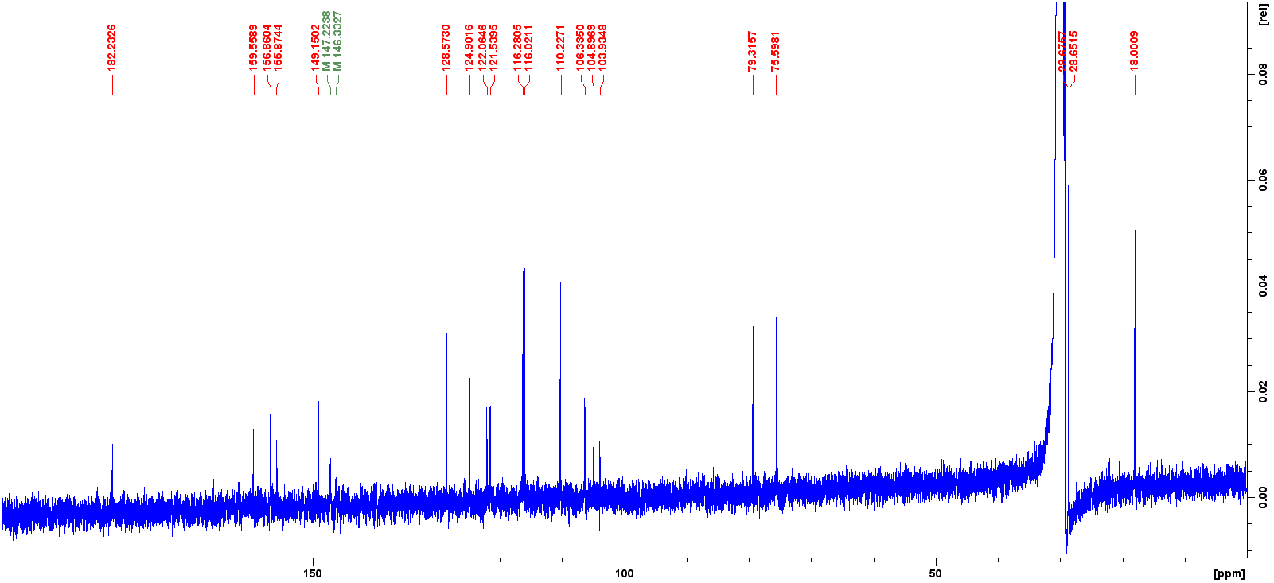
Figure S7. 1D (¹³C) NMR spectrum (100 MHz, acetone-d₆) of compound 2.

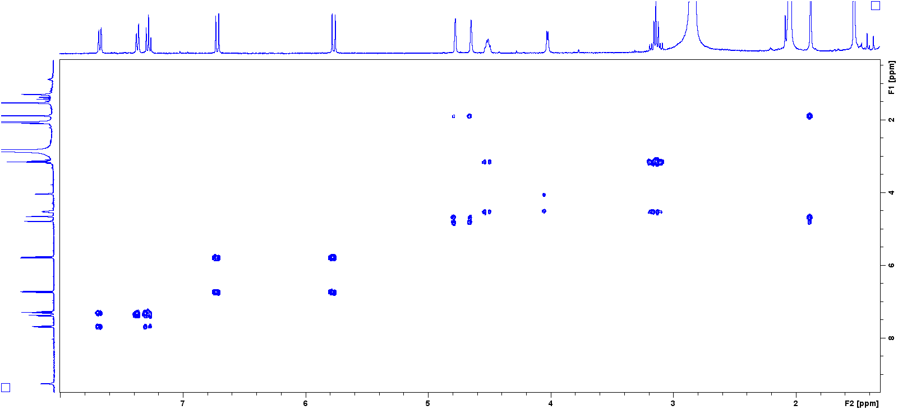
Figure S8. 2D (COSY) NMR spectrum of compound 2.

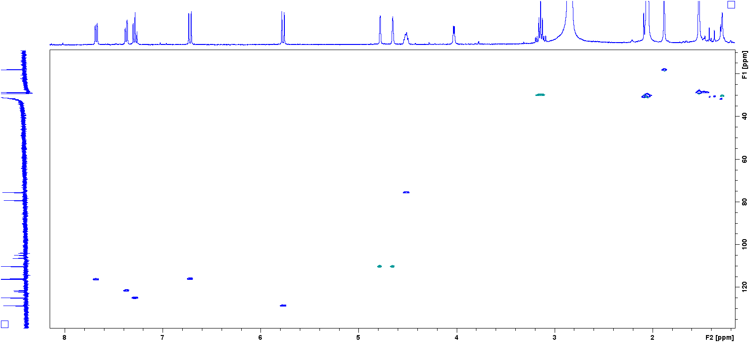
Figure S9. 2D (HSQC) NMR spectrum of compound 2.

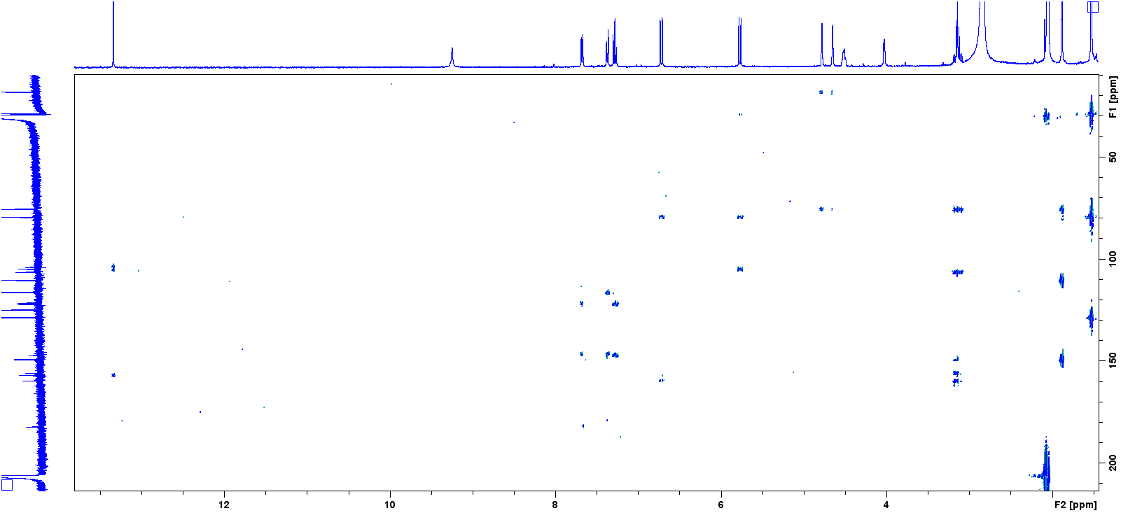
Figure S10. 2D (HMBC) NMR spectrum of compound 2.

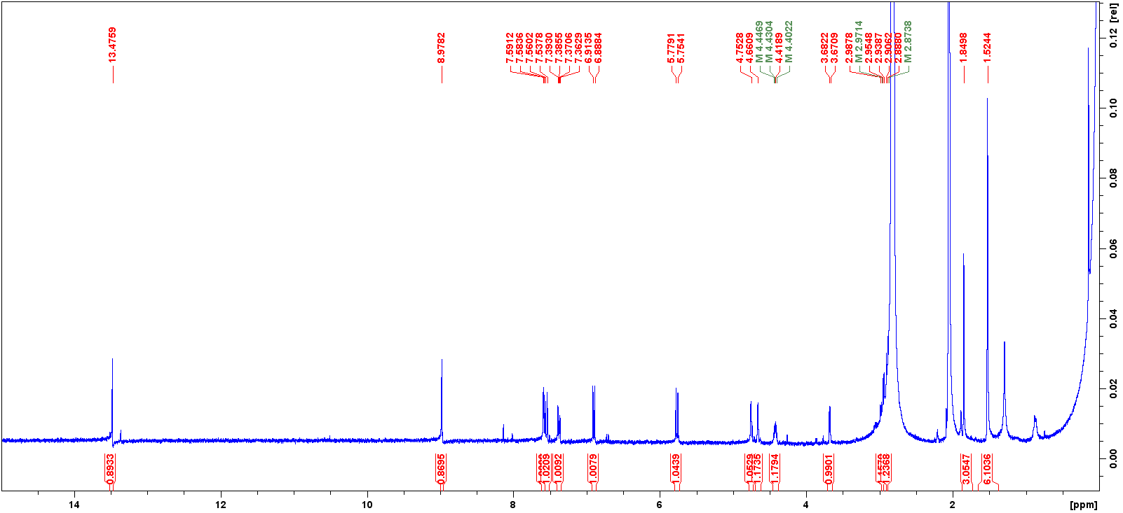
Figure S11. 1D (¹H) NMR spectrum (400 MHz, acetone-d₆) of compound 3.

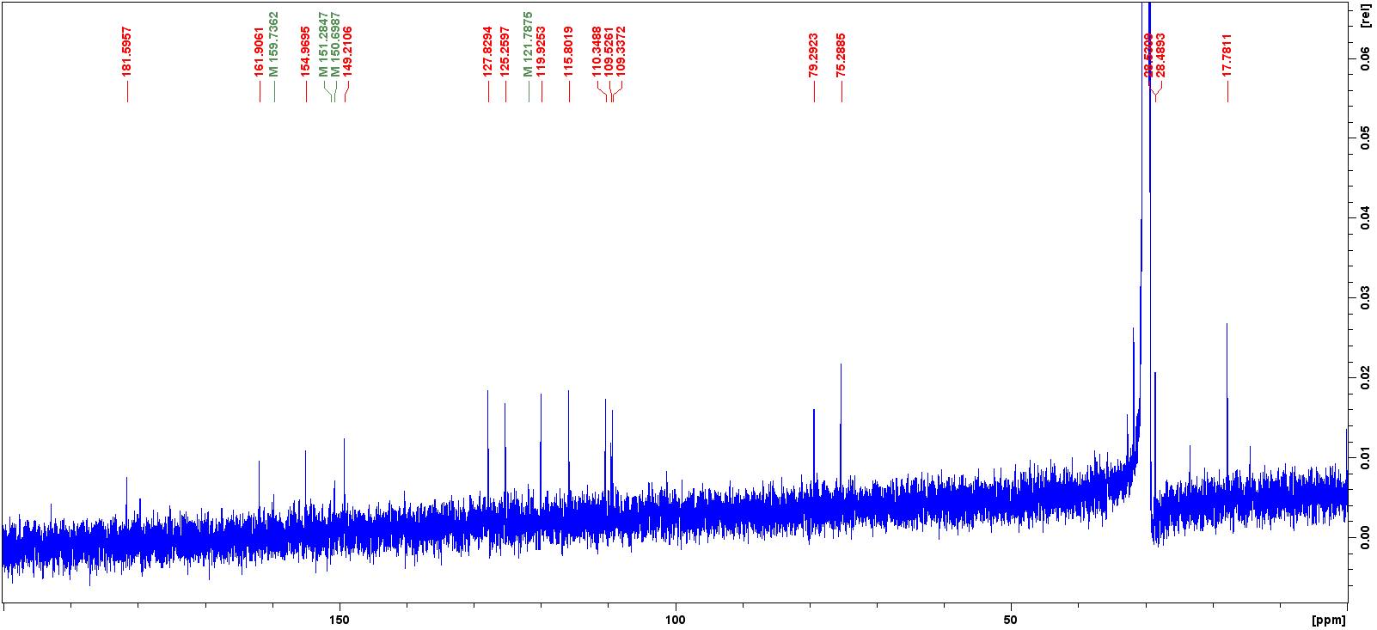
Figure S12. 1D (¹³C) NMR spectrum (100 MHz, acetone-d₆) of compound 3.

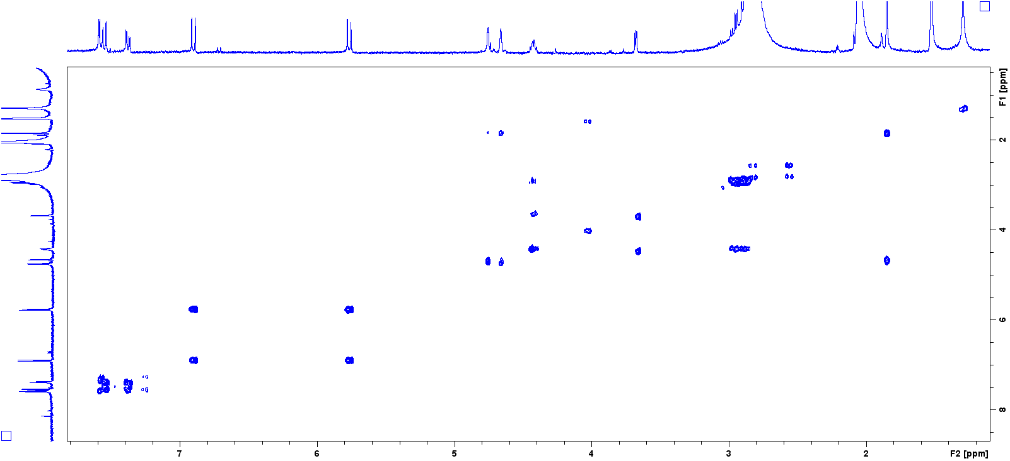
Figure S13. 2D (COSY) NMR spectrum of compound 3.

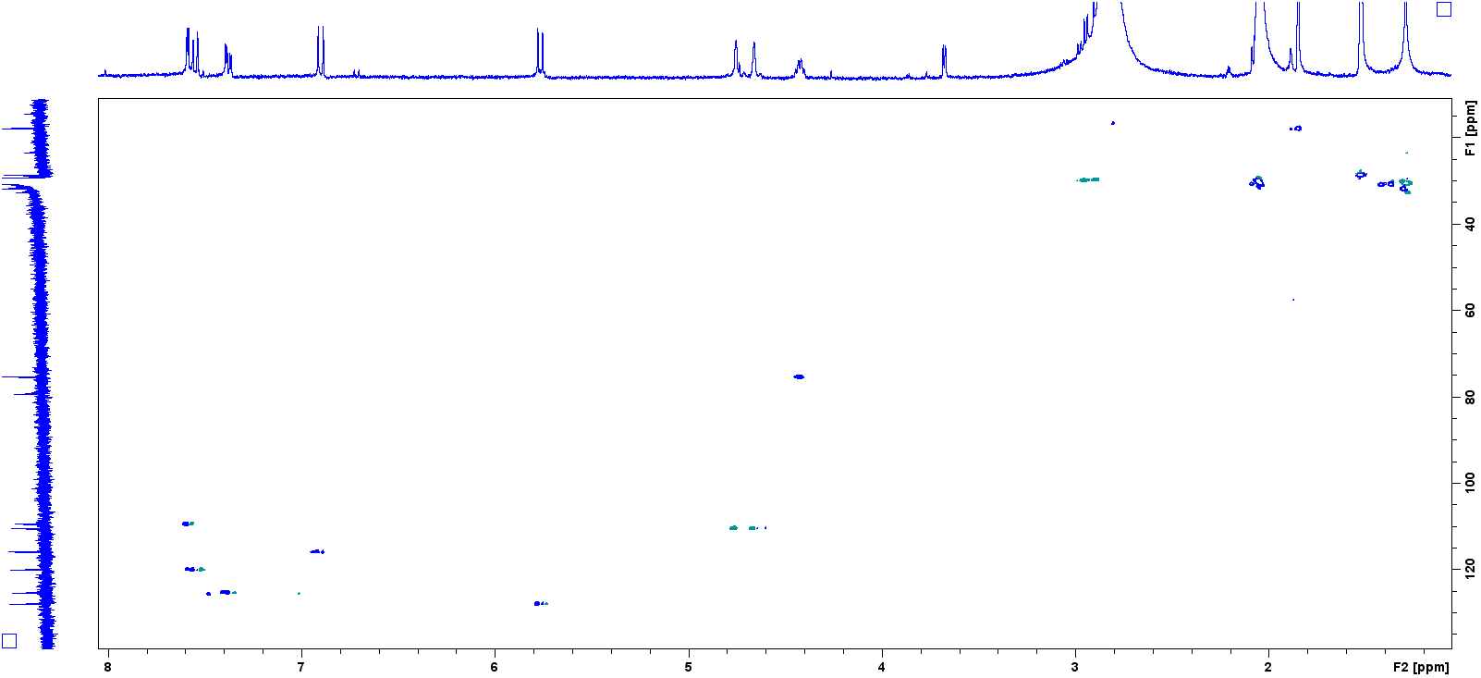
Figure S14. 2D (HSQC) NMR spectrum of compound 3.

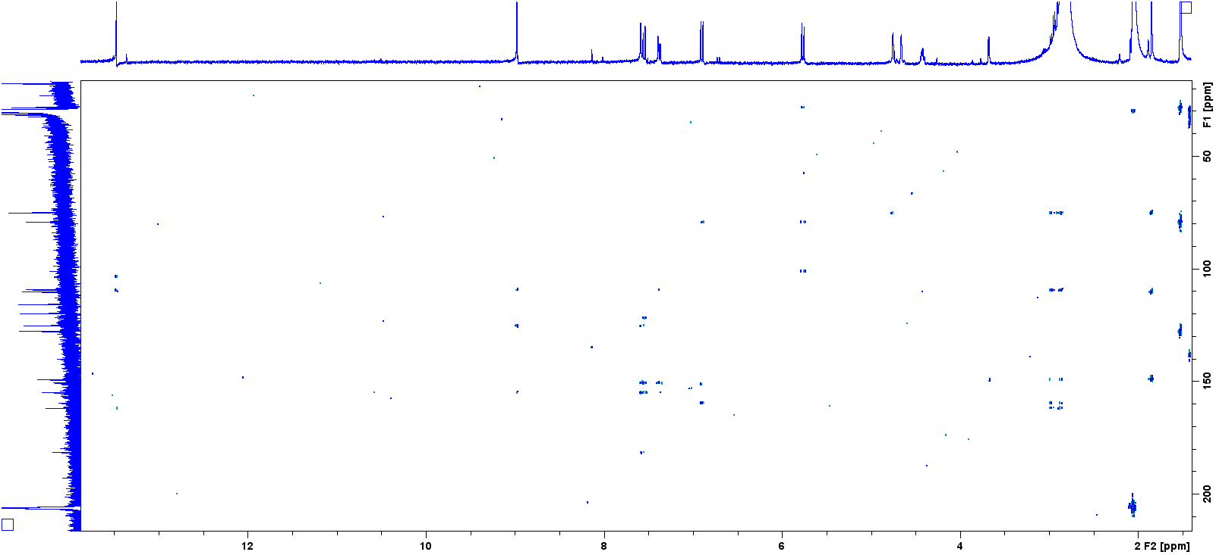
Figure S15. 2D (HMBC) NMR spectrum of compound 3.

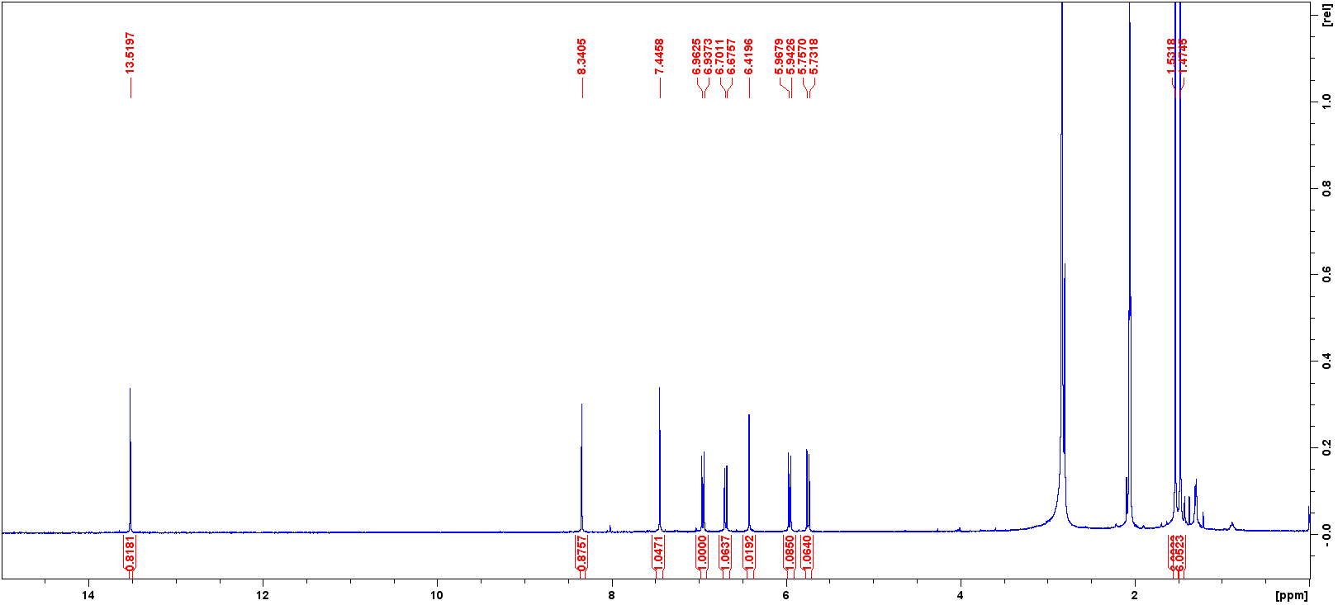
Figure S16. 1D (¹H) NMR spectrum (400 MHz, acetone-d₆) of compound 4.

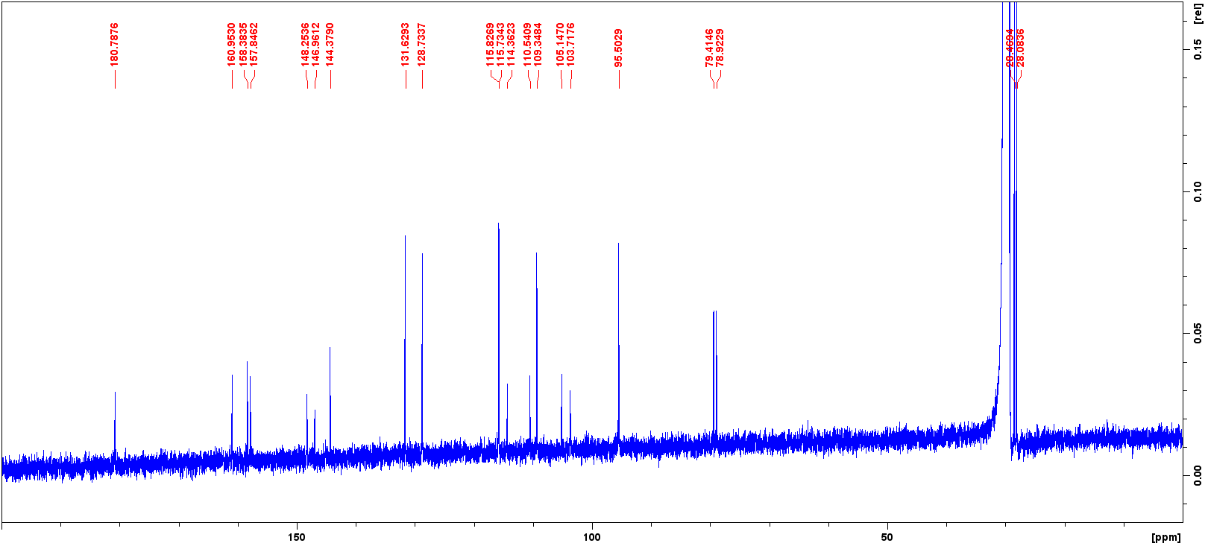
Figure S17. 1D (¹³C) NMR spectrum (100 MHz, acetone-d₆) of compound 4.

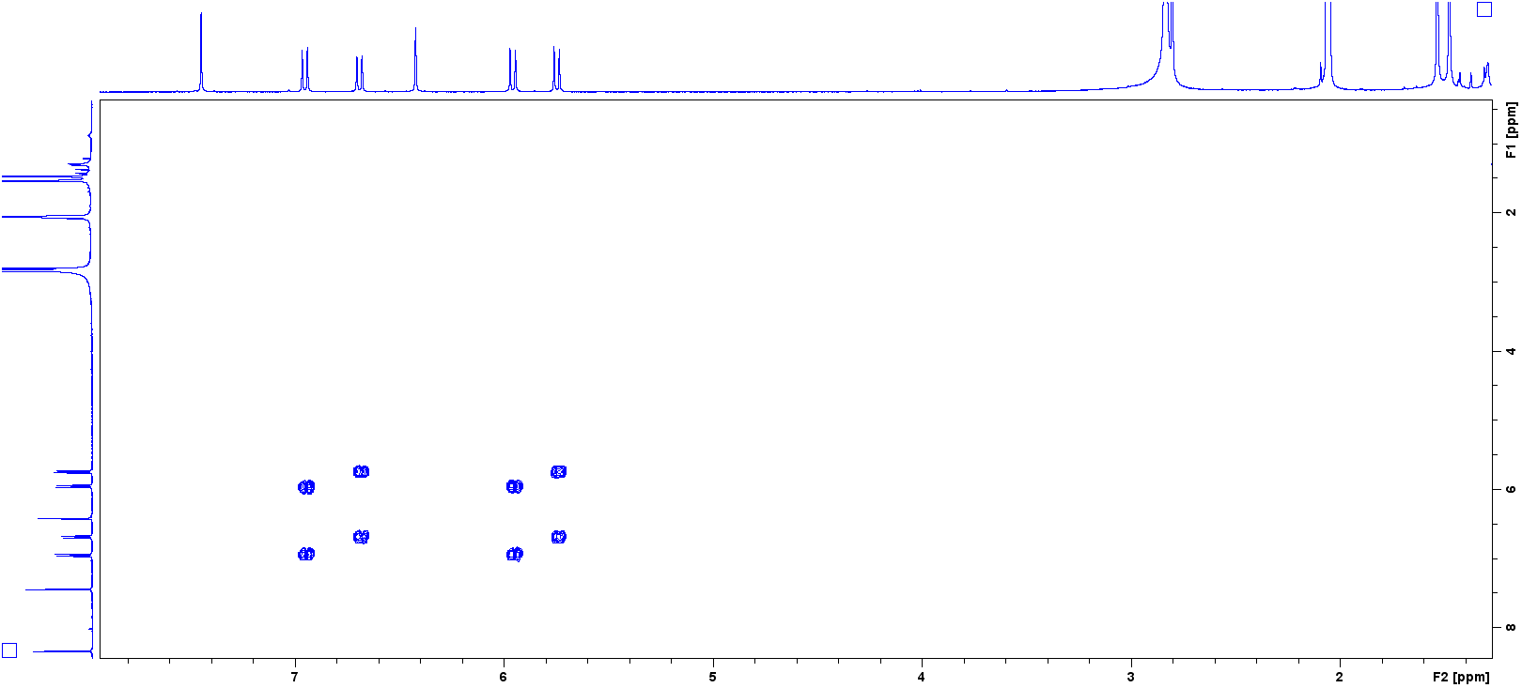
Figure S18. 2D (COSY) NMR spectrum of compound 4.

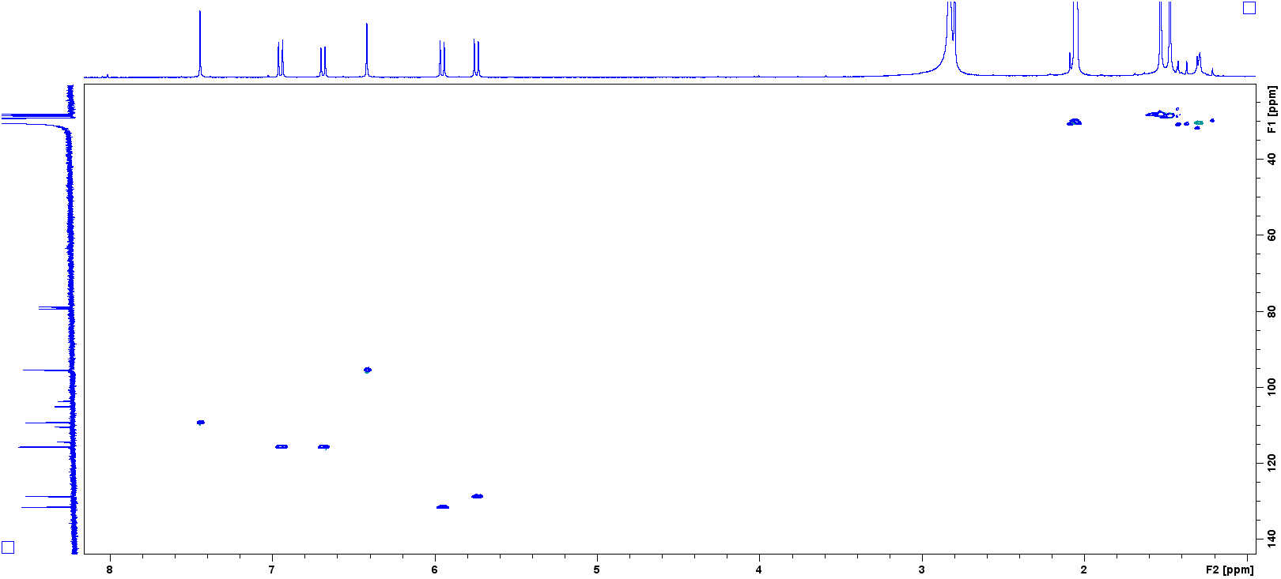
Figure S19. 2D (HSQC) NMR spectrum of compound 4.

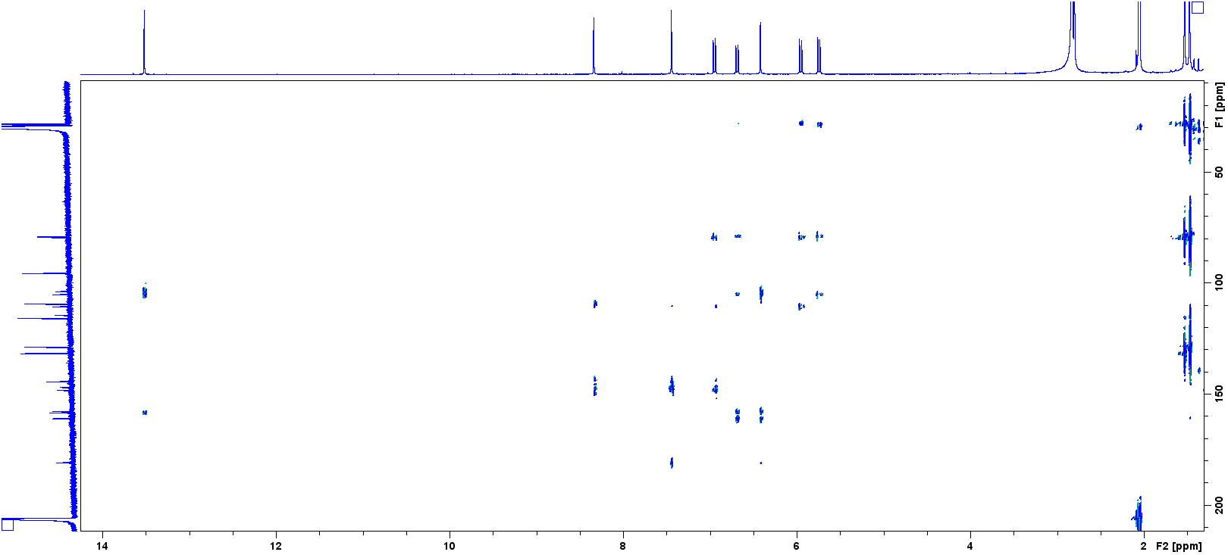
Figure S20. 2D (HMBC) NMR spectrum of compound 4.

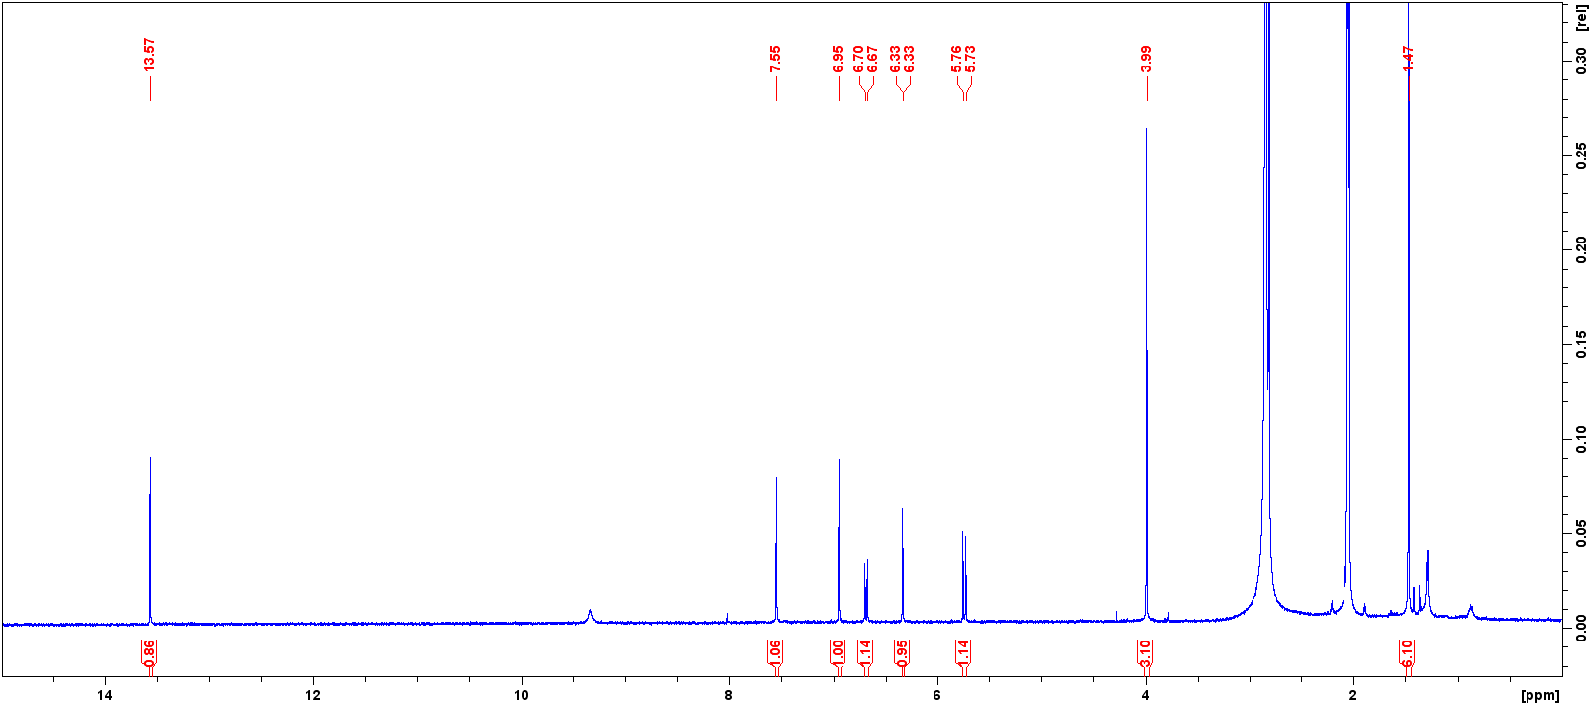
Figure S21. 1D (¹H) NMR spectrum (400 MHz, acetone-d₆) of compound 5.

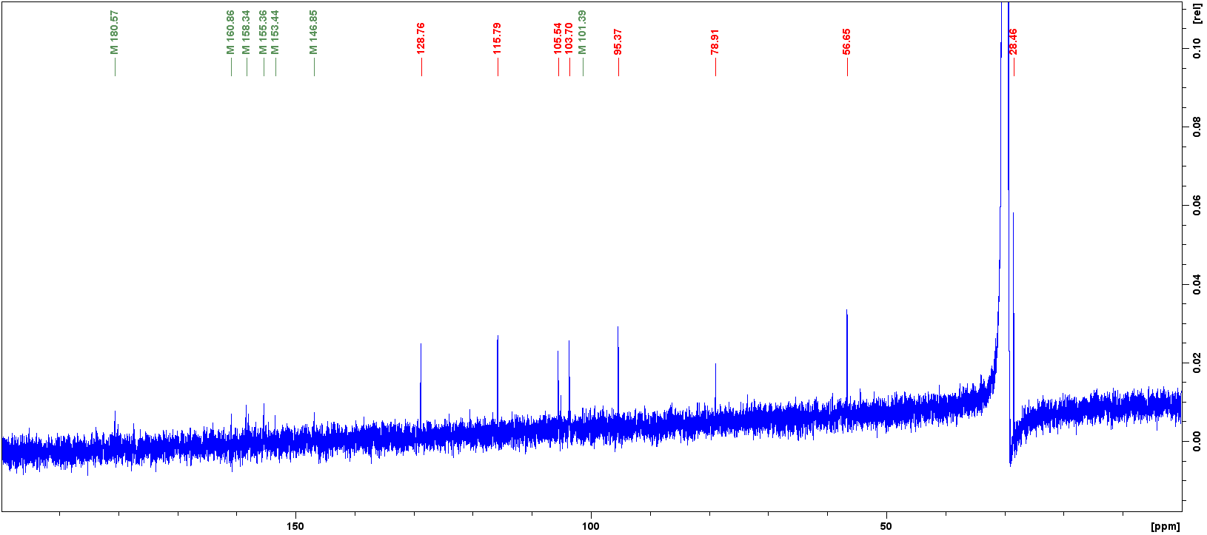
Figure S22. 1D (¹³C) NMR spectrum (100 MHz, acetone-d₆) of compound 5.

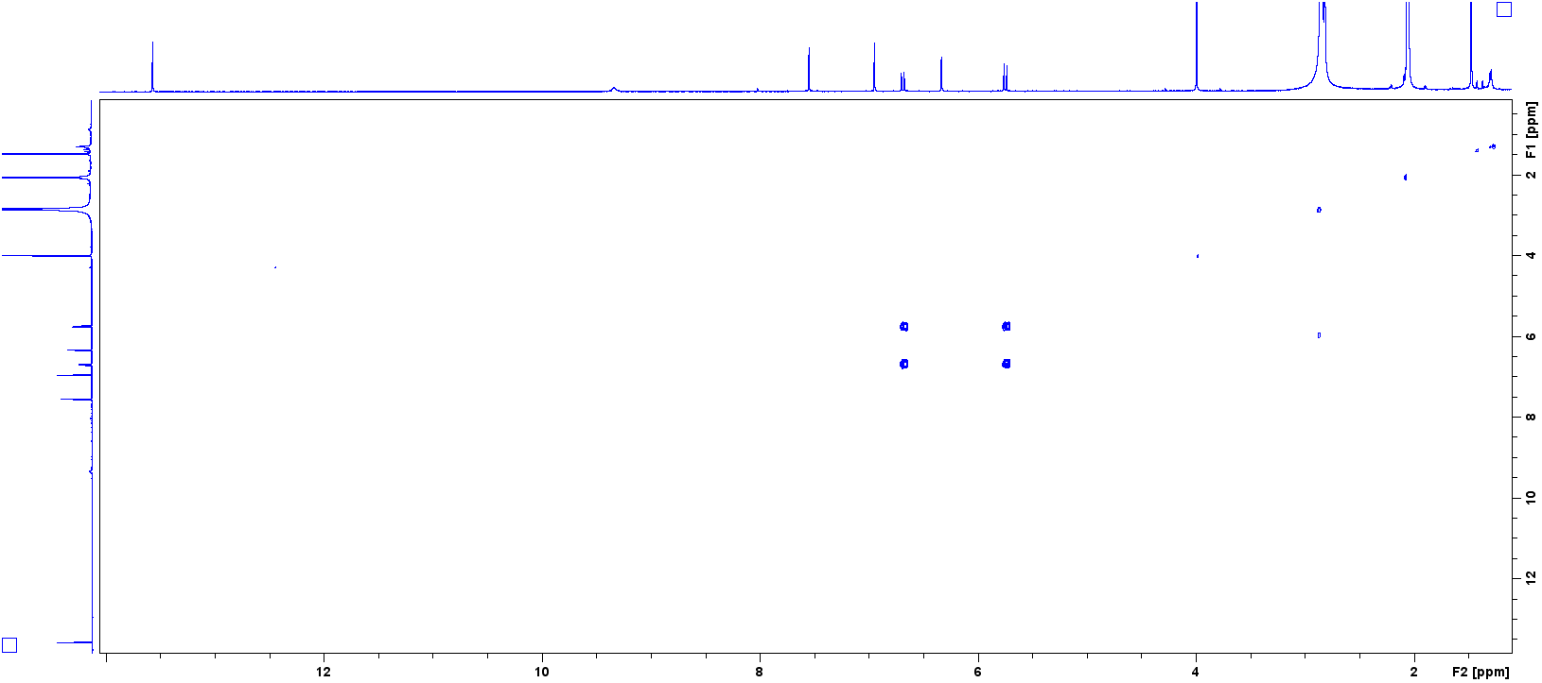
Figure S23. 2D (COSY) NMR spectrum of compound 5.

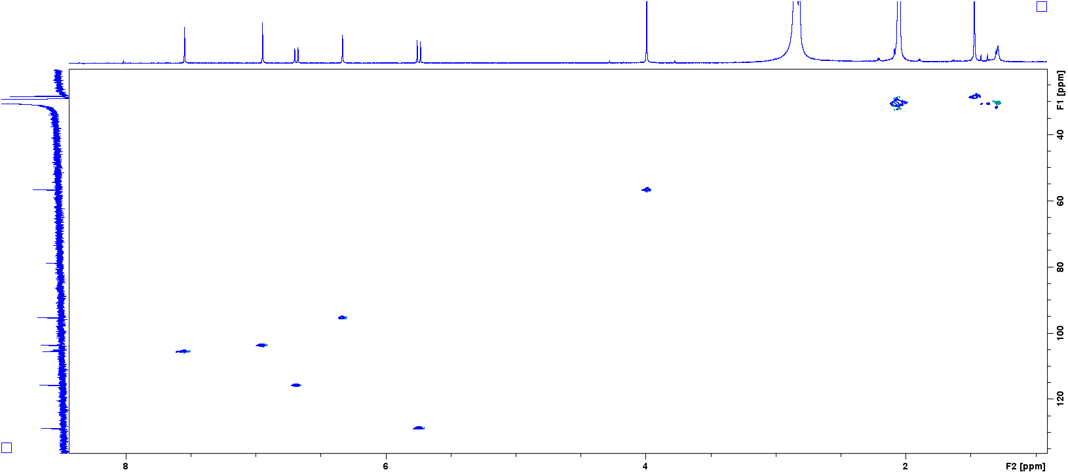
Figure S24. 2D (HSQC) NMR spectrum of compound 5.

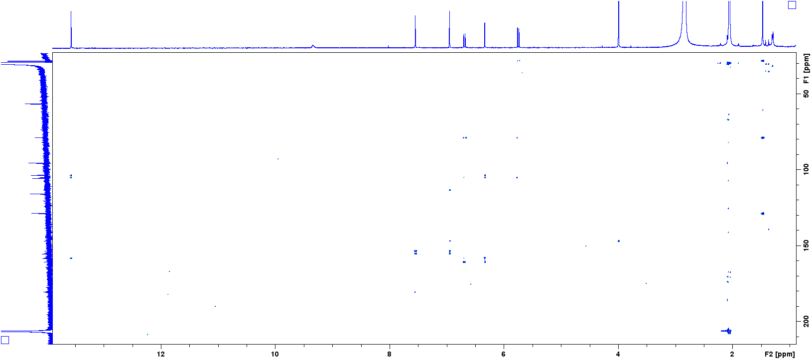
Figure S25. 2D (HMBC) NMR spectrum of compound 5.

