Appendix

Appendix 1: Maps of the population dynamics of the OPM in Bavaria
The compiled dispersion data based on the underlying source data of the map material from the AELF districts were transferred to the county boundaries in the following map representations. This allows for easier classification in terms of urban and municipal administrative units as well as state administrative districts.
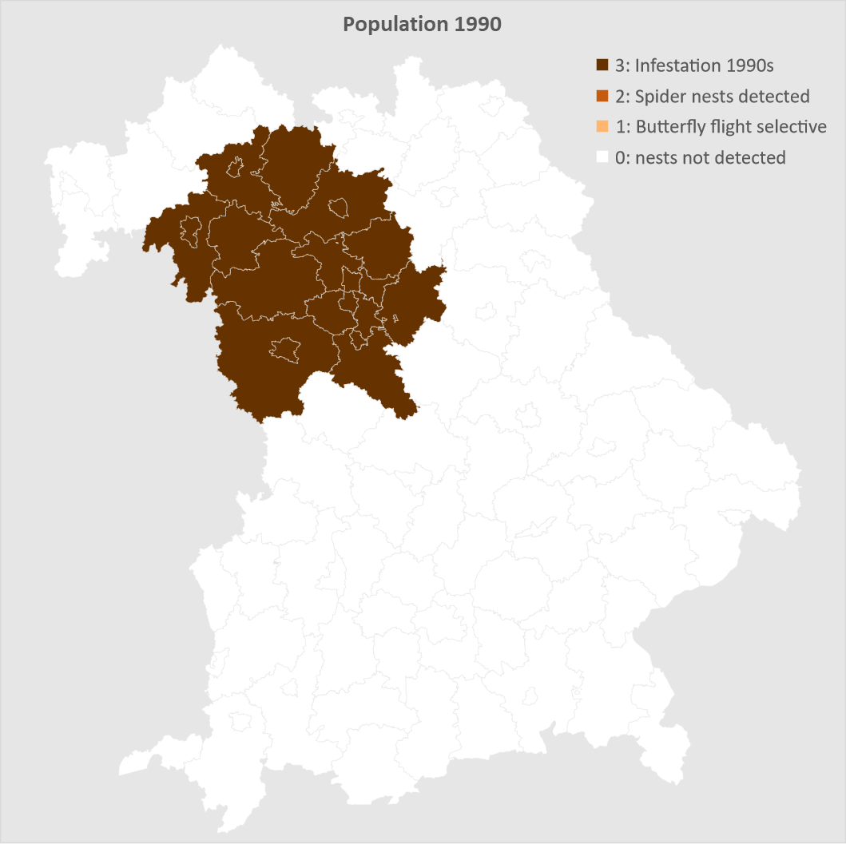
Fig. 6 Area of infestation in the 1990, an estimation according to Lobinger (2019).
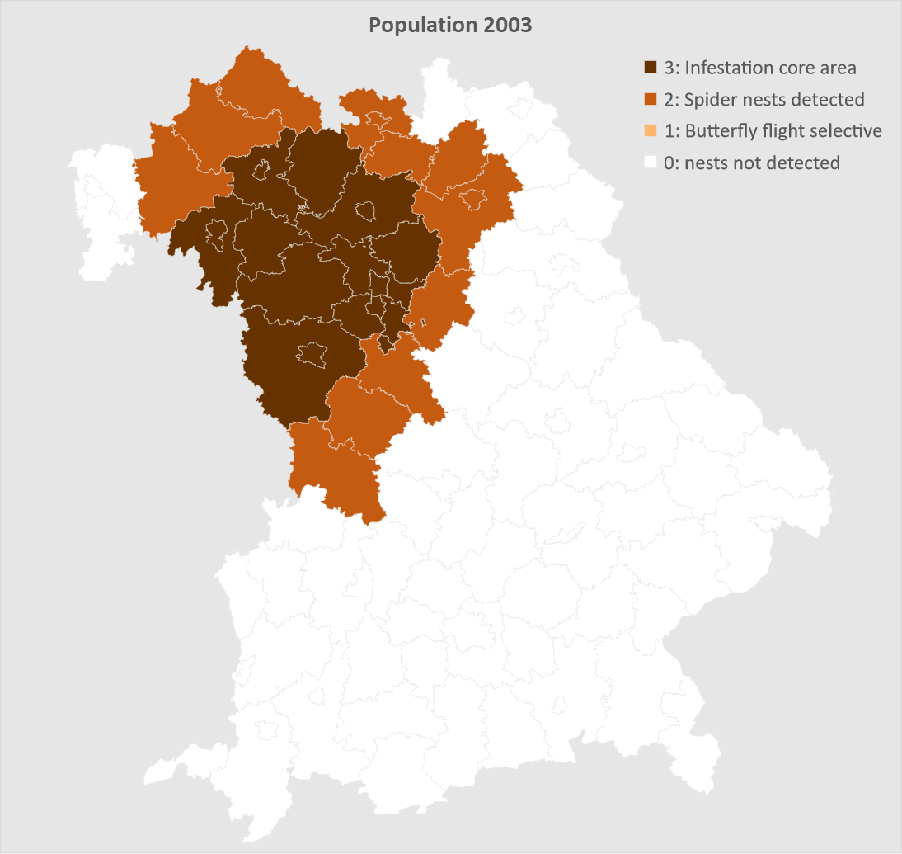
Fig. 7 OPM population in Bavaria 2003 shown in relation to Bavarian counties according (unpublished source).
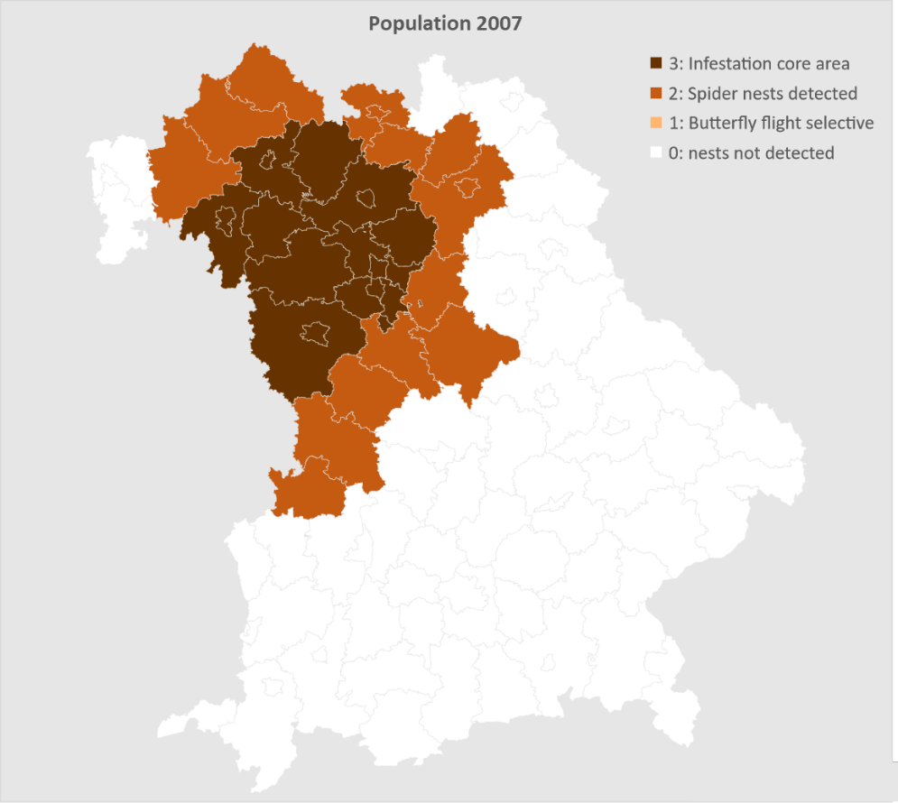
Fig. 8 OPM population in Bavaria 2007 shown in relation to Bavarian counties according to Bräsicke (2013), Lobinger (2008), Lobinger (2019), Petercord (2011) and Wulf (2009).
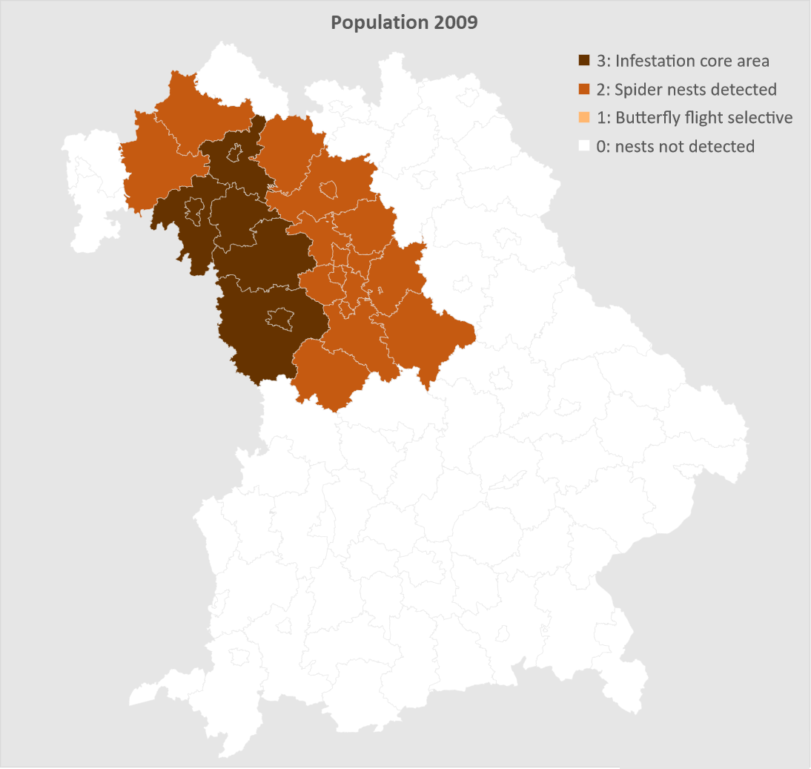
Fig. 9 OPM population in Bavaria 2009 shown in relation to Bavarian counties according to Bräsicke (2013), Lobinger 2019.
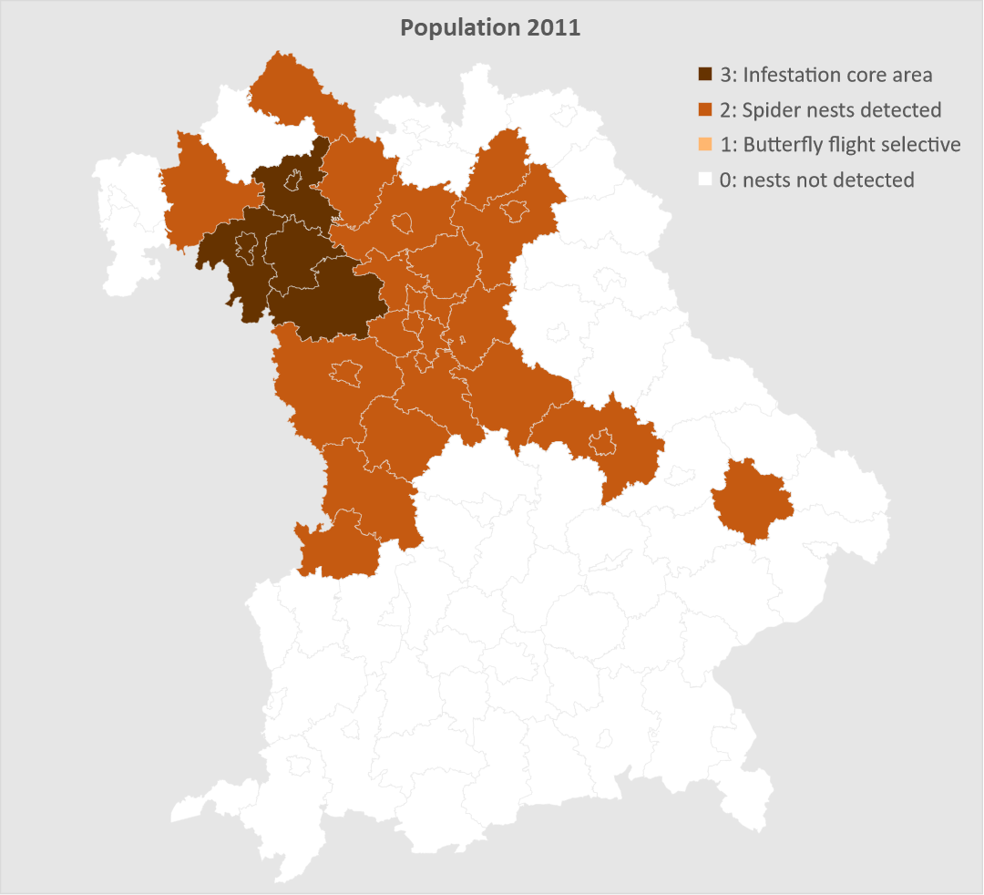
Fig. 10 OPM population in Bavaria 2011 shown in relation to Bavarian counties according to Bräsicke (2013), Lobinger (2019).
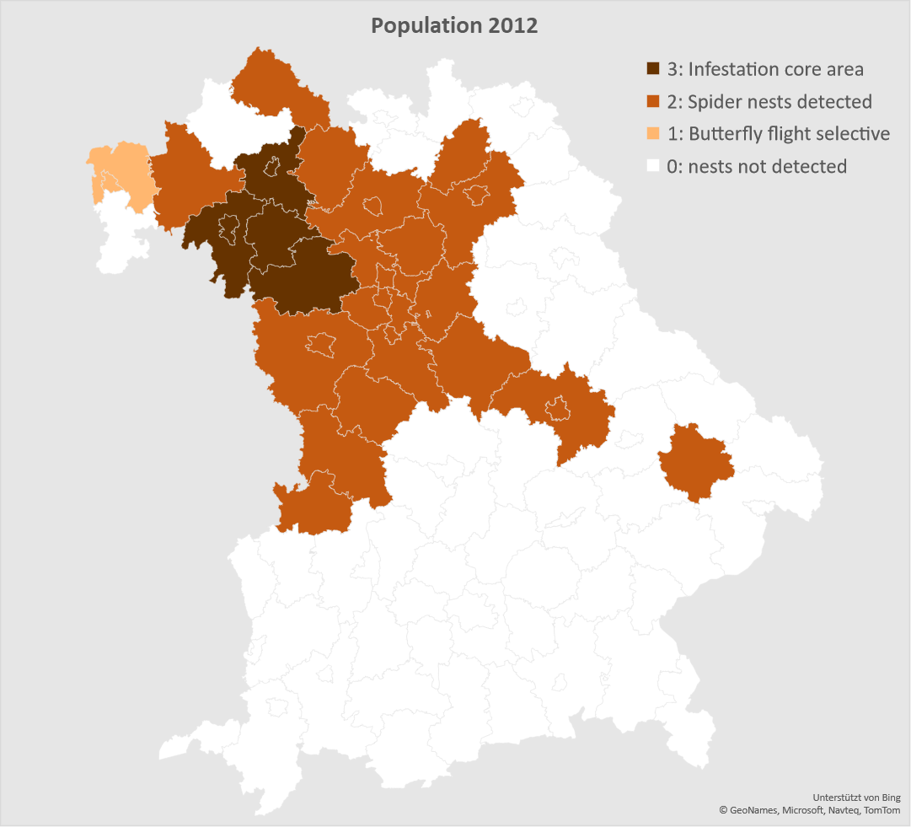
Fig. 11 OPM population in Bavaria 2012 shown in relation to Bavarian counties according to Schwegler and Lobinger (2013).
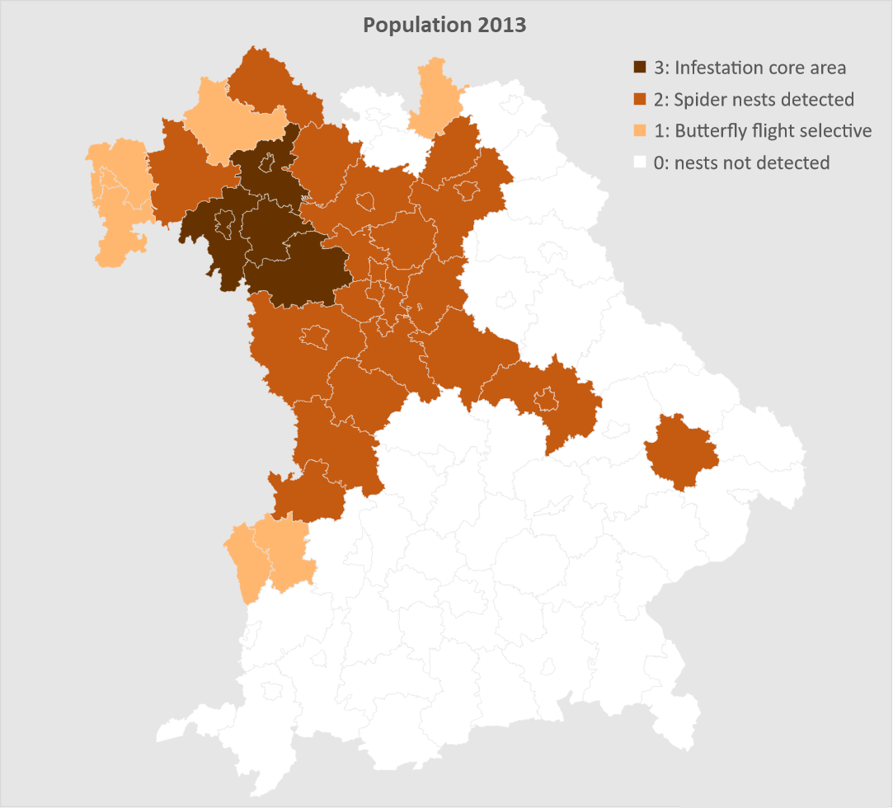
Fig. 12 OPM population in Bavaria 2013 interpolated between maps of 2012 and 2014 shown in relation to Bavarian counties according to Schwegler and Lobinger (2013) and Sobczyk (2014).
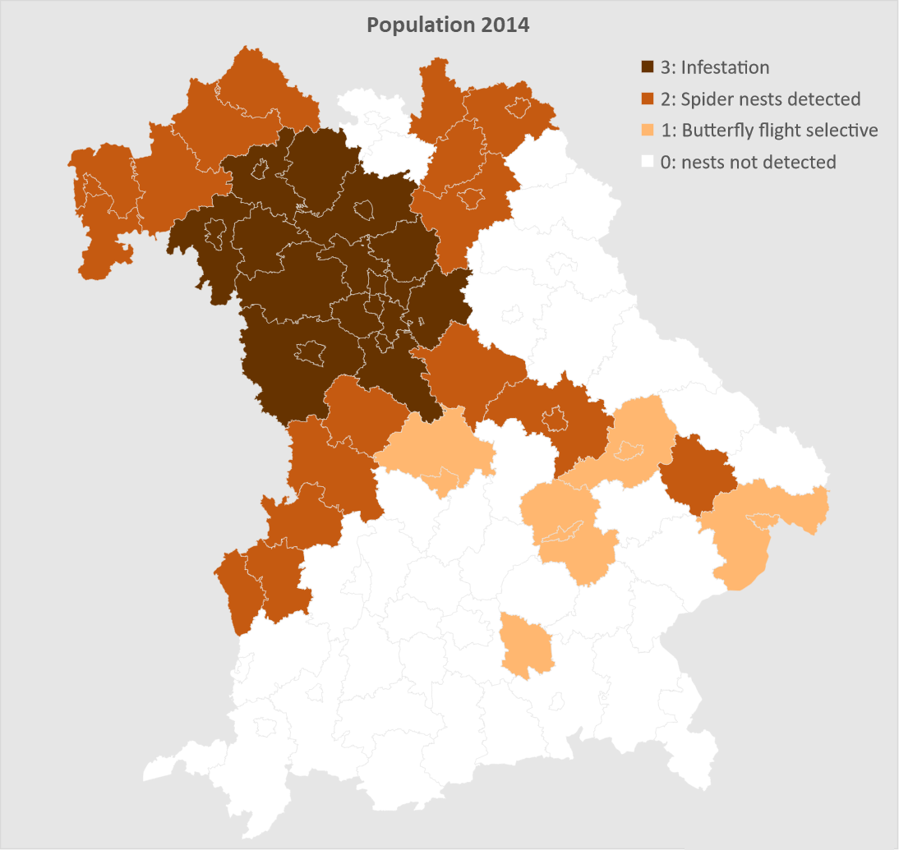
Fig. 13 OPM population in Bavaria 2014 shown in relation to Bavarian counties according to Lobinger (2019).
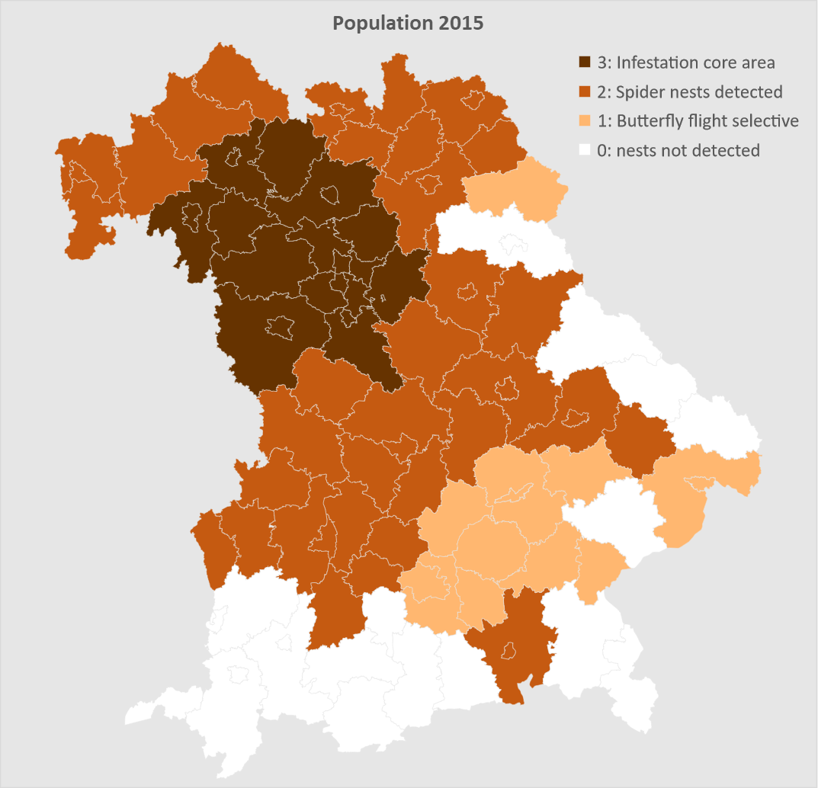
Fig. 14 OPM population in Bavaria 2015 shown in relation to Bavarian counties according to Lobinger (2019).
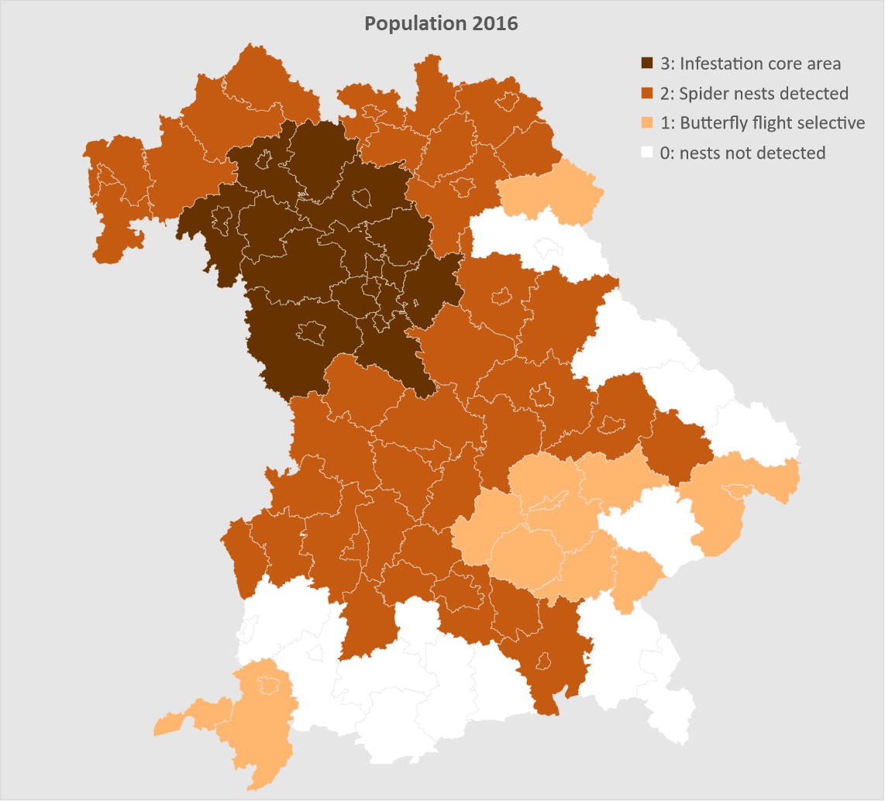
Fig. 15 OPM population in Bavaria 2016 shown in relation to Bavarian counties according to Lobinger (2019).
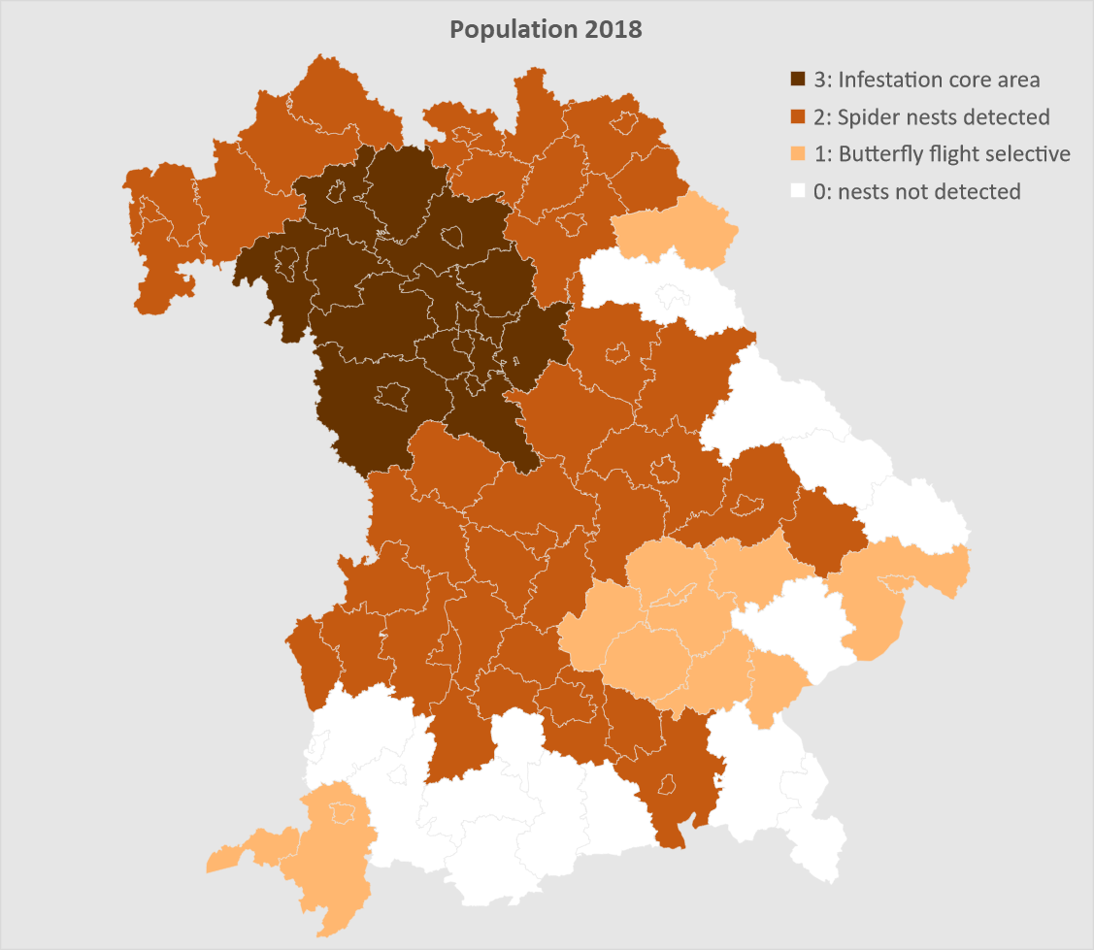
Fig. 16 OPM population in Bavaria 2018 shown in relation to Bavarian counties according to Lobinger (2018).
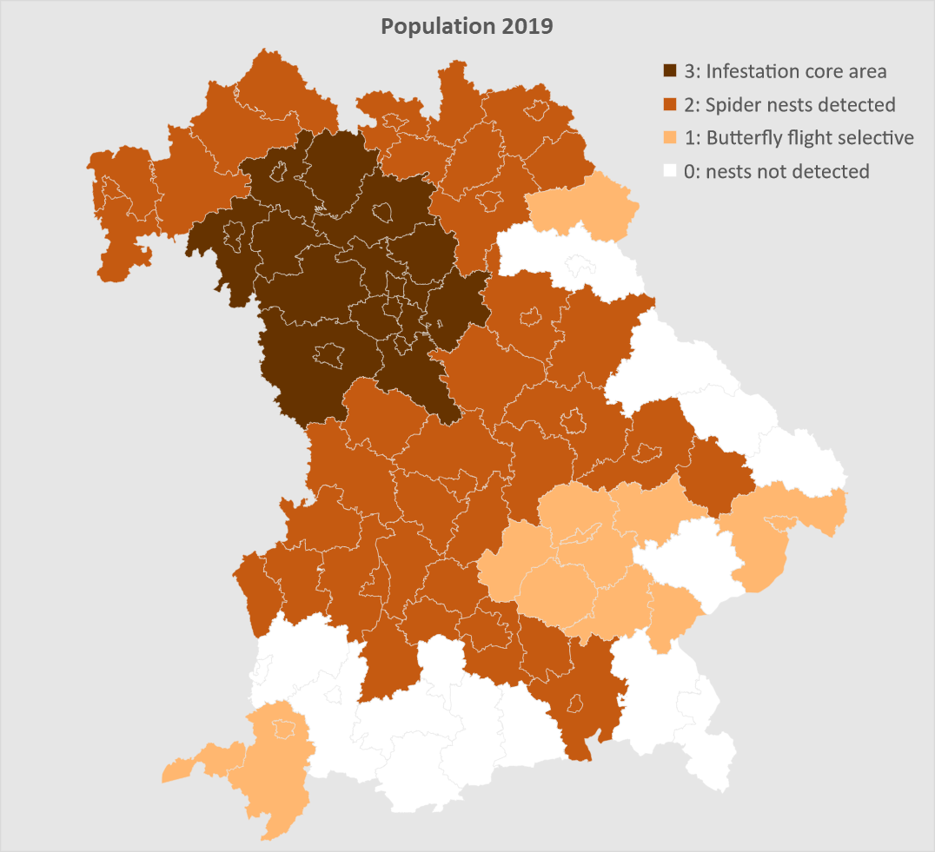
Fig. 17 OPM population in Bavaria 2019 shown in relation to Bavarian counties according to Saku (2020).
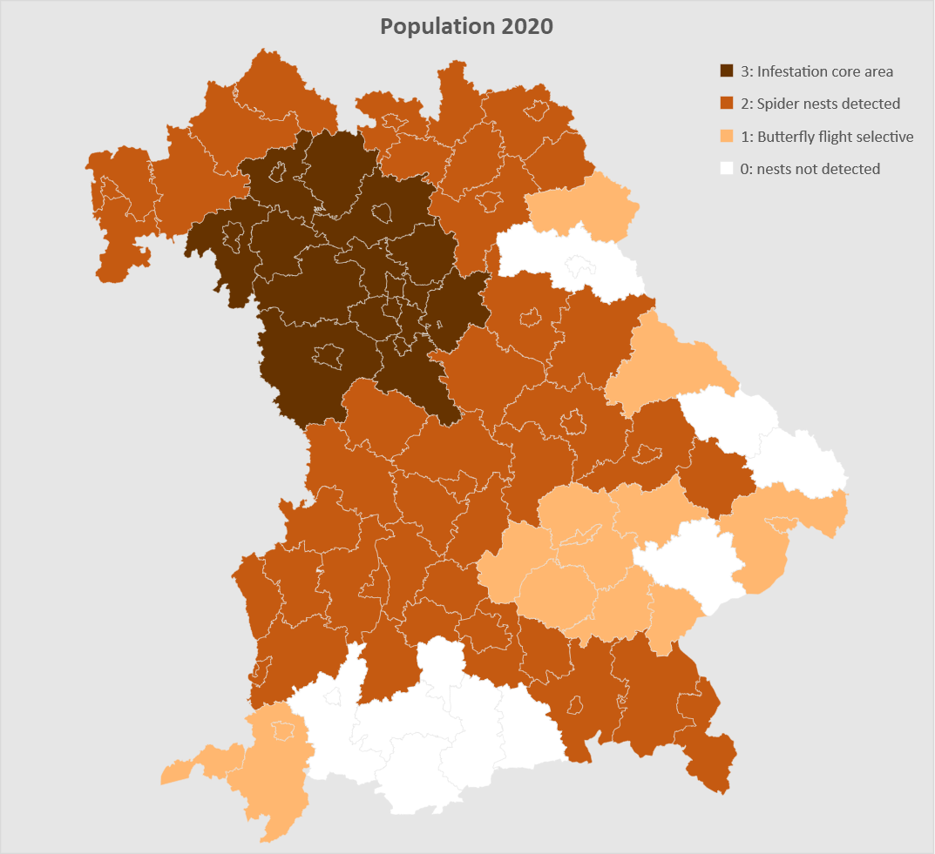
Fig. 18 OPM population in Bavaria 2020 shown in relation to Bavarian counties according to Lobinger and Wallerer (2022).
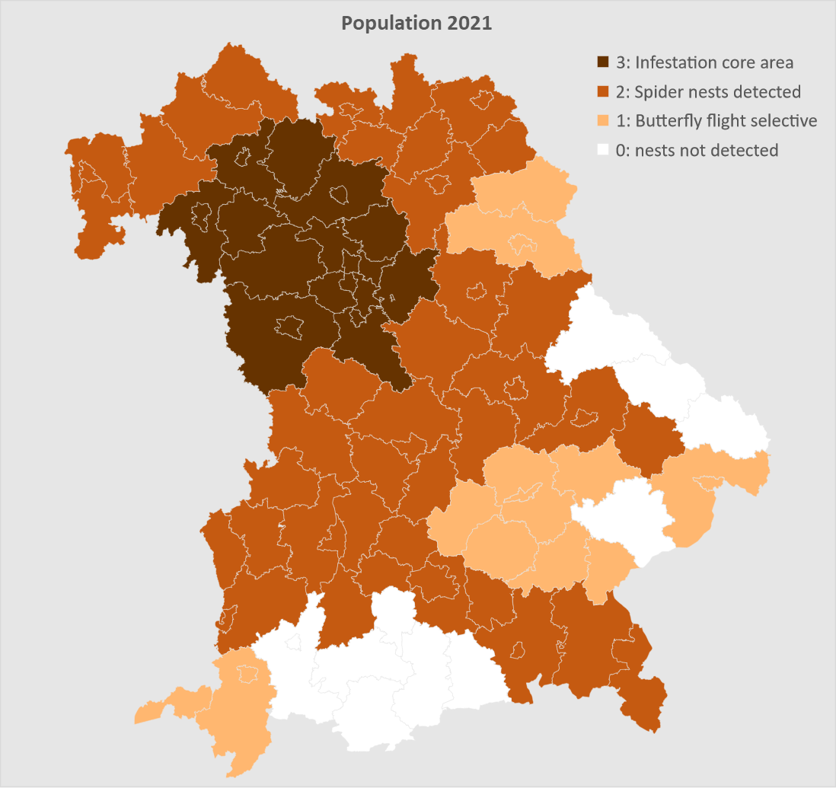
Fig. 19 OPM population in Bavaria 2021 shown in relation to Bavarian counties according to LFW (2022).

Appendix 2: The regional natural forest composition of Bavaria
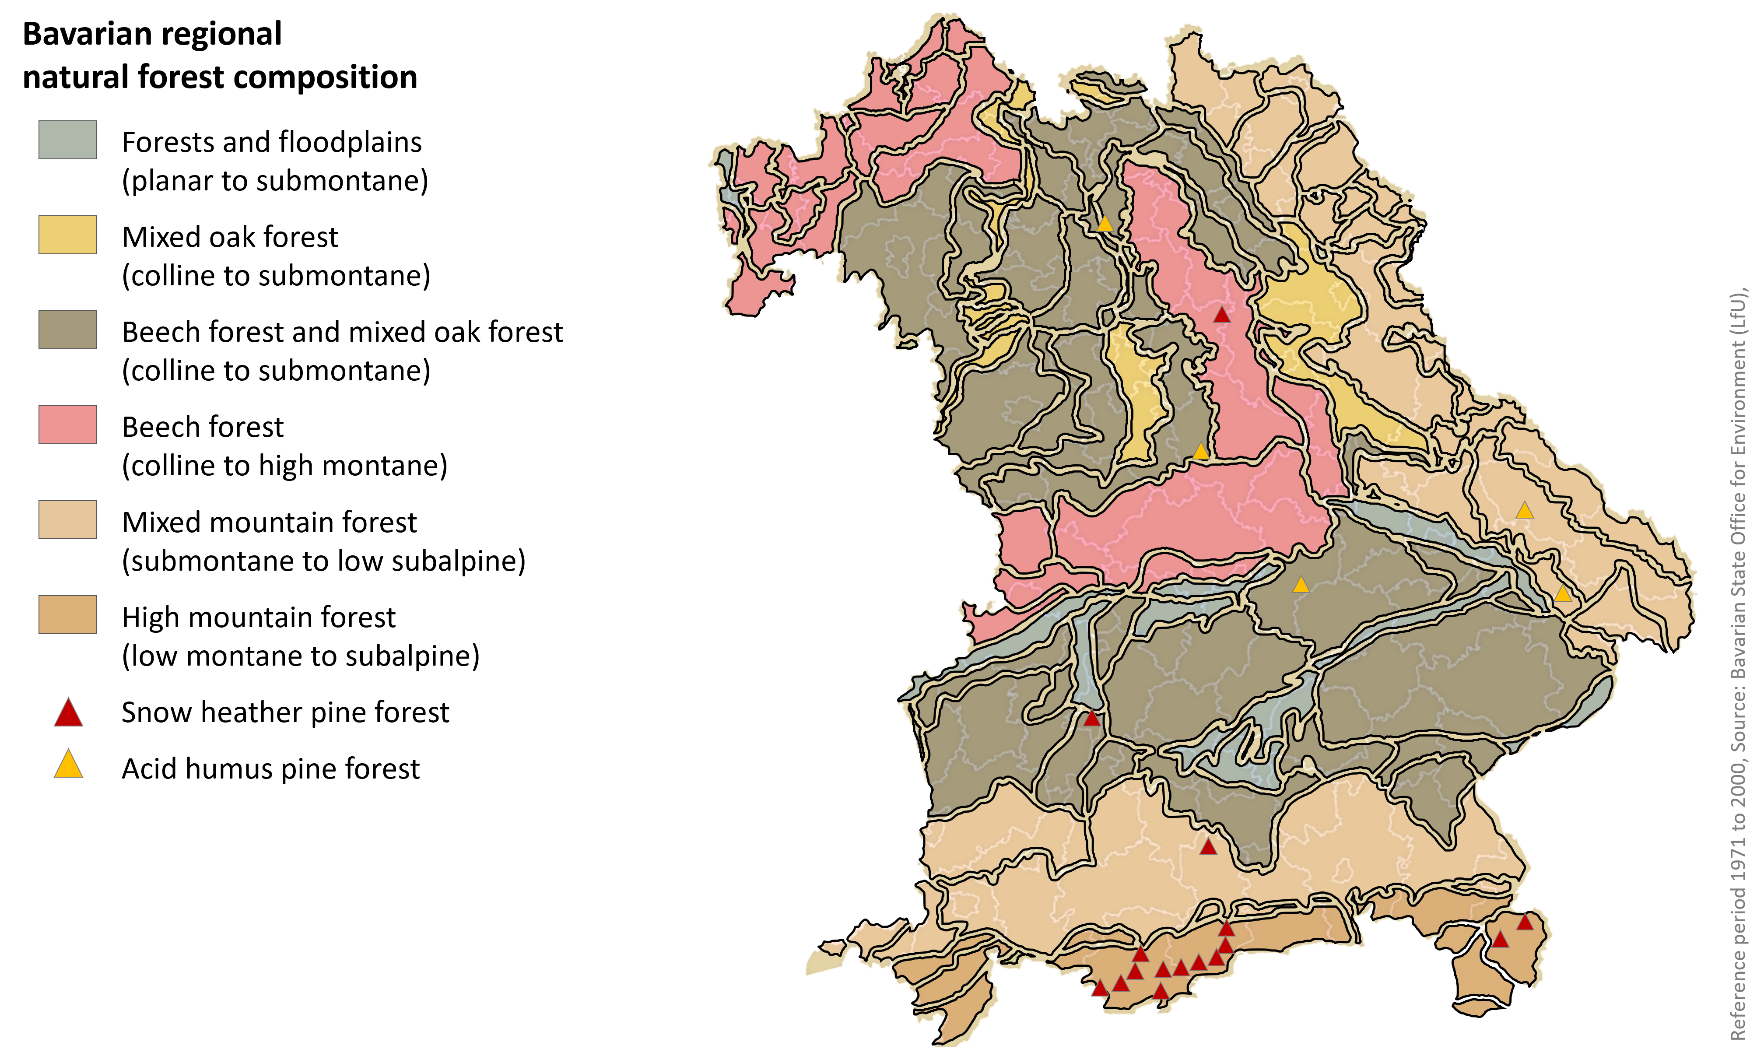
Fig. 20 Bavarian regional natural forest composition shown in relation to Bavarian counties according to PEFC 2015.

Appendix 3: The density of oak trees in Bavaria's forests
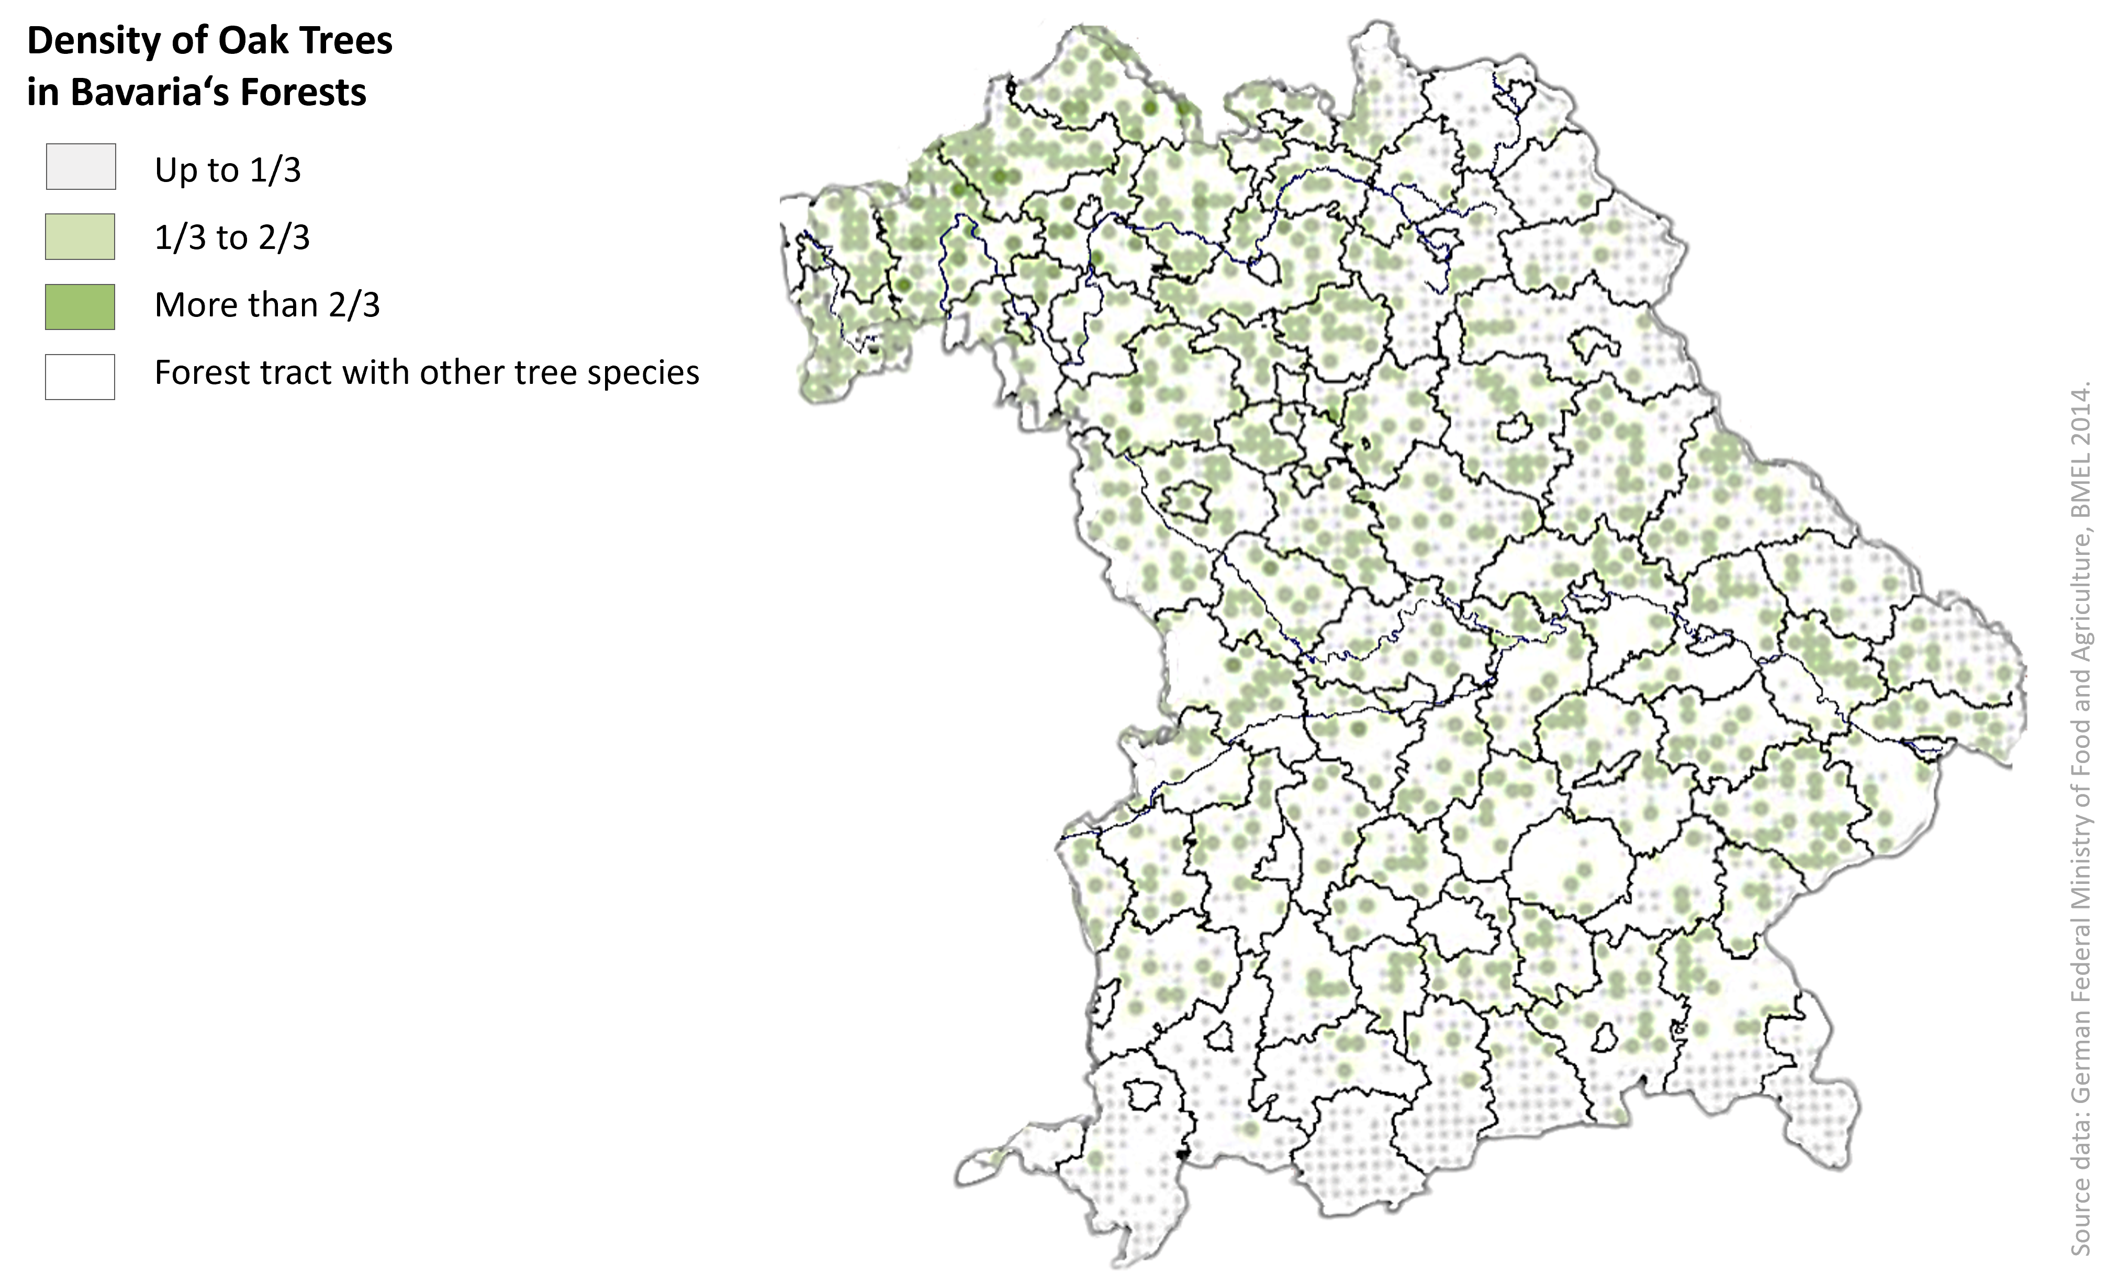
Fig. 21 The density of oak trees in Bavaria's forests shown in relation to Bavarian counties (Federal Ministry of Food and Agriculture 2014).

Appendix 4: Data on climate change in Bavaria in the past and future

Change in the beginning of vegetation in the period 1951 to 2019
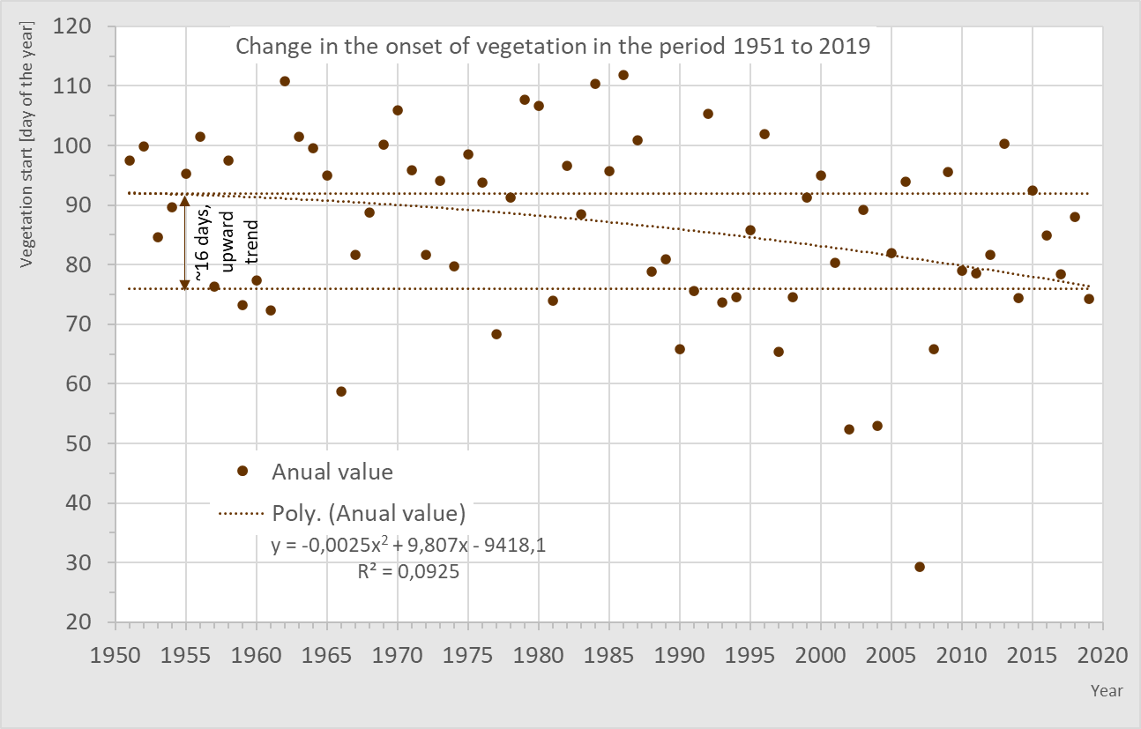
Fig. 22 Change in the beginning of vegetation in the period 1951 to 2019 (Data source: LFU 2023).

Projected change in the start of vegetation in the period 2071 to 2100
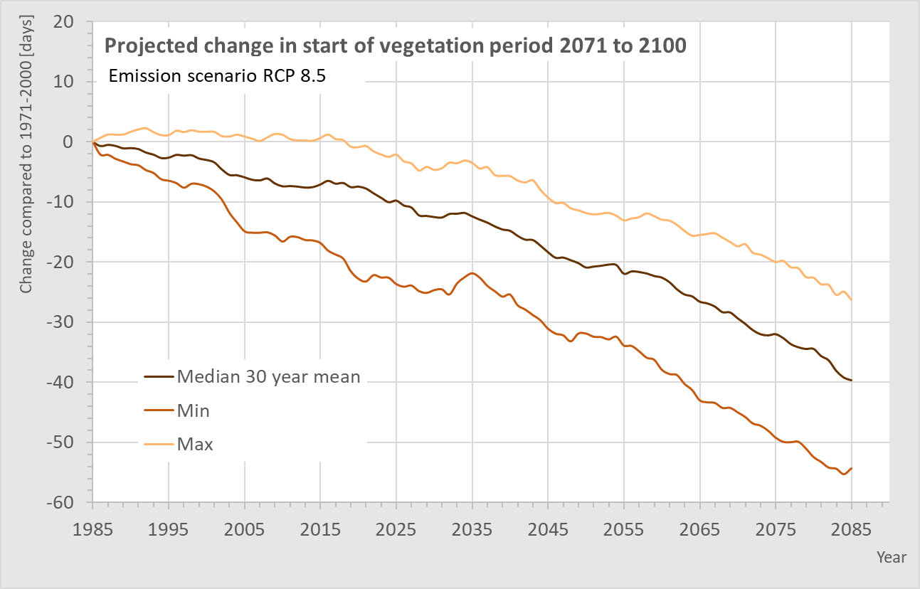
Fig. 23 Projected change in the start of vegetation in the period 2071 to 2100 (Data source: LFU 2023).

Change in the duration of the frost-free period 1951 to 2019
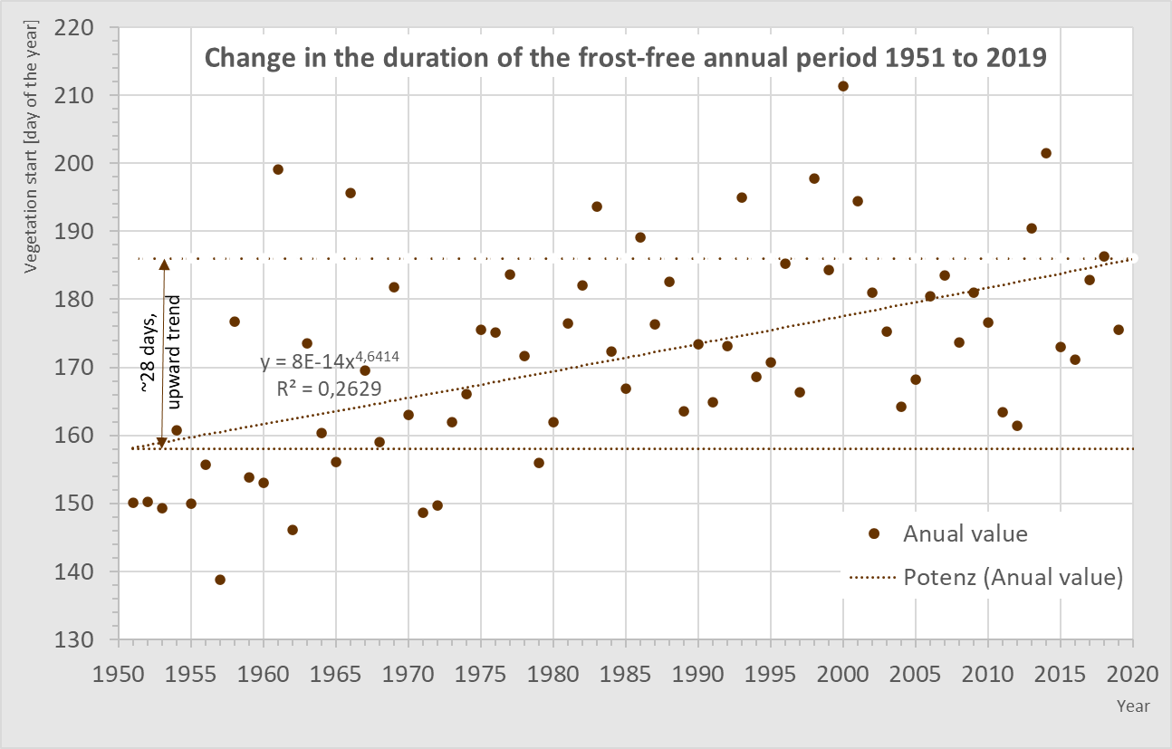
Fig. 24 Change in the duration of the frost-free period 1951 to 2019 (Data source: LFU 2023).

Projected change of duration of the frost-free annual period 2071 to 2100
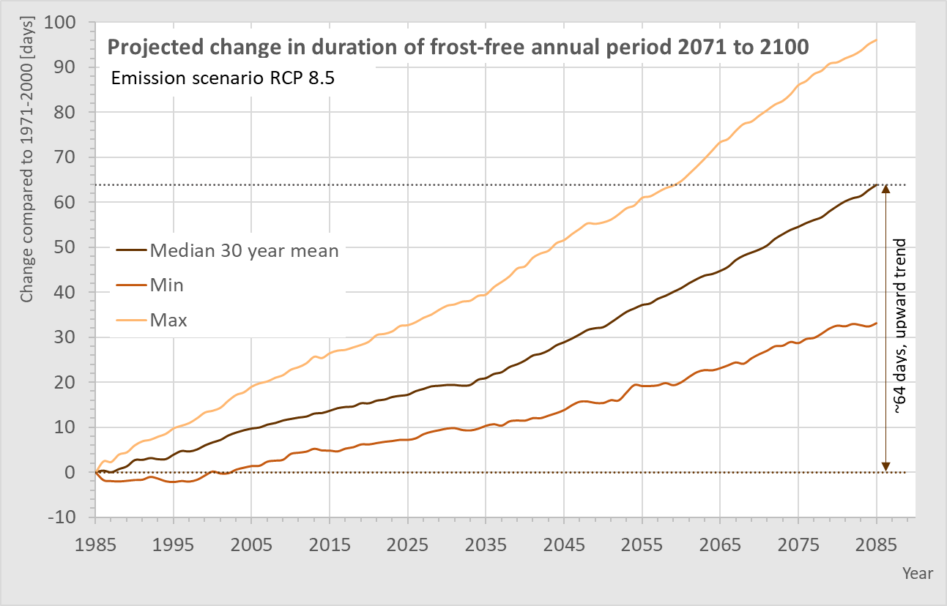
Fig. 25 Projected change of duration of the frost-free annual period 2071 to 2100 (Data source: LFU 2023).

