Supplemental material for
Identifying relationships between landscape values, spatial perceptions of risk, and physical assets

Journal
Climatic Change

Authors
Malcolm S. Johnson ^{a, b*} (0000-0002-1187-071X), Vanessa M. Adams ^{a, b} (0000-0002-3509-7901), & Jason Byrne ª (0000-0001-8733-0333)
ª School of Geography, Planning, and Spatial Sciences, University of Tasmania, Hobart, Tasmania 7000, Australia
^{b} Centre for Marine Socioecology, Institute for Marine and Antarctic Studies, College of Sciences and Engineering, University of Tasmania, Hobart, TAS, Australia
*Corresponding author email: malcolm.johnson@utas.edu.au

A – Method variations, survey details, and mapping platform examples
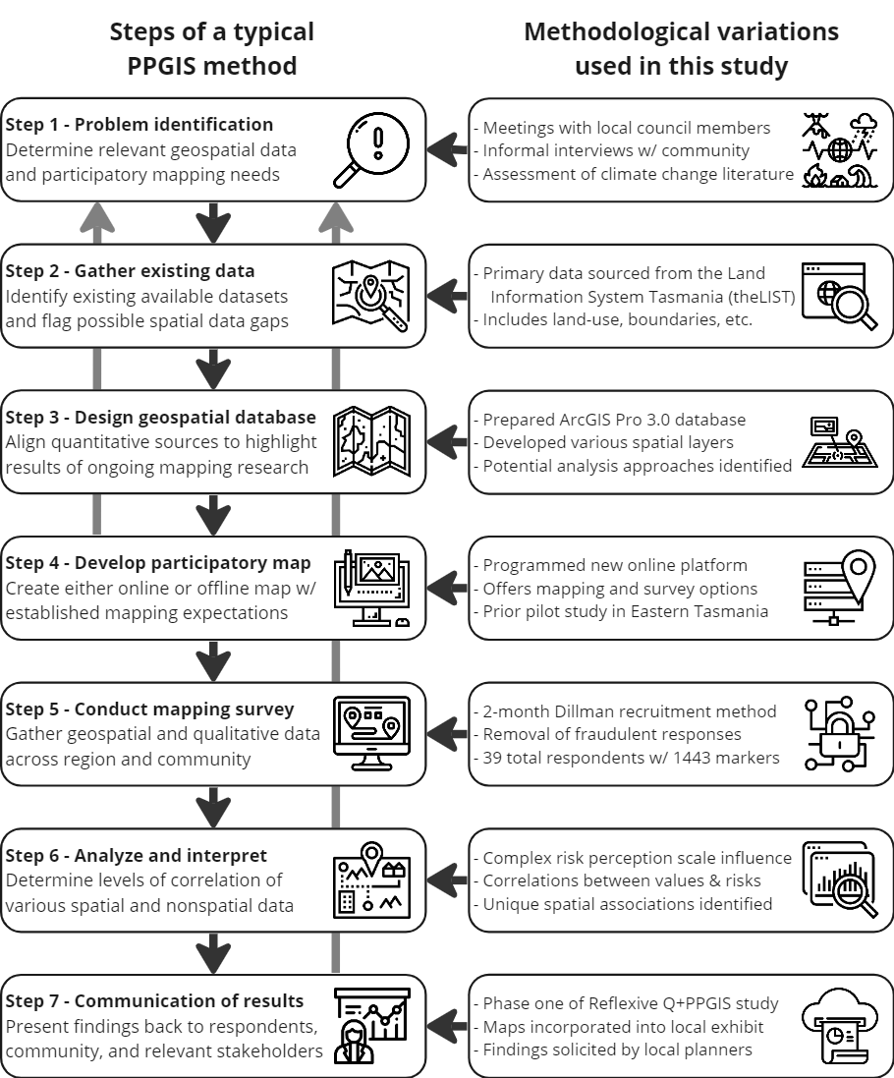
Figure SM1. Steps of a typical PPGIS study and the methodological variations employed in this study

B – Select survey and analysis statistical analyses
Table SM1 - Respondent sociodemographic characteristics with comparison to Huon Valley census data (ABS, 2021)
Sociodemographic Characteristics | Survey Respondents | Huon Valley¹
Age
18 – 24 | 2.6% | ≈ 6%²
25 – 34 | 7.7% | 9.2%
35 – 44 | 10.3% | 11.7%
45 – 54 | 17.9% | 14.8%
55 – 64 | 23.1% | 16.6%
65+ | 38.5% | 20.0%
Gender
Male | 33.3% | 49.9%
Female | 64.1% | 50.1%
Non-binary | 2.6% | n/a³
Aboriginal or Torres Strait Islander
Identifies as… | 5.1% | 9.2%
Highest Level of Education Completed
High school or at university | 12.8% | 38.4%
Undergraduate degree | 33.3% | 15.7%  8.6%
Postgraduate degree | 30.8% | 15.7%  8.6%
Vocational/TAFE or Other | 23.1% | 22.1%
Income level
$0 - $9,999 | 12.9% | ≈ 13%²
$10k - $24,999 | 20.5% | ≈ 25%²
$25k - $49,999 | 23.1% | ≈ 25%²
$50k - $74,999 | 10.3% | ≈ 15%²
$75k - $99,999 | 12.8% | ≈ 8%²
$100k or greater | 12.8% | ≈ 6%²
Prefer not to answer | 7.7% | ≈ 8%²
¹Census data from the Australia Bureau of Statistics 2021
²Approximation due to categories in Census data
³Non-binary was not included as an option in Census data

Table SM2 - Descriptive statistics and intercorrelations for scales and key questions
 |  | 1 | 2 | 3 | 4 | 5 | 6 | 7 | 8 | 9 | 10 | Mean | SD
1.Time lived in Huon valley | Pearson Correlation | -- |  |  |  |  |  |  |  |  |  | 4.18 | 1.393
2. Knowledge of Huon valley | Pearson Correlation | 0.453** | -- |  |  |  |  |  |  |  |  | 2.82 | 0.823
2. Knowledge of Huon valley | Sig. (2-tailed) | 0.004
3. Experienced extreme weather event? | Pearson Correlation | 0.043 | 0.301 | -- |  |  |  |  |  |  |  | 1.8485 | 0.3641
3. Experienced extreme weather event? | Sig. (2-tailed) | 0.810 | 0.089
4. Likely to experience extreme weather in the future? | Pearson Correlation | 0.214 | 0.296 | .410* | -- |  |  |  |  |  |  | 4.73 | 0.761
4. Likely to experience extreme weather in the future? | Sig. (2-tailed) | 0.232 | 0.094 | 0.018
5. Perception of political effort to address climate change | Pearson Correlation | -0.020 | 0.036 | 0.167 | .366* | (0.879) |  |  |  |  |  | 1.8788 | 0.7184
5. Perception of political effort to address climate change | Sig. (2-tailed) | 0.910 | 0.843 | 0.354 | 0.036
6. Dissatisfaction with possible climate changes | Pearson Correlation | 0.216 | 0.239 | 0.334 | .516** | -0.018 | (0.859) |  |  |  |  | 4.5476 | 0.8621
6. Dissatisfaction with possible climate changes | Sig. (2-tailed) | 0.252 | 0.204 | 0.071 | 0.004 | 0.924
7. Place identity scale | Pearson Correlation | 0.217 | 0.352* | 0.216 | 0.219 | -0.213 | 0.134 | (0.881) |  |  |  | 1.6717 | 0.5392
7. Place identity scale | Sig. (2-tailed) | 0.225 | 0.044 | 0.227 | 0.220 | 0.233 | 0.481
8. Place dependence scale | Pearson Correlation | 0.283 | 0.440* | 0.254 | 0.268 | -0.144 | .379* | 0.680** | (0.881) |  |  | 2.3081 | 0.8591
8. Place dependence scale | Sig. (2-tailed) | 0.111 | 0.010 | 0.154 | 0.132 | 0.423 | 0.039 | 0.000
9. Combined place attachment scale | Pearson Correlation | 0.280 | 0.441* | 0.260 | 0.270 | -0.186 | 0.310 | 0.872** | 0.952** | (0.911) |  | 3.9798 | 1.2881
9. Combined place attachment scale | Sig. (2-tailed) | 0.115 | 0.010 | 0.144 | 0.128 | 0.301 | 0.095 | 0.000 | 0.000
10. Risk perception scale | Pearson Correlation | 0.126 | 0.359* | 0.259 | .730** | -0.251 | .517** | 0.102 | 0.232 | 0.197 | (0.980) | 4.0091 | 1.1397
10. Risk perception scale | Sig. (2-tailed) | 0.484 | 0.040 | 0.145 | 0.000 | 0.158 | 0.003 | 0.574 | 0.194 | 0.271
Note: Cronbach’s alpha scale reliabilities for are provided along the diagonal. **. Correlation is significant at the 0.01 level (2-tailed). *. Correlation is significant at the 0.05 level (2-tailed).

Table SM3 – CSR hypothesis testing of landscape values and risks by value and risk using nearest neighbour analysis
 | Average Nearest Neighbor
 | R Value (Rank) | z-value | Ho: values are CSR
Landscape values
Special Places | 0.71 (9) | -5.24*** | Reject
Aesthetic | 0.61 (5) | -8.68*** | Reject
Biological | 0.95 (11) | -0.87 | Accept
Economic | 0.60 (3) | -8.36*** | Reject
Intrinsic / Existence | 0.78 (10) | -3.95*** | Reject
Heritage / Culture | 0.59 (2) | -6.57*** | Reject
Learning / Research | 0.60 (4) | -4.94*** | Reject
Life Sustaining | 0.96 (12) | -0.62 | Accept
Recreation | 0.65 (7) | -7.84*** | Reject
Social | 0.55 (1) | -7.73*** | Reject
Spiritual | 0.63 (6) | -4.82*** | Reject
Wilderness | 0.65 (8) | -7.41*** | Reject
Places at risk
Biodiversity change | 0.88 (5) | -1.29 | Accept
Biodiversity loss | 0.75 (4) | -3.74*** | Reject
Bushfire | 0.70 (3) | -7.65*** | Reject
Coastal erosion | 1.05 (6) | 0.39 | Accept
Land erosion | 1.07 (7) | 0.61 | Accept
River flooding | 0.60 (1) | -4.08*** | Reject
Sea-level rise | 0.69 (2) | -3.51** | Reject
Storm surge | 1.17 (8) | 1.21 | Accept
Other risks | 1.29 (9) | 1.93* | Reject
*p <0.05, **p <0.001, ***p<0.0001
Table SM4 – Linear regression for number of mapped landscape values regressed against scale-based measures of place attachment, risk perception, and risk satisfaction scales.
Model results | Place attachment |  |  | Risk Perception |  | Future dissatisfaction
 | R | R² | R |  | R² | R | R²
 | 0.561 | 0.314 | 0.571 |  | 0.326 | 0.516 | 0.267
 | F | P | F |  | P | F | P
 | 0.875 | 0.576 | 0.923 |  | 0.538 | 0.595 | 0.809
Landscape Values | β | t | β |  | t | β | t
Aesthetic | 0.15 | 0.49 | 0.10 |  | 0.35 | 0.19 | 0.62
Biological | -0.04 | -0.06 | 0.16 |  | 0.22 | 0.66 | 0.73
Economic | -0.28 | -0.84 | -0.33 |  | -0.99 | -0.09 | -0.25
Heritage / Culture | -0.46 | -1.24 | 0.29 |  | 0.79 | 0.35 | 0.97
Intrinsic / Existence | -0.25 | -0.50 | -0.04 |  | -0.08 | -0.76 | -1.42
Learning / Research | 0.95 | 1.99 | 0.15 |  | 0.31 | -0.01 | -0.01
Life sustaining | -0.32 | -1.00 | 0.04 |  | 0.11 | 0.17 | 0.65
Recreation | 0.69 | 1.18 | -0.27 |  | -0.46 | -0.45 | -0.67
Social | 0.12 | 0.35 | -0.50 |  | -1.64 | -0.04 | -0.14
Spiritual | -0.54 | -1.40 | 0.08 |  | 0.21 | -0.07 | -0.22
Wilderness | 0.07 | 0.13 | 0.22 |  | 0.37 | 0.17 | 0.30
β = standardized beta coefficients

Table SM5 – Linear regression for number of mapped places at risk regressed against scale-based measures of place attachment, risk perception, and risk satisfaction scales.
Model results | Place attachment |  |  | Risk Perception |  | Risk satisfaction
 | R | R² | R |  | R² | R | R²
 | 0.529 | 0.280 | 0.632 |  | 0.400 | 0.670 | 0.449
 | F | P | F |  | P | F | P
 | 1.166 | 0.359 | 1.996 |  | .091 | 2.142 | 0.077
Places at Risk | β | t | β |  | t | β | t
Biodiversity change | 0.53 | 2.36* | 0.01 |  | 0.07 | 0.09 | 0.39
Biodiversity loss | -0.03 | -0.12 | 0.35 |  | 1.70 | 0.42 | 1.62
Bushfire | -0.21 | -0.73 | -0.57 |  | -2.21* | -0.52 | -1.32
Coastal erosion | 0.13 | 0.38 | 0.25 |  | 0.84 | 0.08 | 0.26
Land erosion | 0.27 | 1.35 | 0.17 |  | 0.92 | 0.32 | 1.76
River flooding | 0.33 | 1.11 | -0.18 |  | -0.65 | -0.31 | -1.30
Sea level rise | -0.33 | -1.21 | 0.36 |  | 1.47 | -0.04 | -0.12
Wave/storm action | -0.23 | -0.76 | -0.07 |  | -0.25 | 0.11 | 0.38
* = significant at p <0.05; β = standardized beta coefficients

Table SM6 – Linear regression for the number of mapped landscape values regressed against climate risks (as dependent variables; standardized β coefficients) and spatial cross-correlations between landscape values and climate risks (Spearman Rho’s r values) with rank of top spatial associations
Landscape values (as predictor) | Perceived climate change risks
Landscape values (as predictor) | Bushfire | Bio-diversity loss | Bio-diversity change | Sea-level rise | River flooding | Land erosion | Coastal erosion | Storm surge
Recreation | -0.17  (0.73) (3) | -0.16  (0.68) (3) | -0.22  (0.71) (2) | 0.08  (0.73) (2) | 0.04  (0.42) | -0.17  (0.51) (3) | -0.14  (0.55) (1) | 0.02  (0.45) (2)
Wilderness | -0.14  (0.47) | 0.57  (0.49) | 0.35  (0.37) | -0.06  (0.19) | -0.29  (NS) | 0.14  (0.19) | -0.78  (0.25) | -0.89  (NS)
Economic | -0.31  (0.59) | -0.28  (0.38) | -0.91*  (0.48) | 0.03  (0.66) | 0.28  (0.64) (1) | -0.52  (0.66) (1) | 0.05  (0.38) | 0.35  (0.34)
Aesthetic | -0.26  (0.69) | 0.15  (0.64) | 0.99*  (0.70) (3) | -0.93*  (0.75) (1) | -0.88*  (0.34) | -0.44  (0.46) | 0.26  (0.49) | 0.22  (0.48) (1)
Social | 0.72*  (0.50) | 0.03  (0.27) | 0.4  (0.38) | 0.05  (0.64) | -0.04  (0.58) (2) | 0.38*  (0.50) | 0.34  (0.29) | -0.14  (0.28)
Intrinsic/  Existence | 0.19  (0.76) (1) | -0.04  (0.68) (2) | -0.36  (0.68) | 1.07  (0.53) | 1.01*  (0.26) | -0.26  (0.41) | -0.59  (0.39) | -0.79  (0.31)
Heritage/  Culture | -0.26  (0.64) | -0.42  (0.49) | -0.77**  (0.48) | -0.14  (0.70) (3) | -0.04  (0.32) | 0.01  (0.35) | 0.57  (0.50) (2) | 0.55  (0.26)
Biological | 0.39  (0.73) (2) | 0.35  (0.76) (1) | 1.06*  (0.77) (1) | -0.5  (0.63) | -0.63  (0.31) | 0.23  (0.45) | 0.55  (0.49) (3) | 0.57  (0.43) (3)
Life-sustaining | 0.41  (0.64) | -0.12  (0.59) | -0.31  (0.50) | 0.13  (0.35) | -0.16  (0.29) | 1.48***  (0.52) | 0.02  (0.24) | -0.19  (0.13)
Learning/  Research | -0.11  (0.58) | 0.45  (0.37) | 0.1  (0.43) | 0.32  (0.49) | 0.54*  (0.53) (3) | 0.05  (0.58) (2) | 0.26  (0.24) | 0.65  (0.24)
Spiritual | -0.30  (0.63) | -0.49  (0.56) | -0.09  (0.59) | 0.32  (0.45) | 0.61*  (0.24) | -0.87***  (0.39) | -0.44  (0.26) | -0.14  (0.18)
R | 0.74 | 0.56 | 0.56 | 0.63 | 0.81 | 0.8 | 0.56 | 0.53
R² | 0.55 | 0.31 | 0.31 | 0.4 | 0.66 | 0.64 | 0.32 | 0.28
F | 3.01 | 1.11 | 1.09 | 1.63 | 4.69 | 4.43 | 1.14 | 0.94
P | 0.01* | 0.39 | 0.41 | 0.15 | .00*** | .00*** | 0.37 | 0.516
For the linear regression: * = significant at p <0.05; ** = significant at p <0.005; *** = significant at p <0.001
(italic) = Spearman Rho’s cross-correlations where r ≥ 0.5 indicates strong correlation, 0.3 ≤ r < 0.5 moderate correlation, r ≤ 0.3 weak correlation, non-significant correlations are indicated with NS, and (#) denotes rank of top three spatial associations

