Supplementary Material

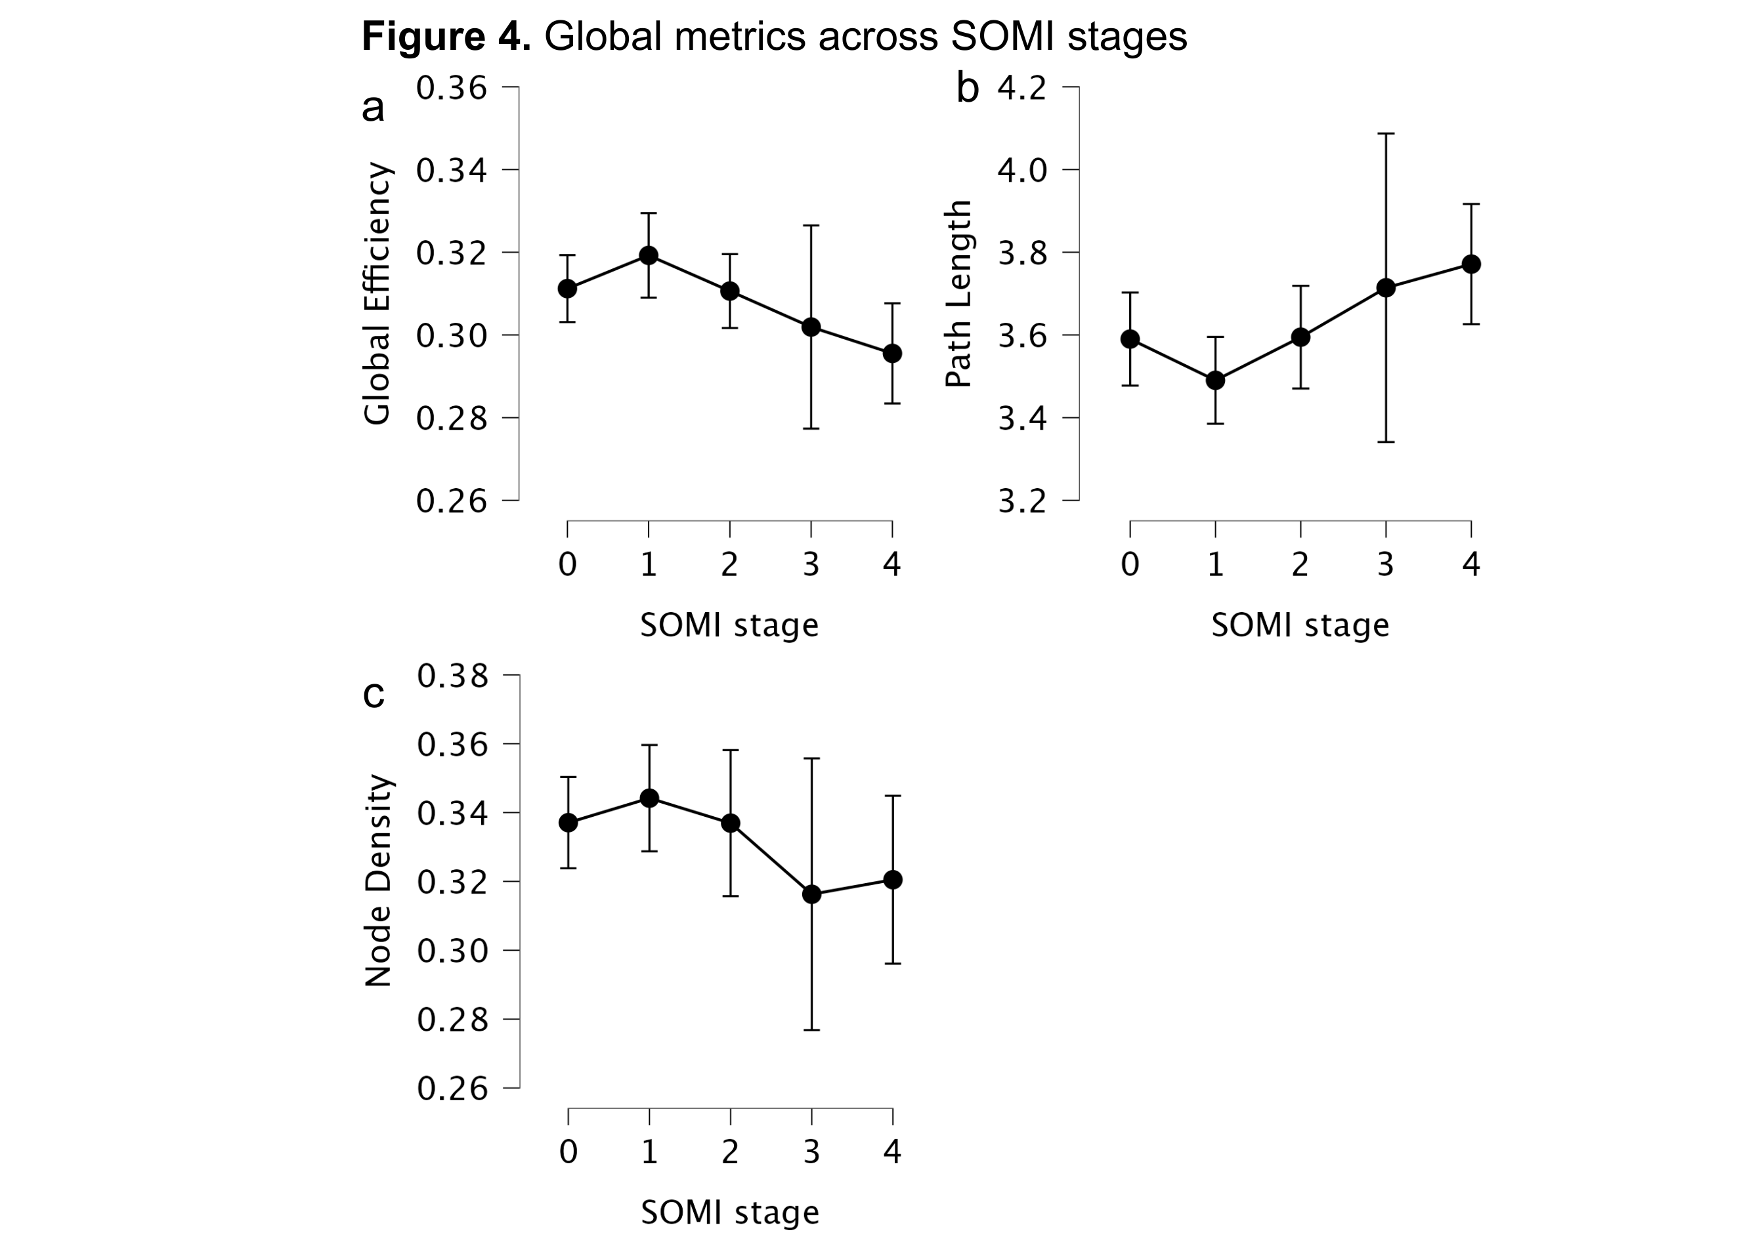
Figure 4. Kruskal-Wallis plots of the dependent variables shown represent three global metrics (global efficiency, characteristic path length, and node density) across the fixed factor, SOMI stage.

