Extended Data

On-surface synthesis of anti-aromatic cyclo[12]carbon and aromatic cyclo[6]carbon
Luye Sun§, Wei Zheng§, Wenze Gao, Faming Kang, Wei Xu*
Interdisciplinary Materials Research Center, School of Materials Science and Engineering, Tongji University, Shanghai 201804, People’s Republic of China.
*Corresponding author. Email: xuwei@tongji.edu.cn
§equal contribution

Table of Contents
Figs. 1 to 9
Supplementary Texts
References

Fig. 1. The bond lengths, Mayer bond orders, and bond angles in a cyclo[12]carbon. Calculations were conducted at the ωB97XD/def2-TZVP level, revealing a polyynic structure of C₁₂ (BLA = 0.17 Å, BAA ≈ 0).

Fig. 2. Other intermediates observed during manipulations. (a-c) C12Br₄I₃, (d-f) C12Br₂I₃, (g-i) C12Br₃I. The Laplace-filtered AFM images are also shown. Reference set point of Δz: I = 0.4 pA, V = 0.3 V for b and e, I = 0.5 pA, V = 0.3 V for h. The double bond indicated by blue in (d) represents different bond length from the other double bonds within the carbon ring.
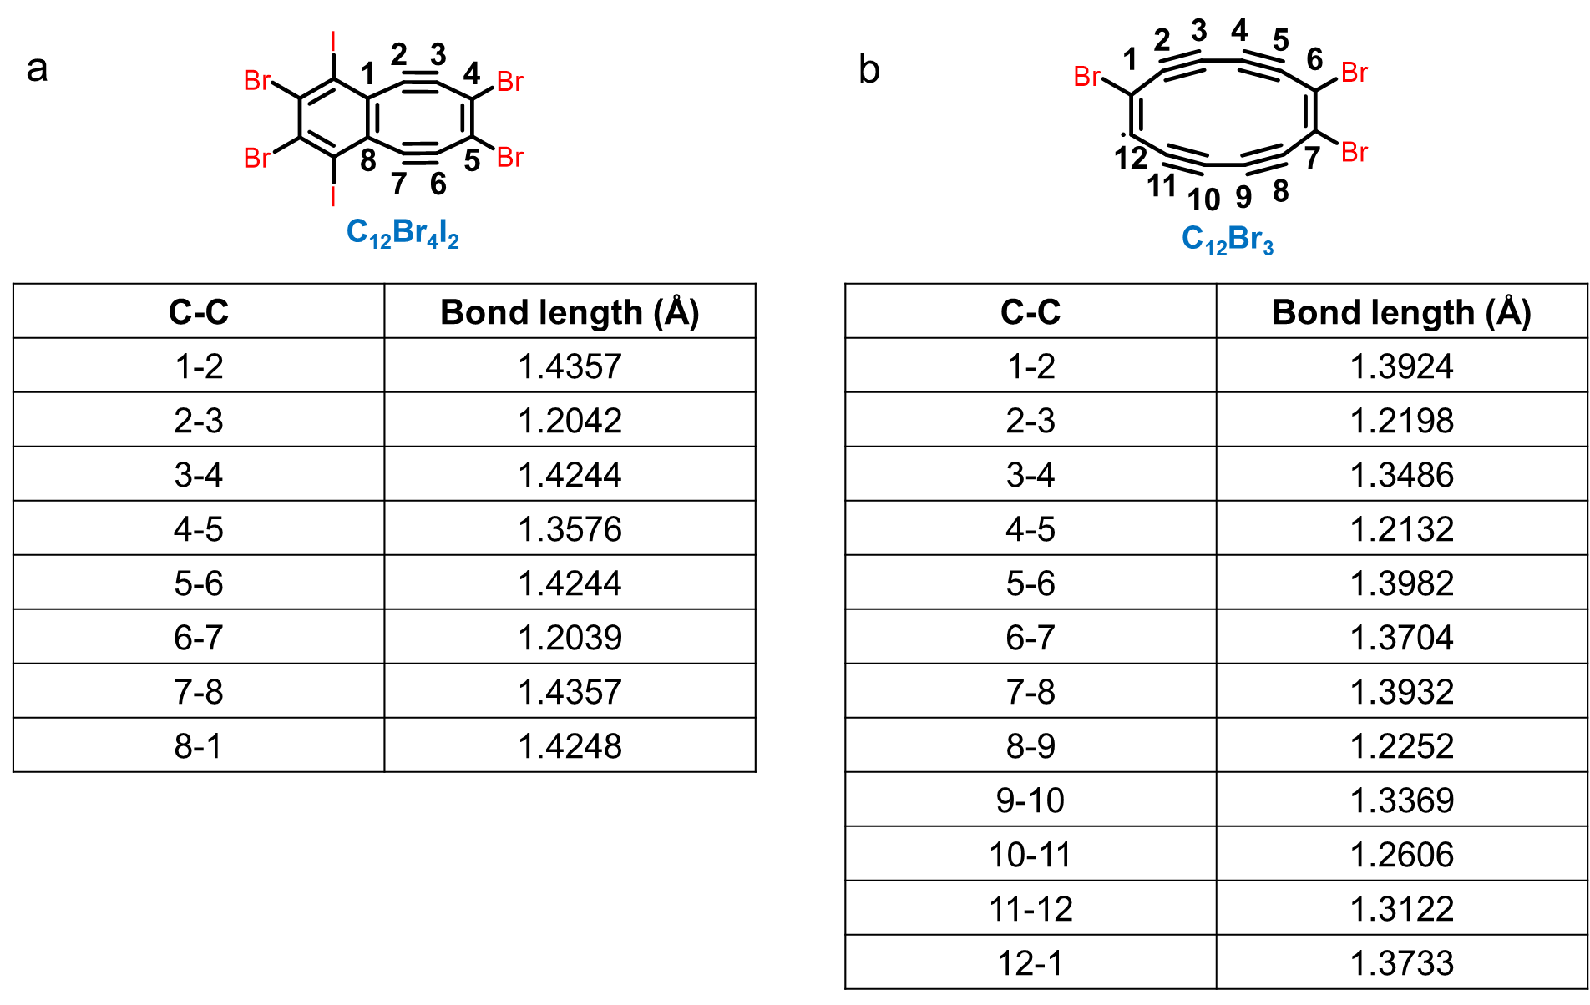
Fig. 3. The bond lengths of an eight-membered ring of the C₁₂Br₄I₂ intermediate (a) and a twelve-membered ring of the C₁₂Br₃ intermediate (b). Calculations were conducted at the ωB97XD/def2-TZVP level.

Fig. 4. AFM imaging of cyclo[12]carbon at different tip heights (Δz) acquired with a CO-terminated tip. Reference set point of Δz: I = 0.4 pA, V = 0.3 V.

Fig. 5. DFT calculated C₁₂ structures adsorbed on Cl-top site (a, b), Na-top site (c, d) and Na-bridge site (e, f), respectively. The calculated results show that the C₁₂ adsorbed on the NaCl surface prefers the Cl-top site. Note that the Perdew−Burke−Ernzerhof generalized gradient approximation exchange−correlation functional gives a bond angle alternation of ~36º for C₁₂, while the more accurate and suitable ωB97XD exchange-correlation functional shows nearly zero bond angle alternation. Similar results are also shown in the calculations of C₁₆¹.

Fig. 6. The bond lengths, Mayer bond orders, and bond angles in a cyclo[6]carbon. Calculations were conducted at the ωB97XD/def2-TZVP level, revealing a cumulenic structure of C₆ (BLA = 0, BAA ≈ 59°).
Fig. 7. AFM images (a-c) and Laplace-filtered AFM images (d-f) of cyclo[6]carbon at different tip heights (Δz) acquired with a CO-terminated tip. Reference set point of Δz: I = 5 pA, V = 0.3 V.

Fig. 8. DFT calculated C₆ structures adsorbed on Na-top site (a, b), Cl-top site (c, d) and Na-bridge site (e, f), respectively. We find that in these three calculated adsorption sites, the planes of the C₆ rings all show tilting angles with respect to the NaCl plane. In addition, the larger tilting angle, the higher stability.

Fig. 9. Line profile across the C₆Cl₂ chain in the AFM image, showing typical lengths between three triple bonds (i.e., 0.25 nm and 0.26 nm, in comparison with the calculated lattice constant of carbyne: d = 0.2558 nm).

References

1 Gao, Y. et al. On-surface synthesis of a doubly anti-aromatic carbon allotrope: cyclo[16]carbon. ChemRxiv (2023).

