Extended Data

On-surface synthesis and characterization of anti-aromatic cyclo[20]carbon
Luye Sun§, Wei Zheng§, Faming Kang, Wei Xu*
Interdisciplinary Materials Research Center, School of Materials Science and Engineering, Tongji University, Shanghai 201804, People’s Republic of China.
*Corresponding author. Email: xuwei@tongji.edu.cn
§equal contribution

Table of Contents
Figs. 1 to 10

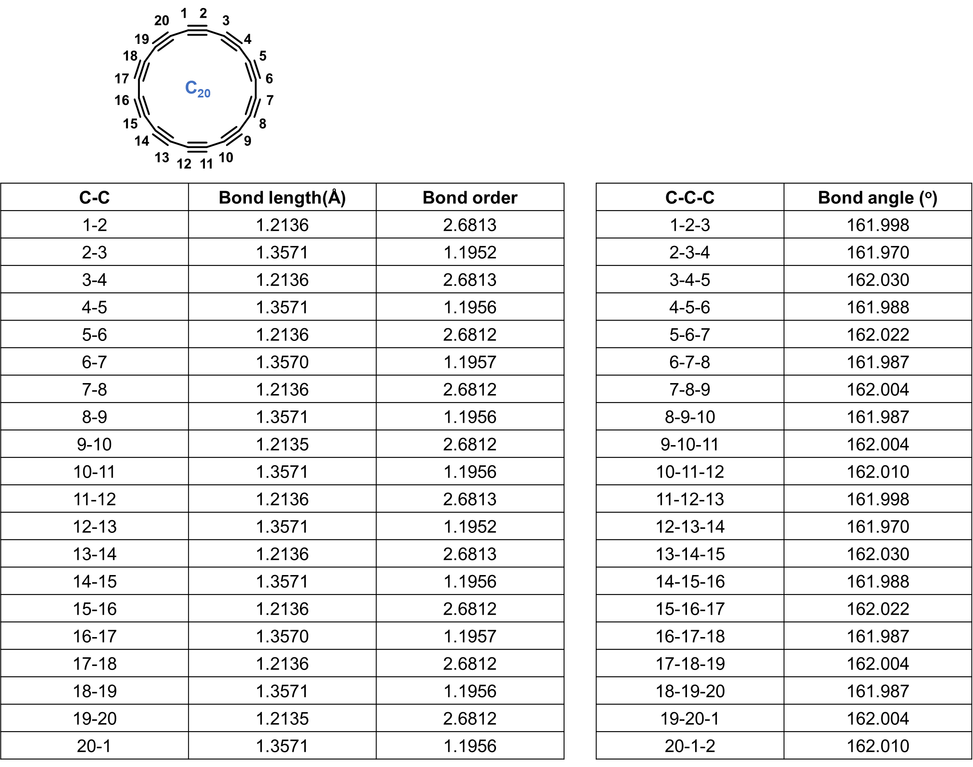
Fig. 1. The bond lengths, Mayer bond orders, and bond angles in a cyclo[20]carbon. Calculations were conducted at the ωB97XD/def2-TZVP level, revealing a polyynic structure of C₂₀ (BLA = 0.14 Å).

Fig. 2. Characterization of the C₂₀Cl₁₂ precursor. (a) Chemical structure. (b, c) Side view of calculated structure of C₂₀Cl₁₂ molecule on the NaCl surface. (d, e) STM and AFM images of C₂₀Cl₁₂. (f) Spectra of frequency shift (Δf) as a function of tip height (Δz). The red and blue spectra were taken at the topmost Cl atom of the C₂₀Cl₁₂ molecule, and the Cl atom at the first layer of NaCl surface, respectively. Inset: schematics of the CO-tip approaching processes. Scanning condition: I = 5 pA, V = 0.3 V.

Fig. 3. Other observed intermediates formed after manipulation of C₂₀Cl₁₂. (a-c) C₂₀Cl₈, (d-f) C₂₀Cl₈, (g-i) C₂₀Cl₇. The scale bar in (b) applies to all images.

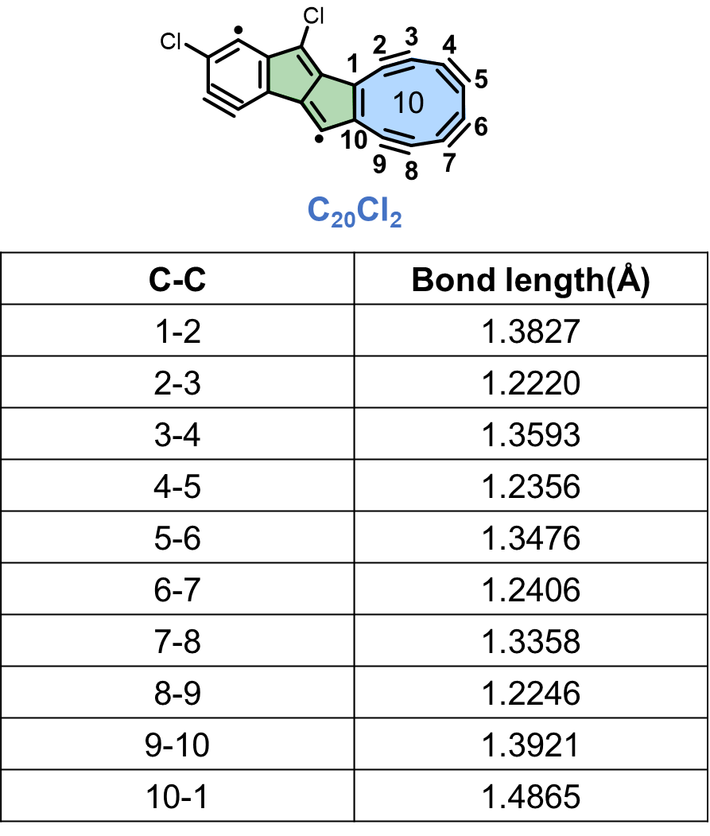
Fig. 4. The bond lengths of a 10-membered ring of a C₂₀Cl₂ intermediate. Calculations were conducted at the ωB97XD/def2-TZVP level.
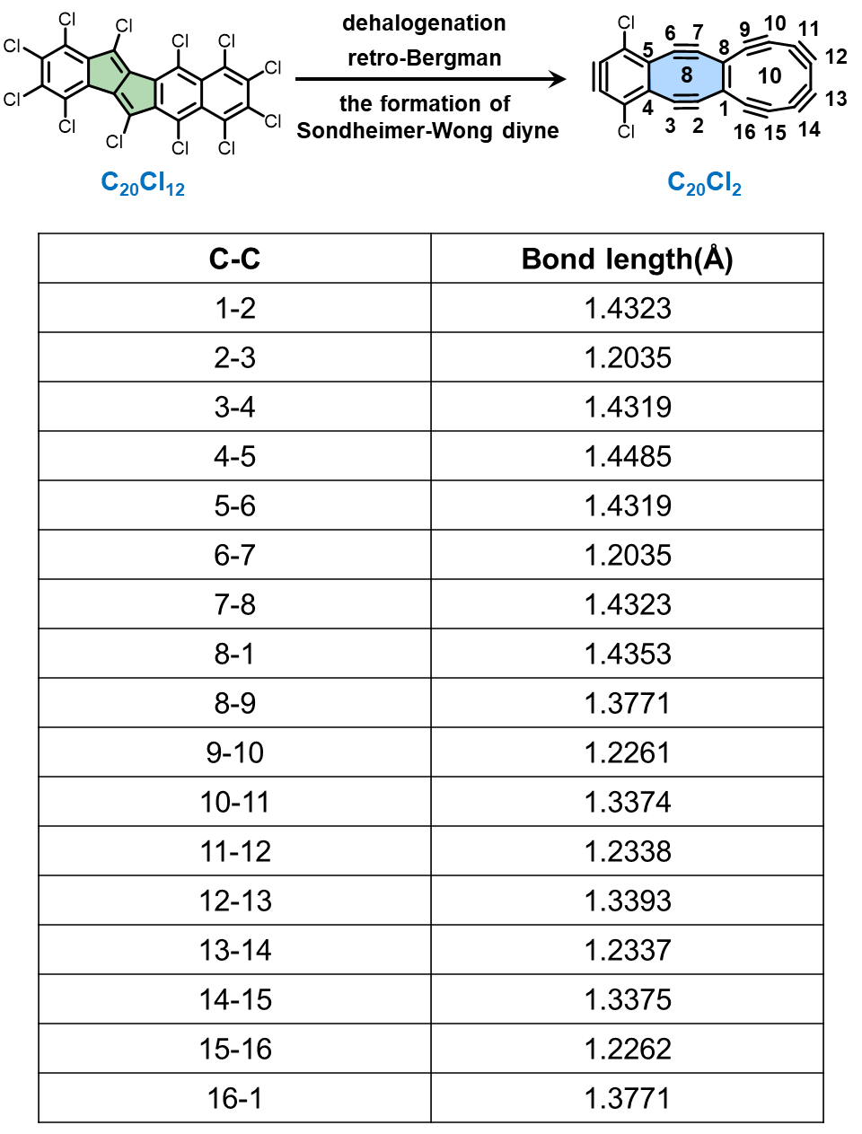
Fig. 5. Reaction scheme and bond lengths calculations. Formation of an 8-membered ring from a 5-5 ring configuration via Sondheimer-Wong diyne reaction. Bond lengths of an 8-membered and a 10-membered ring of a C₂₀Cl₂ intermediate. Calculations were conducted at the ωB97XD/def2-TZVP level.
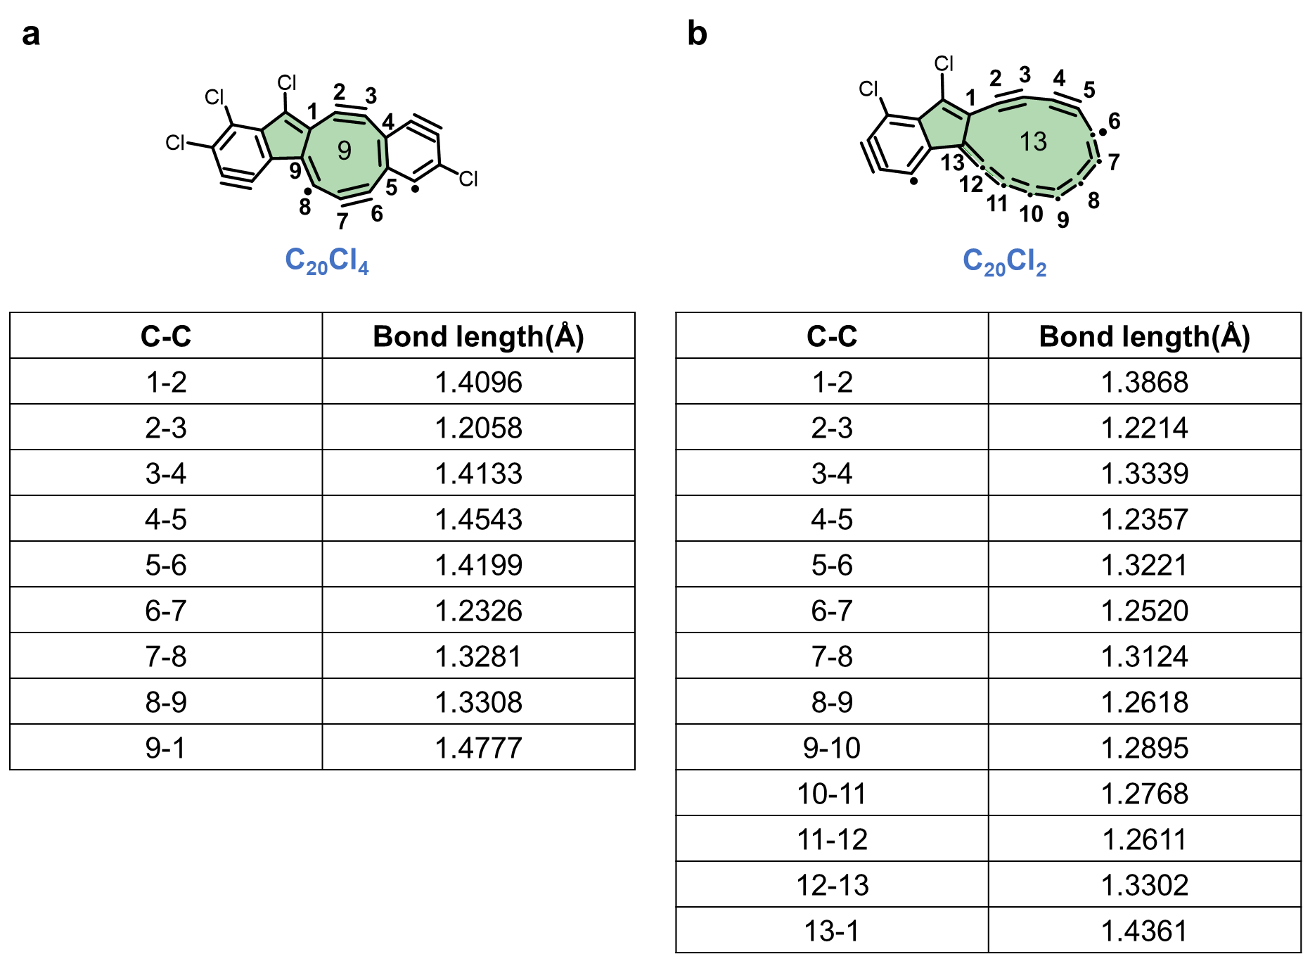
Fig. 6. The bond lengths calculations. The bond lengths of a 9-membered ring of a C₂₀Cl₄ intermediate (a) and a 13-memebered ring of a C₂₀Cl₂ intermediate (b). Calculations were conducted at the ωB97XD/def2-TZVP level.

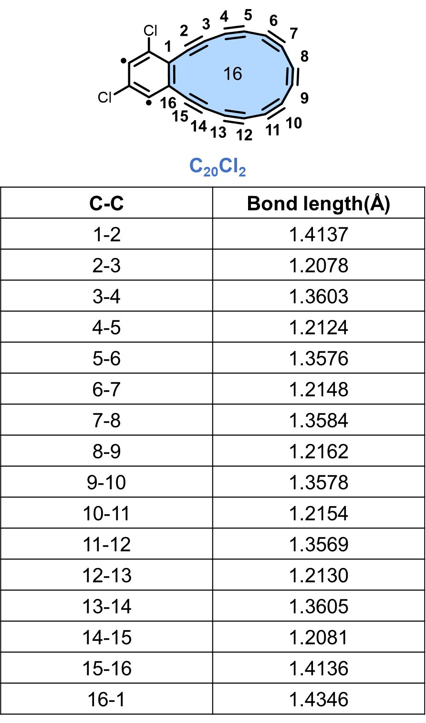
Fig. 7. The bond lengths of a 16-membered ring of a C₂₀Cl₂ intermediate. Calculations were conducted at the ωB97XD/def2-TZVP level.

Fig. 8. Other observed intermediates. (a-c) C₂₀Cl₉, (d-f) C₂₀Cl₇, (g-i) C₂₀Cl₄.
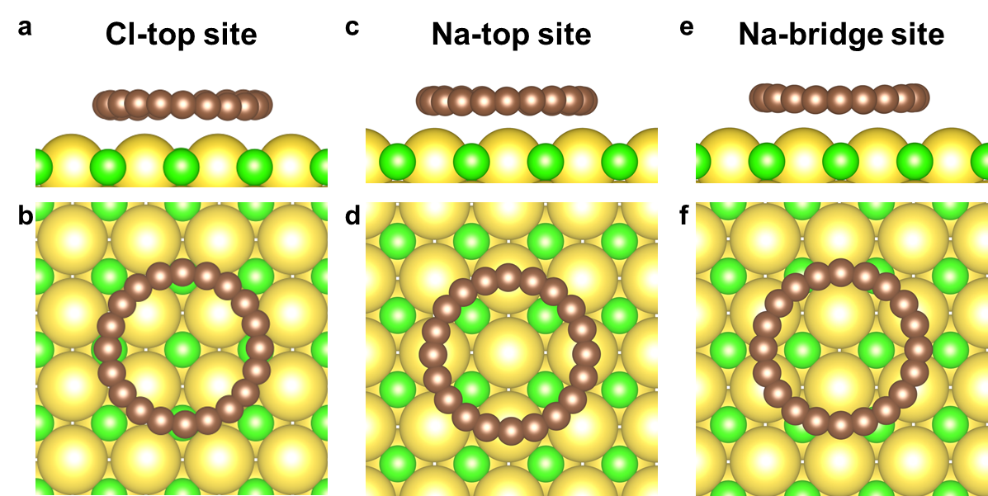
Fig. 9. DFT calculated C₂₀ structures. Adsorbed on Cl-top site (a, b), Na-top site (c, d) and Na-bridge site (e, f), respectively.

Fig. 10. Tip manipulation of a C₂₀ on the NaCl surface. Individual C₂₀ exhibits high mobility on the NaCl surface, and could be easily disturbed by the tip. While, the Cl clusters could help to stabilize the C₂₀ molecule. (a) Moving pathway of a C₂₀. (b) Final location of a C₂₀ blocked by Cl atoms. (c) A more subtle manipulation of a C₂₀ to be trapped into an “atomic fence” formed by Cl atoms. Scanning condition: I = 4 pA, V = 0.3 V.

