Supplemental materials
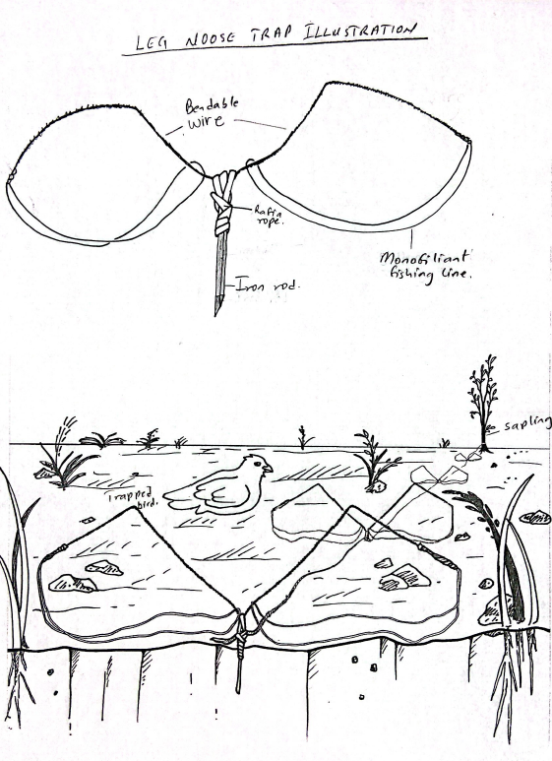
Fig. S1: Artistic illustrations of a single (detached) leg noose trap used to trap stone partridges at the Yankari Game Reserve, Nigeria, 2020 – 2022.

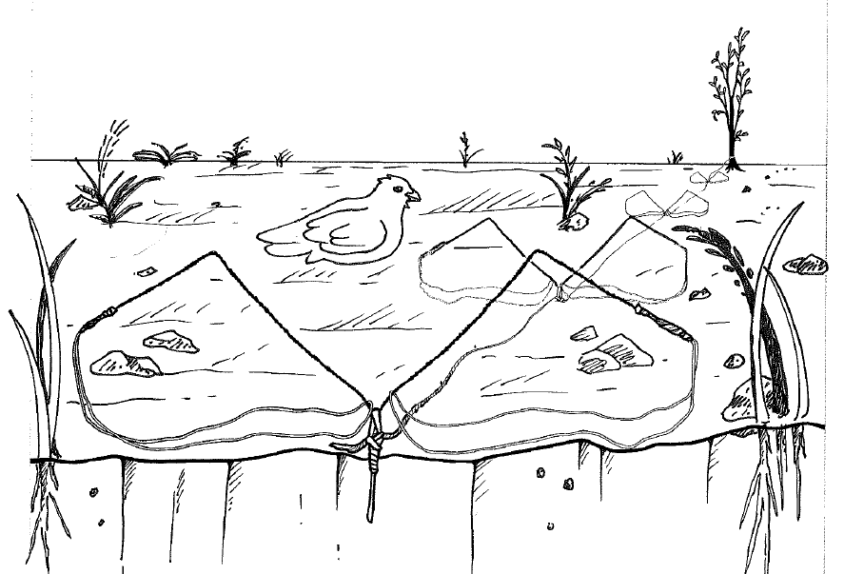
Fig. S2. Artistic illustrations of interconnected leg noose traps used to trap stone partridges at the Yankari Game Reserve, Nigeria, 2020 – 2022.

