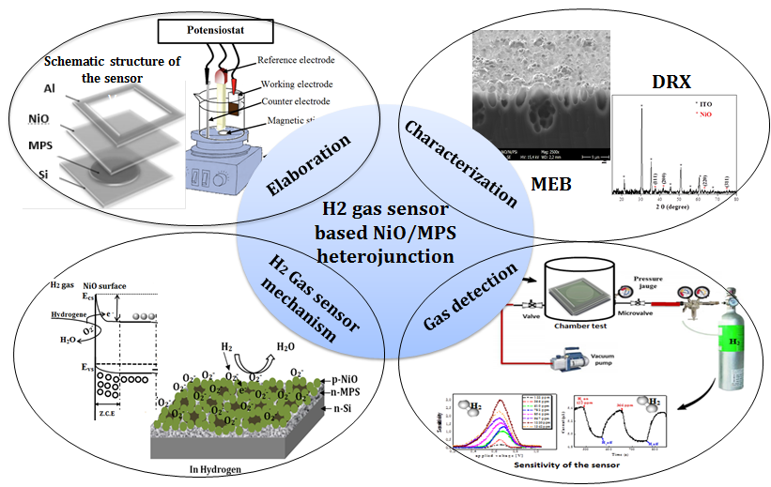

Schematic structure of the designed gas sensor

