Supplementary Information

Cryo-EM and AFM visualize linear polyorganophosphazene: individual chains and single-chain assemblies with proteins

Raman Hlushko#, Edwin Pozharski#, Vivek M. Prabhu† and Alexander K. Andrianov#,*
#Institute for Bioscience and Biotechnology Research, University of Maryland, Rockville, Maryland 20850, United States of America
†Materials Science and Engineering Division, Material Measurement Laboratory, National Institute of Standards and Technology‡, 100 Bureau Drive, Gaithersburg, Maryland 20899, United States of America
*Corresponding author: Alexander K. Andrianov, E-mail: aandrianov@umd.edu

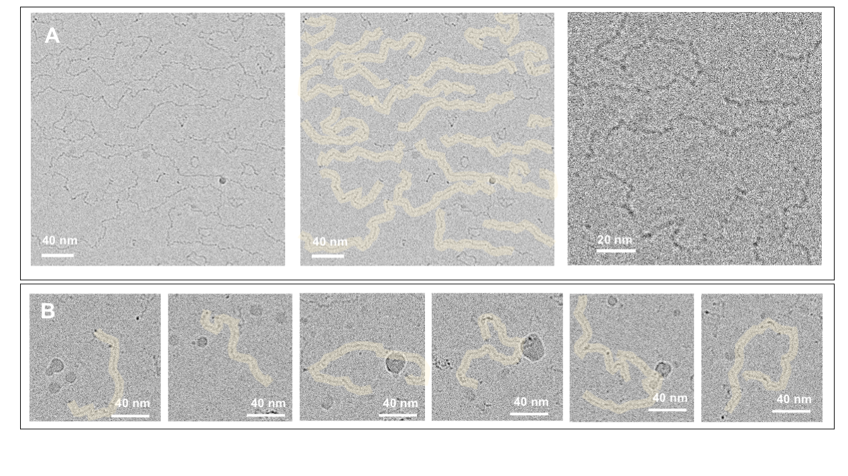

Figure S1. Representative cryogenic electron microscopy (cryo-EM) images of poly[di(carboxylatophenoxy)phosphazene], PCPP at (A) 2.5 mg/mL and (B) 0.5 mg/mL of polymer (50 mmol phosphate buffer, pH 7.4)

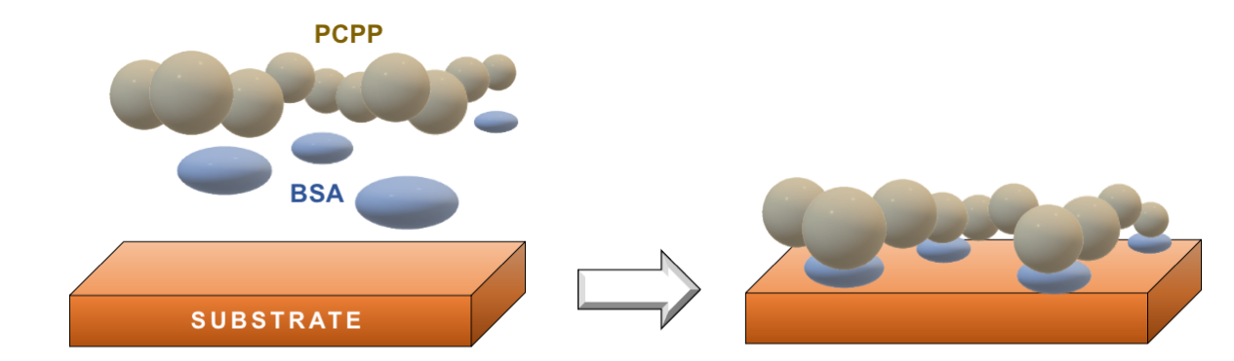

Figure S2. Sample preparation scheme for atomic force microscopy (AFM) analysis of PCPP (BSA - bovine serum albumin).

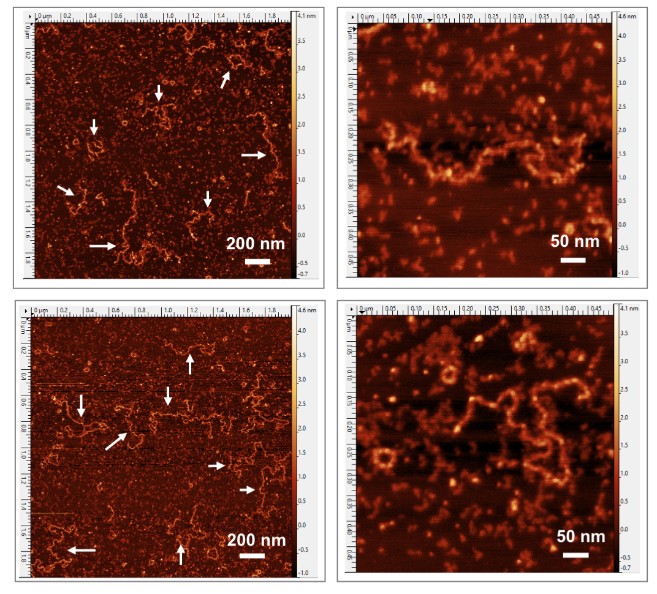
Figure S3. Representative AFM images of PCPP (AFM images are taken from the BSA-mediated mica).

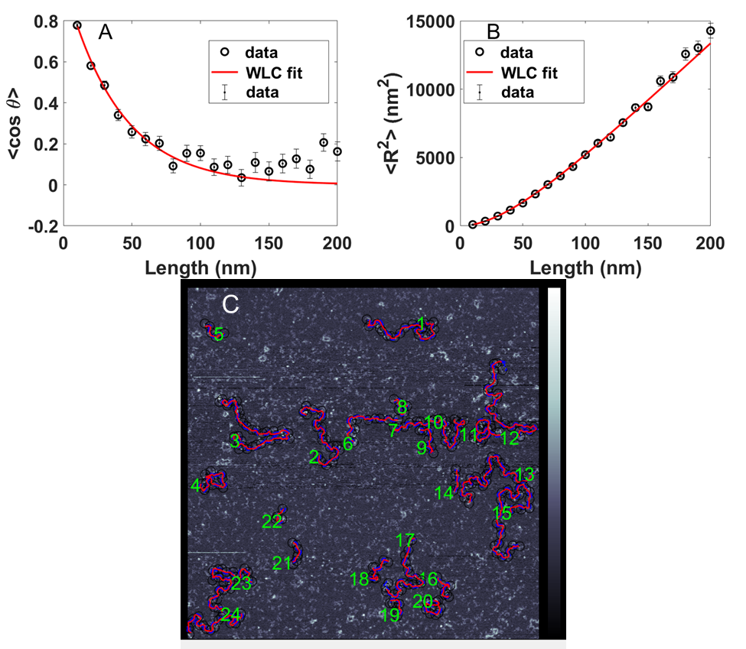

Figure S4. (A) Tangent vector correlation as a function of segment length, (B) mean-square end-to-end distance as a function of segment length for PCPP-BSA AFM images and (C) examples of SmartTrace chain tracing for PCPP-BSA cryo-EM image.

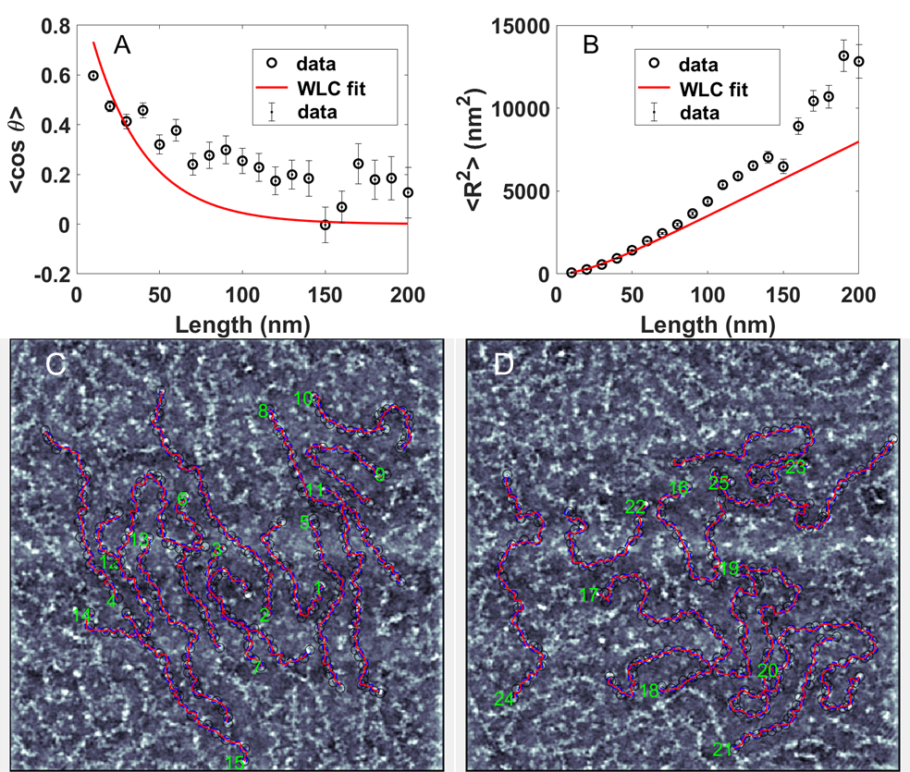
Figure S5. (A) Tangent vector correlation as a function of segment length, (B) mean-square end-to-end distance as a function of segment length for PCPP-BSA CryoEM images and (C, D) examples of SmartTrace chain tracing for PCPP-BSA CryoEM images.

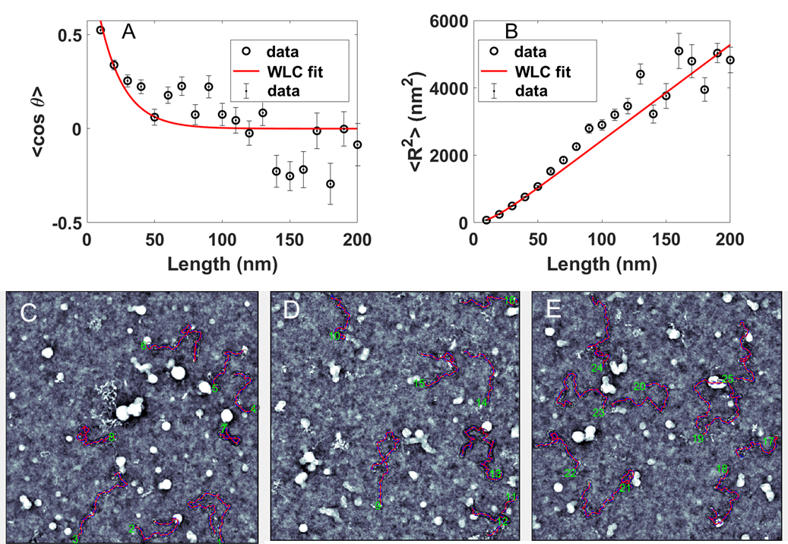
Figure S6. (A) Tangent vector correlation as a function of segment length, (B) mean-square end-to-end distance as a function of segment length for PCPP CryoEM images and (C, D, E) examples of SmartTrace chain tracing for PCPP CryoEM images.
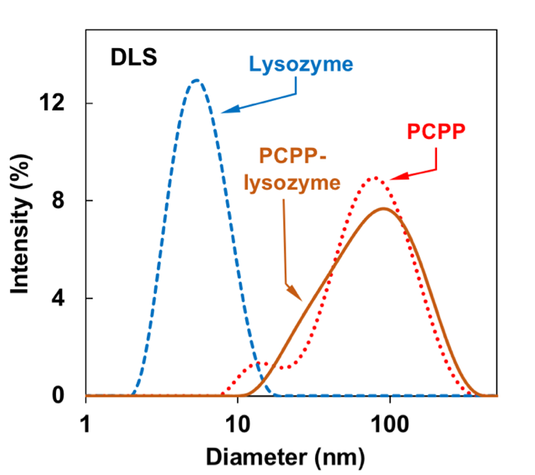
Figure S7. Dynamic light scattering (DLS) profiles of PCPP (dotted line), lysozyme (dashed line), and PCPP-lysozyme mixture (solid line).

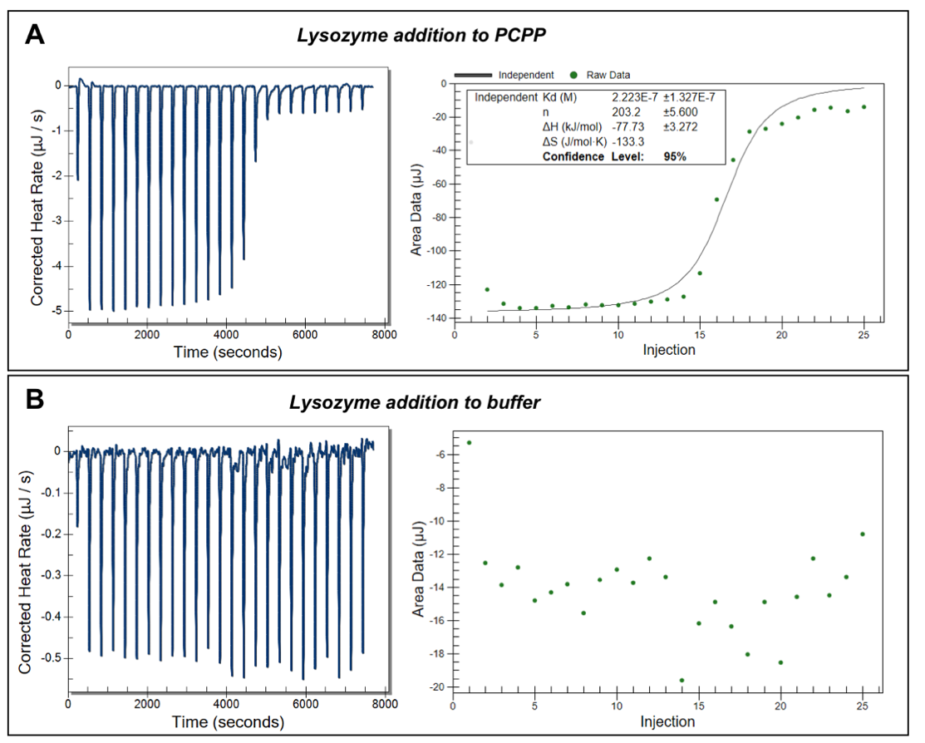

Figure S8. Raw isothermal calorimetry (ITC) data for the titration of PCPP with lysozyme (A) and PCPP dilution (B) (50 mol/L phosphate buffer, pH 7.4).

Table S1. Thermodynamic parameters of PCPP-lysozyme complex formation (ITC, K_{d} - dissociation constant, n - number of protein molecules per polymer chain, 50 mol/L phosphate buffer, phosphate buffered saline (PBS), pH 7.4)).

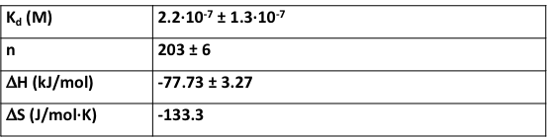

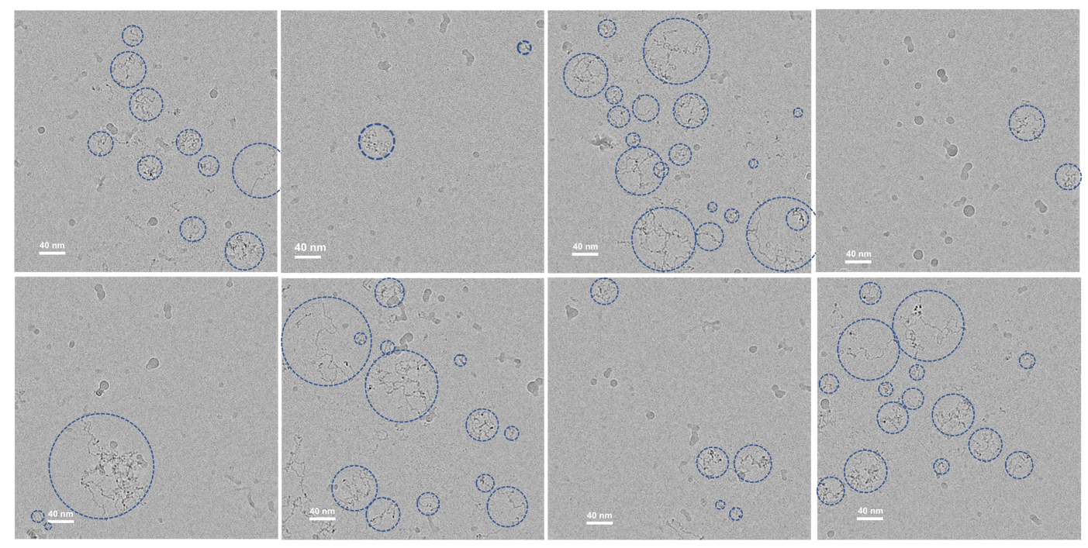

Figure S9. Examples of cryo-EM image processing for PCPP-lysozyme complexes. Dimensions of complexes were assessed by encircling individual images of molecular assemblies and measuring their diameters (scale bars - 40 nm).

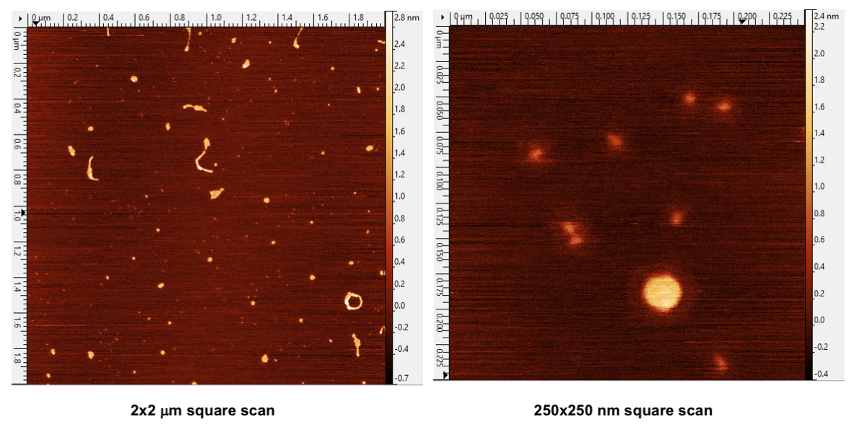

Figure S10. AFM images of PCPP-lysozyme complexes adsorbed on mica surface (AFM images are taken from the BSA-mediated mica).

