Assessing Calibration and Bias of a Deployed Machine Learning Malnutrition Prediction Model within a Large Healthcare System

Lathan Liou MPhil¹, Erick Scott MD², Prathamesh Parchure MS³, Yuxia Ouyang^{4,5}, Natalia Egorova⁴, Robert Freeman RN³, Ira S. Hofer MD^{5,6,7}, Girish N Nadkarni MD^{6,7}, Prem Timsina PhD³, Arash Kia MD^{3,5}, Matthew A Levin MD^{3,5,6}

Supplementary Appendix

Supplementary Table 1. Calibration Statistics for MUST-Plus Model for Asian Patients
 | No Recalibration (95% CI) | Recalibration in the Large  (95% CI) | Logistic Recalibration (95% CI)
Rescaled Brier Score | -0.01  (-0.26, -0.10) | 0.23  (0.19, 0.26) | 0.25  (0.22, 0.29)
Calibration Intercept | -1.61  (-1.74, -1.50) | 0.53  (0.41, 0.65) | 0
Calibration Slope | 1.63  (1.48, 1.77) | 1.63  (1.50, 1.77) | 1
Emax | 0.33  (0.30, 0.35) | 0.31  (0.22, 0.40) | 0.05  (0.01, 0.10)
Eavg | 0.25  (0.23, 0.26) | 0.05  (0.04, 0.07) | 0.007  (0.002, 0.02)

Supplementary Table 2. Calibration Statistics for MUST-Plus Model by Type of Payor
 | No Recalibration |  |  | Logistic Recalibration
 | Medicare  (95% CI) | Medicaid  (95% CI) | Commercial  (95% CI) | Medicare  (95% CI) | Medicaid  (95% CI) | Commercial  (95% CI)
Rescaled Brier Score | -0.01  (-0.02, -0.01) | 0.05  (0.04, 0.07) | 0.26  (0.26, 0.28) | 0.2 (0.19, 0.21) | 0.33  (0.31, 0.35) | 0.25  (0.23, 0.26)
Calibration Intercept | -1.11  (-1.14, -1.08) | -1.33  (-1.38, -1.28) | 0.55  (0.50, 0.59) | 0 | 0 | 0
Calibration Slope | 1.55  (1.50, 1.60) | 1.54  (1.47, 1.61) | 1.62  (1.58, 1.67) | 1 | 1 | 1
Emax | 0.25  (0.24, 0.26) | 0.28  (0.27, 0.29) | 0.27  (0.23, 0.30) | 0.01  (0.008, 0.02) | 0.01  (0.006, 0.04) | 0.02  (0.006, 0.04)
Eavg | 0.18  (0.17, 0.18) | 0.20  (0.19, 0.21) | 0.06  (0.05, 0.06) | 0.005 (0.003, 0.008) | 0.003  (0.002, 0.007) | 0.004  (0.002, 0.008)

Supplementary Table 3. Pairwise Empirical Bootstrap Differences in Calibration Intercept and Slope before Recalibration for Type of Payor
Comparison | Calibration Intercept Mean Difference (P-Value) | Calibration Slope Difference (P-value)
Medicaid - Commercial | 0.31 (0)* | -0.007 (0.46)
Medicare - Commercial | 0.53 (0)* | 0.002 (0.47)
Medicare - Medicaid | 0.22 (0)* | 0.01 (0.40)
*denotes statistical significance at Bonferroni adjusted threshold of 0.003

Supplementary Table 4. Calibration Statistics for MUST-Plus Model by Type of Hospital
 | No Recalibration |  |  | Logistic Recalibration
 | Community Hospital  (95% CI) | Tertiary Acute Care  (95% CI) | Quaternary Academic  (95% CI) | Community Hospital  (95% CI) | Tertiary Acute Care  (95% CI) | Quaternary Academic  (95% CI)
Rescaled Brier Score | 0.06  (0.05, 0.08) | -0.02  (-0.04, -0.01) | 0.03  (0.01, 0.03) | 0.32  (0.30, 0.34) | 0.22  (0.21, 0.24) | 0.29  (0.27, 0.30)
Calibration Intercept | -1.23  (-1.28, -1.18) | -1.22  (-1.26, -1.17) | -1.30  (-1.34, -1.26) | 0 | 0 | 0
Calibration Slope | 1.64  (1.50, 1.60) | 1.47  (1.42, 1.53) | 1.58  (1.52, 1.64) | 1 | 1 | 1
Emax | 0.27  (0.25, 0.28) | 0.26  (0.25, 0.27) | 0.28  (0.27, 0.29) | 0.043  (0.01, 0.08) | 0.008  (0.005, 0.03) | 0.02  (0.01, 0.03)
Eavg | 0.19  (0.19, 0.20) | 0.19  (0.19, 0.20) | 0.20 (0.19, 0.20) | 0.005  (0.002, 0.010) | 0.003  (0.002, 0.007) | 0.007 (0.004, 0.01)

Supplementary Table 5. Pairwise Empirical Bootstrap Differences in Calibration Intercept and Slope before Recalibration by Type of Hospital
Comparison | Calibration Intercept Mean Difference (P-Value) | Calibration Slope Difference (P-value)
Tertiary - Community | 0.01 (0.37) | -0.17 (0)*
Quaternary - Community | -0.07 (0.02) | -0.06 (0.08)
Quaternary - Tertiary | -0.08 (0.005) | 0.11 (0.003)
*denotes statistical significance at Bonferroni adjusted threshold of 0.003

A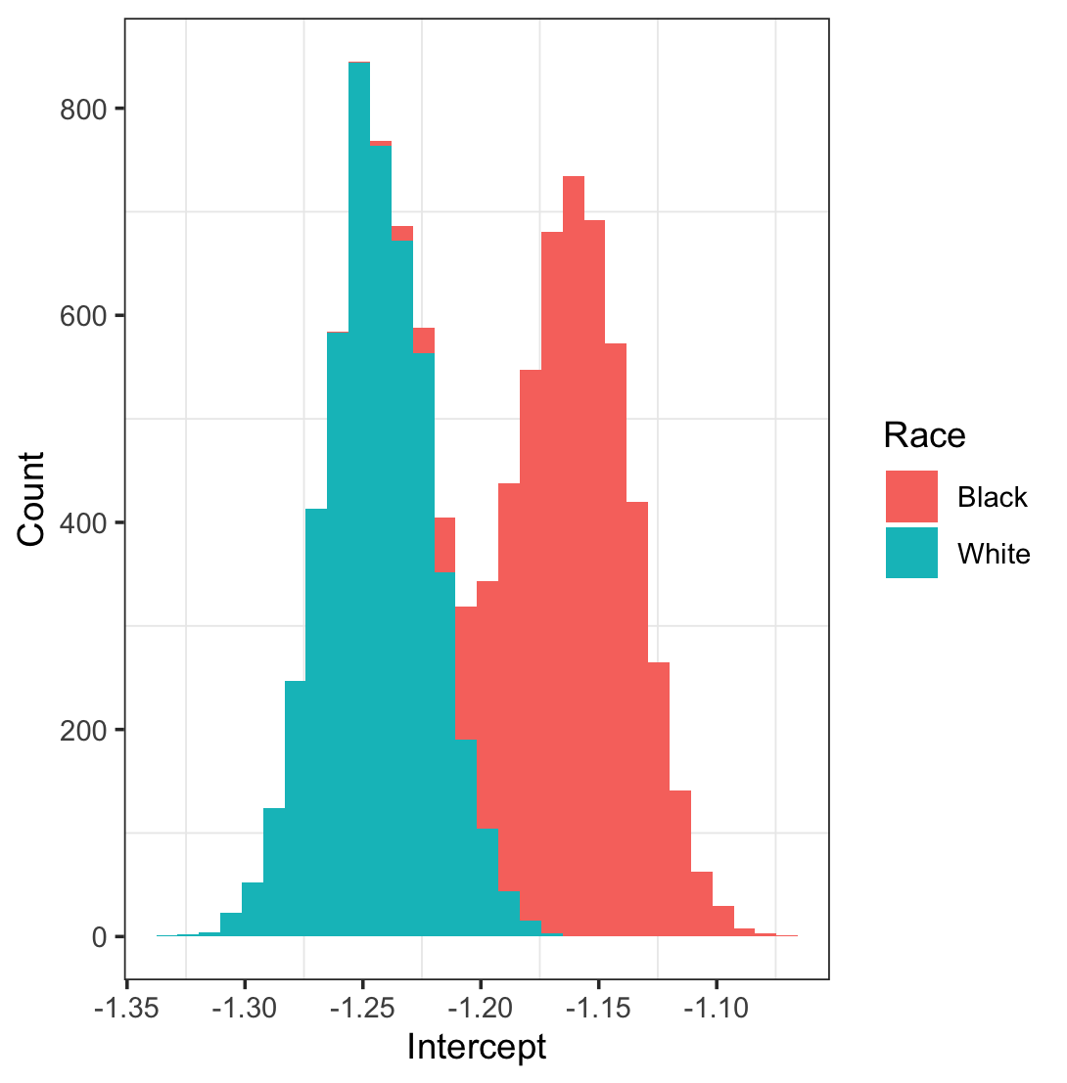 | B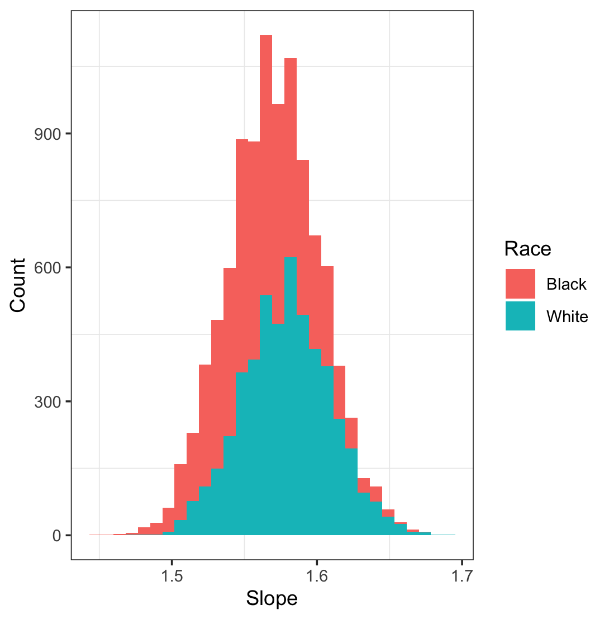
C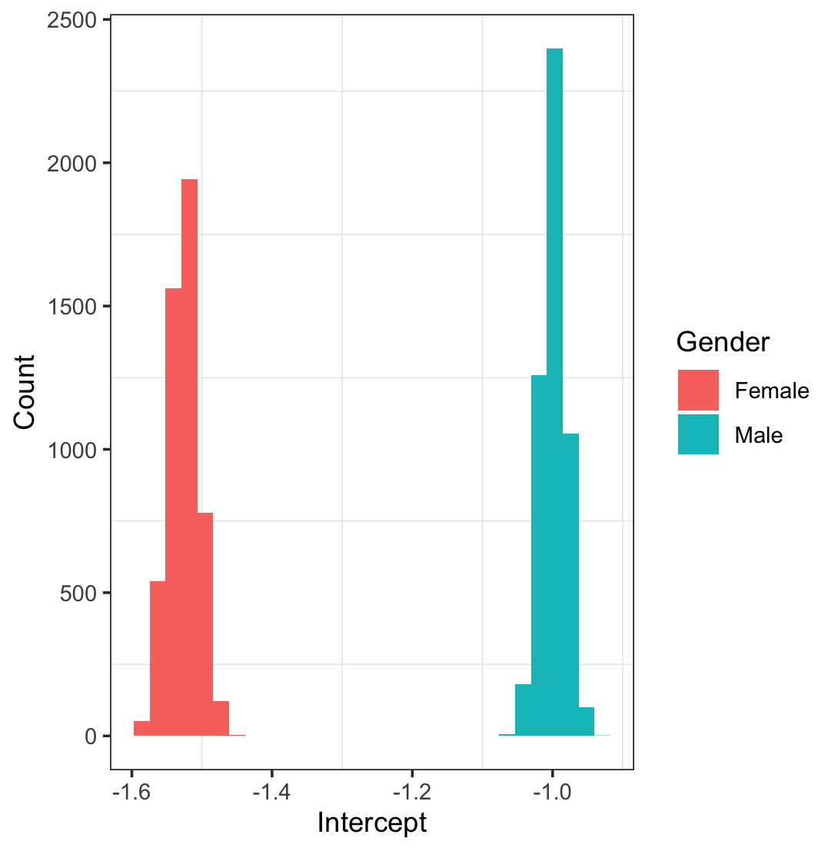 | D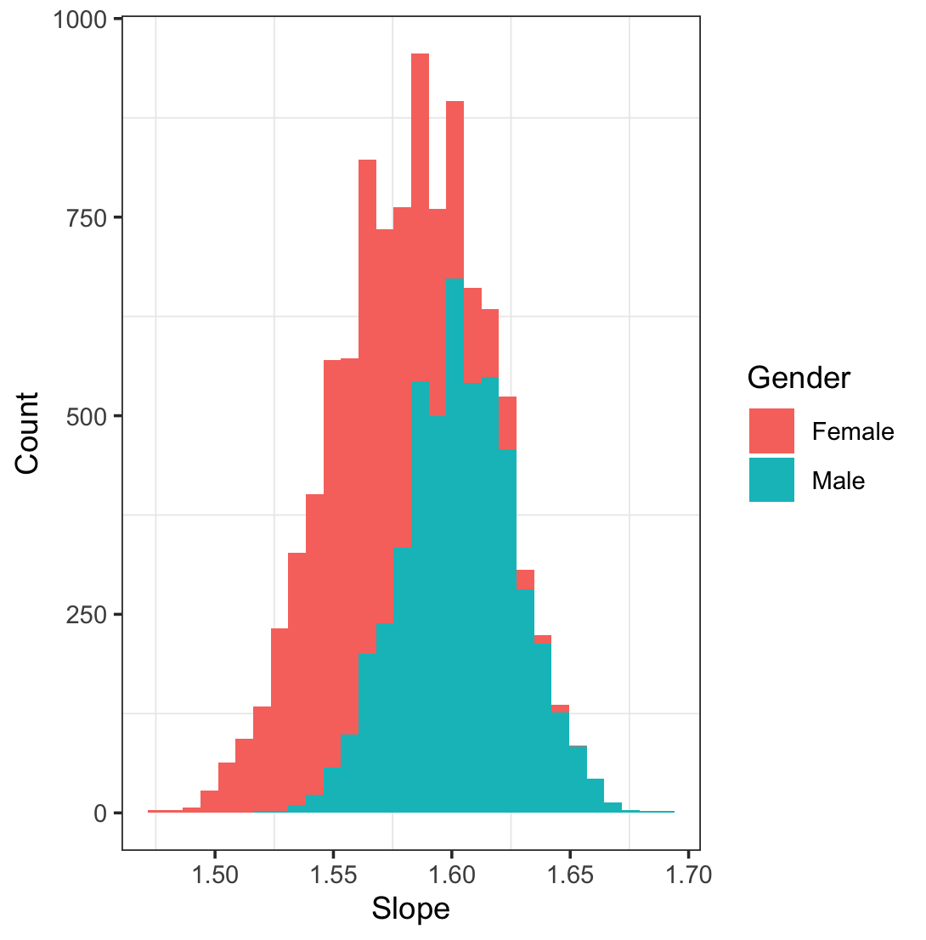
E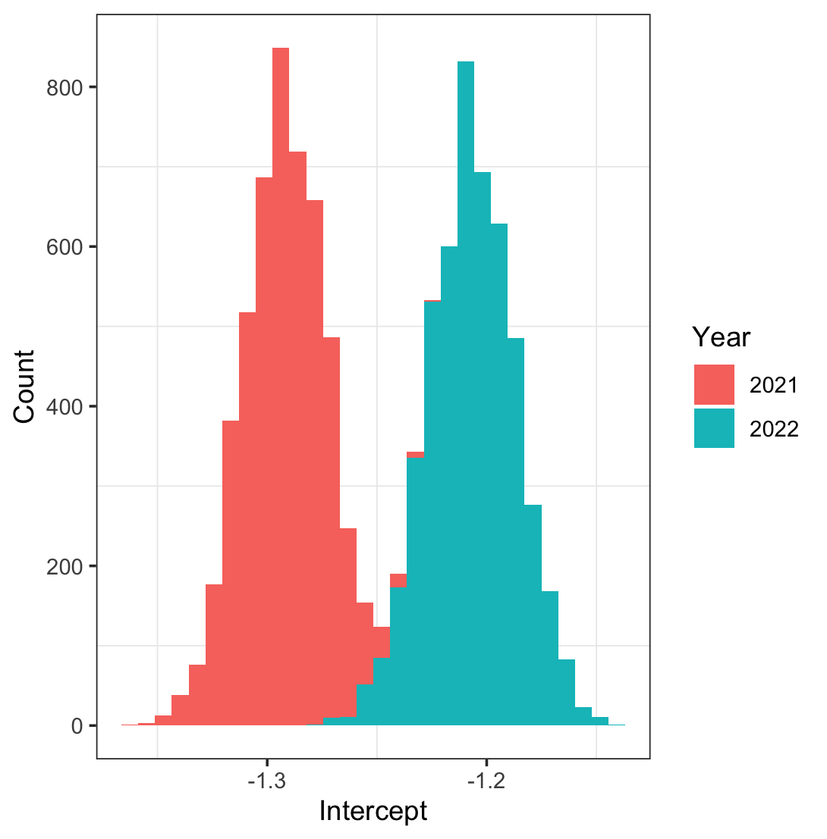 | F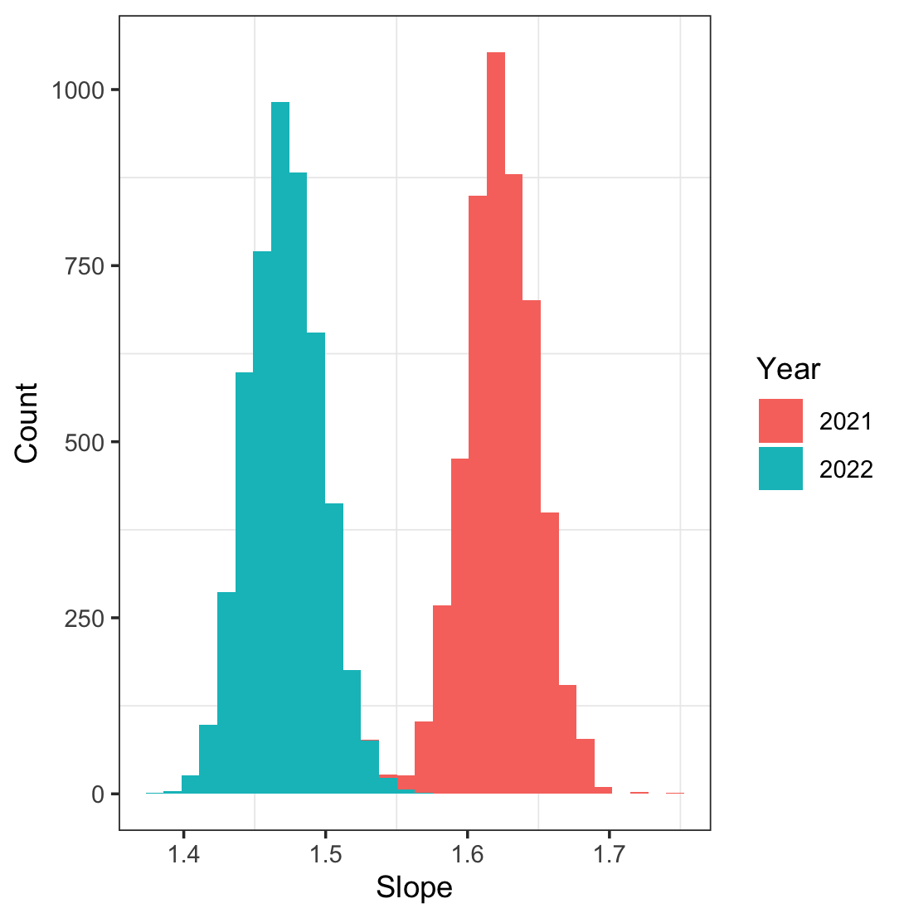
Supplementary Figure 1. Histograms of bootstrapped calibration intercepts (left column) and calibration slopes (right column) for A-B) Black and White patients C-D) male and female patients E-F) 2021 and 2022

A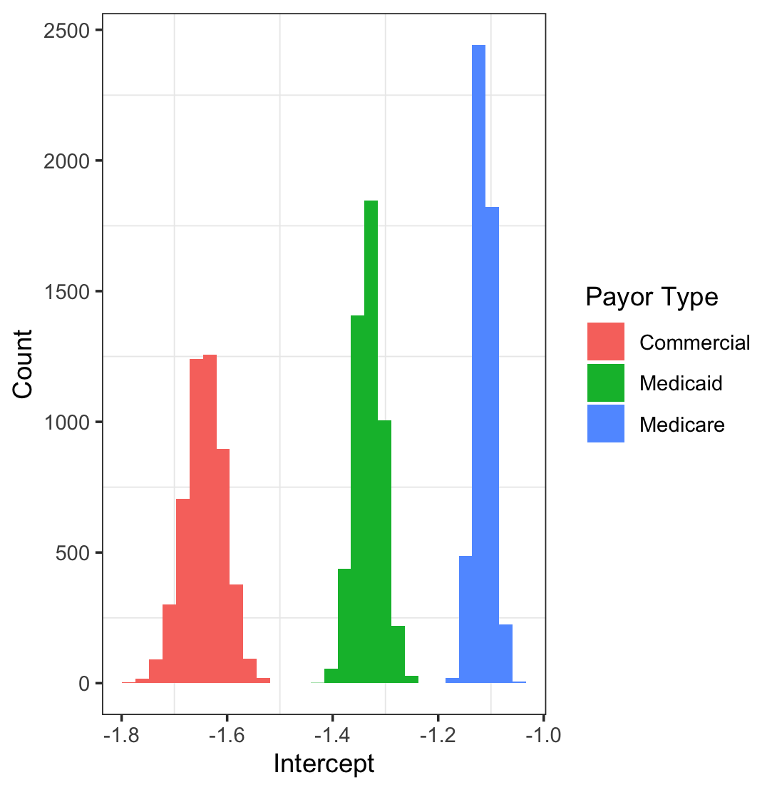 | B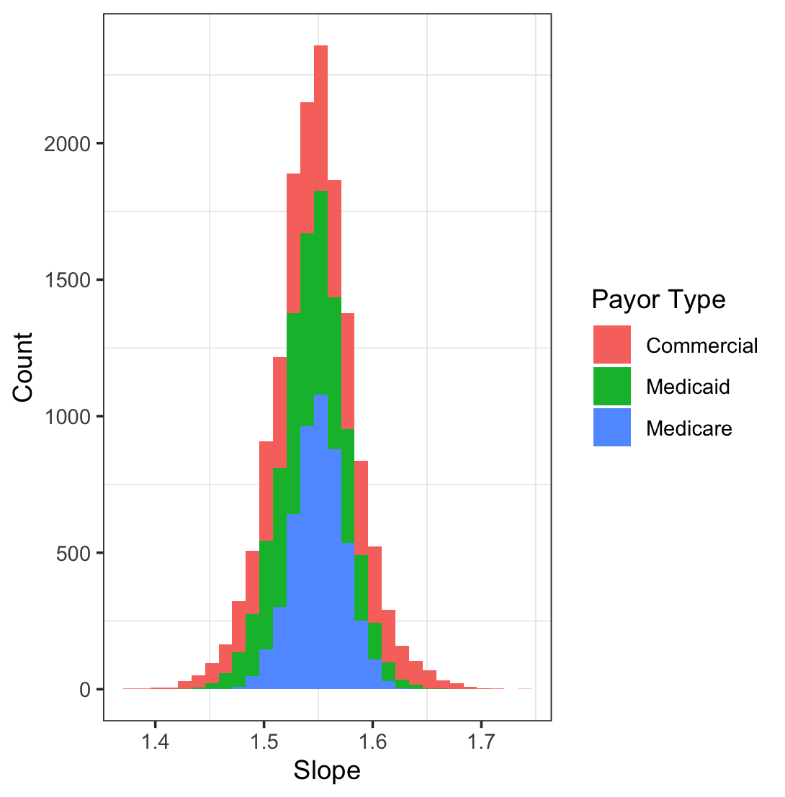
C  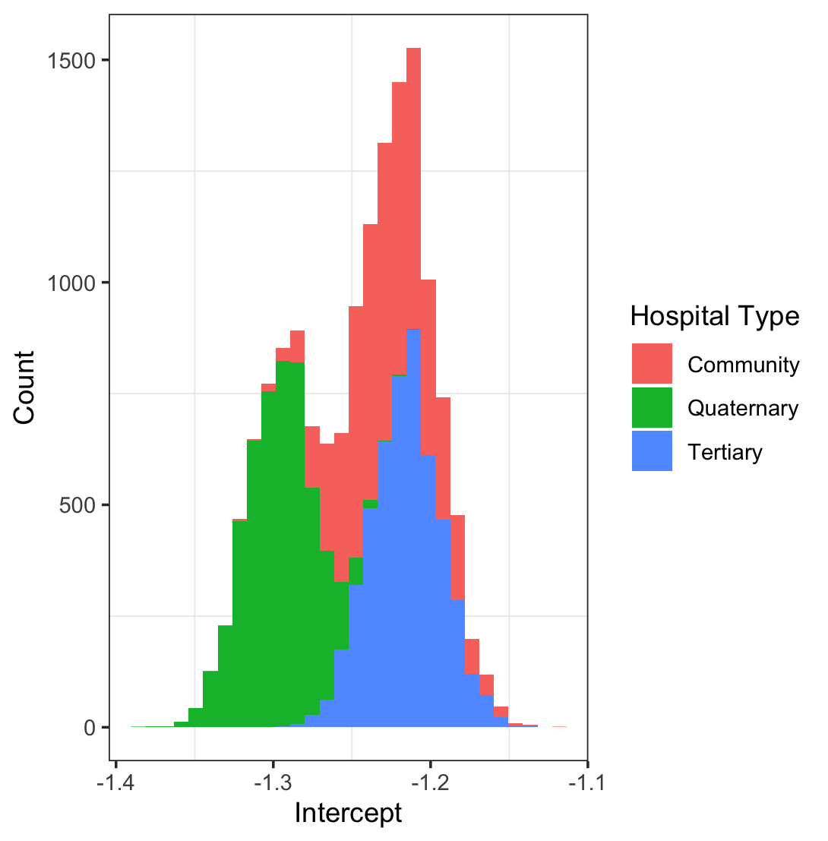 | D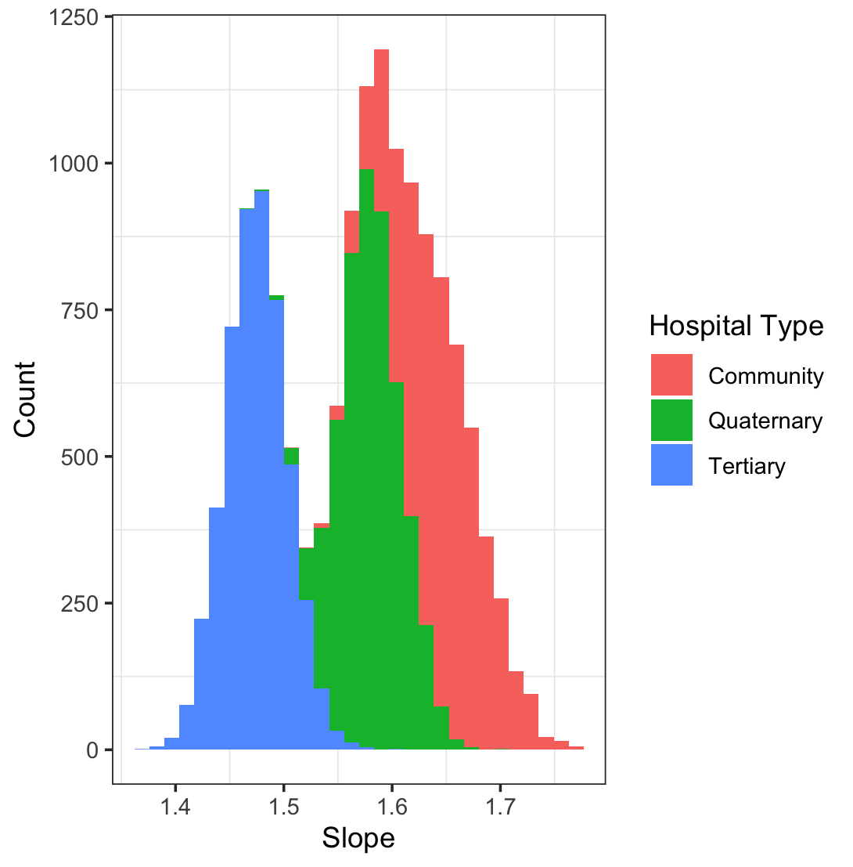
Supplementary Figure 2. Histograms of bootstrapped calibration intercepts (left column) and calibration slopes (right column) for A-B) payor types and C-D) hospital types

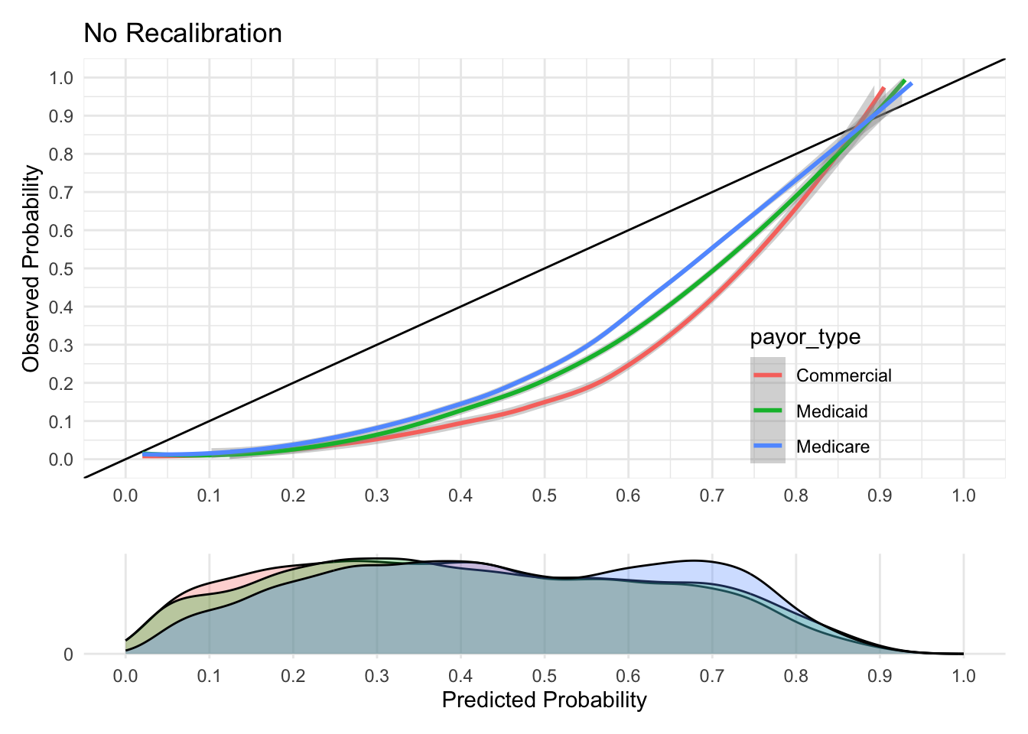 | 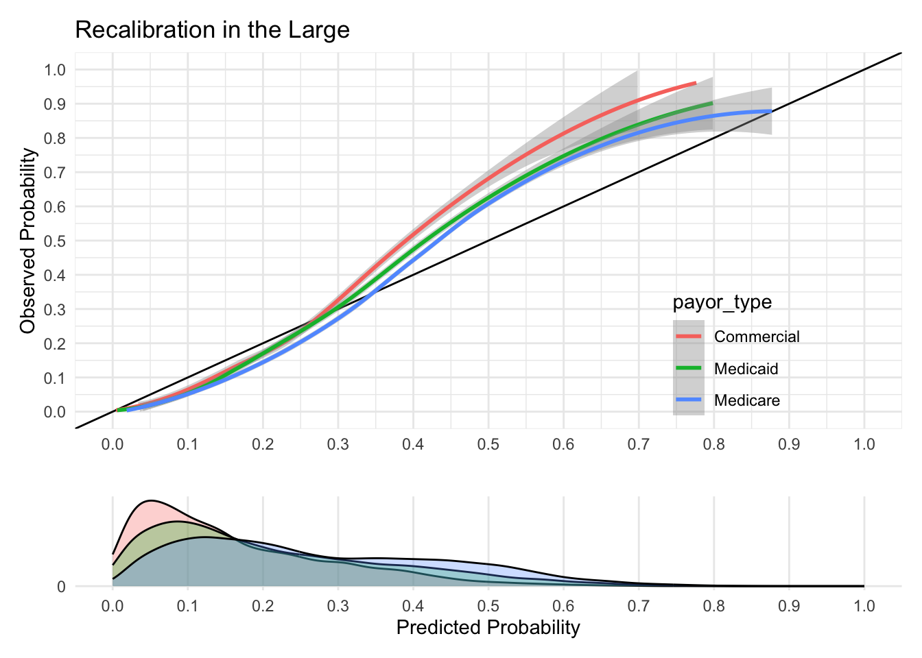 | 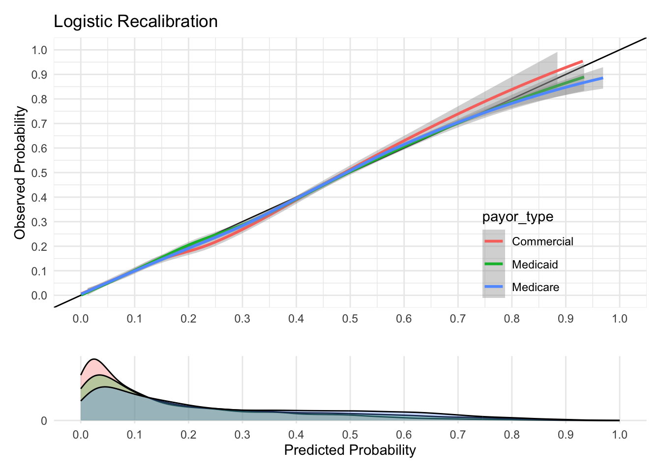
Supplementary Figure 3. Calibration curves for different payor types. Columns from left to right are curves for No Recalibration, Recalibration-in-the-Large, and Logistic Recalibration.

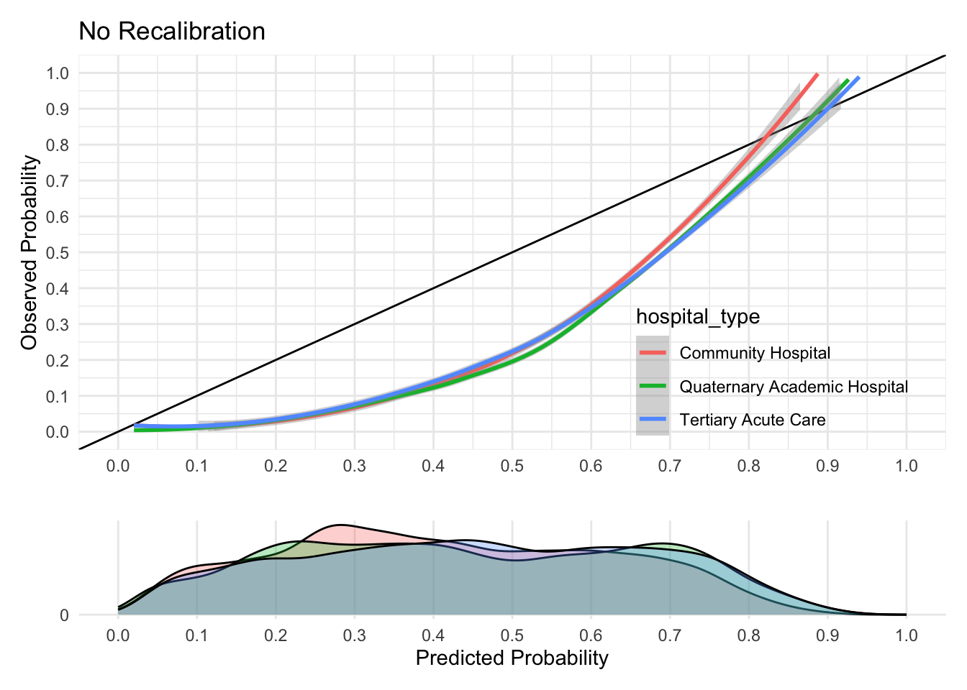 | 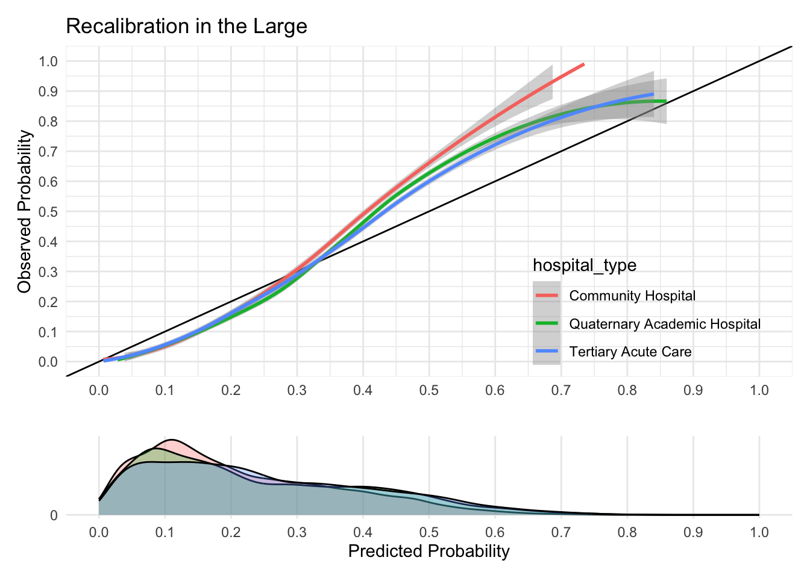 | 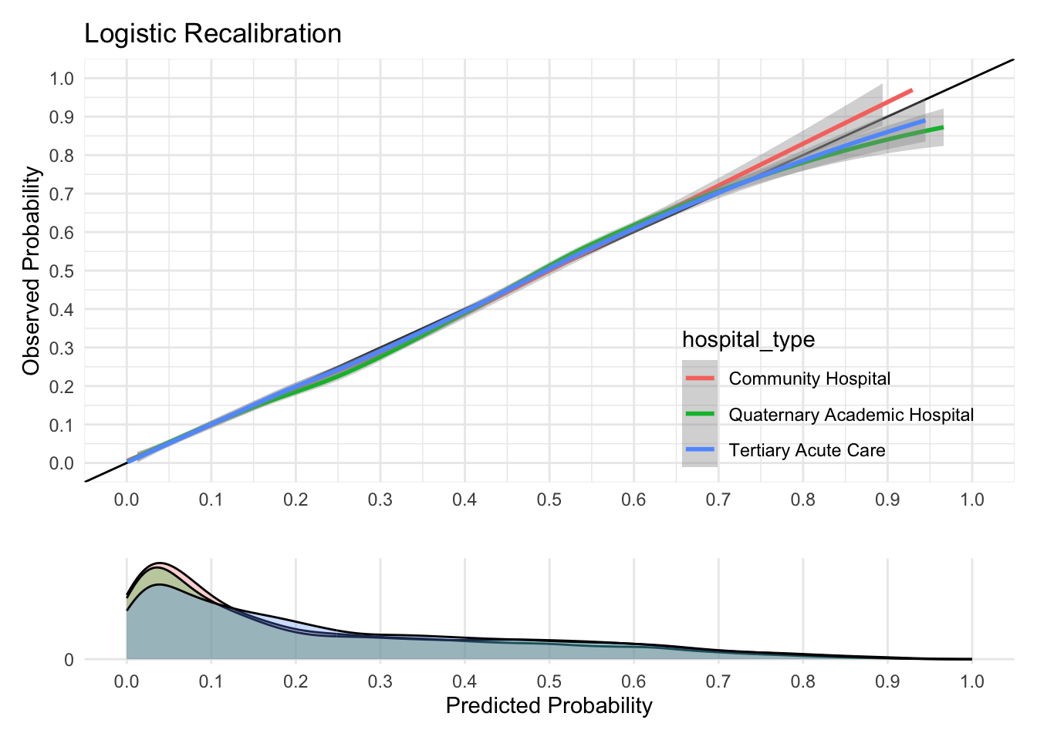
Supplementary Figure 4. Calibration curves for different hospital types. Columns from left to right are curves for No Recalibration, Recalibration-in-the-Large, and Logistic Recalibration.

