Appendix A.

Figure A1. Choice situation example.

 | ALTERNATIVE A | ALTERNATIVE B | ALTERNATIVE C – Do not purchase
MUSSELS FORMAT | FRESH  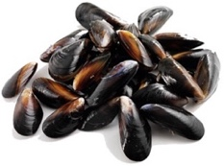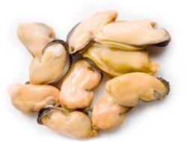 | FROZEN  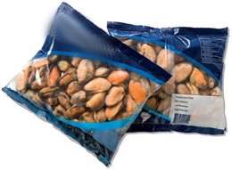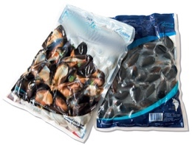 | -
DEPURATION CERTIFICATION | NO - 0% EFFICIENCY | YES - 90% EFFICIENCY | -
PRODUCERS | SMALL-SCALE MUSSEL FARMERS | LARGE-SCALE MUSSEL FARMERS | -
PRICE  (250gr mussels’ meat) | $1.500 CLP (US$ 1.875)   | $2.500 CLP (US$ 3.125) | $0 CLP

Appendix B

“A mussel is a shellfish produced in various parts of the country [Figure B1]. In Chile, the major mussel’s production comes from farming areas where producers hang mussels’ seeds in long rows that they then feed, fatten, and when they reach maturity, extract and sell in the market [Figure B2].

Mussels are filter feeders, i.e., they pass water through a filtering structure and capture suspended particulate matter (including food) [Figure B3]. Moreover, this feeding mechanism causes the mussels to accumulate substances (e.g., chemicals) in their organisms (a process known as bioaccumulation). Due to this characteristic, mussels are used as bioindicators, as they can indicate the pollutants concentrations in the areas they inhabit. In recent years, mussels have been proposed as bioindicators for the presence of microplastics.

Microplastics are small plastic particles with a size between 5mm–0.1µm (between the size of an ant and the width of a human hair, approximately) that are present everywhere. Microplastics can be classified as primary (if they are intentionally created and incorporated into daily products) or secondary (if they are released from larger plastics).

Microplastics can be found in various food products such as sugar, honey, table salt, beer, or bottled water. There is also evidence of their presence in meat or seafood products. Specifically, there is wide evidence of their presence in mussels. This is due to the filtration and bioaccumulation process described above.

[TREATMENT IS HERE]

A procedure that can be used to remove microplastics and other pollutants particles from mussels is through depuration. Depuration involves keeping live mussels in pools with filtered seawater in order to reduce the pollution they contain. Scientific studies show that depuration helps to reduce a significant percentage of the microplastics in mussels.

However, the depuration standard in the country is mainly related to the presence of Escherichia coli bacteria. That is, there may be mussels with microplastics that are not taken to depuration centers because they have low (or very high) levels of Escherichia coli bacteria. Therefore, we are interested in knowing their preferences for mussels that have undergone a certified depuration period that ensures a lower percentage of microplastics or other pollutants.”

Figure B1
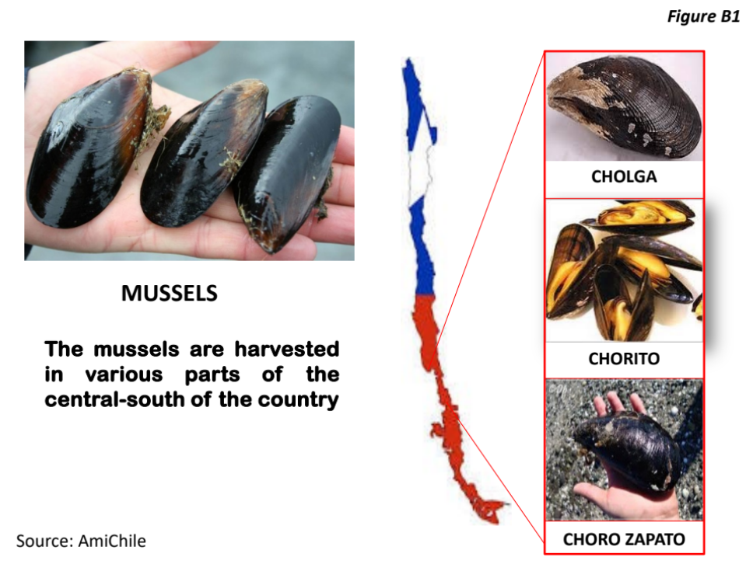
Note: “Cholga”, “Chorito”, and “Choro Zapato” are different types of mussels.

Figure B2
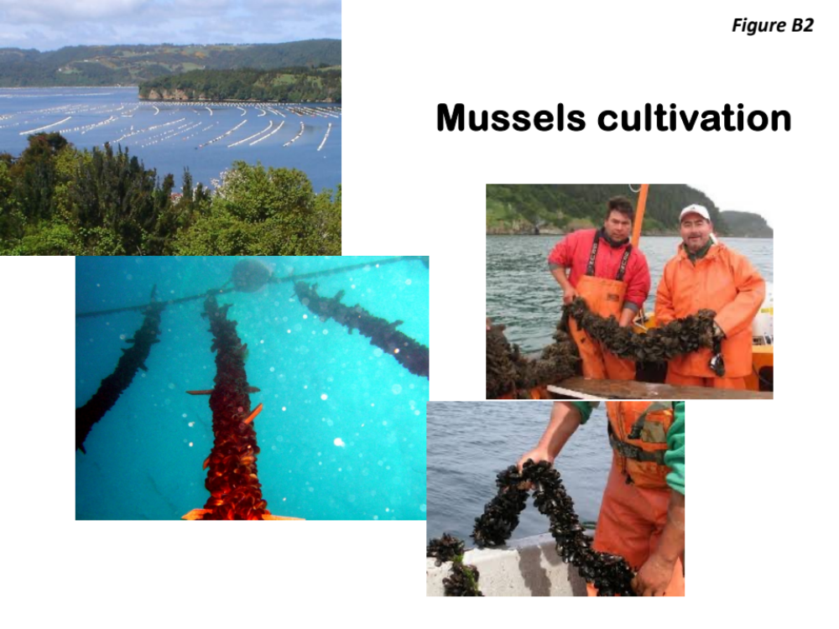

Figure B3

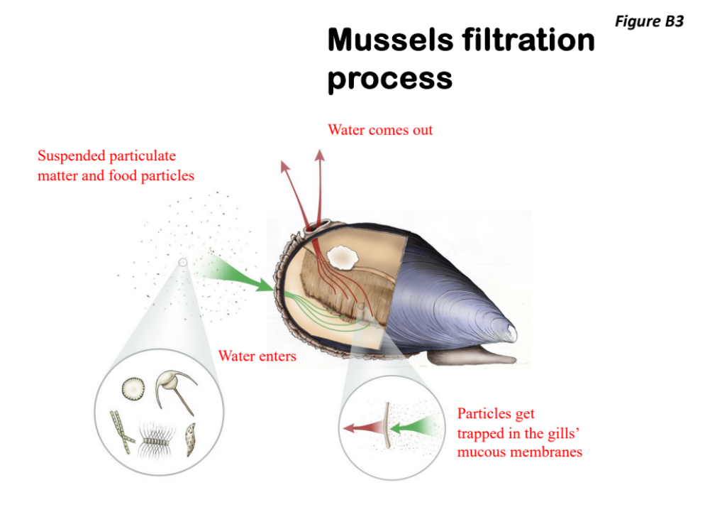
Image source: Kimberly Andrews, "Filter-feeding in a mussel," 2013. Accessed via https://www.kimberly-andrews.com/filter-feeding-in-a-mussel.html

Appendix C.

Table C1. Mixed logit estimations in WTP-space by treatment group for certainty 60% or higher.

 | Full sample  MXL1 | CONTROL  MXL2 | ENV  MXL3 | HEA  MXL4 | HEA-ENV MXL5
Mean
ASC - No purchase | -3.60 (0.19)*** | -3.18 (0.28)*** | -3.81 (0.39)*** | -3.46 (0.35)*** | -3.36 (0.36)***
Format: Frozen | -0.21 (0.10)* | 0.26 (0.13)* | -0.90 (0.07)*** | 0.37 (0.15)** | 0.13 (0.47)
Format: Canned | -0.67 (0.22)*** | -0.05 (0.23) | -1.53 (0.35)*** | -0.71 (0.24)*** | 0.42 (0.26)
Depuration: 25% | 0.90 (0.11)*** | 1.00 (0.13)*** | 1.16 (0.19)*** | 0.51 (0.34)*** | 0.24 (0.19)
Depuration: 50% | 2.95 (0.08)*** | 2.73 (0.15)*** | 2.99 (0.10)*** | 3.50 (0.30)*** | 2.72 (0.12)***
Depuration: 90% | 4.15 (0.13)*** | 3.73 (0.15)*** | 4.71 (0.37)*** | 5.41 (0.29)*** | 3.43 (0.17)***
Producer: Small-scale | 0.45 (0.12)*** | 0.46 (0.10)*** | 0.85 (0.14)*** | 0.80 (0.30)*** | -0.05 (0.10)
Price | -0.66 (0.11)*** | -0.77 (0.18)*** | -0.93 (0.19)*** | -0.80 (0.17)*** | -0.52 (0.20)***
Standard Deviation
Format: Frozen | 3.01 (0.10)*** | 3.09 (0.15)*** | 3.23 (0.22)*** | 4.80 (0.55)*** | 2.17 (0.23)***
Format: Canned | 2.80 (0.16)*** | 1.97 (0.21)*** | 4.36 (0.30)*** | 4.93 (0.63)*** | 2.66 (0.31)***
Depuration: 25% | 0.35 (0.07)*** | 0.80 (0.14)*** | 0.60 (0.09)*** | 3.28 (0.37)*** | 1.26 (0.17)***
Depuration: 50% | 2.30 (0.15)*** | 2.38 (0.19)*** | 1.33 (0.08)*** | 1.84 (0.43)*** | 1.74 (0.12)***
Depuration: 90% | 3.02 (0.15)*** | 2.19 (0.19)*** | 3.68 (0.29)*** | 3.02 (0.34)*** | 2.15 (0.77)***
Producer: Small-scale | 2.17 (0.11)*** | 1.18 (0.11)*** | 0.52 (0.12)*** | 1.69 (0.32)*** | 2.48 (0.26)***
Price | 1.74 (0.13)*** | 1.77 (0.31)*** | 1.85 (0.26)*** | 1.64 (0.30)*** | 1.66 (0.34)***
Observations | 6692 | 1680 | 1652 | 1724 | 1636
Log Likelihood convergence | -5805.31 | -1476.87 | -1398.14 | -1450.43 | -1445.66
***p < 0.001; **p < 0.01; *p < 0.05 Standard Errors in Brackets; ASC = Alternative Specific Constant. WTPs are in US$ 2023.

Table C2. Mixed logit estimations in WTP-space by treatment group for perceived policy consequentiality 60% or higher.

 | Full sample  MXL1 | CONTROL  MXL2 | ENV  MXL3 | HEA  MXL4 | HEA-ENV MXL5
Mean
ASC - No purchase | -3.41 (0.18)*** | -2.93 (0.27)*** | -3.89 (0.52)*** | -3.85 (0.44)*** | -3.70 (0.51)***
Format: Frozen | 0.20 (0.30) | 0.37 (0.20)*** | 0.36 (0.12)*** | -0.23 (0.04)*** | 0.10 (0.13)
Format: Canned | -0.48 (0.27)* | -0.13 (0.36) | -0.55 (0.24)* | -0.69 (0.15)*** | 0.40 (0.19)
Depuration: 25% | 1.01 (0.20)*** | 1.18 (0.19)*** | 1.18 (0.12)*** | 0.83 (0.24)*** | 0.25 (0.37)
Depuration: 50% | 3.16 (0.16)*** | 2.74 (0.05)*** | 3.16 (0.16)*** | 4.31 (0.11)*** | 2.85 (0.28)***
Depuration: 90% | 4.50 (0.21)*** | 4.47 (0.24)*** | 4.42 (0.18)*** | 5.60 (0.19)*** | 3.12 (0.37)***
Producer: Small-scale | 0.73 (0.25)** | 0.75 (0.18)*** | 1.24 (0.06)*** | 0.82 (0.09)*** | 0.52 (0.22)**
Price | -0.73 (0.10)*** | -1.12 (0.26)*** | -0.82 (0.25)*** | -0.73 (0.20)*** | -0.26 (0.20)
Standard Deviation
Format: Frozen | 4.10 (0.37)*** | 3.35 (0.24)*** | 5.30 (0.29)*** | 4.60 (0.15)*** | 1.97 (0.22)***
Format: Canned | 3.43 (0.39)*** | 2.69 (0.28)*** | 4.31 (0.24)*** | 5.00 (0.22)*** | 2.38 (0.32)***
Depuration: 25% | 0.80 (0.17)*** | 0.11 (0.64) | 0.24 (0.10)** | 2.84 (0.27)*** | 1.58 (0.28)***
Depuration: 50% | 2.53 (0.42)*** | 2.26 (0.13)*** | 2.57 (0.19)*** | 3.12 (0.15)*** | 1.47 (0.24)***
Depuration: 90% | 3.22 (0.31)*** | 2.73 (0.40)*** | 3.89 (0.23)*** | 4.33 (0.17)*** | 1.90 (0.20)***
Producer: Small-scale | 1.93 (0.30)*** | 1.85 (0.16)*** | 1.22 (0.03)*** | 1.63 (0.09)*** | 2.41 (0.24)***
Price | 1.65 (0.11)*** | 2.18 (0.30)*** | 2.04 (0.33)*** | 2.11 (0.36)*** | 1.39 (0.48)**
Observations | 5864 | 1456 | 1488 | 1544 | 1376
Log Likelihood convergence | -5034.53 | -1275.66 | -1251.76 | -1283.95 | -1194.28
***p < 0.001; **p < 0.01; *p < 0.05 Standard Errors in Brackets; ASC = Alternative Specific Constant. WTPs are in US$ 2023.

Table C3. Mixed logit estimations in WTP-space by treatment group for consumers with previous knowledge about microplastics.

 | Full sample  MXL1 | CONTROL  MXL2 | ENV  MXL3 | HEA  MXL4 | HEA-ENV MXL5
Mean
ASC - No purchase | -3.20 (0.27)*** | -2.91 (0.37)*** | -4.28 (0.71)*** | -3.75 (0.51)*** | -2.97 (0.)***
Format: Frozen | -0.06 (0.09) | -0.54 (0.06)*** | -0.62 (0.08)*** | -0.01 (0.01)*** | 0.07 (0.19)
Format: Canned | -0.54 (0.14)*** | -0.59 (0.08)*** | -0.72 (0.16)*** | -0.83 (0.31)** | 0.15 (0.27)
Depuration: 25% | 0.79 (0.11)*** | 1.24 (0.13)*** | 1.89 (0.12)*** | 0.52 (0.14)*** | 0.26 (0.78)
Depuration: 50% | 3.08 (0.20)*** | 3.13 (0.17)*** | 3.95 (0.08)*** | 3.79 (0.15)*** | 2.94 (0.30)***
Depuration: 90% | 4.53 (0.23)*** | 5.03 (0.43)*** | 5.88 (0.16)*** | 4.89 (0.10)*** | 3.50 (0.55)***
Producer: Small-scale | 0.44 (0.27)* | 1.01 (0.06)*** | 0.28 (0.10)** | 1.02 (0.09)*** | 0.38 (0.20)*
Price | -0.67 (0.14)*** | -1.30 (0.49)** | -0.35 (0.24) | -0.40 (0.28) | -0.49 (0.22)*
Standard Deviation
Format: Frozen | 2.74 (0.56)*** | 3.66 (0.09)*** | 3.69 (0.14)*** | 2.93 (0.14)*** | 2.26 (0.32)***
Format: Canned | 3.03 (0.38)*** | 2.71 (0.19)*** | 3.04 (0.13)*** | 3.11 (0.24)*** | 2.02 (0.43)***
Depuration: 25% | 2.01 (0.21)*** | 0.89 (0.08) | 1.88 (0.07)** | 2.32 (0.13)*** | 2.14 (0.98)*
Depuration: 50% | 2.26 (0.25)*** | 2.01 (0.18)*** | 2.91 (0.10)*** | 2.20 (0.14)*** | 1.17 (0.38)**
Depuration: 90% | 3.53 (0.50)*** | 3.97 (0.13)*** | 3.99 (0.13)*** | 2.52 (0.08)*** | 1.98 (0.56)***
Producer: Small-scale | 1.99 (0.18)*** | 3.71 (0.16)*** | 2.90 (0.10)*** | 2.53 (0.13)*** | 2.09 (0.35)***
Price | 1.90 (0.39)*** | 2.57 (0.84)*** | 2.03 (0.37)*** | 2.01 (0.28)*** | 1.41 (0.33)***
Observations | 3488 | 852 | 896 | 900 | 840
Log Likelihood convergence | -3063.35 | -757.35 | -751.46 | -765.69 | -748.63
***p < 0.001; **p < 0.01; *p < 0.05 Standard Errors in Brackets; ASC = Alternative Specific Constant. WTPs are in US$ 2023.

Appendix D.

Table D1. Z-test for mean WTP differences between treatments.

 | CONTROL x ENV | CONTROL x HEA | CONTROL x HEA-ENV | ENV x HEA | ENV x HEA-ENV | HEA x HEA-ENV
Mean
ASC - No purchase | 0.641  (0.522) | 0.471  (0.638) | 0.716  (0.474) | 0.183  (0.855) | 0.094  (0.925) | 0.273  (0.785)
Format: Frozen | -2.691  (0.007) | -7.894  (0.000) | 3.635  (0.000) | 13.747  (0.000) | 7.346  (0.000) | 12.495  (0.000)
Format: Canned | 1.128  (0.259) | 1.493  (0.135) | 0.685  (0.493) | 0.063  (0.950) | -0.318  (0.750) | -0.341  (0.733)
Depuration: 25% | -1.392  (0.164) | 18.450  (0.000) | 2.529  (0.011) | -17.785  (0.000) | 3.633  (0.000) | -12.237  (0.000)
Depuration: 50% | -4.529  (0.000) | -19.756  (0.000) | -2.122  (0.034) | 3.188  (0.001) | 2.808  (0.005) | 9.950  (0.000)
Depuration: 90% | -2.575  (0.010) | -12.199  (0.000) | -0.671  (0.502) | 4.805  (0.000) | 1.615  (0.106) | 7.216  (0.000)
Producer: Small-scale | -1.715  (0.086) | 3.386  (0.001) | 3.836  (0.000) | -4.138  (0.000) | 4.591  (0.000) | 1.859  (0.063)
Price | 0.370  (0.711) | 1.303  (0.193) | -1.261  (0.207) | -1.025  (0.305) | -1.467  (0.142) | -1.981  (0.048)
Standard Deviation
Format: Frozen | -4.069  (0.000) | -49.972  (0.000) | 2.772  (0.006) | 6.261  (0.000) | 4.958  (0.000) | 28.809  (0.000)
Format: Canned | -4.561  (0.000) | -31.714  (0.000) | -0.257  (0.797) | 5.092  (0.000) | 3.181  (0.001) | 9.785  (0.000)
Depuration: 25% | -4.047  (0.000) | -55.461  (0.000) | -0.238  (0.812) | 34.966  (0.000) | 3.111  (0.002) | 37.143  (0.000)
Depuration: 50% | 0.083  (0.934) | -7.259  (0.000) | 2.658  (0.008) | 4.118  (0.000) | 1.845  (0.065) | 8.179  (0.000)
Depuration: 90% | -3.528  (0.000) | -21.187  (0.000) | -1.860  (0.063) | 7.468  (0.000) | -0.117  (0.907) | 3.362  (0.001)
Producer: Small-scale | 25.060  (0.000) | -23.876  (0.000) | -1.787  (0.074) | 46.070  (0.000) | -10.365  (0.000) | 5.502  (0.000)
Price | -0.232  (0.816) | -2.123  (0.034) | 0.745  (0.456) | 2.095  (0.036) | 1.211  (0.226) | 2.813  (0.005)
P-values are in parentheses.

