Supporting Information

Influence of Microcrystalline Cellulose on The Structure and Properties of PVDF/1-Allyl-3-methylimidazolium Chloride Composite Materials
Kun Liu¹, Haijun Wang^{1*}, Mengen Zhao¹, Yao Wu¹, Chunlei Yuan¹, Chao Yan^{2*}, Qinglong Jiang^{3*}

¹ College of Chemistry and Chemical Engineering, Shaanxi University of Science and Technology, Xi’an 710021, Shaanxi, China
²School of Material Science & Engineering, Jiangsu University of Science and Technology, Zhenjiang 212003, Jiangsu, China
² Department of Chemistry and Physics, University of Arkansas, Pine Bluff, AR, 71601, USA
*Corresponding author: wanghaijun@sust.edu.cn; chaoyan@just.edu.cn; jiangq@uapb.edu
Table S1 The component compositions of the three composite materials: PVDF/[AMIM]Cl, PVDF/[AMIM]Cl/MCC and PVDF/MCC.

 | PVDF (%) | AMIMCI (%) | MCC (%)
ratio | 100 | 0 | 0
ratio | 100 | 1 | 0
ratio | 100 | 3 | 0
ratio | 100 | 5 | 0
ratio | 100 | 7 | 0
ratio | 100 | 0 | 10
ratio | 100 | 1 | 10
ratio | 100 | 3 | 10
ratio | 100 | 5 | 10
ratio | 100 | 7 | 10
ratio | 100 | 0 | 1
ratio | 100 | 0 | 5
ratio | 100 | 0 | 15
ratio | 100 | 7 | 1
ratio | 100 | 7 | 5
ratio | 100 | 7 | 15
ratio | 100 | 7 | 20

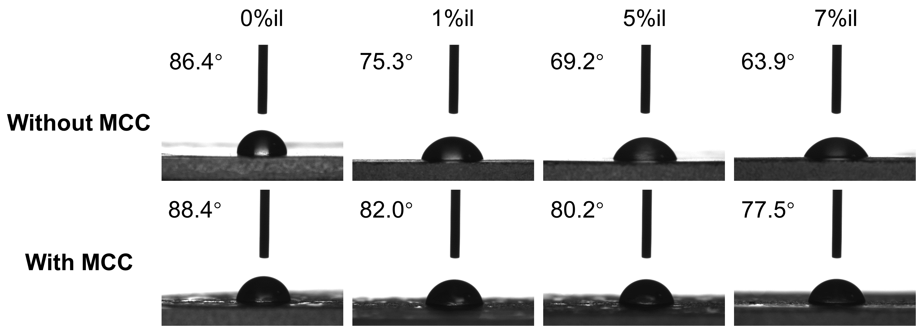
Figure S1. The images of water droplets' water contact angles on PVDF/[AMIM]Cl, PVDF/[AMIM]Cl/MCC samples.

