Supplementary information

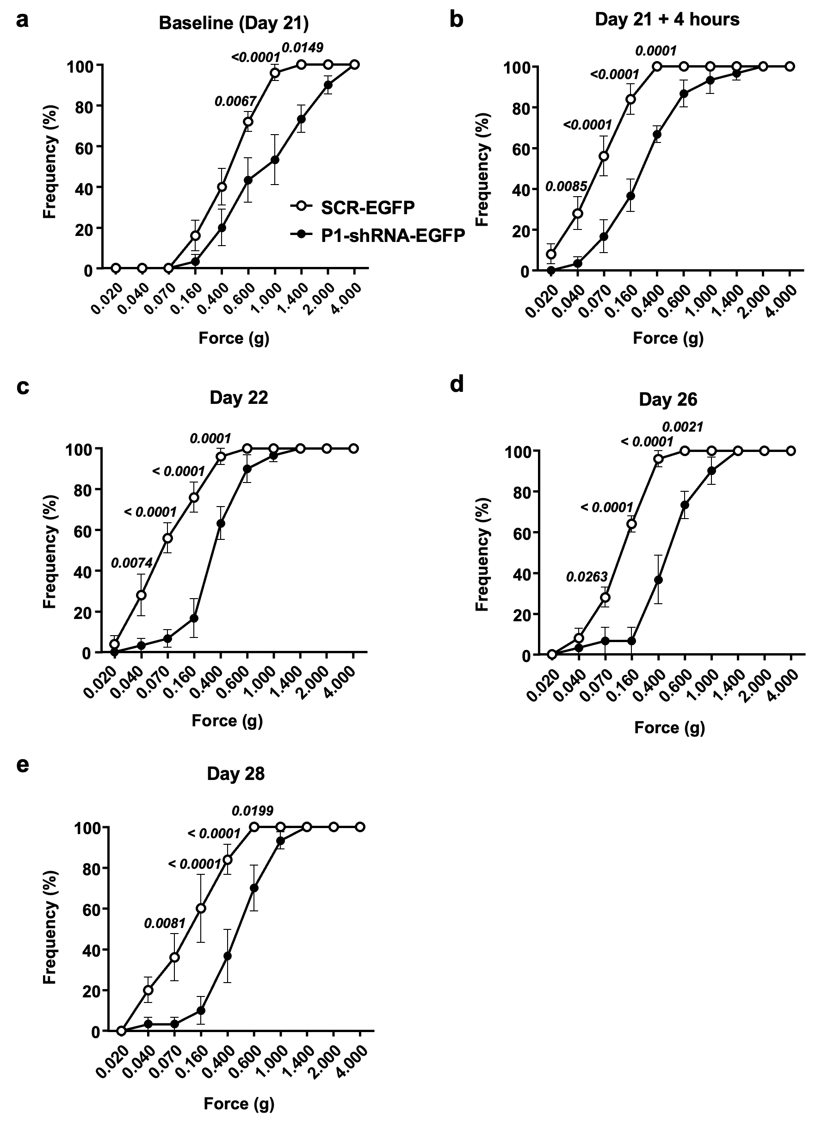
Supplementary Fig. 1

Supplementary Fig. 1 Paw withdrawal frequencies of carrageenan-injected mice before and after infection of SRC-EGFP or P1-shRNA-EGFP virus, related to Fig. 5b.
a Paw withdrawal frequency measured at the baseline (after DRG virus injection) (see also Fig. 5b, n = 5 for SCR-EGFP-injected mice; n = 6 for P1-shRNA-EGFP-injected mice). (Two-way ANOVA: P_{treatment} < 0.0185, F(1, 9) = 8.224); Bonferroni’s P_{adjusted}: P_{0.600g} = 0.0067, P_{0.600g} < 0.0001, P_{1.400g} = 0.0149). b–e Paw withdrawal frequency measured at 4 h (Two-way ANOVA: P_{treatment} = 0.0021, F(1, 9) = 18.14; Bonferroni’s P_{adjusted}: P_{0.040g} = 0.0085; P_{0.070g} < 0.0001; P_{0.160g} < 0.0001; P_{0.400g} = 0.0001, b), Day 22 (Two-way ANOVA: P_{treatment} = 0.0009, F(1, 9) = 23.22; Bonferroni’s P_{adjusted}: P_{0.40g} = 0.0074; P_{0.070g} < 0.0001; P_{0.160g} < 0.0001; P_{0.400g} = 0.0001, c), Day 26 (Two-way ANOVA: P_{treatment} = 0.0022, F(1, 9) = 18; Bonferroni’s P_{adjusted}: P_{0.070g} = 0.0263; P_{0.160g} < 0.0001; P_{0.400g} < 0.0001; P_{0.600g} = 0.0021, d), and Day 28 (Two-way ANOVA: P_{treatment} = 0.0082, F(1, 9) = 11.41; Bonferroni’s P_{adjusted}: P_{0.070g} = 0.0081; P_{0.160g} < 0.0001; P_{0.400g} < 0.0001; P_{0.600g} = 0.0199, e) after the injection of 2% carrageenan in mice (n = 5 for SCR-EGFP-injected mice; n = 6 for P1-shRNA-EGFP-injected mice).

