Household Air Pollution and Risk of Pulmonary Tuberculosis in HIV-Infected Adults
Authors and Affiliations:
Patrick D.M.C. Katoto, PhD^{1,2}, Dieudonné Bihehe, MD³, Amanda Brand, PhD⁴, Raymond Mushi, MD¹, Aline Kusinza, MD³, Brian W. Alwood, PhD⁵, Richard N. van Zyl-Smit, PhD⁶, Nadia A. Sam-Agudu, MD^{7,8}, Marcel Yotebieng, PhD⁹, John Metcalfe, MD¹⁰, Grant Theron, PhD¹¹, Krystal J. Godri Pollitt, PhD¹², Maia Lesosky, PhD¹³, Jeroen Vanoirbeek, PhD², Kevin Mortimer, PhD¹⁴, Tim Nawrot, PhD^{2,15}, Benoit Nemery, PhD*², Jean B. Nachega, PhD*^{9,16,17}

- Department of Internal Medicine, Division of Respiratory Medicine & Prof. Lurhuma Biomedical Research Laboratory, Mycobacterium Unit, Catholic University of Bukavu, Bukavu, DR Congo
- Centre for Environment and Health, Department of Public Health and Primary Care, KU Leuven, Leuven, Belgium
- Department of Internal Medicine, Université Evangélique en Afrique, Bukavu, DR Congo
- Centre for Evidence-Based Health Care, Division of Epidemiology and Biostatistics, Department of Global Health, Stellenbosch University, Cape Town, South Africa
- Department of Medicine, Division of Pulmonology, Faculty of Medicine and Health Sciences, Stellenbosch University, Cape Town, South Africa
- Division of Pulmonology & UCT Lung Institute, Department of Medicine, University of Cape Town, Cape Town, South Africa
- International Research Center of Excellence, Institute of Human Virology Nigeria, Abuja, Nigeria.
- Division of Epidemiology and Prevention, Institute of Human Virology, University of Maryland School of Medicine, Baltimore, MD, USA
- Department of Medicine, Albert Einstein College of Medicine, New York, NY, USA.
- Division of Pulmonary and Critical Care Medicine, Zuckerberg San Francisco General Hospital and Trauma Center, University of California, San Francisco, CA, USA
- NRF-DST Centre of Excellence for Biomedical Tuberculosis Research; South African Medical Research Council Centre for Tuberculosis Research; Division of Molecular Biology and Human Genetics, Faculty of Medicine and Health Sciences, Stellenbosch University, Cape Town, South Africa.
- Department of Environmental Health Sciences, School of Public Health, Yale University, New Haven, CT USA
- Division of epidemiology and Biostatistics, University of Cape Town, Rondebosch, Western Cape, South Africa
- Liverpool School of Tropical Medicine, Liverpool, L3 5QA, UK
- Centre of Environmental Health, University of Hasselt, Hasselt, Belgium
- Department of Medicine and Center for Infectious Diseases, Faculty of Medicine and Health Sciences, Stellenbosch University, Cape Town, South Africa
- Department of Epidemiology, Infectious Diseases and Microbiology, University of Pittsburgh Graduate School of Public Health, Pittsburgh, PA, USA

Supplementary Materials

- Full methods
- Background measurements of CO
- eTable 1: Time-weighted average concentrations of carbon monoxide
- eTable 2: Multivariable Analysis: Quintiles of time-weighted average and maximum 24h personal CO as predictors for tuberculosis among 255 HIV-infected adults.

eFigures, Legends

- eFigure 1: Twenty-four-hour time-weighted average (panel A) and maximum (panel B) personal CO concentrations among 96 cases (HIV+/TB+) and 159 controls (HIV+/TB-). Horizontal lines indicate medians and interquartile ranges.

- eFigure 2: Twenty-four-hour (h) time-weighted average (TWA) and maximum (Max) personal CO concentrations among 196 women and 58 men HIV-infected patient in South Kivu, DR Congo.

Full methods

Study Design, Population and Setting

We conducted a case-control study spanning with participants being recruited between March 2018 and February 2019 (Figure 1) from four major HIV treatment clinics in Bukavu, the capital city of South Kivu province, eastern DRC. We recruited patients attending four HIV treatment clinics (ART clinics) or organisations in Bukavu, the capital city (5-6 million inhabitants) of the South-Kivu province, in eastern DRC. These PLHIV came from both urban and rural areas to attend 1) the general hospital of reference of Panzi (Université Evangélique en Afrique); 2) the Provincial General Hospital of Bukavu (Université Catholique de Bukavu, UCB); 3) Pharmakina; or 4) the Bureau Diocésain des Oeuvres Médicales network of private clinics (Muhungu, Ciriri and Kadutu hospitals).

All male and female adult (≥18 years) inpatients or outpatients attending an ART clinic for a regular appointment or for complications were approached by the clinic nurse and then presented to a trained medical officer to be recruited into the study. HIV-positive (HIV+) patients, on ART (according to the DRC national treatment guidelines) or not, were eligible for inclusion as cases (HIV+/TB+) if they had confirmed active pulmonary TB or a recent (≤5 years) diagnosis of pulmonary TB disease. For each case, we enrolled two controls with HIV but without TB or a history of TB (HIV+/TB-) who lived in the same neighborhood (same street or village). Given that females in this setting are more likely to cook in most households and be exposed to HAP, we did not perform a matched sampling, to enable us to investigate the effect of gender on PTB risk in stratified analyses(20).

We initially expected to recruit 50 HIV+/TB+ cases per month. Since the number of HIV+/TB+ patients proved too low in some centres (Muhungu, Kadutu, and Pharmakina), we enriched the group by searching actively in laboratory and TB treatment registers. Ninety-eight eligible cases patients were then called via mobile phone to attend the clinic for inclusion in the study, after informed consent.

Variables, Instruments and Measurements

Independent or confounding variables:
Hospital-based study staff were not blinded to patient HIV/TB status, since they were responsible for verifying eligibility from patient records. However, field study staff who collected CO data were blinded to status for methodological reasons and to avoid stigmatization. To reduce the risk of misclassification and (non-differential) bias related to change in behavior, we used a generalized information script.
All questionnaires were administered face-to-face by trained interviewers. We used a short questionnaire to assess socio-demographic characteristics (age, sex, marital status, educational level, employment, and income), location of residence (urban vs rural area), lifestyle (alcohol drinking and active or passive tobacco smoking). History of ART (initiation date and type of ART) and CD4+ T lymphocytes count (n cells per cubic millimeter of blood) at HIV diagnosis (assessed as the first available CD4 count) were abstracted from clinical registries. Participants were asked about active or recent history of TB disease, which was verified through clinical registers. Other TB-relevant information such as Ziehl-Neelsen and/or Xpert MTB/RIF results and TB treatment outcomes, were extracted from medical records.

Household Air Pollution
Energy exposure questionnaire: We used a structured environmental exposure questionnaire, the International Multidisciplinary Programme to Address Lung Health and TB in Africa (IMPALA) questionnaire(21), to collect information on cooking (Figure 1), lighting, and heating (wood, charcoal, type of cooking stove, kerosene, or electricity), location of kitchen (indoor or outdoor), as well as type of house (e.g., with or without ventilation, separate kitchen and living room, type of roof). Of note, improved stoves named “Jiko” have been distributed in some households in South Kivu by NGOs during and after the civil conflict period in the region. Because more than 95% of households in the DRC utilize biomass fuel (BMF) for domestic energy, we anticipated that little or no differences in the prevalence of such exposure would be found between cases and controls. We defined – before conducting any statistical analyses – proxies of cumulative intensity of exposure based on time spent cooking daily and during adult life. Hence, a composite index of “high exposure” was given to participants who reported spending ≥3 hours in the kitchen daily AND cooking at least twice daily AND cooking five or more days a week. To estimate lifetime exposure to cooking, we asked at what age participants had prepared their first “ugali”, a common maize flour-based meal. Preparing ugali is traditionally seen as a sign of maturity and implies that one may take charge in the household’s kitchen. We considered actual age minus age at first ugali to reflect lifetime spent in the kitchen and dichotomized this variable into less or more than 25 years since first ugali. Time spent in the kitchen was then adjusted for age at first ugali and the type of primary fuel used to generate a proxy for cumulative HAP exposure. Of note, some men also worked as cooks for wealthier families.

Carbon monoxide (CO) monitoring: In a random subsample of participants, we measured personal CO exposure for 24 hours using 10 different portable CO data loggers with a USB interface (Lascar monitor, El-USB-CO®).
Computer-generated random numbers were used to select a sub-sample of 105 non-smoking cases; these cases and 165 of their corresponding non-smoking controls were invited for measurement of personal 24h CO exposure, using portable CO data loggers with a USB interface (Lascar monitor, El-USB-CO®). After explaining the purpose of measuring personal CO, a trained physician (PDMK) placed the monitor on participants’ clothing (Figure 2, panel C), at their home, between 6 and 8 AM, encouraged them to do their normal activities until next day, when the recording was ended and data were downloaded. Time-weighted average (TWA) and maximum/minimum CO concentrations were generated using manufacturer software. The personal CO results were later discussed with each participant, together with giving advice on ventilation, cooking habits, and the benefits of clean energy.

Participants were asked about adherence with the monitor. We also visually assessed the quality of the data collected. The measurement was discarded or repeated if the participant had not worn the monitor during a period of more than one hour (except when taking a bath or when sleeping during which he/she was asked to put the device where he placed his/her mobile phone). Two CO monitors were lost (one fell in water and one was destroyed while participant was climbing a tree). Some measurements were discarded: one patient travelled with the monitor for five days due to a family emergency; four patients ( one case and three controls) refused to wear the device (they suspected it was a camera); six patients showed a flat curve (the devices were removed and kept in a “safe place” while working in the kitchen); and two measurements were excluded (very high peaks) because the participants reported that they had been smoking. The CO data analysis finally included 255 participants.

Dependent variables
Tuberculosis: Participants were asked about active or recent history of TB disease and this was verified through clinical registry. Other information regarding history of TB, such as Ziehl-Neelson and/or gene-Xpert MTB RIF, Directly Observed Treatment (DOT), patient categories, hospitalization for TB, and clinical TB treatment outcome were extracted from medical records after the patient interview.

Data Management and Quality Checks

We checked questionnaires for errors and inconsistencies, used Excel and STATA V14 for data entry, cleaning and identifying outliers, and checked for consistency among variables by running frequencies and cross tabulations. We asked participants about adherence with the CO monitor and visually checked the 24h traces of CO concentrations, discarding the measurement (or repeating it) if the participant had not worn the monitor for more than one hour (except when taking a bath or when sleeping, during which they were instructed to place it beside his/her mobile phone).

Data Analysis

Categorical data are reported as proportions, and continuous data as mean (± standard deviation, SD) or median (interquartile range, IQR). To check for normality, we used visual inspection of boxplots and the D’Agostino-Pearson omnibus normality test. CO levels were log-transformed. Chi square tests (for categorical variables) and unpaired t-tests or Mann-Whitney U tests (for continuous variables) tested differences between cases and controls. We used multivariable logistic regression analyses to assess associations between socio-demographic, clinical, and domestic energy-related predictors and CO levels (continuous and by quintiles) and risk of having PTB. We estimated adjusted associations by including all baseline covariates (including CD4+ T-cell count and ART duration) a priori in a multivariable model (Of note, we did not include the variable time spent with electricity in the model as many reported having electricity only late in the night du to regular load shading in South Kivu). Starting with a full model, we then used a backward elimination procedure, excluding predictor variables with a p-value >0·1, and compared the estimated reduced model adjusted odds ratios (aOR) and associated 95% confidence intervals (CIs), with the full multivariable model estimates. The final model was based on variables with statistical significance in both the full and reduced models, plus variables known to have possible clinical significance. Since women (and children) are more likely to be exposed to HAP than men(15, 25), we conducted a stratified analysis by gender to remove gender-related confounding. All p values were two-sided, and p<0·05 was considered statistically significant. Analyses were performed using Stata/SE 14 (Stata Corp, College Station, TX, USA) and GraphPad Prism 8.1.1 (GraphPad Software Inc., San Diego, CA, USA).

Sample Size and Power

A study in Benin demonstrated a significant association between HAP and PTB with an estimated odds ratio of 1.7(23). We, therefore, estimated the number of cases and controls needed to detect a similar effect. Assuming 80% of controls were exposed to HAP, we needed 414 cases and 828 controls (2:1 controls-cases ratio) to demonstrate a significant odds ratio of at least 1.7 with 80% power at 5% significance level. Ultimately, a total sample size of 1,277 participants (435 cases and 842 controls) were recruited. Having two controls to one case increases power over 1:1 controls-cases ratio(24).

Background measurements of CO
In addition to cases and controls, we also invited a resident of another home in the same neighbourhoods to make both personal and static area CO measurements in the kitchen area (monitor placed 1-2 m away from the kitchen’s fire source). This was done, in part, to avoid stigmatization of the cases and controls (HIV+) by their neighbours, but these added homes also constitute appropriate background controls (assumed without HIV and TB). The maximum and TWA values of 24h personal CO average concentrations (median [IQR] ppm) obtained in these 97 controls from the same areas (89 [45-131] and 4 [2-7], respectively) tended to be somewhat lower than those of cases, and, as expected, the CO values obtained by static sampling in kitchen areas were higher (245 [143-349] and 6 [9-23] respectively).

eTable 1: Time-weighted average concentrations (ppm) of carbon monoxide among 255 HIV-infected outpatients attending ART-clinics and among their neighbours (n=97) in South Kivu, DRC

 | HIV+/TB+ | HIV+/TB- | other controls
 | Personal  (N=96) | Personal  (N=159) | Personal  (N=97) | Kitchen area  (N=84)
Minimum | 0·1 | 0·1 | 0·1 | 0·2
25th Percentile | 2·4 | 2·2 | 1·9 | 9·0
Median | 5·6 | 5·0 | 4·3 | 16·4
75th Percentile | 11·8 | 9·1 | 7·4 | 22·8
Maximum | 76·2 | 31·2 | 27·0 | 174·9
Mean | 9·4 | 6·5 | 5·2 | 22·3
Standard· Deviation | 11·2 | 5·9 | 4·4 | 27·2
TB: tuberculosis

eTable 2: Multivariable Analysis: Quintiles of 24h Personal CO as Predictors for Tuberculosis Among 255 HIV-Infected Outpatients Attending ART-Clinics in South Kivu, DRC
Quintiles | Tuberculosis
Quintiles | aOR | 95%CI | p-Value
TWA Personal CO (ppm)
Q1 (0·1-1·9) | Ref
Q2 (2-4·2) | 0·39 | 0·08-1·86 | 0·24
Q3 (4·3-6·6) | 1·09 | 0·27-4·44 | 0·89
Q4 (6·7-12) | 2·99 | 0·65-13·6 | 0·15
Q5 (12·3-76·2) | 4·64 | 1·04-20·7 | 0·04
Max Personal CO (ppm)
Q1 (1-43) | Ref
Q2 (44-89) | 0·7 | 0·23-2·38 | 0·61
Q3 (90-131) | 0·7 | 0·22-2·34 | 0·58
Q4 (132-169) | 1·2 | 0·36-3·99 | 0·76
Q5 (170-211) | 0·8 | 0·24-2·76 | 0·74

Q: quintile; TWA: time-weighted average; Max: maximum; CO: carbon monoxide; aOR: adjusted odds ratio; ART: antiretroviral therapy; Variables adjusted for in the model include gender, age at first ugali (continuous), case contact, reported second hand smoke, type of fuel used, time spent in kitchen, ventilation system, patient on ART, duration on ART, and CD4+ T cell count at diagnosis.

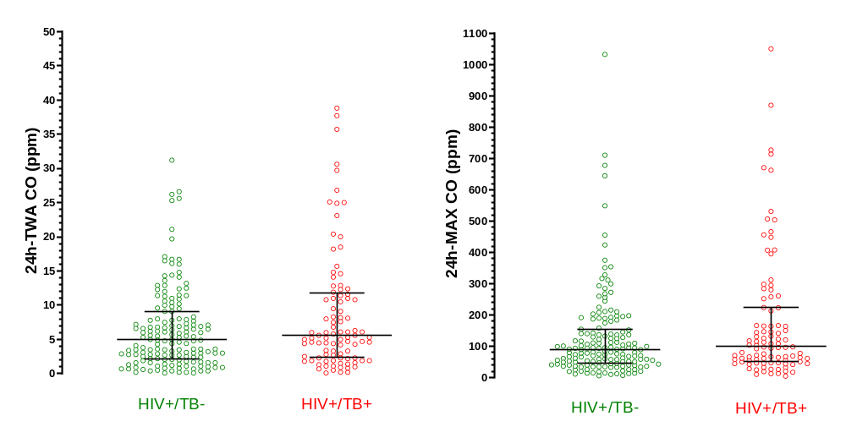
eFigure 1: Twenty-four-hour (h) time-weighted average (TWA) and maximum (MAX) personal CO concentrations among 96 cases (HIV+/TB+) and 159 controls (HIV+/TB-). Horizontal lines indicate medians and interquartile ranges.

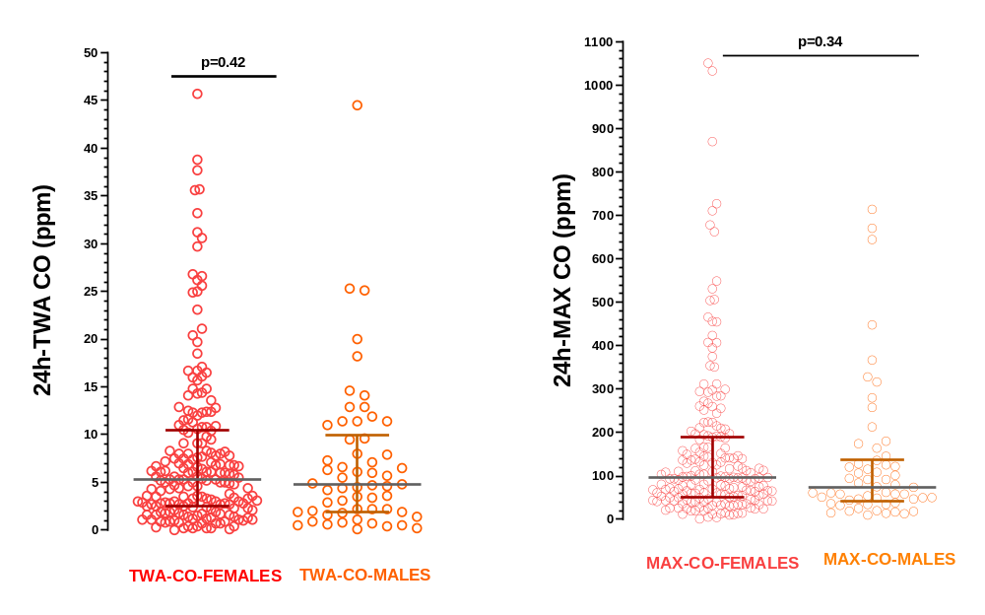
eFigure 2: Twenty-four-hour (h)-weighted average (TWA) and maximum (MAX) personal CO concentration among 196 women and 58 men HIV-infected patients in South-Kivu, DR Congo. Horizontal lines indicate medians and interquartile ranges.

