Cytotoxicity and Toxicoproteomic Analysis of Pioglitazone Exposure in Human-derived Cardiomyocytes
Abdullah Al Sultan^{1,2}, Zahra Rattray & Nicholas J. W. Rattray^{1,}*
¹Strathclyde Institute of Pharmacy and Biomedical Sciences, University of Strathclyde, 161 Cathedral Street, Glasgow, UK, G4 0RE
²Faculty of Pharmacy, Kuwait University, Safat, 13110, Kuwait
*nicholas.rattray@strath.ac.uk

Supplementary File
This file is divided into three sections: supplementary data, supplementary figures, and supplementary tables.

Supplementary Data

In Vitro Cytotoxicity Measurements
The cytotoxicity of PGZ on AC16 cells was investigated using three mitochondrial assays, each of which carries a different endpoint (MTT assay (Cat. No. V13154; Thermo Fisher): implication of mitochondrial dehydrogenases; adenosine triphosphate (ATP) assay (Part No. G7570; Promega): measurement of oxidative phosphorylation; and caspase 3/7 assay (Part No. G8090; Promega): activity of caspase 3/7 in cellular apoptosis).

Cell Viability Assay
The effect of PGZ on cardiomyocyte proliferation was measured using an MTT (3-(4,5-dimethylthiazol-2-yl)-2,5-diphenyltetrazolium bromide) Assay Kit (Cat. No. V13154; Thermo Fisher, Eugene, Oregon, USA). AC16 cells were seeded in 96-well microplates (Cat. No. 655180; Greiner Bio-One, Gillingham, Dorset, UK) (1 × 10⁴ cells/well) and exposed to increasing concentrations of PGZ (0.01, 0.1, 1, 5, 10, 20 and 50 μM) for 24 h. Following the incubation period, the MTT solution (5 mg/mL) was added to each well, the supernatants were removed and 50 μL of DMSO was used to dissolve the yielded formazan precipitate. A plate reader (GloMax Explorer Multimode Microplate Reader; Promega, Madison, WI, USA) was used to measure formazan absorbance at 560 nm.
Cell viability was expressed as a percentage and calculated as follows: (A-treatment – A-blank)/(A-control – A-blank) × 100%, where A = absorbance. The half maximal inhibitory concentration (IC₅₀) value was determined from a three-parameter nonlinear regression curve fitted to PGZ concentration and the obtained absorbance values using GraphPad Prism 9 software (San Diego, CA, USA).

Luminescence Assay Used to Detect Caspase Activity

The activity of caspase 3 and caspase 7 was assessed using the Caspase-Glo 3/7 assay kit (Part No. G8090; Promega, Madison, WI, USA) according to the manufacturer’s protocol. AC16 cells were seeded in white-walled 96-well plates at a density of 1 × 10⁵ cells/well and incubated overnight. Following exposure to various concentrations of PGZ (0.01, 0.1, 1, 5, 10 and 20 µM) for 24 h, the cells were lysed by adding 100 µL of the Caspase-Glo 3/7 reagent to each well. Subsequently, equal volumes of the samples and reagent were mixed and incubated for 1 h at room temperature. Luminescence was measured using a plate reader (GloMax Explorer Multimode Microplate Reader). The activity was expressed as relative luminescence units (RLU) and calculated using the following formula: RLU = luminescence (sample) - luminescence (blank).

Measurement of Adenosine Triphosphate Production

The CellTiter-Glo Luminescent Assay (Part No. G7570; Promega, Madison, WI, USA) was used to determine the level of cellular metabolism by measuring adenosine triphosphate (ATP) levels. AC16 cells were seeded in white 96-well microplates at a density of 1 × 10⁴ cells/well and incubated for 24 h. The cells were then exposed to increasing concentrations of PGZ (1, 5, 10, 50 and 100 μM) in the presence or absence of GW9662 (5 μM) and incubated for a further 24 h. Subsequently, 100 μL of the CellTiter-Glo reagent was added to each well, and the plates were agitated for 1 min in a shaking incubator. A luminometer (GloMax Explorer Multimode Microplate Reader) was then used to measure the luminescence.

Toxicoproteomics Pipeline Methodology

Sample Preparation: Protein Extraction, Trypsin Digestion and Peptide Clean-up
For the protein identification and proteomic profiling steps, the cell pellets were lysed with 100 μL lysis buffer and resuspended thoroughly in 1 μL of universal nuclease for 10–15 cycles until the sample viscosity was reduced. The lysates were collected, and the supernatant protein concentration was determined using the Pierce BCA Protein Assay Kit (Product. No. 10495315; Thermo Fisher, Rockford, IL, USA). For the protein digestion step, an aliquot containing 100 μg of protein was taken from each sample and transferred into a new 1.5 mL Eppendorf microtube, and the final volume was adjusted to 100 μL with the lysis solution. The samples were then reduced by the addition of 50 μL of reduction solution and alkylated by the addition of 50 μL of alkylation solution. The alkylated protein samples were then incubated at 95 °C for 10 min using a heat block. The samples were then left to cool to room temperature. Subsequently, 50 μL of the reconstituted enzyme solution (Trypsin/Lys-C Protease Mix) was added to each sample, and the sample tubes were incubated for 2 h at 37 °C in an Eppendorf ThermoMixer C (Thermo Fisher, San Jose, CA, USA) with agitation (600 rpm). Following the incubation period, 50 μL of digestion stop solution was added to each sample to terminate trypsin digestion.
Following the instructions supplied with the EasyPep Mini MS Sample Prep Kit, peptide clean-up was performed after the enzymatic sample processing. The peptide clean-up columns provided with the kit were first placed in 2 mL microcentrifuge tubes and centrifuged at 3,000 g for 2 min until dry. The protein samples were then transferred into the dry peptide clean-up columns and centrifuged at 1,500 g for 2 min. The flowthrough was discarded from each column. Subsequently, 300 μL of wash solution A was added to each column, the tubes were centrifuged at 1,500 g for 2 min, and the flowthrough was discarded. The same step was repeated with 300 μL of wash solution B. For the elution step, the peptide columns were transferred into new 2 mL microcentrifuge tubes. The elution solution (300 μL) was added to each column, and the sample tubes were centrifuged at 1,500 g for 2 min. The eluted peptides were then collected and evaporated to dryness using a Thermo Scientific Savant SpeedVac (Thermo Fisher, San Jose, CA, USA). The dried samples were reconstituted in 100 μL of 0.1% formic acid in water and eventually transferred to 1.5 mL LC–MS glass vials (Cat. No. 6PSV9-03FIVAPT; Thermo Fisher, Langerwehe, Düren, Germany) for LC–MS analysis. In addition to the experimental samples, quality control (QC) and blank samples were prepared. The QC sample was prepared by pooling equal volumes of all the experimental samples, while the blank sample consisted of 50 μL of acetonitrile: water (50:50).

Micro-flow LC–MS-based Proteomic Data Acquisition
Peptide separation was performed on a binary Thermo Vanquish ultra-high-performance liquid chromatography system where 20 μL of the reconstituted peptide mixture extract was injected onto a Thermo Acclaim C₁₈ PepMap 100 column (150mm x 1mm, particle size 3µm) and separated over a 100min method. The temperature of the column oven was maintained at 40°C while the autosampler temperature was set at 5°C. For chromatographic separation, a consistent flow rate of 50 µl/min was used where the mobile phase in positive and negative heated electrospray ionisation mode (HESI+/-) was composed of Solvent A (99.9% water with 0.1% formic acid) and solvent B (99.9% acetonitrile with 0.1% formic acid). All post columns viper fittings had a 75 μm internal diameter (black colour code).
A high-resolution Exploris 240-Orbitrap mass spectrometer (Thermo Fisher Scientific) was used to perform bottom up proteomics analysis. Operating parameters were set as follows: spray voltages of 3400V in HESI +ve mode. The temperature of the ion transfer tube was set at 320°C with a vaporiser temperature of 75°C. Sheath, aux gas and sheath gas flow rates were set at 25, 5 and 0 Arb, respectively. A Top-20 Data-Dependent Acquisition (DDA) was performed using the following parameter: survey scan range was 275-1500 m/z with MS1 resolution of 120,000, RF Lens of 70% and an intensity threshold of 1.0e⁴. Subsequent MS/MS scans were collected with a resolution of 15,000, isolation window of 1.2 m/z, and with a normalised HCD Collision Energy of 30%. A data dependent cycle time of 3 seconds between master scans was also employed. High-purity nitrogen was used as nebulising and as the collision gas for higher energy collisional dissociation.

LC–MS Data Processing Using Proteome Discoverer 3.0
Using Proteome Discoverer (PD) v3.0 software (Thermo Fisher, San Jose, CA, USA), the MS raw data were used to search the UniProtKB Human Reference Proteome database (v22.07.13; 79,740 entries), including common contaminants (247 entries), using the SEQUEST and Percolator algorithms involved in modified label-free quantification (LFQ) standard processing and consensus workflows. The precursor mass tolerance was set to 10 ppm and 0.02 Da for fragment mass tolerance. Full tryptic digestion was selected, with up to two missed cleavages allowed. The minimum and maximum peptide lengths were set at 6 and 144 amino acids, respectively. Cysteine carbamidomethylation was set as a static modification, and oxidation of methionine (Met), Met loss and N-terminal acetylation were set as dynamic modifications. A maximum of three modifications were allowed per peptide. A concentrated target–decoy approach was applied for the false discovery rate (FDR) calculation, which was set to 1% for highly confident peptide hits.
For protein abundance, the Feature Mapper node was enabled. The raw files were chromatographically aligned with a 10-min retention time shift. The minimum signal-to-noise threshold for feature linking and mapping was set at a value of 5. For precursor peptide abundance, precursor chromatographic intensities were used for precursor quantification results, and the total peptide amount was the selected normalisation mode to correct for experimental bias. Unique and razor peptides were used to quantify the identified proteins.

Supplementary Figures

Weighted Correlation Network Analysis (WGCNA) Construction and Module Identification
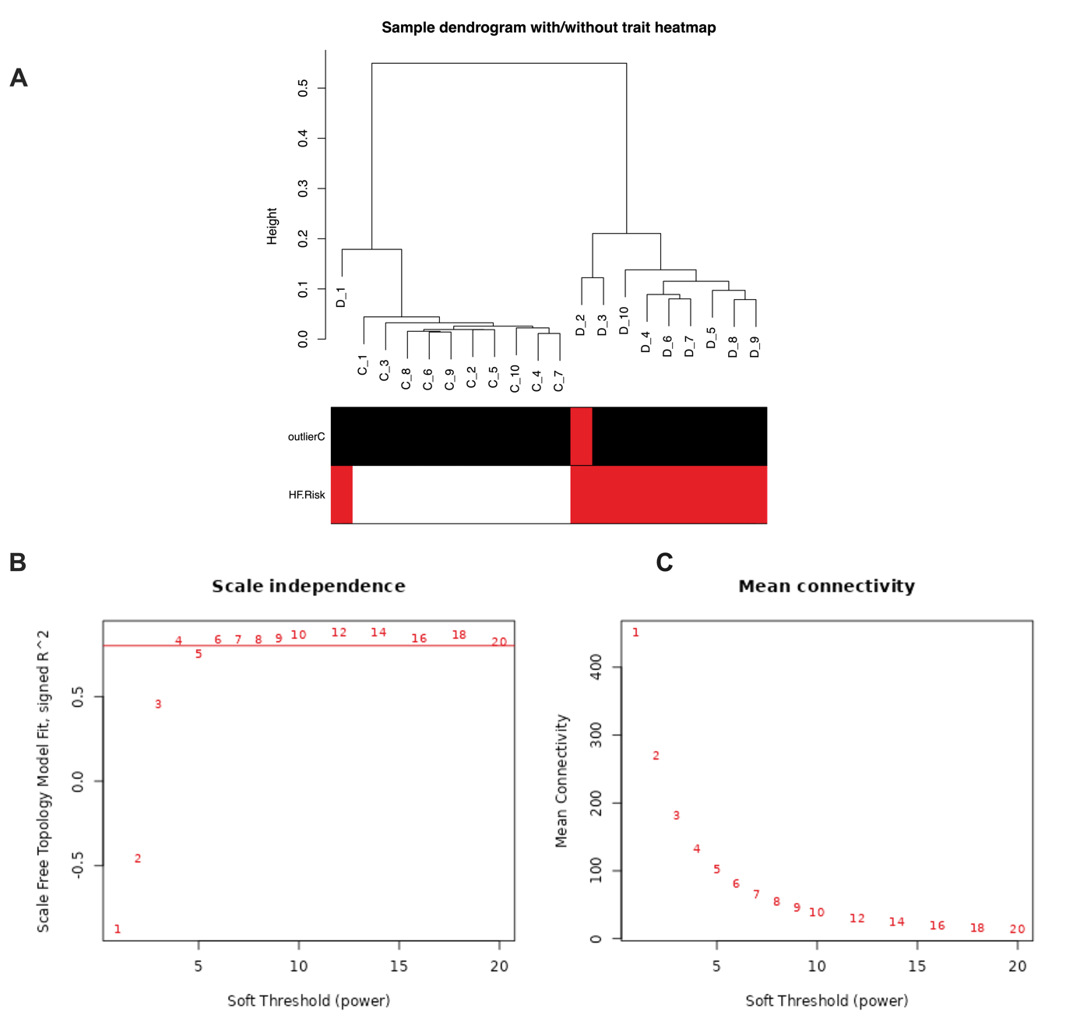
Figure S1. WGCNA network construction. (A) Clustering dendrogram of 20 samples for detection of outliers. (B, C) Determination of optimal soft threshold power for scale-free topology. (B) and (C) show the scale-free topology index and the mean connectivity for each power value between 1 and 20, respectively. WGCNA: weighted correlation network analysis.

Quantitative Profiling of AC16 Cells with and without Pioglitazone (PGZ) Treatment
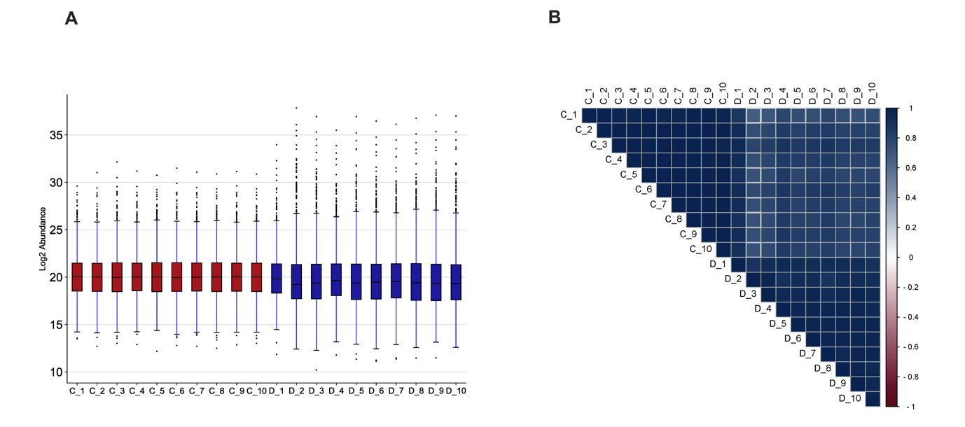
Figure S2. Quantitative profiling of AC16 cells with and without PGZ treatment. (A) Box plot of the log₂ LFQ intensity for each tested sample. (B) Pearson correlation matrix. The upper triangular plot represents the Pearson correlation coefficient of the log₂ LFQ intensities between each two samples. Positive and negative correlations are displayed in graded blue and red, respectively. The colour intensity and the size of the square are proportional to the correlation coefficients. PGZ: pioglitazone; LFQ: label-free quantification.

Functional, Disease and Pathway Analyses of the Blue Module
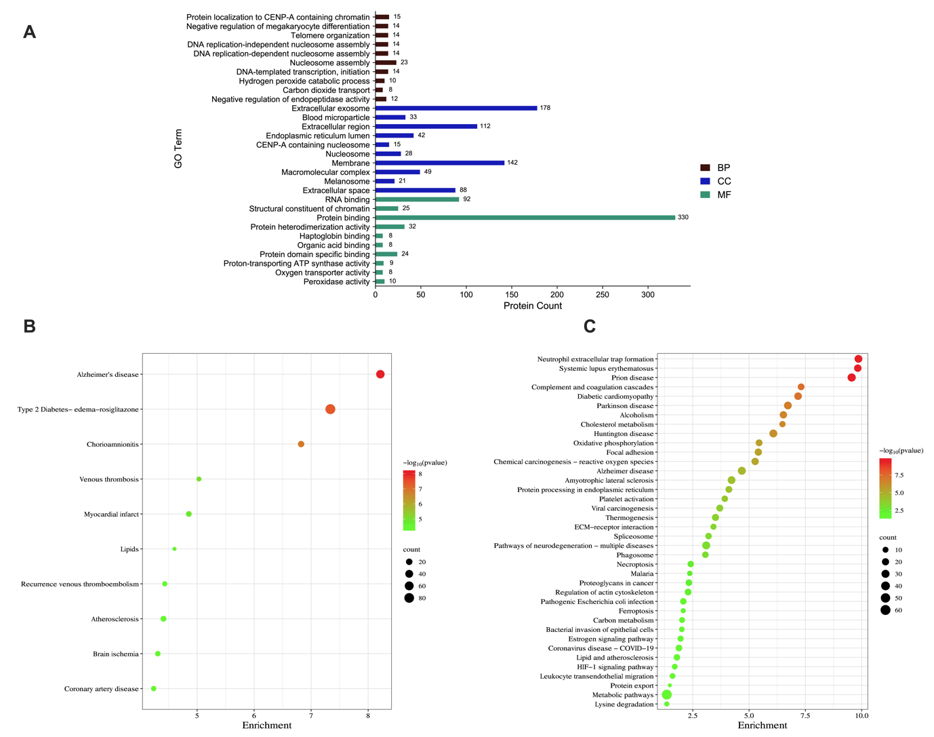

Figure S3. Functional, disease and pathway analyses of the blue module. (A) The top 10 enriched GO terms for the BP, CC and MF categories. (B) DO enrichment analysis results for the blue module. (C) KEGG enrichment analysis results for the blue module. In (B) and (C), the bubble size and colour represent the number of blue MMs enriched in the pathway and the enrichment significance, respectively. GO: Gene Ontology; BP: biological process; CC: cellular component; MF: molecular function; DO: Disease Ontology; KEGG: Kyoto Encyclopedia of Genes and Genomes; MMs: module members.

WGCNA and Identification of the Hub Proteins
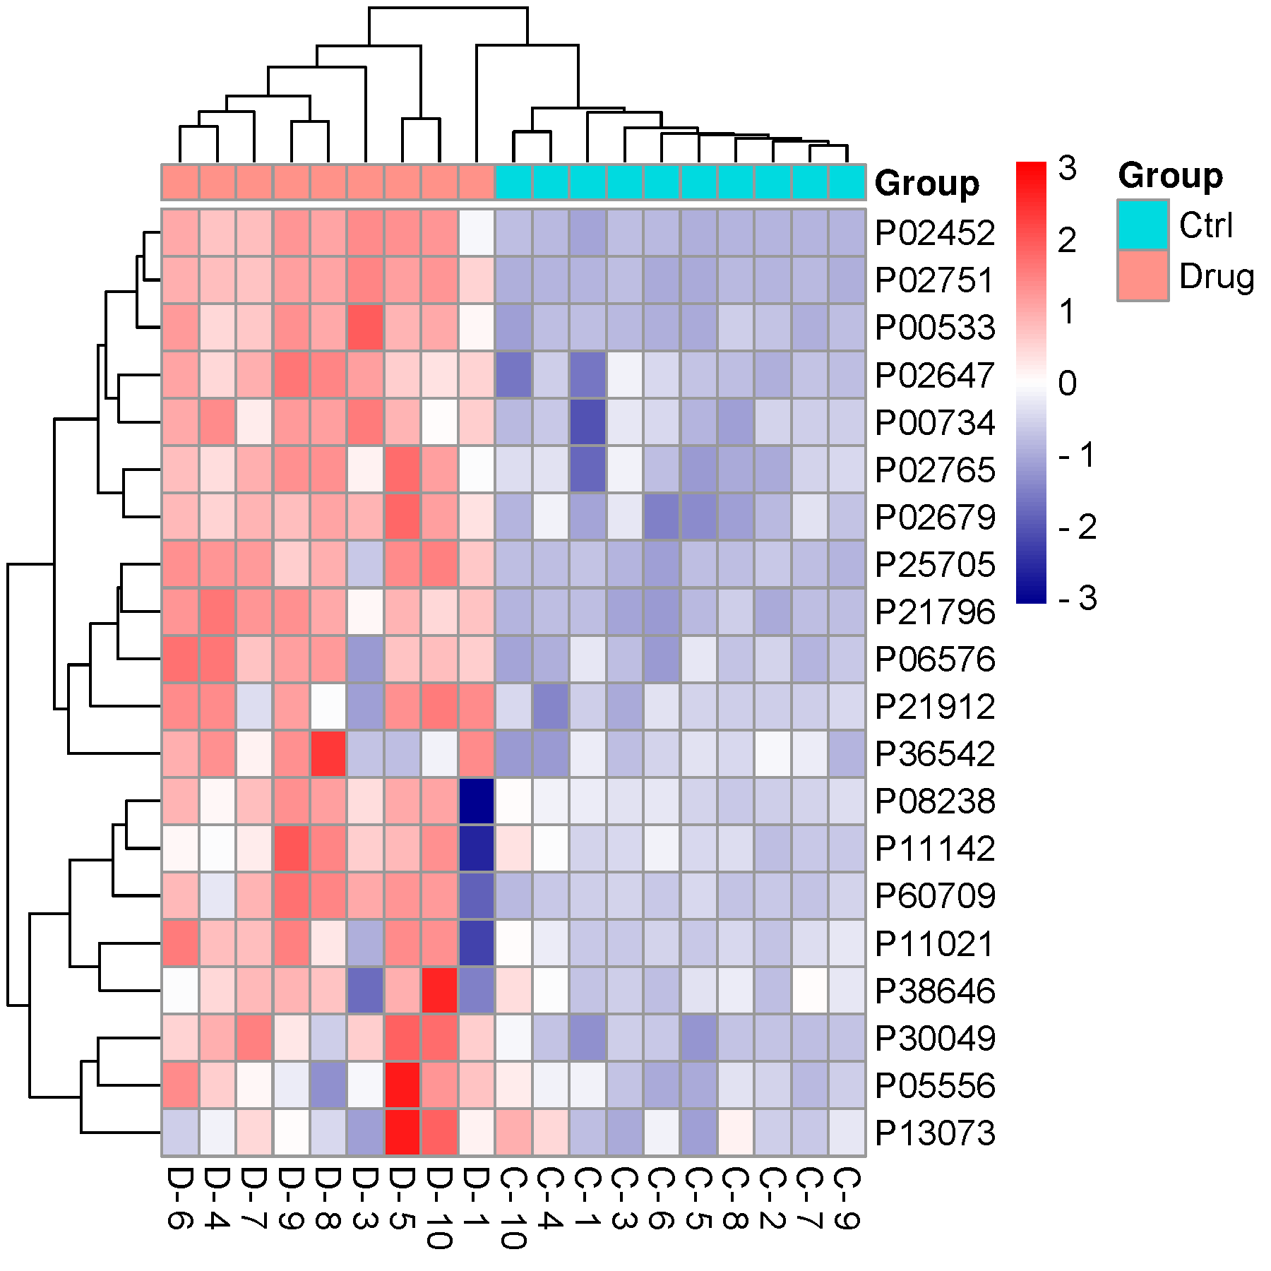
Figure S4. Heatmap of the top 20 hub proteins in the blue module identified using Cytoscape’s cytoHubba plugin. Red and blue blocks, respectively, represent high and low expression of proteins, whereas white blocks indicate no difference in expression.

Identification of the Feature Proteins
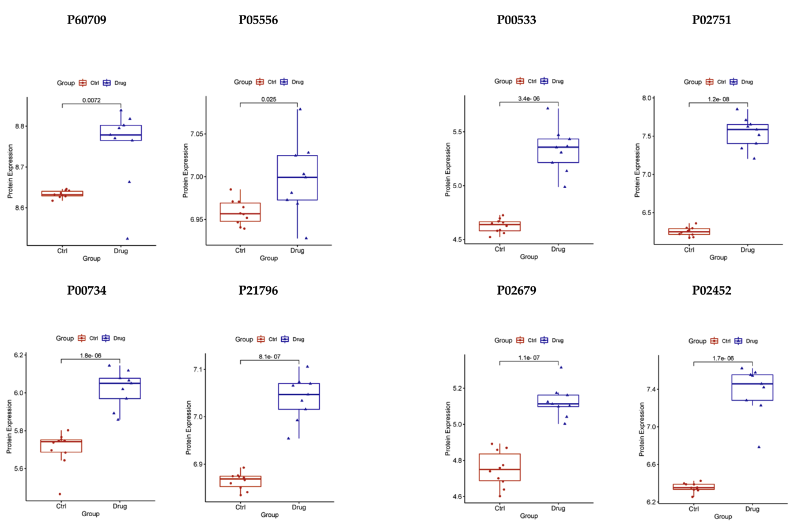
Figure S5. The protein expression levels of the feature proteins in the control and treated groups.

Supplementary Tables

Tables from S1-11 are provided as an Excel sheet.

Table S12
Table S12. The top 20 hub proteins in the blue module identified using Cytoscape’s cytoHubba plugin.

Rank | Protein ID | Score | Protein Description | Gene Name | FC | p-value
1 | P60709 | 32 | Actin, cytoplasmic 1 | ACTB | 0.45 | 1.80E-03
2 | P25705 | 30 | ATP synthase subunit-α, mitochondrial | ATP5A1 | 0.37 | 4.05E-04
3 | P06576 | 28 | ATP synthase subunit-β, mitochondrial | ATP5B | 0.24 | 9.71E-03
3 | P05556 | 28 | Integrin β-1 | ITGB1 | 0.14 | 1.04E-02
5 | P00533 | 27 | Epidermal growth factor receptor | EGFR | 2.54 | 3.95E-06
6 | P02751 | 25 | Fibronectin | FN1 | 4.48 | 2.35E-08
7 | P00734 | 23 | Prothrombin | F2 | 1.08 | 2.89E-06
7 | P30049 | 23 | ATP synthase subunit-δ, mitochondrial | ATP5D | 0.40 | 3.22E-03
7 | P11142 | 23 | Heat shock cognate 71 kDa protein | HSPA8 | 0.09 | 2.96E-02
7 | P21796 | 23 | Voltage-dependent anion-selective channel protein 1 | VDAC1 | 0.52 | 2.80E-05
7 | P38646 | 23 | Stress-70 protein, mitochondrial | HSPA9 | 0.07 | 1.47E-01
7 | P36542 | 23 | ATP synthase subunit-γ, mitochondrial | ATP5C1 | 0.12 | 2.39E-01
13 | P08238 | 22 | Heat shock protein HSP 90-β | HSP90AB1 | 0.10 | 5.19E-02
13 | P02679 | 22 | Fibrinogen-γ chain | FGG | 1.25 | 1.31E-05
15 | P21912 | 21 | Succinate dehydrogenase [ubiquinone] iron-sulphur subunit, mitochondrial | SDHB | 0.69 | 8.11E-04
15 | P02647 | 21 | Apolipoprotein A-I | APOA1 | 1.44 | 3.10E-07
15 | P11021 | 21 | Endoplasmic reticulum chaperone BiP | HSPA5 | 0.12 | 4.42E-02
18 | P02765 | 20 | α-2-HS-glycoprotein | AHSG | 0.95 | 6.44E-05
18 | P02452 | 20 | Collagen α-1(I) chain | COL1A1 | 3.61 | 3.71E-07
18 | P13073 | 20 | Cytochrome c oxidase subunit 4 isoform 1, mitochondrial | COX4I1 | -0.08 | 3.29E-01

