Table 1. Structures and bioactivities of the training and test sets of molecule.
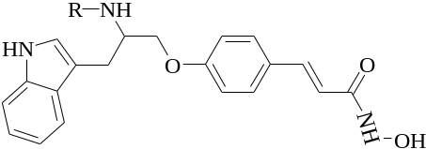

Compound | R | IC₅₀ (nM) | pIC₅₀
10a | 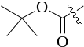 | 530.0 | 6.28
11a | 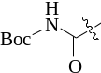 | 96.6 | 7.02
11b | 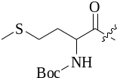 | 255.1 | 6.59
11c | 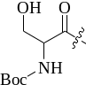 | 97.6 | 7.01
11d | 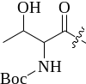 | 84.3 | 7.07
*11e | 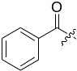 | 10.5 | 7.98
11f | 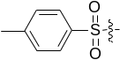 | 636.9 | 6.20
*11g | 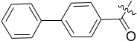 | 1703.4 | 5.77
*11i | 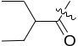 | 130.3 | 6.89
11j | 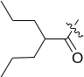 | 977.8 | 6.01
11k | 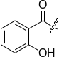 | 20.8 | 7.68
*11l | 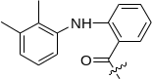 | 673.7 | 6.17
11m | 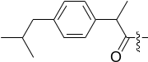 | 1043.1 | 5.98
*11p | 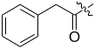 | 23.2 | 7.63
11q | 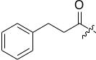 | 52.3 | 7.28
11r | 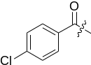 | 5.6 | 8.25
11s | 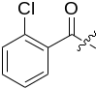 | 50.4 | 7.30
11t | 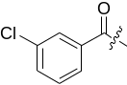 | 147.9 | 6.83
*11u | 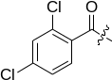 | 186.5 | 6.73
11v | 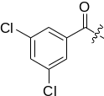 | 209.8 | 6.68
11w | 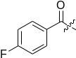 | 6.7 | 8.17
11x | 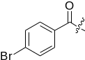 | 20.4 | 7.69
*11y | 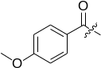 | 4.8 | 8.32
*24a | 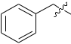 | 198.5 | 6.70
24b | 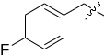 | 148.0 | 6.83
*24c | 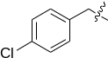 | 157.8 | 6.80
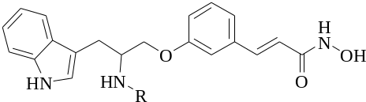

29a |  | 917.4 | 6.04
29b | 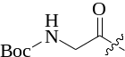 | 886.4 | 6.05
29c | 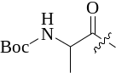 | 861.5 | 6.06
29d |  | 421.4 | 6.38
29e |  | 447.7 | 6.35
29f |  | 464.5 | 6.33
29g | 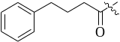 | 498.6 | 6.30
29h |  | 447.6 | 6.35
29i |  | 369.8 | 6.43
29j |  | 692.4 | 6.16
29k |  | 191.2 | 6.72
29l | 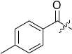 | 218.7 | 6.66
29m |  | 81.9 | 7.09
29n |  | 357.9 | 6.45
29o |  | 258.9 | 6.59
29p |  | 779.0 | 6.11
*29q | 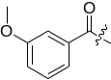 | 67.4 | 7.17
*29r | 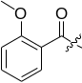 | 38.5 | 7.41
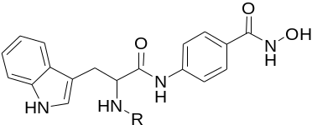

36a |  | 280.4 | 6.55
*36b | 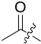 | 425.0 | 6.37
*36c | 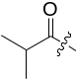 | 526.4 | 6.28
*36d |  | 332.8 | 6.48
36e |  | 211.5 | 6.67
36f | 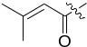 | 138.8 | 6.86
36g |  | 23.8 | 7.62
36h |  | 47.5 | 7.32
36i |  | 59.7 | 7.22
36j |  | 98.7 | 7.01
36k | 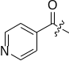 | 100.1 | 7.00
36l | 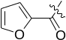 | 31.0 | 7.51
*36m | 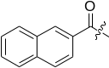 | 27.0 | 7.57
36n | 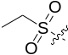 | 1085.8 | 5.96
36o | 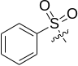 | 177.8 | 6.75
36p |  | 195.7 | 6.71
*36q |  | 2.4 | 8.62
36r |  | 1.5 | 8.82
36s |  | 3.7 | 8.43
36t |  | 8.6 | 8.07
36u |  | 13.0 | 7.89
36v | 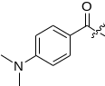 | 4.7 | 8.33
36w | 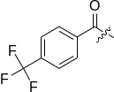 | 30.0 | 7.52
36x |  | 156.8 | 6.80
36y |  | 43.1 | 7.37
36z |  | 41.2 | 7.39
37a |  | 23.3 | 7.63
* Test sets

