The following document serves as supplementary material for the manuscript entitled "Higher crop diversity in less diverse landscapes” submitted to the special issue, Improving landscape sustainability across urban and rural regions in a changing world, in Landscape Ecology.

Manuscript Title:
Higher crop diversity in less diverse landscapes

Authors:
Josepha Schiller^{1,2}, Clemens Jänicke^{3,4,5}, Moritz Reckling^{1,6}, Masahiro Ryo^{1,2,*}

Affiliations:
¹Leibniz Centre for Agricultural Landscape Research (ZALF), Eberswalder Str. 84, 15374 Müncheberg, Germany
²Brandenburg University of Technology Cottbus–Senftenberg, Platz der Deutschen Einheit 1, 03046 Cottbus, Germany
³Leibniz Institute of Agricultural Development in Transitions Economies (IAMO), 06120 Halle (Saale), Germany
⁴Humboldt-Universität zu Berlin, Unter den Linden 6, 10099 Berlin, Germany
⁵Integrative Research Institute on Transformations of Human-Environment Systems (IRI THESys), Humboldt Universität zu Berlin, Unter den Linden 6, 10099 Berlin, Germany
⁶Department of Crop Production Ecology, Swedish University of Agricultural Sciences (SLU), Uppsala, Sweden
* Corresponding author: email: Masahiro.Ryo@zalf.de ; telephone: +49 (0)33432 82-206

Acknowledgements:
The authors thank the ZALF IPP “CrossDiv” team, Claas Nendel and Diana-Maria Seserman, the ZALF data research management group, and Konlavach Mengsuwan for support and advice in carrying out the study.

Supplementary Material:
Table S1. Overview of landscape diversity indicators and their classification scheme.
Diversity Indicator | Classification Scheme
Habitat classes | Running waters
Habitat classes | Standing waters
Habitat classes | Anthropogenic bare soil sites and ruderal areas
Habitat classes | Moors and swamps
Habitat classes | Grass and herbaceous vegetation
Habitat classes | Heath and coniferous shrubs
Habitat classes | Deciduous shrubs, field woodlands, avenues, rows of trees
Habitat classes | Forests
Habitat classes | Arable land
Habitat classes | Green and open spaces
Habitat classes | Special habitats
Habitat classes | Built-up areas, transport infrastructure and special areas
Land use land cover types | Continuous urban fabric
Land use land cover types | Discontinuous urban fabric
Land use land cover types | Industrial or commercial units
Land use land cover types | Road and rail networks and associated land
Land use land cover types | Port areas
Land use land cover types | Airports
Land use land cover types | Mineral extraction sites
Land use land cover types | Dump sites
Land use land cover types | Construction sites
Land use land cover types | Green urban areas
Land use land cover types | Sport and leisure facilities
Land use land cover types | Non-irrigated arable land
Land use land cover types | Fruit trees and berry plantations
Land use land cover types | Pastures
Land use land cover types | Complex cultivation patterns
Land use land cover types | Land principally occupied by agriculture, with significant areas of natural vegetation
Land use land cover types | Broad-leaved forest
Land use land cover types | Coniferous forest
Land use land cover types | Mixed forest
Land use land cover types | Natural grasslands
Land use land cover types | Moors and heathland
Land use land cover types | Transitional woodland-shrub
Land use land cover types | Beaches, dunes, sands
Land use land cover types | Sparsely vegetated areas
Land use land cover types | Inland marshes
Land use land cover types | Peat bogs
Land use land cover types | Water courses
Land use land cover types | Water bodies

Table S2. Summary statistics of the variables used to analyze the federal state of Brandenburg, Germany, per 10x10 km sampling sites; number_types = number of land use land cover; number_habitats = number of habitats; number_crop = average number of crop types per field, SQR_mean = average soil quality rating score; mean_temp = average of annual mean temperature; mean_prec = average of annual precipitation sum; x_coord = x coordinate; y_coord = y coordinate.

number_types | number_habitats | number_crop | SQR_mean | mean_temp | mean_prec | x_coord | y_coord
Min. : 2.000 | Min. : 3.00 | Min. :1.196 | Min. :40.87 | Min. : 9.499 | Min. :472.8 | Min. :252217 | Min. :5691608
1st Qu.: 8.000 | 1st Qu.:10.00 | 1st Qu.:2.264 | 1st Qu.:47.85 | 1st Qu.:10.038 | 1st Qu.:530.3 | 1st Qu.:352217 | 1st Qu.:5761608
Median :10.000 | Median :11.00 | Median :2.551 | Median :50.57 | Median :10.263 | Median :548.8 | Median :392217 | Median :5821608
Mean : 9.437 | Mean :10.67 | Mean :2.549 | Mean :51.77 | Mean :10.215 | Mean :552.7 | Mean :390602 | Mean :5815425
3rd Qu.:11.000 | 3rd Qu.:11.00 | 3rd Qu.:2.810 | 3rd Qu.:53.66 | 3rd Qu.:10.436 | 3rd Qu.:573.0 | 3rd Qu.:432217 | 3rd Qu.:5871608
Max. :20.000 | Max. :12.00 | Max. :5.000 | Max. :74.71 | Max. :10.726 | Max. :639.8 | Max. :482217 | Max. :5931608

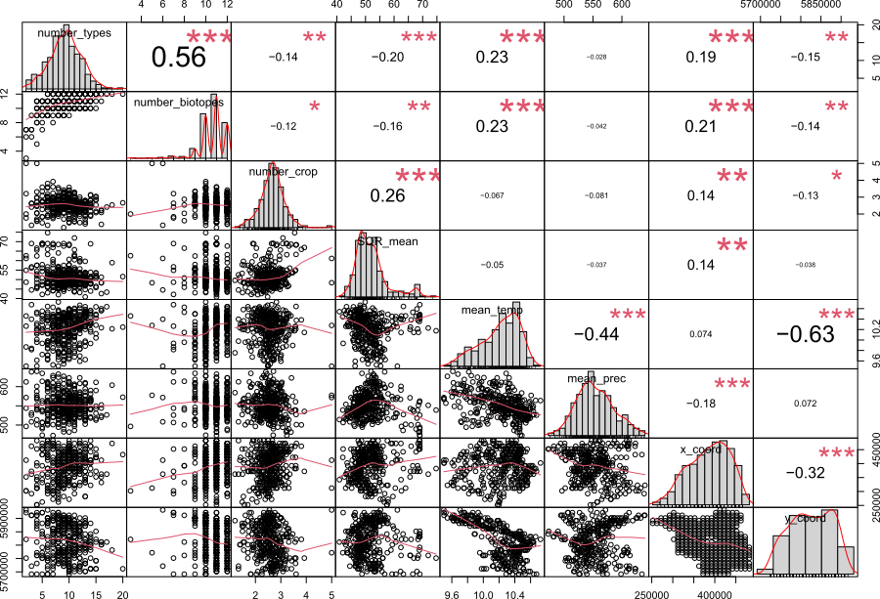
Figure S1. Correlation Matrix showing Pearson’s correlation; number_types = number of land use land cover; number_habitats = number of habitats; number_crop = average number of crop types per field, SQR_mean = average soil quality rating score; mean_temp = average of annual mean temperature; mean_prec = average of annual precipitation sum; x_coord = x coordinate; y_coord = y coordinate.
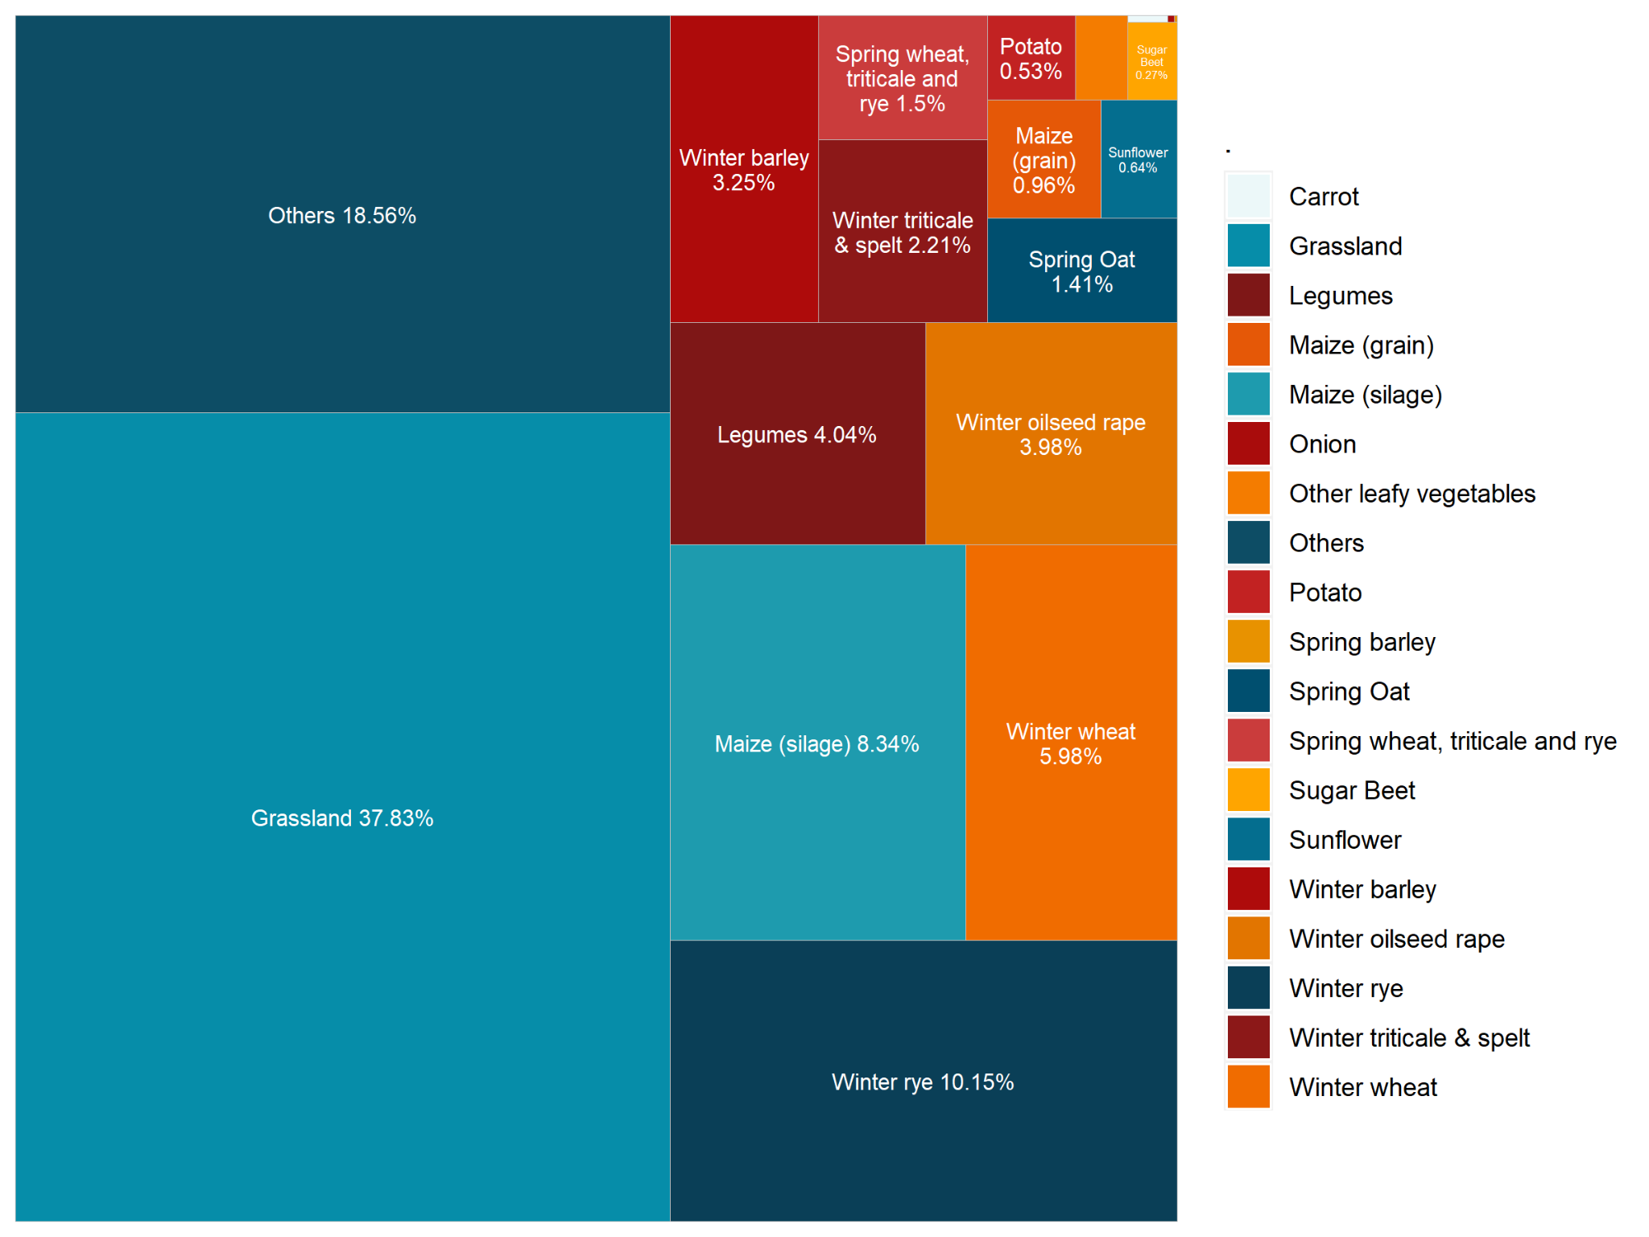
Figure S2. Distribution of crop types per field between 2011-2020 based on IACS. All fields with no data entries were removed before calculating proportions.

