Figure S1. qPCR validation of seven cell-cycle related genes during the head development in zebrafish.

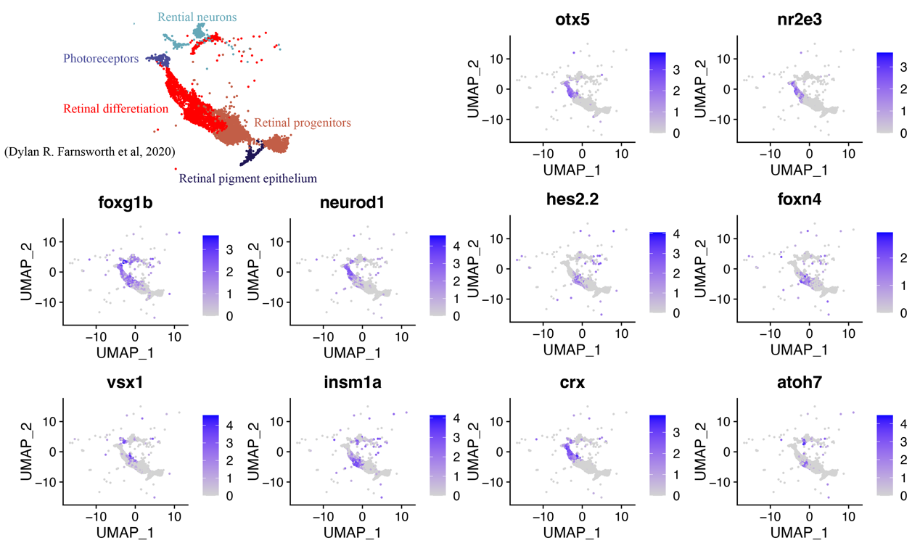
Figure S2. Expression of 10 TFs in cluster 4 from Fig. 1c based on single-cell RNA sequencing of developmental zebrafish. Only cell clusters related with eye development were shown. UMAP plot of these cell clusters was retrieved from the study.

Figure S3. GO enrichment (Biological Process) of genes in Fig. 2C of the main text by comparison between 48 h and 24 h. Left panel is enrichment of up-regulated genes only detected in head transcriptome the given criterion. Right panel is enrichment of up-regulated genes only detected in White et al study at the given criterion.

