Supplementary materials:
Journal name: Plant and Soil

Root secretory purple acid phosphatase is involved in the utilization of phosphorus from organic fertilizer in rice
Bingshuang Wangª, Yan Sunª, Ziwei Daiª, Yongjian Tangª, Yang Wangª, Yunsheng Lou^{b}, Chuang Wang^{c}, Yinglong Chen^{d}, Guohua Xuª, Lixuan Ren^{a,*}
ª College of Resources and Environmental Sciences, Nanjing Agricultural University; Key Laboratory of Plant Nutrition and Fertilization in Low-Middle Reaches of the Yangtze River, Ministry of Agriculture; Jiangsu Collaborative Innovation Center for Solid Organic Waste Resource Utilization, Nanjing 210095, China
^{b}School of Applied Meteorology, Nanjing University of Information Science and Technology, Nanjing 210044, China
^{c} College of Resources and Environment, Huazhong Agricultural University, Wuhan 430070, China
^{d}The UWA Institute of Agriculture, and School of Agriculture and Environment, The University of Western Australia, Perth, WA 6009, Australia
* Corresponding author: Associate Professor Dr. Lixuan REN
E-mail address: lxren@njau.edu.cn
ORCID：0000-0003-2841-3803
Telephone: +86-13814069608

Effect of long-term organic fertilization on pH value in soil in the field
The pH of the COF treated rhizosphere soil was less than in NF soil, but higher than in CF treated soil (Fig. S1a). The effects of COF and CF on the pH of non-rhizosphere soil were similar to those in the rhizosphere soil (Fig. S1b).
(b)
(a)

Fig. S1. Effect of long-term (10 years) organic fertilizer application on pH values in rhizosphere (a) and non-rhizosphere bulk soil (b) under no fertilizer (NF), chemical fertilizer (CF) and 50% chemical fertilizer + pig manure organic fertilizer (COF) in the field in Experiment 1. The values are the means ± standard errors (n=3). Bar data with the same letters indicate non-significant difference among fertilizer treatments (P ≤ 0.05).

OsPAP10c positively regulates rice seeds
Rice seed width was 9.4 % and 14.4 % greater in PAP10c-OE rice and 8.5 % and 5.0 % less in pap10c rice compared with WT under CF and OF treatments, respectively (Fig. S2a, S2b). Similarly, the seed length was 7.8 % and 7.4 % greater in PAP10c-OE rice and 3.5 % and 4.0 % less in pap10c rice compared with WT in CF and OF treatment, respectively (Fig. S2a, S2c).
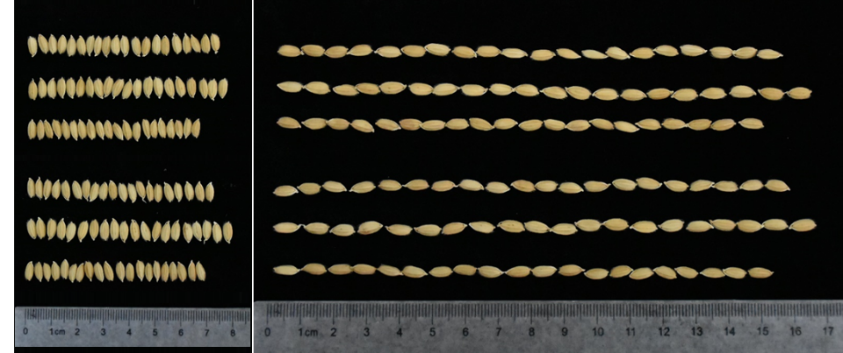
(a)
WT
PAP10c-OE
CF
pap10c

WT
OF
PAP10c-OE
pap10c


(c)
(b)

Fig. S2. Effect of organic fertilizer application on photos of seeds of three rice genotypes (WT, PAP10c-OE and pap10c) showing variation in the seed width and length (a), seed width (b) and seed length (c) under chemical fertilizer (CF) and organic fertilizer (OF) in the filling stage in rice cv. Nipponbare in Experiment 3. The values are the means ± standard errors (n=7). Bar data with the same letters indicate non-significant difference among fertilizer treatments (P ≤ 0.05).

Gene-specific primer pair
Gene-specific primer pair were showed in Table S1.
Table S1 Primers used for PCR amplification under chemical fertilizer (CF) and organic fertilizer (OF) in the tillering stage in rice cv. Nipponbare in Experiment 2.
Gene | Gene number | Primer sequence(5′-3′)
OsACTIN | Os03g50885 | F: TGGCATCTCTCAGCACATTCC
 |  | R: TGCACAATGGATGGGTCAGA
OsPAP10c | Os12t0637100 | F: TACCAGCCATGGATCTGGAC
 |  | R: GAGGCGATCTTGACGGAGTA

