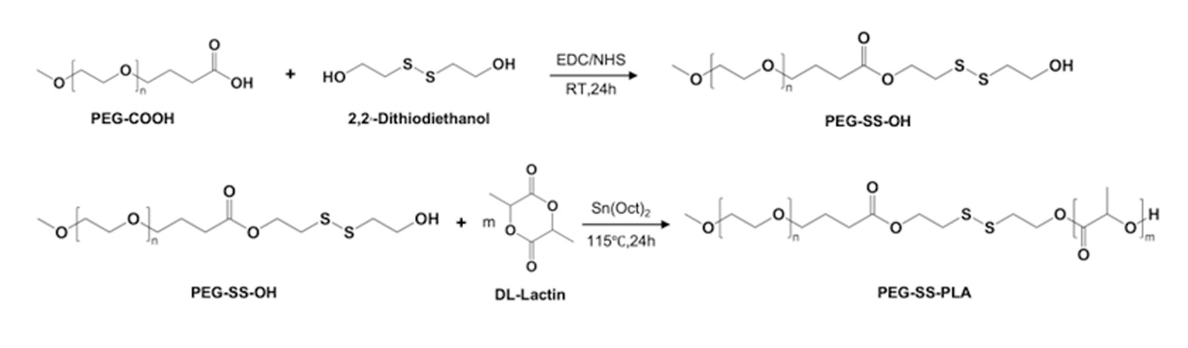

Fig. S1. Synthesis route of PEG-SS-PLA

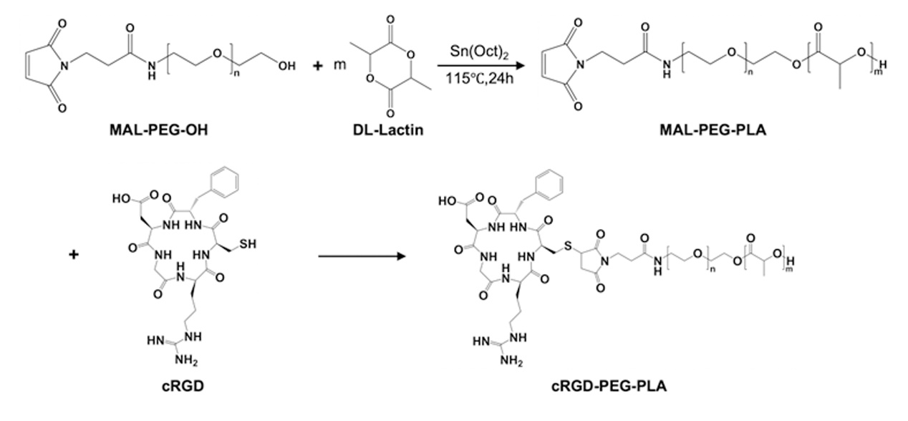

Fig. S2. Synthesis route of cRGD-PEG-PLA.

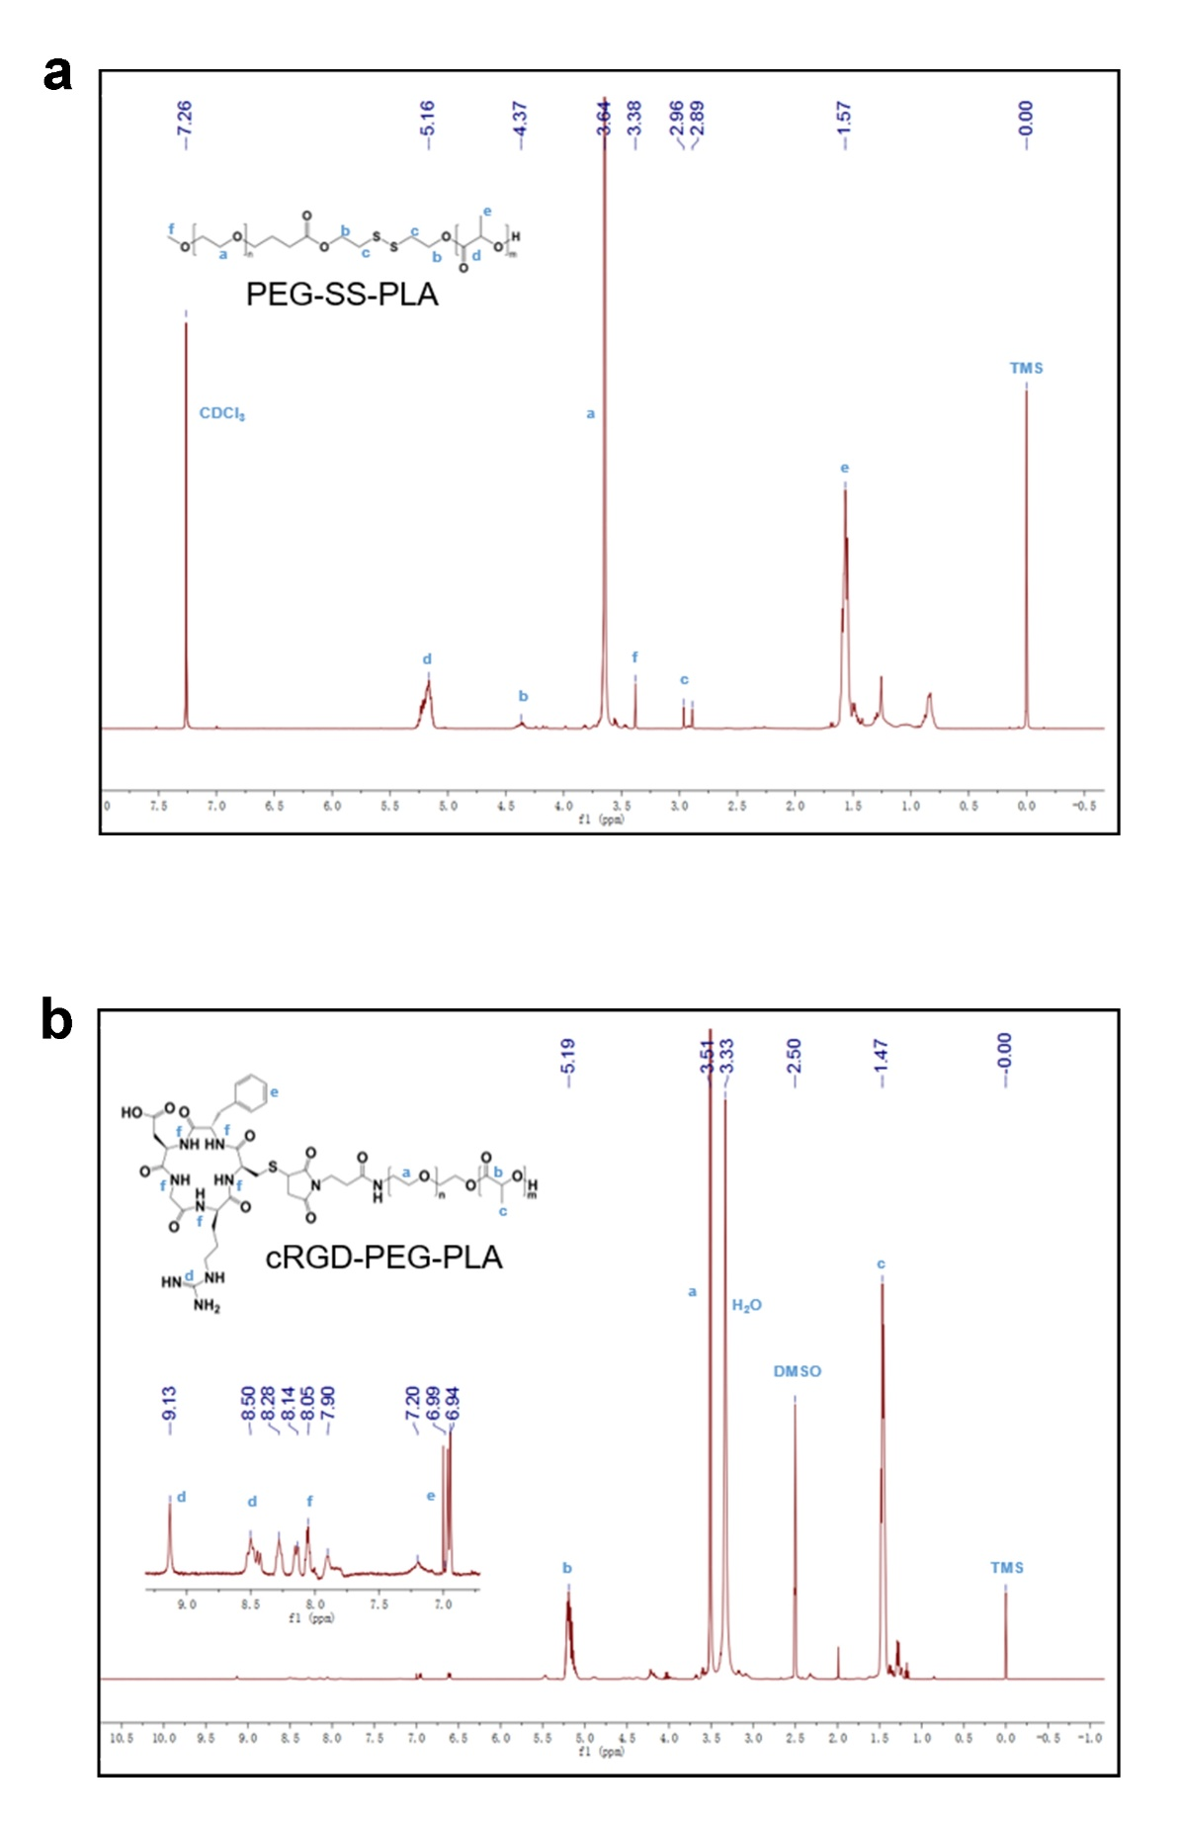

Fig.S3. Structural identification of PEG-SS-PLA(a) and cRGD-PEG-PLA(b).

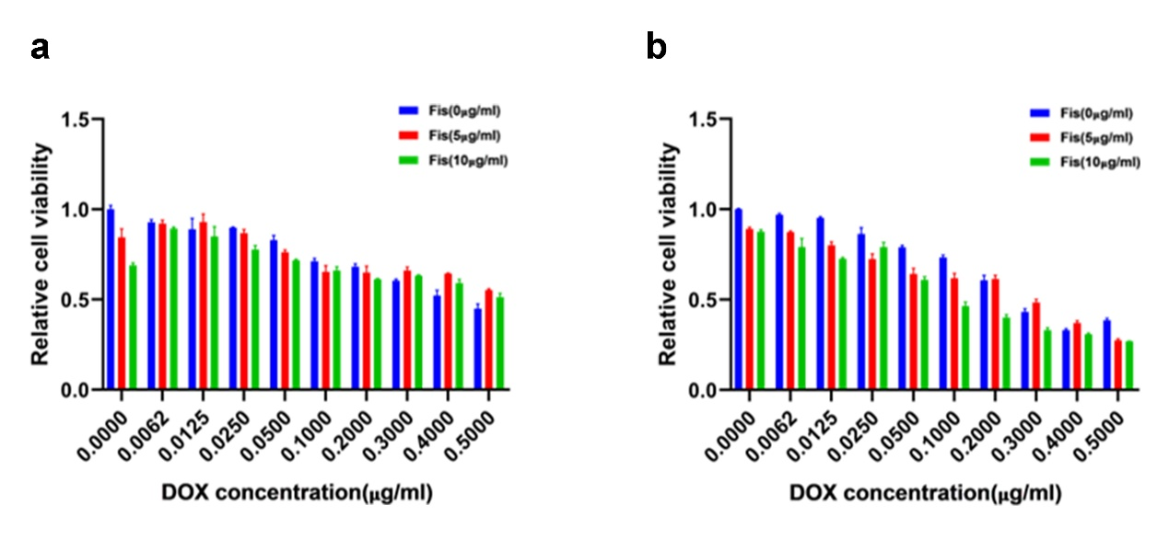

Fig. S4. Cell viability study of the nanocomposites by CCK8 assay in U87 cells. Synergistic effects of DOX and Fisetin in the NPs carrier system on cytotoxicity in U87 cells. CCK-8 assay was used to assess the cytotoxicity of blank NPs, DOX/NPs, and Fis-DOX/NPs from 0 μg/ml to 0.5 μg/ml at 24 h (a) and 48 h (b). N=3.

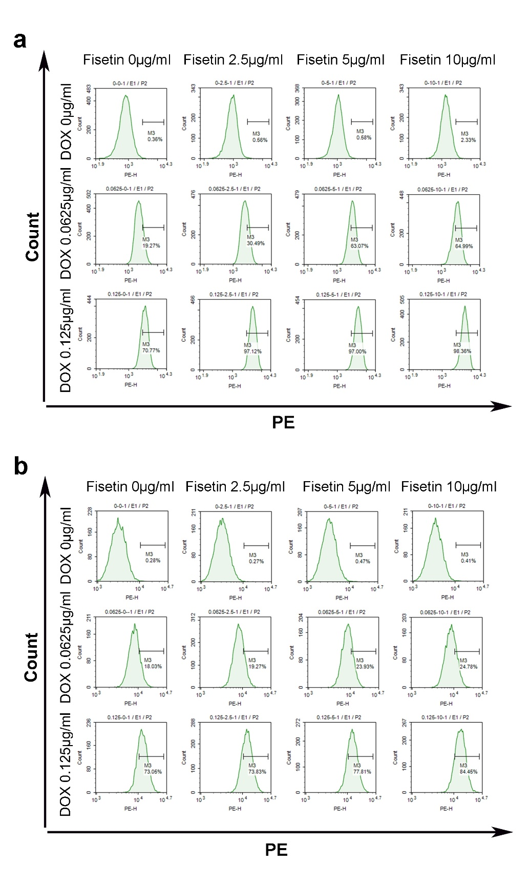
Fig. S5. Flow cytometry analysis of the uptake of Dox in GL-261 cells and U87-MG after different treatments.

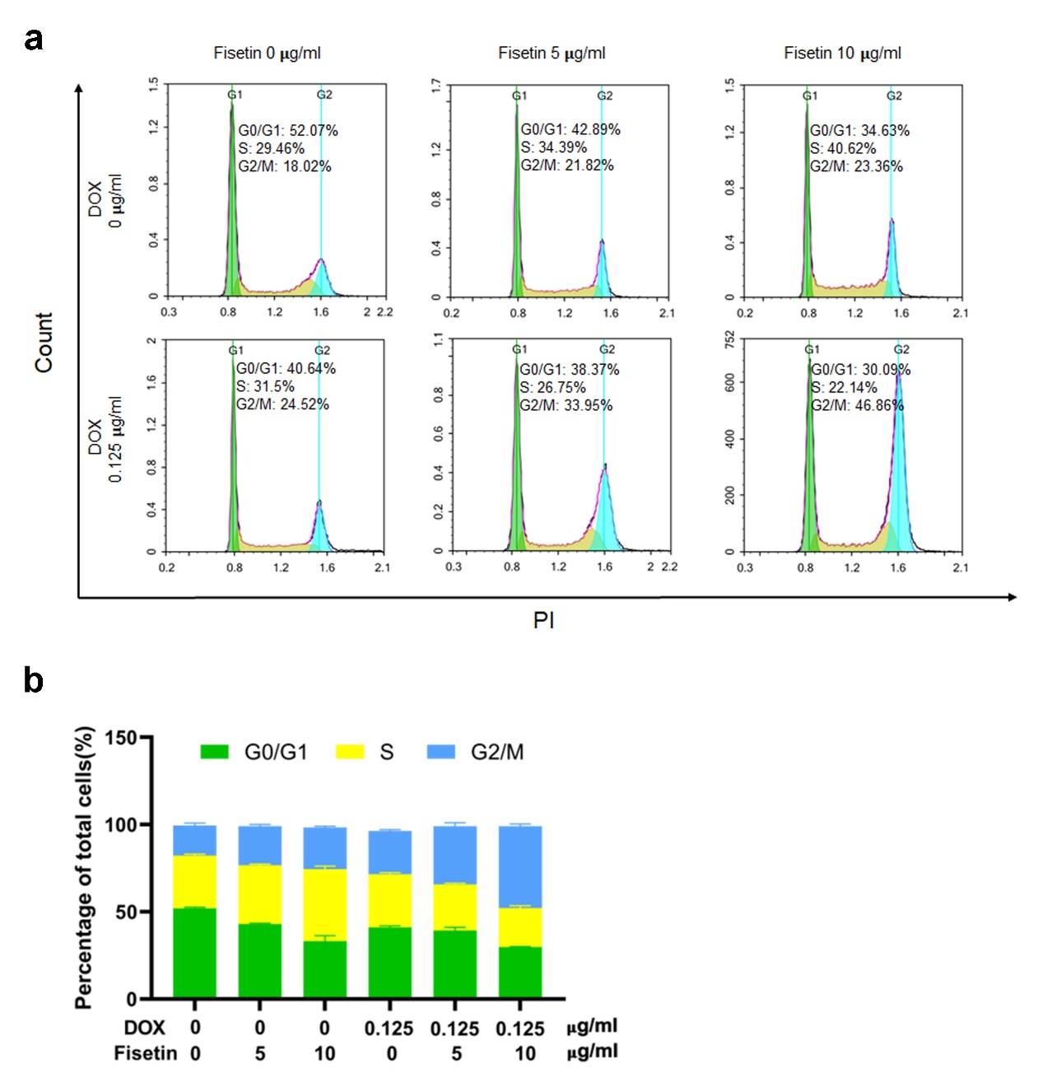

Fig. S6. Analysis of cell cycle in U87-MG cells. Synergistic effects of DOX and Fisetin in the NPs carrier system cell cycle arrest in U87 cells. (a) Flow cytometric analysis. U87 cells were treated with blank NPs, DOX/NPs, and Fis-DOX/NPs at 0.125 μg/ml for 24 h. (b) Populations of cells at G0/G1, S, and G2/M phases were displayed as percentages of the whole cell population.

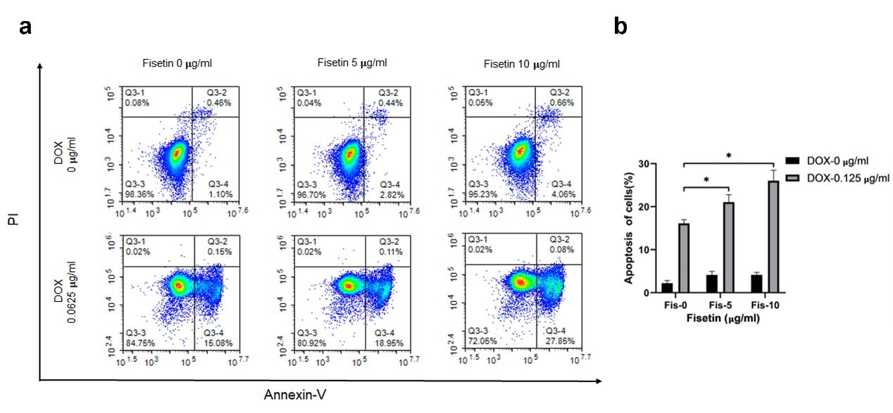

Fig. S7. Apoptosis assay of U87-MG cells. Synergistic effects of DOX and Fisetin in the NPs carrier system on tumor cell apoptosis. U87 cells were treated with blank NPs, DOX/NPs and Fis-DOX/NPs at concentrations of 0 μg/ml and 0.0625 μg/ml for 24 h. (a)(b) Cells were collected and stained with Annexin V and PI for flow cytometric analysis.

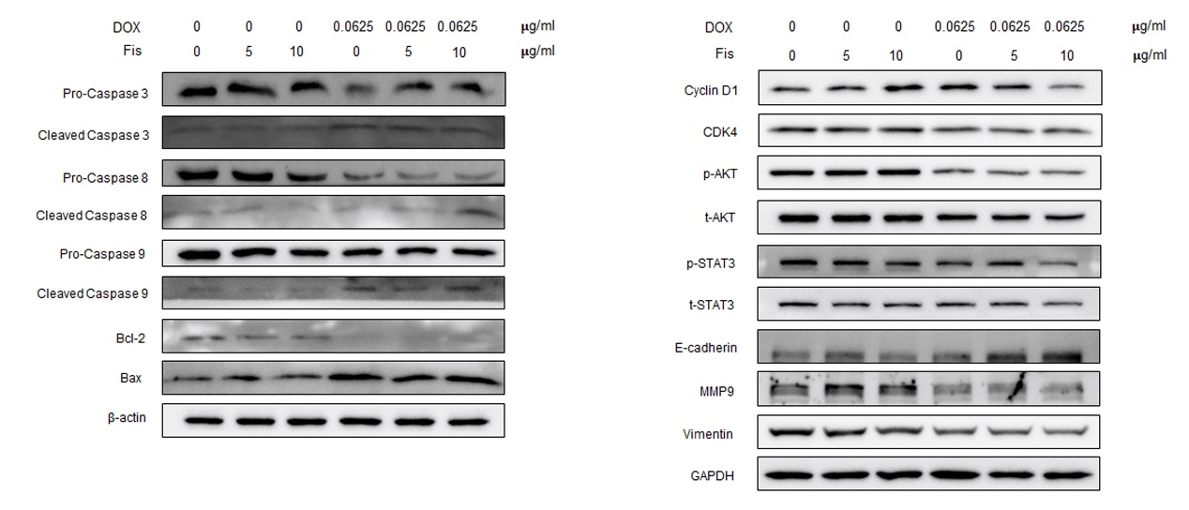

Fig. S8. Western blot analysis of U87-MG Cell.

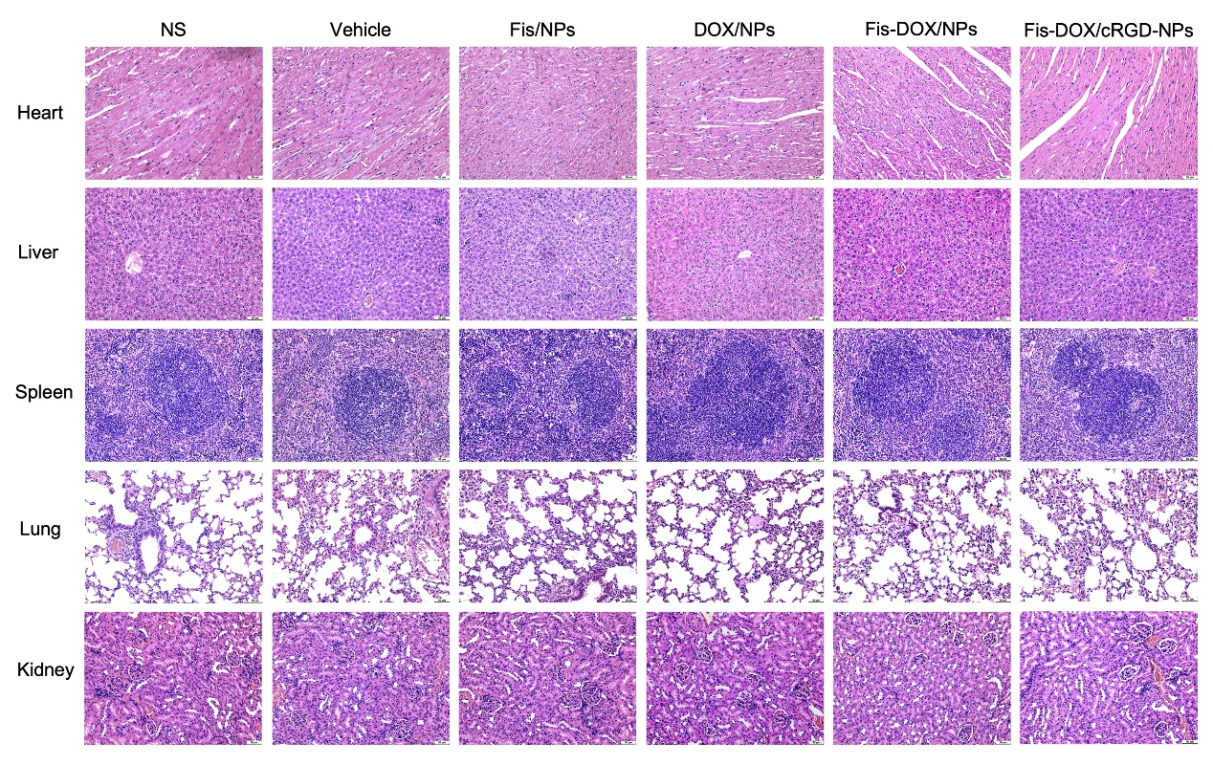
Fig. S9. Toxicity assessment in H&E staining with pathological section.

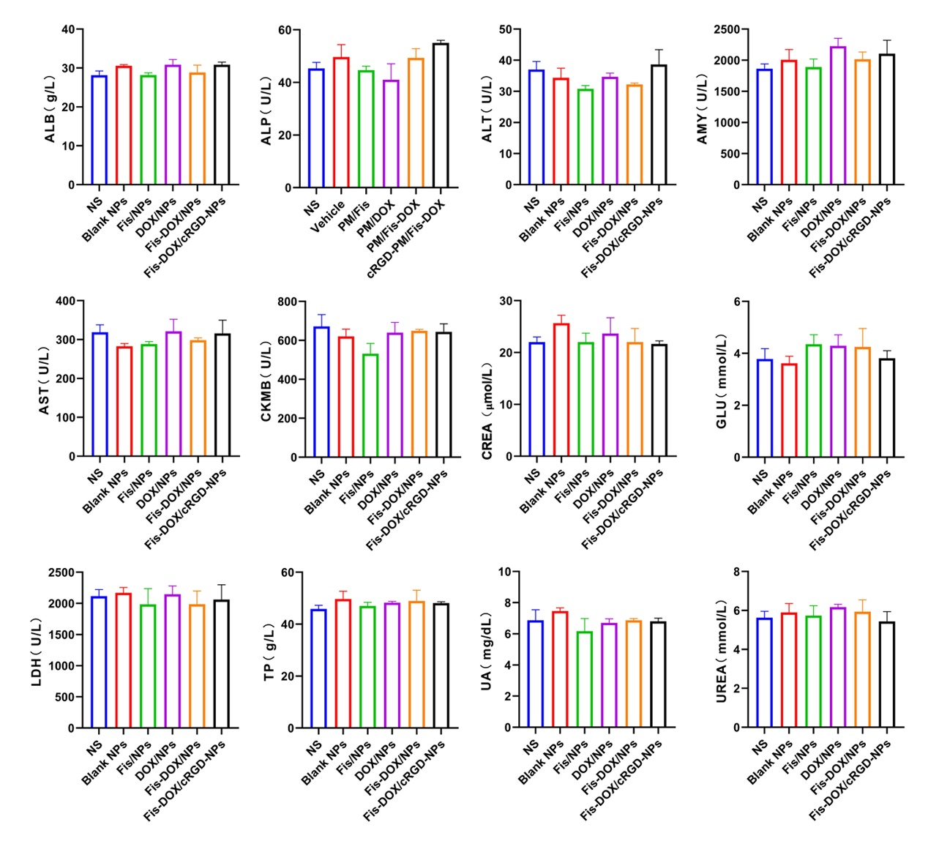
Fig. S10. Toxicity assessment in serologic biochemical analysis.

