Table 1. The optimization of Rh-catalyzed twofold and unsymmetrical functionalization of enantioselective C–H activation via transient directing group strategy.ª
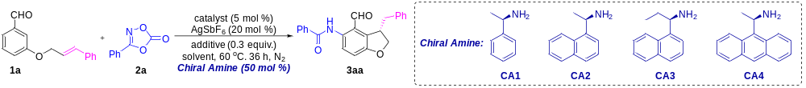
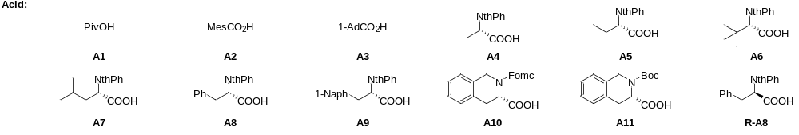
entry | catalyst | additive | salt | chiral amine | solvent | yield^{b} | ee
1 | [Cp*RhCl₂]₂ | - | - | CA2 | HFIP | 41 | 70
2 | [Cp*RhCl₂]₂ | - | - | CA2 | DCE:HFIP | 37 | 86
3 | [Cp*RhCl₂]₂ | - | - | CA2 | PhMe:HFIP | 20 | 87
4 | [Cp*RhCl₂]₂ | - | - | CA2 | PhCl:HFIP | 23 | 87
5^{c} | [Cp*RhCl₂]₂ | - | KH₂PO₄ | CA2 | DCE:HFIP | 45 | 88
6^{d} | [Cp*RhCl₂]₂ | - | KH₂PO₄ | CA2 | DCE:HFIP | 53 | 87
7e | [Cp*RhCl₂]₂ | - | KH₂PO₄ | CA2 | DCE:HFIP | 32 | 86
8^{d} | [Cp*RhCl₂]₂ | A1 | KH₂PO₄ | CA2 | DCE:HFIP | 60 | 70
9^{d} | [Cp*RhCl₂]₂ | A2 | KH₂PO₄ | CA2 | DCE:HFIP | 59 | 87
10^{d} | [Cp*RhCl₂]₂ | A3 | KH₂PO₄ | CA2 | DCE:HFIP | 48 | 84
11^{d} | [Cp*RhCl₂]₂ | A4 | KH₂PO₄ | CA2 | DCE:HFIP | 78 | 75
12^{d} | [Cp*RhCl₂]₂ | A5 | KH₂PO₄ | CA2 | DCE:HFIP | 75 | 83
13^{d} | [Cp*RhCl₂]₂ | A6 | KH₂PO₄ | CA2 | DCE:HFIP | 68 | 86
14^{d} | [Cp*RhCl₂]₂ | A7 | KH₂PO₄ | CA2 | DCE:HFIP | 77 | 83
15^{d} | [Cp*RhCl₂]₂ | A8 | KH₂PO₄ | CA2 | DCE:HFIP | 89 | 91
16^{d} | [Cp*RhCl₂]₂ | A9 | KH₂PO₄ | CA2 | DCE:HFIP | 78 | 91
17^{d} | [Cp*RhCl₂]₂ | A10 | KH₂PO₄ | CA2 | DCE:HFIP | 42 | 84
18^{d} | [Cp*RhCl₂]₂ | A11 | KH₂PO₄ | CA2 | DCE:HFIP | 63 | 53
19^{d} | [Cp*RhCl₂]₂ | R-A8 | KH₂PO₄ | CA2 | DCE:HFIP | 86 | 90
20^{d} | [Cp*RhCl₂]₂ | A8 | KH₂PO₄ | CA1 | DCE:HFIP | 46 | 35
21^{d} | [Cp*RhCl₂]₂ | A8 | KH₂PO₄ | CA3 | DCE:HFIP | 58 | 91
22^{d} | [Cp*RhCl₂]₂ | A8 | KH₂PO₄ | CA4 | DCE:HFIP | trace | -
23^{f} | [Cp*RhCl₂]₂ | A8 | KH₂PO₄ | CA2 | DCE:HFIP | 57 | 91
24^{g} | [Cp*RhCl₂]₂ | A8 | KH₂PO₄ | CA2 | DCE:HFIP | 31 | 90
25^{d} | [Cp*IrCl₂]₂ | A8 | KH₂PO₄ | CA2 | DCE:HFIP | nr | -
26^{d} | [Cp*CoI₂]₂ | A8 | KH₂PO₄ | CA2 | DCE:HFIP | nr | -
27^{d} | [Ru(cymene)Cl₂]₂ | A8 | KH₂PO₄ | CA2 | DCE:HFIP | nr | -
28^{d} | MnBr(CO)₅ | A8 | KH₂PO₄ | CA2 | DCE:HFIP | nr | -
ªReaction conditions: 1a (0.05 mmol), 2a (0.125 mmol, 2.5 equiv.), [Cp*RhCl₂]₂ (5 mol %), AgSbF₆ (20 mol %), CA2 (50 mol %), additive (0.3 equiv.), solvent (1 : 1, 0.6 mL), 60 °C, N₂, 36 h. ^{b}Isolated yield. ^{c}KH₂PO₄ (1.0 equiv.) was used. ^{d}KH₂PO₄ (1.5 equiv.) was used. ^{e}KH₂PO₄ (2.0 equiv.) was used. ^{f}CA2 (30 mol %) was used. ^{g}CA2 (20 mol %) was used.
Table 2. The scope of Rh-catalyzed twofold and enantioselective C–H activation via transient directing group strategy.ª

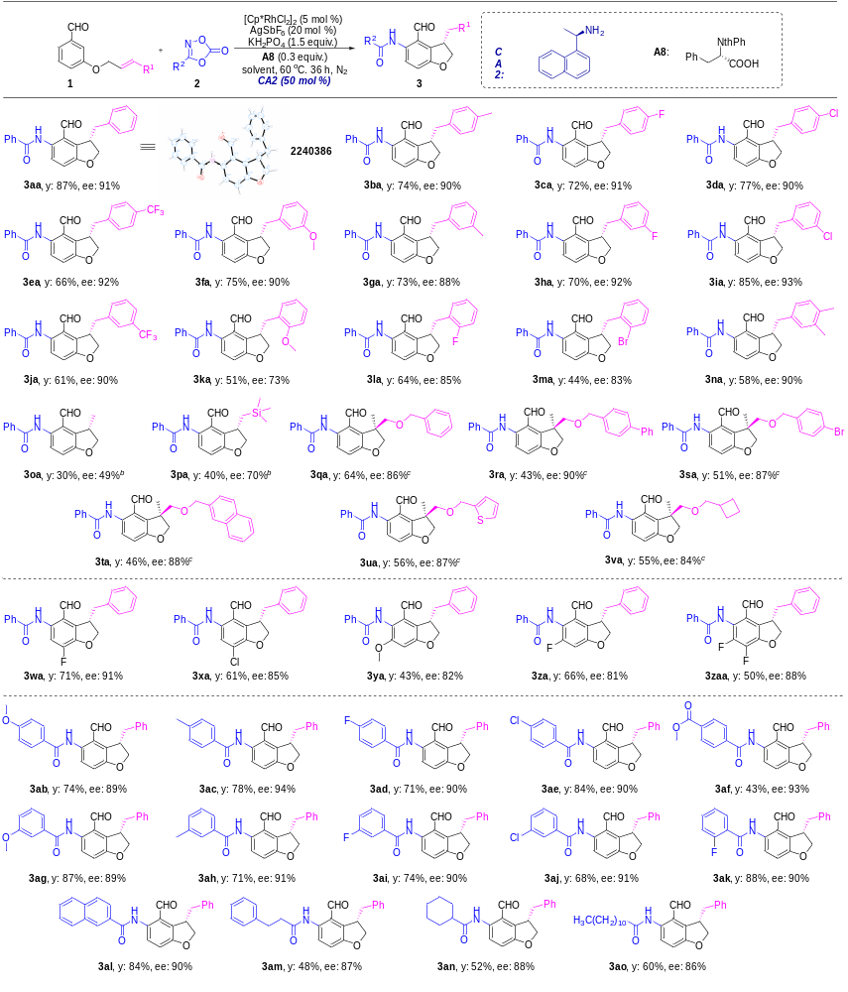
ªReaction conditions: 1 (0.15 mmol), 2 (0.375 mmol, 2.5 equiv.), [Cp*RhCl₂]₂ (5 mol %), AgSbF₆ (20 mol %), CA2 (50 mol %), KH₂PO₄ (1.5 equiv.), A8 (0.3 equiv.), DCE : HFIP (1 : 1, 1.8 mL), 60 °C, N₂, 36 h. Isolated yield. ^{b}70 ºC, 24 h. ^{c}Reaction conditions: 1 (0.15 mmol), 2 (0.375 mmol, 2.5 equiv.), [Cp*RhCl₂]₂ (5 mol %), AgSbF₆ (20 mol %), CA2 (50 mol %), MesCO₂H (0.5 equiv.), DCE (0.9 mL), 50 °C, N₂, 36 h. Isolated yield.
Table 3. Photophysical properties of selected compounds.
compounds | λ^{abs}_{max} (nm) | λ^{em}_{max} (nm) | ε_{max}ª | Φ^{b} | τ (ns)^{c} | k_{r} (10⁸ s⁻¹)^{d} | k_{nr} (10⁸ s⁻¹)^{e} | Stokes shift (cm⁻¹)
3aa | 394 | 500 | 7500 | 0.223 | 4.59 | 0.49 | 1.69 | 5400
3aa (crystal) |  | 560 |  | 0.425
10a | 340 | 418, 544 | 5200 | 0.323 | - | - | - | 11000
10b | 355 | 432, 556 | 5600 | 0.019 | - | - | - | 10200
10c | 369 | 456 | 5500 | 0.287 | 5.29 | 0.54 | 1.35 | 5200
10d | 386 | 500 | 7600 | 0.045 | 0.95 | 0.47 | 10.05 | 5900
10e | 398 | 500 | 6800 | 0.232 | 4.55 | 0.51 | 1.69 | 5100
ªCorresponding to the strongest absorption maximum, the unit for ε is M⁻¹ cm⁻¹. ^{b}Absolute fluorescence quantum yield. ^{c}Fluorescence lifetime. ^{d}Radiative transition rate constant. ^{e}Nonradiative transition rate constants.

