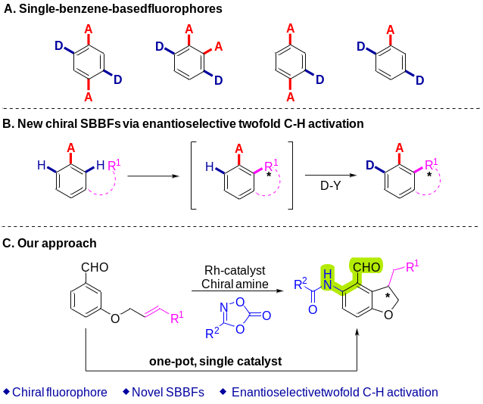
Scheme 1. The synthesis of chiral SBBFs with D-A-D motif via twofold and enantioselective C–H activation.
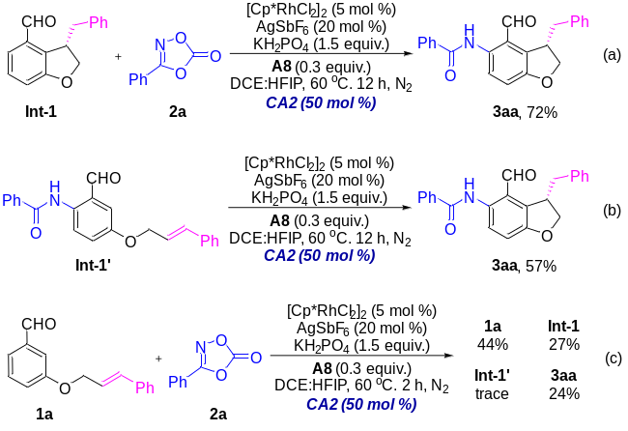
Scheme 2. Control experiments

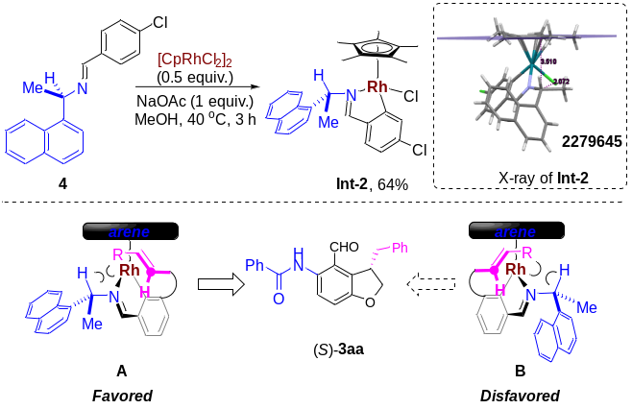
Scheme 3. Proposed asymmetric model
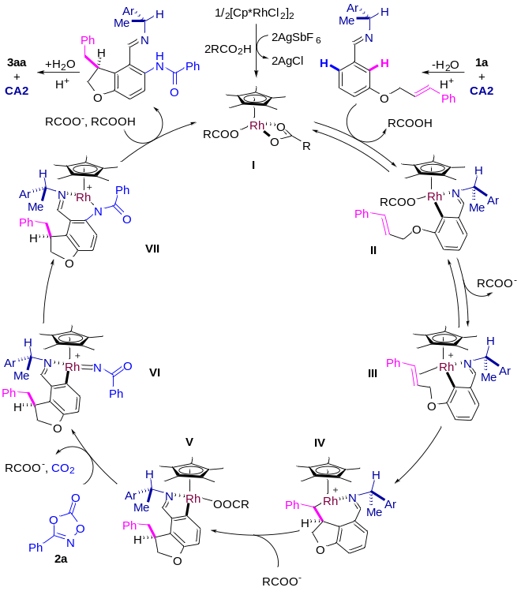
Scheme 4. Plausible mechanism.
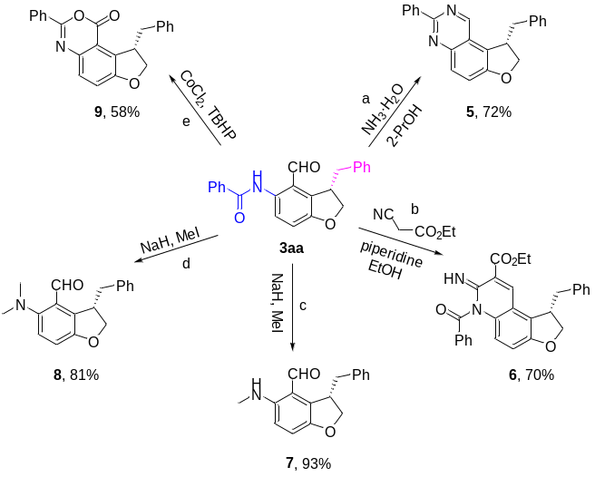
Scheme 5. a: 3aa (0.1 mmol), 25% NH₃·H₂O (1.2 mL), 2-PrOH (0.8 mL), 100 ºC, 12 h; b: 3aa (0.1 mmol), ethylcyanoacetate (0.12 mmol), piperidine (2 mol %), EtOH (1 mL), 80 ºC, 24 h; c: 3aa (0.1 mmol), NaH (0.3 mmol), MeI (0.2 mmol), THF (0.5 mL), room temperature, 8 h; d: 3aa (0.1 mmol), NaH (0.6 mmol), MeI (1.0 mmol), THF (0.5 mL), room temperature, 12 h; e: 3aa (0.1 mmol), CoCl₂ (15 mol %), TBHP (5.0 equiv.), MeCN (0.4 mL), 80 ºC, 8 h.

