Interpretable Machine Learning for Early Prediction of Multidrug-Resistant Organism Infection：A Discovery and Validation Study
Pei Sun^{1#}
Wenting Zhao^{1#}
Jinqi Wen¹
Yuanhui Yang¹
Wei Guo¹
Linping Shang^{2*}
1 College of Nursing, Shanxi Medical University, Taiyuan, Shanxi, China
2 Nursing Department of the First Hospital of Shanxi Medical University, Taiyuan, Shanxi, China
#: These authors contributed equally to this work.
*: Address correspondence
Linping Shang: Email: shanglp2002@163.com

Pei Sun
ORCID: 0009-0003-4948-5555
1792246092@qq.com
Wenting Zhao
wtzhao256@126.com
Jinqi Wen
wenjinqi777@163.com
Yuanhui Yang
yangyuanhui009@163.com
Wei Guo
393975367@qq.com

Acknowledges
The work was supported by grants from the Shanxi Province Graduate Education Innovation Project (Project No.: 2021Y371)

Supplementary Tables and Figures
Table S1 All extracted variables (N=45)
Variables | Variable type
Age - year | Demographics information
Female | Demographics information
BMI | Demographics information
Rural_patients | Demographics information
LOS | Clinical treatment information
SDH | Clinical treatment information
Number_of_hospitalizations | Clinical treatment information
Days_for_ventilator_therapy | Clinical treatment information
Times_for_ventilator_therapy | Clinical treatment information
Days_of_central_venous_catheterization | Clinical treatment information
Times_of_central_venous_catheterization | Clinical treatment information
Days_of_indwelling_catheter | Clinical treatment information
Times_of_indwelling_catheter | Clinical treatment information
Length_of_fever | Clinical treatment information
Operation_history | Clinical treatment information
Scores_of_fall-down_risk | Clinical nursing score
Scores_of_pressure_sores | Clinical nursing score
Scores_of_ADL | Clinical nursing score
Nutrition_risk_scores | Clinical nursing score
Days_of_using_antibiotics | Information on the use of antibiotics
Penicillin | Information on the use of antibiotics
Cephalosporin | Information on the use of antibiotics
Aminoglycosides | Information on the use of antibiotics
Carbapenem | Information on the use of antibiotics
Tetracyclines | Information on the use of antibiotics
Macrolides | Information on the use of antibiotics
Glycopeptides | Information on the use of antibiotics
Quinolones | Information on the use of antibiotics
Combined_use_of_antibiotics | Information on the use of antibiotics
Diabetes | Basic disease information
Hypertension | Basic disease information
Hypoproteinemia | Basic disease information
Respiratory_failure | Basic disease information
Renal_failure | Basic disease information
Liver_insufficiency | Basic disease information
Hypokalemia | Basic disease information
Anemia | Basic disease information
AKI | Basic disease information
MODS | Basic disease information
Pneumonia | Basic disease information
Cerebral_infarction | Basic disease information
Cerebral_Hemorrhage | Basic disease information
Sepsis | Basic disease information
Electrolyte_disturbance | Basic disease information
Acidosis | Basic disease information
BMI: Body Mass Index; LOS: Length of Stay; SDH: Surgery during hospitalization; Scores_of_ADL: Scores_of Activity of Daily Living; AKI: Acute renal injury; MODS: Multiple Organ Dysfunction Syndrome.

Table S2 Clinical features used for developing the models (N=31)
Variables | Variable type
Age, year | Demographics information
Female | Demographics information
Rural patients | Demographics information
BMI | Demographics information
SDH | Clinical treatment information
Length of fever | Clinical treatment information
Times for ventilator therapy | Clinical treatment information
Days of central venous catheterization | Clinical treatment information
Times of central venous catheterization | Clinical treatment information
Days of indwelling catheter | Clinical treatment information
Times of indwelling catheter | Clinical treatment information
Scores of fall-down risk | Clinical nursing score
Scores of pressure sores | Clinical nursing score
Nutrition risk scores | Clinical nursing score
Days of using antibiotics | Information on the use of antibiotics
Aminoglycosides | Information on the use of antibiotics
Carbapenem | Information on the use of antibiotics
Tetracyclines | Information on the use of antibiotics
Macrolides | Information on the use of antibiotics
Quinolones | Information on the use of antibiotics
Combined use of antibiotics | Information on the use of antibiotics
Hypoproteinemia | Basic disease information
Hypokalemia | Basic disease information
AKI | Basic disease information
MODS | Basic disease information
Pneumonia | Basic disease information
Cerebral infarction | Basic disease information
Cerebral Hemorrhage | Basic disease information
Sepsis | Basic disease information
Electrolyte disturbance | Basic disease information
Acidosis | Basic disease information
BMI: Body Mass Index; LOS: Length of Stay; SDH: Surgery during hospitalization; AKI: Acute renal injury; MODS: Multiple Organ Dysfunction Syndrome.

Figure S1. Study flowchart
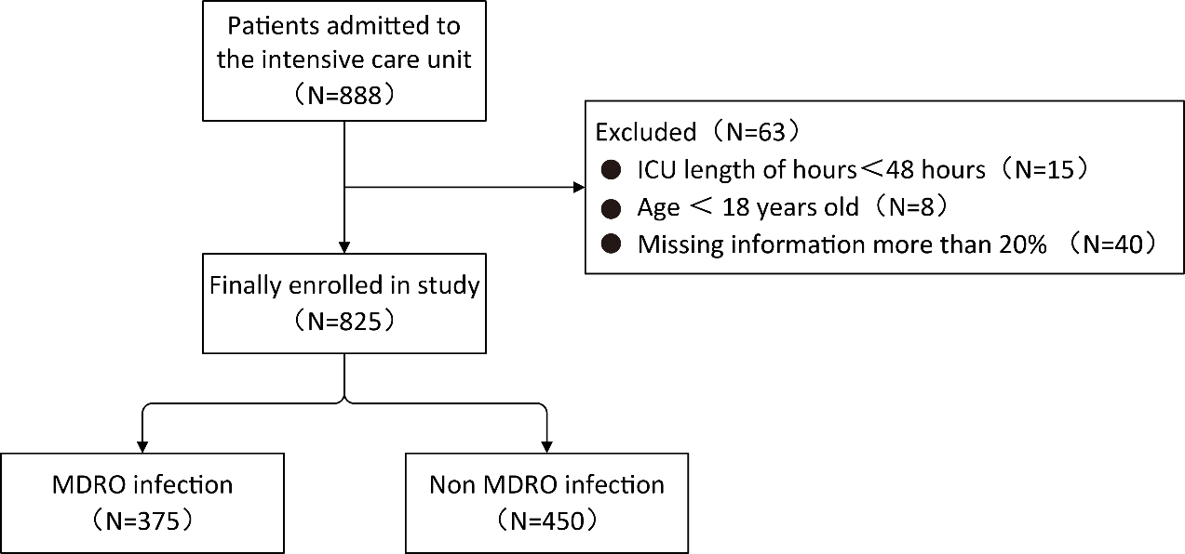

Figure S2. Percentages of missing data for all included variables.
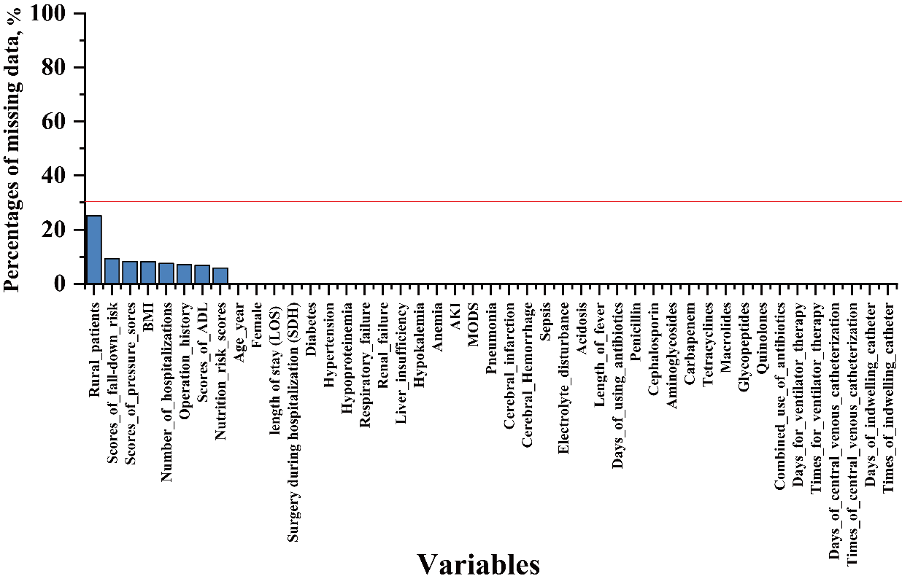

Figure S3. Feature selection using the LASSO regression model.
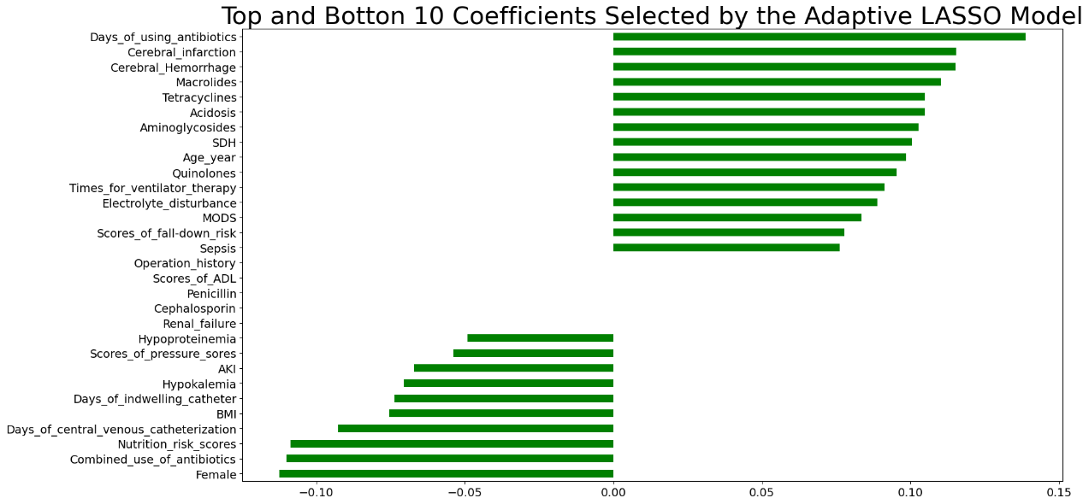

Figure S4. Clinical Decision Curve Analysis of Machine Learning Algorithms model.
