Appendix 1
Table 5 and table 6 report the incidence and intensity of CHE due to inpatient and outpatient services respectively.
Table 5: Incidence and intensity of catastrophic health expenditure of elderly population
As a share of household usual consumption expenditure |  |  |  |  |  |  | As a share of non-subsistence expenditure (Tendulkar) |  |  | As a share of non-subsistence expenditure (Rangarajan)
Threshold |  |  | 10% | 20% | 30% | 40% | 20% | 30% | 40% | 20% | 30% | 40%
Headcount (%)
Mean |  |  | 38.33 | 23.08 | 15.09 | 10.83 | 36.44 | 27.55 | 22.35 | 37.92 | 29.92 | 24.49
Quintile
1-Poorest |  |  | 40.35 | 25.94 | 18.1 | 12.22 | 51.24 | 42.01 | 37.93 | 38.41 | 34.59 | 30.17
2 |  |  | 36.33 | 23.58 | 15.03 | 10.46 | 39.96 | 32.49 | 26.92 | 46.64 | 39.05 | 34.28
3 |  |  | 37.27 | 22.92 | 14.71 | 10.32 | 35.32 | 27.56 | 20.69 | 40.94 | 33.15 | 27.52
4 |  |  | 37.62 | 20.81 | 13.88 | 10.94 | 31.26 | 21.24 | 16.52 | 35.99 | 25.31 | 19.33
5-Richest |  |  | 39.67 | 22.58 | 14.18 | 10.34 | 27.94 | 18.36 | 13.45 | 30.55 | 21.18 | 15.15
Sector
Rural |  |  | 38.58 | 23.81 | 15.74 | 11.17 | 38.26 | 29.69 | 24.41 | 39.06 | 31.23 | 25.94
Urban |  |  | 37.89 | 21.78 | 13.94 | 10.23 | 33.22 | 23.75 | 18.68 | 35.91 | 27.59 | 21.92
Gender
Male |  |  | 38.27 | 22.75 | 14.99 | 10.96 | 36.6 | 27.78 | 22.5 | 38.01 | 29.82 | 24.57
Female |  |  | 38.55 | 24.22 | 15.45 | 10.4 | 35.9 | 26.79 | 21.85 | 37.64 | 30.27 | 24.23
Social group
SC |  |  | 33.85 | 19.08 | 10.61 | 7.09 | 35.13 | 25.57 | 21.45 | 34.23 | 26.78 | 22.33
ST |  |  | 29.27 | 17.06 | 11.02 | 6.4 | 29.73 | 23.43 | 19.24 | 32.43 | 26.08 | 20.78
OBC |  |  | 39.18 | 23.87 | 15.32 | 10.91 | 37.81 | 28.69 | 23.31 | 38.93 | 30.74 | 24.97
Others |  |  | 40.43 | 24.62 | 17.25 | 12.89 | 36.29 | 27.61 | 22.02 | 39.03 | 30.8 | 25.34
Religion
Hinduism |  |  | 39.18 | 24.01 | 15.81 | 11.34 | 37.39 | 28.37 | 23.23 | 38.65 | 30.61 | 25.14
Islam |  |  | 30.78 | 16.45 | 10.41 | 7.95 | 30.83 | 23.1 | 18.36 | 33.12 | 26.06 | 21.13
Christianity |  |  | 45.05 | 26.72 | 17.45 | 11.14 | 36.38 | 28.43 | 21.56 | 40.49 | 31.09 | 25.54
Others |  |  | 38.21 | 21.78 | 13.11 | 9.4 | 36.01 | 24.34 | 18.16 | 35.9 | 27.05 | 20.81
Concentration Index headcount |  |  | 0.003 | -0.039 | -0.053 | -0.026 | -0.189 | -0.233 | -0.27 | -0.097 | -0.161 | -0.201
Rank-weighted headcount (%) |  |  | 38.21 | 23.99 | 15.9 | 11.12 | 43.34 | 33.99 | 28.39 | 41.63 | 34.75 | 29.44
Overshoot (%)
Mean |  |  | 12.8 | 9.83 | 7.96 | 6.67 | 41.06 | 37.89 | 35.41 | 57.17 | 53.81 | 51.1
Quintile
1-Poorest |  |  | 14.3 | 11.11 | 8.94 | 7.42 | 131.51 | 126.84 | 122.87 | 159.17 | 155.53 | 152.27
2 |  |  | 12.63 | 9.7 | 7.8 | 6.55 | 32.7 | 29.12 | 26.16 | 74.43 | 70.16 | 66.5
3 |  |  | 12.34 | 9.39 | 7.55 | 6.28 | 22.04 | 18.93 | 16.51 | 33.13 | 29.44 | 26.4
4 |  |  | 11.95 | 9.14 | 7.43 | 6.2 | 16.87 | 14.29 | 12.44 | 22.16 | 19.12 | 16.9
5-Richest |  |  | 12.87 | 9.87 | 8.1 | 6.89 | 13.71 | 11.42 | 9.84 | 15.7 | 13.15 | 11.4
Sector
Rural |  |  | 12.93 | 9.88 | 7.93 | 6.58 | 51.19 | 47.82 | 45.13 | 66.48 | 62.99 | 60.13
Urban |  |  | 12.57 | 9.73 | 8.02 | 6.82 | 23.02 | 20.2 | 18.1 | 40.6 | 37.46 | 35.02
Gender
Male |  |  | 12.7 | 9.74 | 7.89 | 6.6 | 42.42 | 39.25 | 36.76 | 58.76 | 55.39 | 52.68
Female |  |  | 13.17 | 10.14 | 8.21 | 6.9 | 36.36 | 33.19 | 30.75 | 51.72 | 48.35 | 45.64
Social group
SC |  |  | 8.87 | 6.3 | 4.82 | 3.94 | 37.12 | 34.15 | 31.79 | 48.87 | 45.87 | 43.4
ST |  |  | 6.85 | 4.65 | 3.29 | 2.41 | 40.11 | 37.47 | 35.39 | 44.3 | 41.38 | 39.09
OBC |  |  | 13.04 | 10 | 8.1 | 6.8 | 51.94 | 48.61 | 46.04 | 67.28 | 63.82 | 61.04
Others |  |  | 14.96 | 11.79 | 9.73 | 8.23 | 30.15 | 27.01 | 24.53 | 50.59 | 47.11 | 44.32
Religion
Hinduism |  |  | 13.57 | 10.5 | 8.55 | 7.2 | 45.8 | 42.53 | 39.98 | 61.33 | 57.89 | 55.12
Islam |  |  | 8.02 | 5.78 | 4.45 | 3.55 | 23.12 | 20.47 | 18.39 | 48.44 | 45.52 | 43.13
Christianity |  |  | 14.26 | 10.8 | 8.65 | 7.26 | 20.74 | 17.57 | 15.01 | 35.77 | 32.32 | 29.53
Others |  |  | 11.18 | 8.28 | 6.63 | 5.57 | 26.77 | 23.81 | 21.75 | 21.9 | 18.72 | 16.29
Concentration Index overshoot |  |  | -0.019 | -0.021 | -0.017 | -0.012 | -0.468 | -0.495 | -0.516 | -0.458 | -0.481 | -0.499
Rank-weighted overshoot (%) |  |  | 13.05 | 10.04 | 8.09 | 6.76 | 60.27 | 56.64 | 53.7 | 83.38 | 79.72 | 76.64
Mean positive overshoot (%) |  |  | 33.39 | 42.59 | 52.75 | 61.58 | 112.67 | 137.53 | 158.43 | 150.76 | 179.84 | 208.65
Source: Author's computation using NSSO 75th round, 2018

Table 6: Incidence and intensity of catastrophic health expenditure of elderly population
As a share of household usual consumption expenditure |  |  |  |  |  |  | As a share of non-subsistence expenditure (Tendulkar) |  |  | As a share of non-subsistence expenditure (Rangarajan)
Threshold |  |  | 10% | 20% | 30% | 40% | 20% | 30% | 40% | 20% | 30% | 40%
Headcount (%)
Mean |  |  | 43.56 | 24.74 | 16.16 | 11.84 | 38.91 | 29.05 | 23.28 | 41.06 | 31.61 | 25.98
Quintile
1-Poorest |  |  | 58.11 | 38.4 | 29.82 | 23.78 | 59.77 | 56.06 | 48.69 | 44.78 | 43.5 | 40.98
2 |  |  | 52.12 | 33.02 | 18.86 | 13.43 | 57.62 | 44.1 | 36.28 | 65.55 | 53.58 | 46.24
3 |  |  | 45.25 | 24.23 | 15.42 | 10.06 | 41.12 | 27.9 | 23.01 | 50.87 | 35.14 | 28.53
4 |  |  | 40 | 21.56 | 14.44 | 10.51 | 33.05 | 22.06 | 16.27 | 36.24 | 27.32 | 19.74
5-Richest |  |  | 33.39 | 16 | 9.58 | 6.98 | 21.39 | 13.08 | 8.8 | 24.12 | 14.87 | 10.56
Sector
Rural |  |  | 48.58 | 28.96 | 19.13 | 14.18 | 45.52 | 35.33 | 29.38 | 46.54 | 36.69 | 31.59
Urban |  |  | 35.97 | 18.35 | 11.66 | 8.31 | 28.92 | 19.54 | 14.06 | 32.78 | 23.92 | 17.49
Gender
Male |  |  | 45.1 | 25.57 | 16.34 | 11.7 | 40.68 | 30.38 | 24.24 | 42.87 | 32.94 | 27.15
Female |  |  | 40.39 | 23.03 | 15.78 | 12.13 | 35.27 | 26.32 | 21.31 | 37.34 | 28.85 | 23.56
Social group
SC |  |  | 51.67 | 33.06 | 22.37 | 15.45 | 47.07 | 38.7 | 31.93 | 46.57 | 39.82 | 35
ST |  |  | 52.87 | 34.98 | 24.53 | 15.52 | 50.16 | 43.92 | 35.17 | 45.44 | 38.72 | 36.93
OBC |  |  | 42.31 | 23.4 | 15.06 | 11.01 | 40.58 | 29.38 | 23.07 | 42.23 | 33.01 | 26.22
Others |  |  | 40.42 | 21.51 | 13.76 | 10.77 | 32.71 | 23.16 | 18.65 | 37.16 | 26.06 | 20.83
Religion
Hinduism |  |  | 44.87 | 25.72 | 17.03 | 12.68 | 40.14 | 29.8 | 23.74 | 42.46 | 32.73 | 26.79
Islam |  |  | 42.99 | 21.48 | 12.14 | 7.69 | 39.06 | 30.17 | 25.03 | 39.71 | 30.47 | 25.92
Christianity |  |  | 29.74 | 15.44 | 9.15 | 5.64 | 24.37 | 15.63 | 12.2 | 28.21 | 18.76 | 14.04
Others |  |  | 34.8 | 25.55 | 18.72 | 14.57 | 30.57 | 26.69 | 22.36 | 31.51 | 27.43 | 23.94
Concentration Index headcount |  |  | -0.202 | -0.238 | -0.252 | -0.257 | -0.351 | -0.407 | -0.432 | -0.279 | -0.338 | -0.38
Rank-weighted headcount (%) |  |  | 52.37 | 30.64 | 20.24 | 14.89 | 52.58 | 40.9 | 33.36 | 52.55 | 42.31 | 35.88
overshoot (%)
Mean |  |  | 13.58 | 10.36 | 8.38 | 7.02 | 52.46 | 49.12 | 46.52 | 88.2 | 84.6 | 81.73
Quintile
1-Poorest |  |  | 27.01 | 22.5 | 19.2 | 16.51 | 241.06 | 235.25 | 230.06 | 409.99 | 405.57 | 401.35
2 |  |  | 18.56 | 14.42 | 11.89 | 10.37 | 44.56 | 39.46 | 35.37 | 86.11 | 80.14 | 75.16
3 |  |  | 12.02 | 8.89 | 6.92 | 5.72 | 21.77 | 18.48 | 15.98 | 34.42 | 30.1 | 26.96
4 |  |  | 11.02 | 8.06 | 6.34 | 5.12 | 15.32 | 12.61 | 10.75 | 20.12 | 16.99 | 14.61
5-Richest |  |  | 6.88 | 4.57 | 3.34 | 2.54 | 6.82 | 5.17 | 4.09 | 8.08 | 6.21 | 4.96
Sector
Rural |  |  | 16.18 | 12.52 | 10.18 | 8.57 | 74.94 | 70.94 | 67.7 | 125.41 | 121.25 | 117.85
Urban |  |  | 9.66 | 7.09 | 5.65 | 4.68 | 18.48 | 16.12 | 14.48 | 31.93 | 29.17 | 27.1
Gender
Male |  |  | 12.59 | 9.29 | 7.29 | 5.91 | 54.69 | 51.19 | 48.47 | 68.02 | 64.27 | 61.3
Female |  |  | 15.61 | 12.55 | 10.62 | 9.3 | 47.91 | 44.87 | 42.52 | 129.55 | 126.26 | 123.59
Social group
SC |  |  | 23.04 | 18.97 | 16.36 | 14.56 | 121.65 | 117.3 | 113.79 | 218.13 | 213.82 | 210.06
ST |  |  | 16.88 | 12.76 | 9.83 | 7.94 | 58.21 | 53.52 | 49.37 | 153.79 | 149.69 | 145.94
OBC |  |  | 13.09 | 9.98 | 8.07 | 6.8 | 53.13 | 49.7 | 47.09 | 82.23 | 78.48 | 75.51
Others |  |  | 9.73 | 6.86 | 5.17 | 3.97 | 22.07 | 19.36 | 17.31 | 32.61 | 29.49 | 27.18
Religion
Hinduism |  |  | 13.81 | 10.46 | 8.4 | 6.96 | 53.15 | 49.7 | 47.04 | 71.89 | 68.16 | 65.19
Islam |  |  | 10.14 | 7.26 | 5.51 | 4.58 | 48.24 | 44.86 | 42.17 | 72.13 | 68.69 | 65.93
Christianity |  |  | 9.55 | 7.48 | 6.32 | 5.69 | 15.62 | 13.66 | 12.27 | 20.94 | 18.58 | 16.98
Others |  |  | 24.36 | 21.4 | 19.3 | 17.64 | 98.14 | 95.37 | 92.99 | 577.17 | 574.26 | 571.66
Concentration Index overshoot |  |  | -0.267 | -0.306 | -0.333 | -0.354 | -0.636 | -0.662 | -0.681 | -0.664 | -0.684 | -0.699
Rank-weighted overshoot (%) |  |  | 17.21 | 13.54 | 11.17 | 9.51 | 85.84 | 81.64 | 78.23 | 146.8 | 142.47 | 138.87
Mean positive overshoot (%) |  |  | 31.17 | 41.87 | 51.85 | 59.29 | 134.82 | 169.08 | 199.82 | 214.8 | 267.63 | 314.58
Source: Author's computation using NSSO 75th round, 2018

Appendix 2
Figure 4 and figure 5 report the concentration curve of the incidence of CHE due to inpatient and outpatient services respectively.
Figure 4: Concentration curve of incidence of CHE based on subsistence and non-subsistence expenditure among elderly due to inpatient services, 2018.
The concentration curve of incidence of CHE at subsistence expenditure due to inpatient services
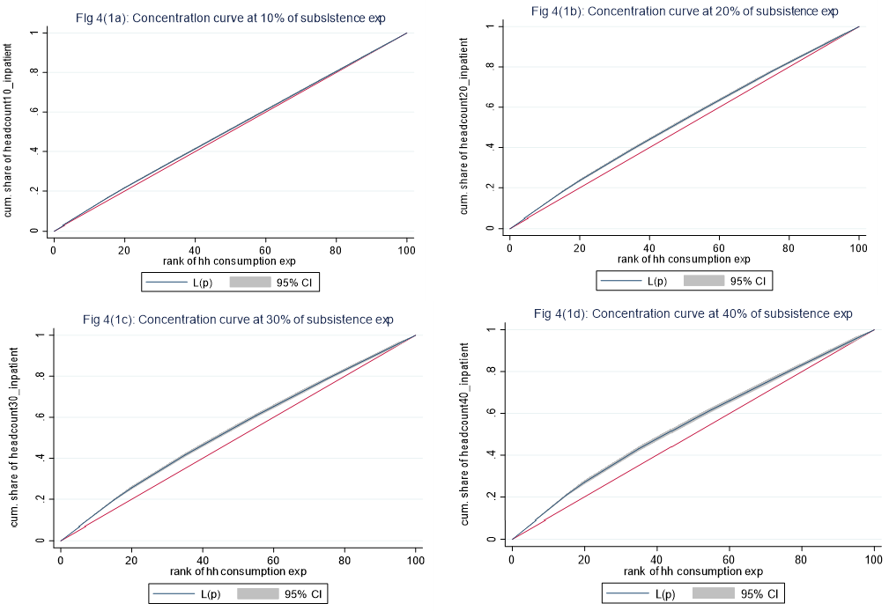
Concentration curve of incidence of CHE at non-subsistence expenditure (Tendulkar) due to inpatient services
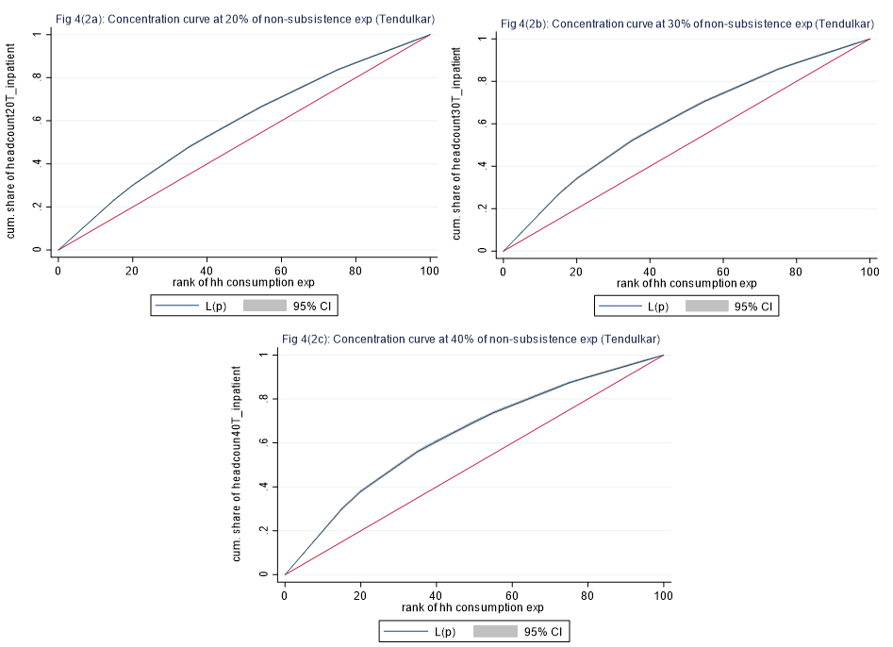
Concentration curve of incidence of CHE at non-subsistence expenditure (Rangarajan) due to inpatient services
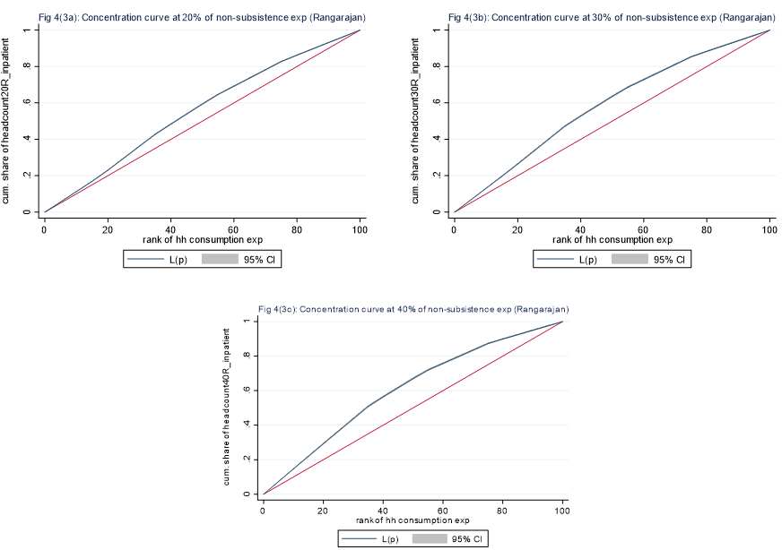
Figure 5: Concentration curve of incidence of CHE based on subsistence and non-subsistence expenditure among elderly due to outpatient services, 2018.
Concentration curve of incidence of CHE at subsistence expenditure due to outpatient services
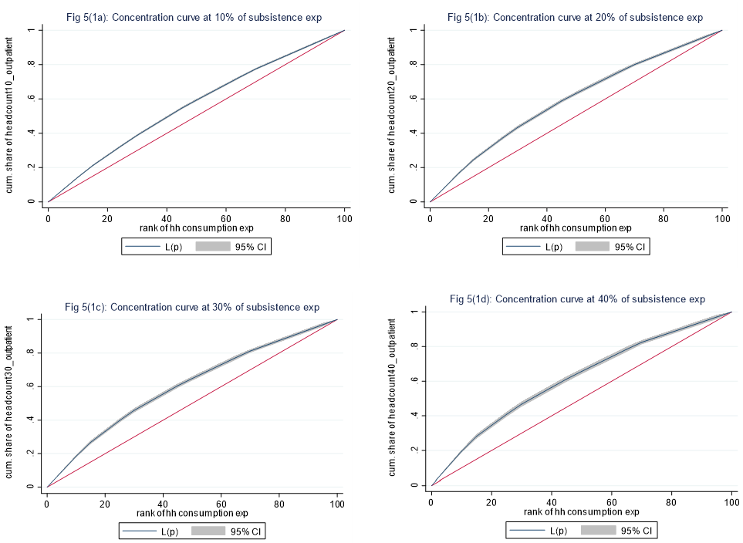
Concentration curve of incidence of CHE at non-subsistence expenditure (Tendulkar) due to outpatient services
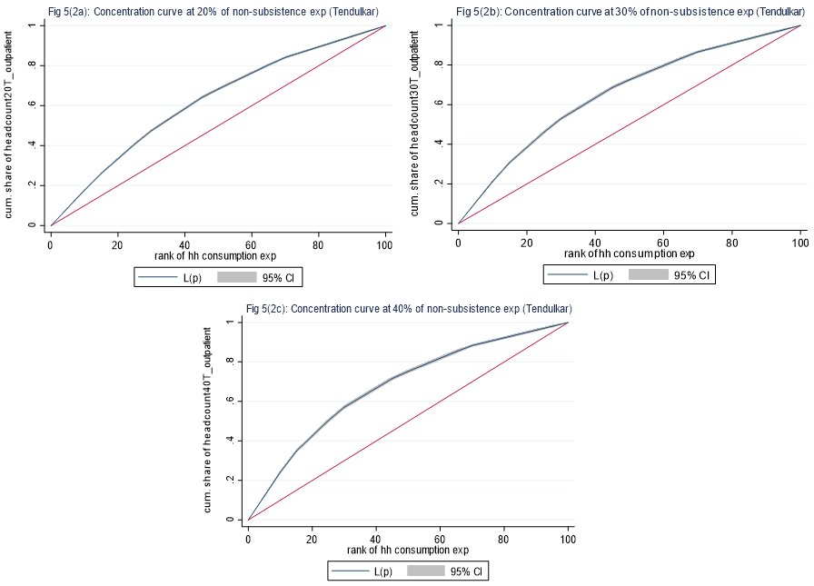
Concentration curve of incidence of CHE at non-subsistence expenditure (Rangarajan) due to outpatient service
