Supplementary Information 1
Palms predict the distributions of birds in southwestern Amazônia and are potential surrogates for land-use planning by local communities.
Bioviversity and Conservations
Juliana Menger^{1*}, Sergio Santorelli Junior², Thaise Emilio³, William E. Magnusson⁴, Marina Anciães⁴
¹ Helmholtz Centre for Environmental Research, Department of Conservation Biology, Leipzig, Germany
²Universidade Federal do Amazonas, Instituto de Educação, Agricultura e Ambiente, Manaus, Amazonas, Brazil
³ Instituto de Biologia, Universidade de Campinas, Campinas, São Paulo, Brazil
⁴ Instituto Nacional de Pesquisas da Amazônia, Coordenação de Biodiversidade, Manaus, Amazonas, Brazil
*Correspondent author:
E-mail: julianamenger@gmail.com

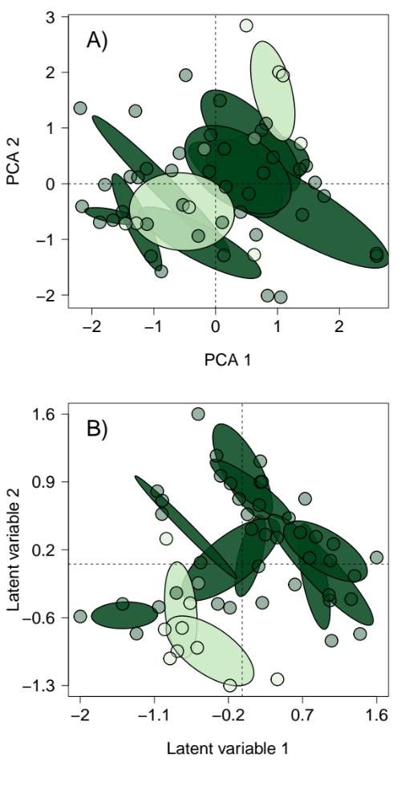
FigS1. Ordinations of environmental factors along the interfluve Purus-Madeira and the palm-species abundance used in the Procrustes analysis to compare the similarity of overall bird-species patterns. The color represents indicates samples taken in the dense forest (dark green) and open forest (light green) along the Purus-Madeira interfluve. The points represent the 250 m plots, and the ellipses represent the standard deviations of the points in each transect. A) the variation in environmental factors along the interfluve Purus-Madeira analyzed using Principal Components Analysis (PCA); B) Ordination results for palm-species abundances.
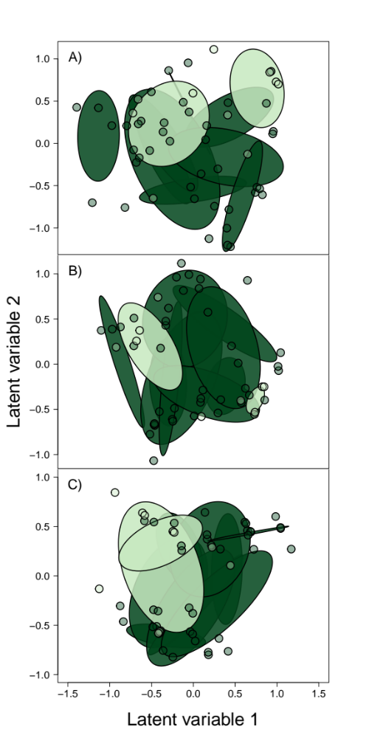

FigS2. Ordinations of bird-species co-occurrence based on presence and absence of species. The color represents the samples taken in the dense forest (dark green) and open forest (light green) along the Purus-Madeira interfluve. The points represent the 250 m plots, and the ellipses represent the standard deviations of the points in each transect. The letters A, B and C represent the taxonomic groups: A) All birds; B) Canopy birds; and C) Understory birds.

