Supplementary materials A
Confirmatory Factor Analysis (CFA) and Exploratory Factor Analysis (EFA) to assess factor loadings for the Structural Equational Model (SEM) used in ‘Facets of mindfulness act as a mediator between stressful life experiences, and stressful combat experiences, and Post-Traumatic Stress Symptoms (PTS-S) in UK Military Veterans
Harper, L., Jones, A., Goodwin, L. & Gillespie, S
Contents
Rationale 2
Methods 2
Results 3
Post-traumatic stress. 3
Mindfulness. 4
Conclusion 7
References 8

Rationale
Two CFA’s were used to test latent variables, before running a Structural Equation Model, as recommended by Nachtigall and colleagues [1]. There were no concerns regarding the CFA fit for the PCL-5, given its strong psychometric evidence [2], [3]. However, as research has reported psychometric issues in the latent structure and replicability of the FFMQ [4] the research team proposed that, if the CFA was not an acceptable fit for the FFMQ, an Exploratory Factor Analysis (EFA) would be required to assess the factor loadings of the FMMQ in this dataset. It is proposed that this method would offer the most reliable findings within the overall Structural Equation Model (SEM) to test the hypothesis in this research. There are not currently any measures of mindfulness which offer a sound methodological basis, as highlighted in Lucuona and colleagues [4] psychometric review of the FFMQ.

Methods
Amos Version 26 [5] was used for Confirmatory Factor Analysis (CFA). Model fit for CFAs were assessed through examination of: normed X² statistic (X²/df), Comparative Fit Index (CFI), Tucker-Lewis Index (TLI), Standardised Root Mean Square Residual (SRMR), and Root Mean Square Error of Approximation (RMSEA), as recommended by Brown [6] pp. 71-75. Normed X²/df ratios of < 2 [7] and CFI and TLI < 0.9 [8] were considered acceptable fit. SRMR values close to 0.08 were considered good fit [9]. RMSEA < 0.05 was considered good, > 0.05 to < 0.08 was acceptable [10] and > 0.08 to < 0.1 was mediocre [11]. Values were determined after inspection of the modification indices, and conclusions about the fit of the model took all measures into account
R Studio [12] was used for Exploratory Factor Analysis (EFA), to assess the factor loadings of the FFMQ in this dataset. As the data were ordinal, they were treated as polychoric [13]. Data were acceptable for EFA if the Keiser-Meyer-Olkin [14] was above 0.5 [15], and the Bartlett Test of Sphericity [16] was statistically significant at p < .05. A parallel analysis, using the Monte-Carlo simulation method [17], and a scree-plot [18] were used to identify an initial factor solution, which was followed by a principle component analysis with oblique rotation [19]. Items were removed if they had no loadings > 0.5, had loadings of > 0.35 on more than one factor, or if the factor was < 0.6 with > 0.2 on at least two other loadings [20].

Results

Post-traumatic stress.
A CFA of the PCL-5 was carried out, to test the factor loading of latent variables, outlined in figure 1. This demonstrated an acceptable fit for the data (X²/df = 3.372, CFI = 0.943, TLI = 0.933, SRMR = 0.0412, RMSEA = 0.074), with covariance pathways for two items within the Negative alterations cluster. Standard factor loadings indicated that all items appropriately reflected their underlying latent variables (p < 0.001)
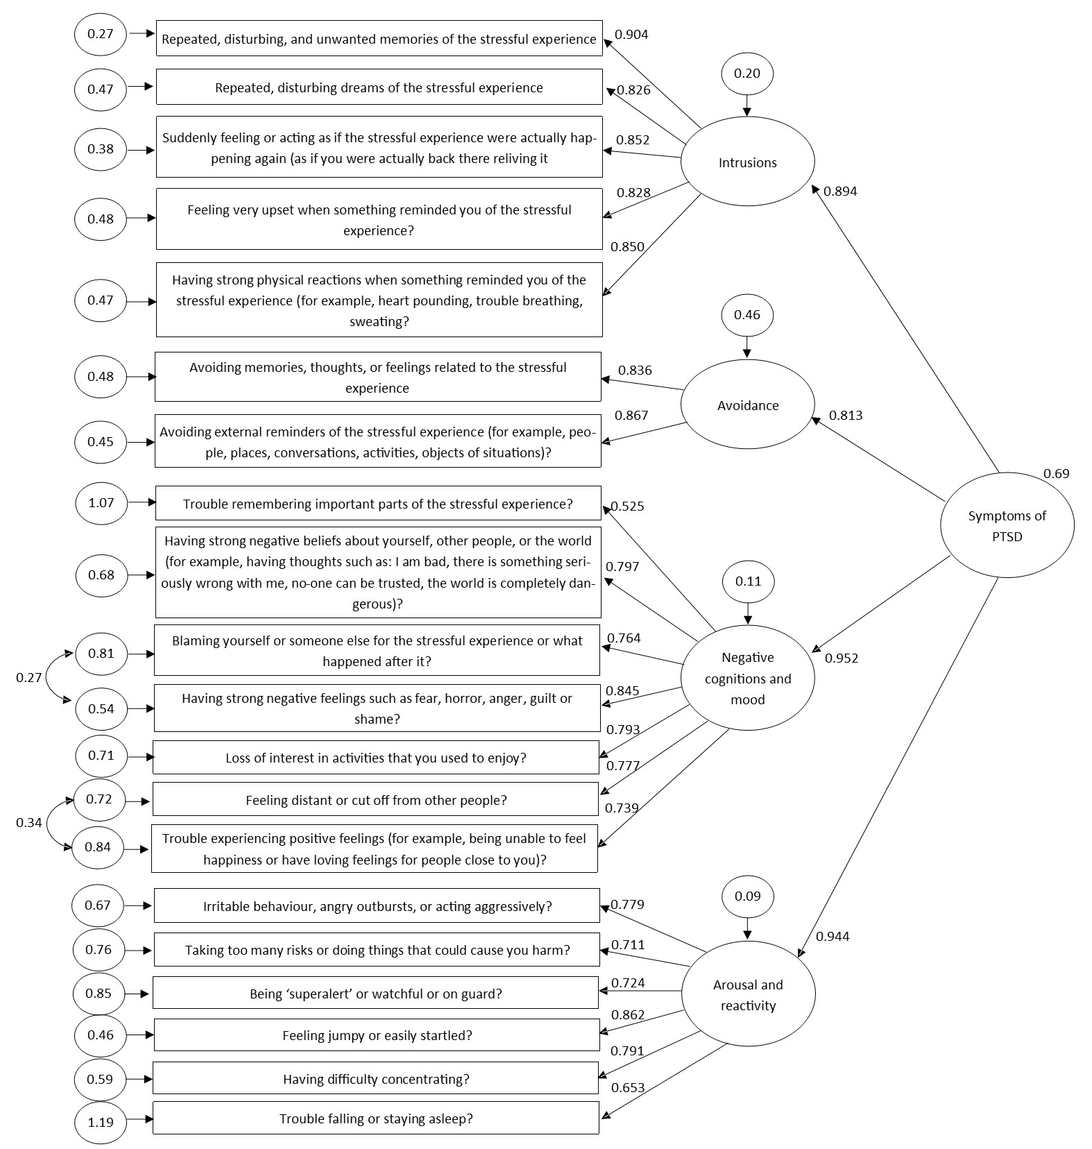
Figure 1. Confirmatory Factor Analysis model of the PCL-5 with standardised factor loadings (values with unidirectional arrows), error terms (circled values), and covariances (values with bidirectional arrows).

Mindfulness.
A CFA of the FFMQ, with latent variables for Observe, Describe, Act with awareness, Non-judge and Non-react, and an overarching Mindfulness latent variable, was not a good fit for the data (X²/df = 3.215, CFI = 0.814, TLI = 0.802, SRMR = 0.124, RMSEA = 0.071), nor did it fit the data without an overarching Mindfulness latent variable (X²/df = 3.073, CFI = 0.827, TLI = 0.815, SRMR= 0.109, RMSEA = 0.069). These results are consistent with findings from a psychometric review of the FFMQ, which concluded that the five-factor structure of this questionnaire fails to provide conceptual replication [4]. An exploratory factor analysis (EFA) was therefore completed for these data.
Pre-analysis checks confirmed that the data were acceptable for EFA (KMO = 0.90, Χ²₍₇₄₁₎ = 5051.66, p < 0.001). Participants’ data were randomly assigned to two near-equal groups, n¹ = 217 for exploratory analysis, and n² = 218 for confirmatory analysis. An exploratory parallel analysis and scree-plot initially identified a two-factor model, however on closer inspection these factors appeared to be a method effect due to reverse-scored items; a limitation of the FFMQ previously highlighted by Van Dam and colleagues [21]. A subsequent principle component analysis was conducted, with a varimax rotation, whereby a four-factor model gave the most parsimonious solution (with all components having Eigenvalues above 1). Twelve items were removed due to insufficient factor loadings; three from each facet except for non-judge, where no items were removed (table 1).
Table 1. Items from the FFMQ that were removed from analysis due to insufficient factor loadings
Original Facet | FFMQ No. | Question
OBS | 1 | When I’m walking, I deliberately notice the sensations of my body moving
OBS | 11 | I notice how foods and drinks affect my thoughts, bodily sensations, and emotions
OBS | 36 | I pay attention to how my emotions affect my thoughts and behaviour
DES | 12 | It’s hard for me to find the words to describe what I’m thinking
DES | 22 | When I have a sensation in my body, it’s difficult for me to describe it because I can’t find the right words (reverse scored)
DES | 18 | I find it difficult to stay focused on what’s happening in the present (reverse scored)
AWA | 13 | I am easily distracted
AWA | 16 | I have trouble thinking of the right words to express how I feel about things
AWA | 38 | I find myself doing things without paying attention (reverse scored)
NR | 4 | I perceive my feelings and emotions without having to react to them
NR | 9 | I watch my feelings without getting lost in them
NR | 19 | When I have distressing thoughts or images, I “step-back” and am aware of the thought or image without getting taken over by it

Table 2 outlines the items that made-up a four-factor model of mindfulness. The first factor was named Nonjudging awareness and consisted of items derived from the Act with awareness and Non-judge facets, all of which were reverse scored. All other factors were exclusively comprised of items from individual facets of the original FFMQ, and thus were named accordingly. Non-judging awareness explained 24% of the overall variance in the model; Describe explained 12%, Observe explained 9%, and Non-react explained 7% of the model variance.
Table 2. Items from the FFMQ that were included in the facet-factor model of mindfulness
Original Facet | FFMQ No. | Question | Factor loading
Nonjudging Awareness (eigenvalue = 9.29)
AWA | 5 | When I do things, my mind wanders off and I'm easily distracted (reverse scored) | 0.70
AWA | 8 | I don't pay attention to what I'm doing because I'm daydreaming, worrying, or otherwise distracted (reverse scored) | 0.69
AWA | 23 | It seems I am "running on automatic" without much awareness of what I'm doing (reverse scored) | 0.57
AWA | 28 | I rush through activities without being really attentive to them (reverse scored) | 0.58
AWA | 34 | I do jobs or tasks automatically without being aware of what I'm doing (reverse scored) | 0.54
NJ | 3 | I criticise myself for having irrational or inappropriate emotions (reverse scored) | 0.67
NJ | 10 | I tell myself I shouldn't be feeling the way I'm feeling (reverse scored) | 0.70
NJ | 14 | I believe some of my thoughts are abnormal or bad and I shouldn't think that way (reverse scored) | 0.73
NJ | 17 | I make judgements about whether my thoughts are good or bad (reverse scored) | 0.65
NJ | 25 | I tell myself that I shouldn't be thinking the way I'm thinking (reverse scored) | 0.75
NJ | 30 | I think some of my emotions are bad or inappropriate and I shouldn't feel them (reverse scored) | 0.72
NJ | 35 | When I have distressing thoughts or images, I judge myself as good or bad, depending what the thought/image is about (reverse scored) | 0.66
NJ | 39 | I disapprove of myself when I have irrational thoughts (reverse scored) | 0.67
Describe (eigenvalue = 4.64) |  |  | 4.64
DES | 2 | I'm good at finding words to describe my feelings | 0.71
DES | 7 | I can easily put my beliefs, opinions, and expectations into words | 0.61
DES | 27 | Even when I'm feeling terribly upset, I can find a way to put it into words | 0.62
DES | 32 | My natural tendency is to put my experiences into words | 0.71
DES | 37 | I can usually describe how I feel at the moment in considerable detail | 0.75
Observe (eigenvalue = 3.55) |  |  | 3.55
OBS | 6 | When I take a shower or bath, I stay alert to the sensations of water on my body | 0.62
OBS | 15 | I pay attention to sensations, such as the wind in my hair or sun on my face | 0.61
OBS | 20 | I pay attention to sounds, such as clocks ticking, birds chirping, or cars passing | 0.72
OBS | 26 | I notice the smells and aromas of things | 0.65
OBS | 31 | I notice visual elements in art or nature, such as colours, shapes, textures or patterns of light and shadow | 0.59
Non-react (eigenvalue = 2.91) |  |  | 2.91
NR | 21 | In different situations, I can pause without immediately reacting | 0.57
NR | 24 | When I have distressing thoughts or images, I feel calm soon after | 0.67
NR | 29 | When I have distressing thoughts or images, I am able to just notice them without reacting | 0.77
NR | 33 | When I have distressing thoughts or images, I just notice them and let them go | 0.75
*AWA= Act with awareness; NJ= Non-judge; DES= Describe; OBS= Observe; NR= Non-react

CFA of the second randomised data group confirmed a good overall fit for the data, thus a CFA for the whole dataset (n = 435) is presented in figure 2. This four-facet model was acceptable for the data when facets were presented as independent, which was accounted for in co-variances, and did not make up an overall measure of mindfulness (Χ²/df = 2.695, CFI = 0.890, TLI = 0.877, SRMR = 0.1158, RMSEA = 0.063). This supports Baer and colleagues [22] theoretical argument that mindfulness should be viewed as a multifaceted construct. Nonjudging awareness was negatively correlated with Observe (r = -0.328, p < 0.001), and positively correlated with Non-react (r = 0.44, p = 0.095). All other facets were positively correlated at p < 0.001 (appendix 3.14). Five covariances were identified in the modification indices for Non-judging awareness.

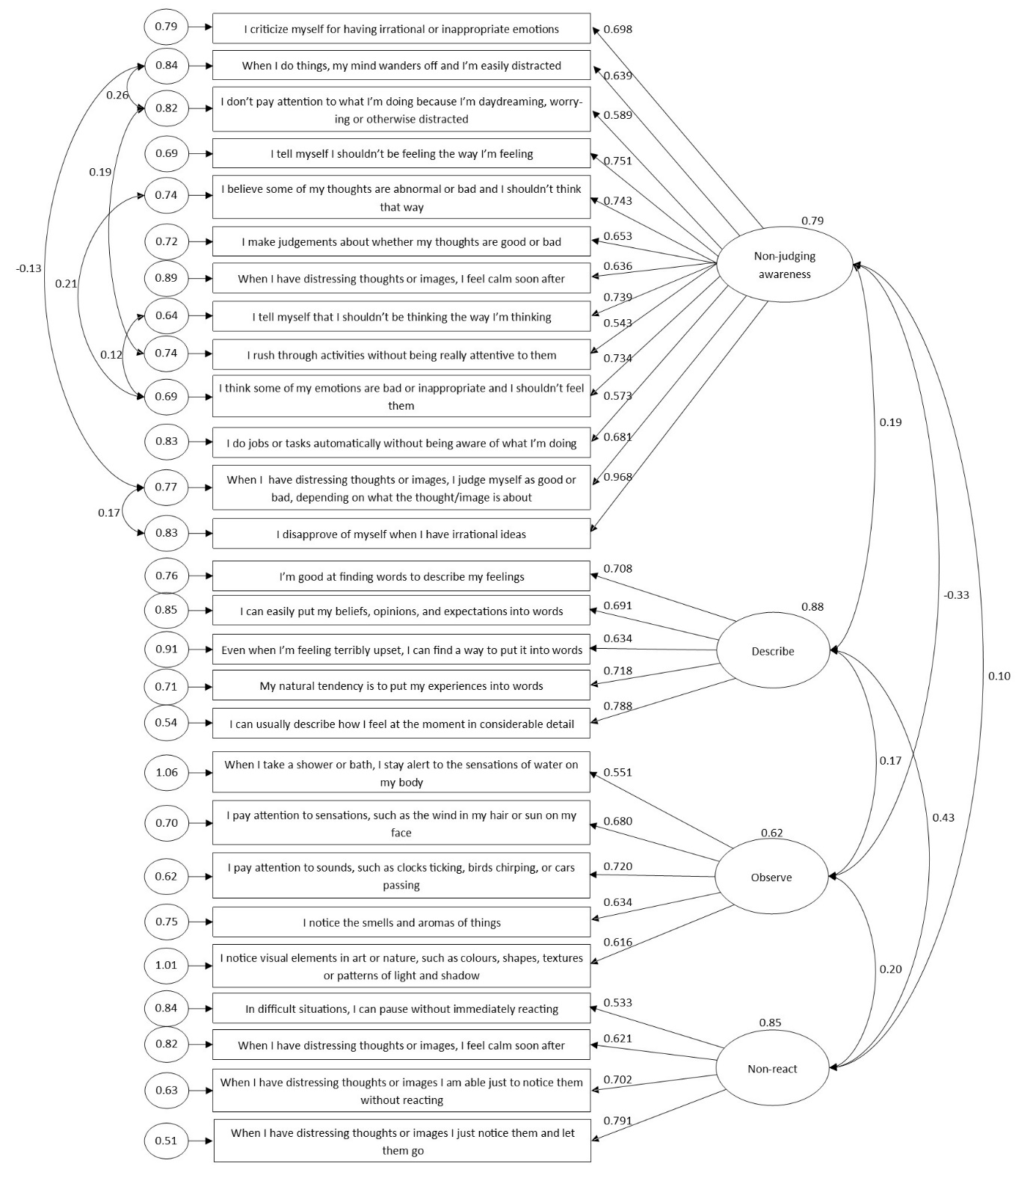
Figure 2. Confirmatory Factor Analysis model of a four-factor model of mindfulness, taken from the FFMQ, with standardised factor loadings (value corresponding to one-way arrows), error terms (circled values) and covariances (values corresponding to two-way arrows).

Conclusion
The factor-structure of the FFMQ did not fit with the dataset used in this analysis. This supports Lecuana and colleagues [4] conclusions that there the latent structure of the FFMQ is not replicable, and there are psychometric issues with the FFMQ across research samples. The Non-judging awareness facet was derived exclusively from reverse score items, thus could be related to methodological bias [21]. Moreover, only 52% of variance in the Exploratory Factor Analysis of the FFMQ was explained by mindfulness facets, with Non-react only accounting for 7% of this variance. Whilst the four-factor model of mindfulness used in this analysis is valid to this dataset, additional testing and exploration should be considered why comparing these results across research.

References
[1] C. Nachtigall, U. Kroehne, F. Funke, and R. Steyer, “(Why) should we use SEM? Pros and cons of structural equation modeling,” Methods Psychol. Res. Online, vol. 8, no. 2, pp. 1–22, 2003.
[2] J. H. Wortmann et al., “Psychometric analysis of the PTSD checklist-5 (PCL-5) among treatment-seeking military service Mmmbers,” Psychol. Assess. public domain 2016, vol. 28, no. 11, pp. 1392–1403, 2016, doi: 10.1037/pas0000260.
[3] M. J. Bovin et al., “Psychometric properties of the PTSD checklist for diagnostic and statistical manual of mental disorders – fifth edition (PCL-5) in veterans.,” Psychol. Assess., vol. 28, no. 11, pp. 1379–1391, Nov. 2016, doi: 10.1037/pas0000254.
[4] O. Lecuona, E. García-Garzón, C. García-Rubio, and R. Rodríguez-Carvajal, “A Psychometric Review and Conceptual Replication Study of the Five Facets Mindfulness Questionnaire Latent Structure,” Assessment, vol. 27, no. 5, pp. 859–872, Jul. 2020, doi: 10.1177/1073191119873718.
[5] J. . Arbuckle, “Amos (Version 26.0).” IMB SPSS, Chicago, 2019.
[6] T. A. Brown, Confirmatory Factor Analysis for Applied Research, Second Edi. New York, NY: The Guilford Press, 2015.
[7] J. B. Ullman, “Structural equation modeling,” in Using Multivariate Statistics, 4th Editio., B. G. Tabachnick and L. S. Fidell, Eds. Needham Heights, MA: Allyn & Bacon, 2001, pp. 653–771.
[8] P. M. Bentler, “Comparative fit indexes in structural models,” Psychol. Bull., vol. 107, no. 2, pp. 238–246, 1990, doi: 10.1037/0033-2909.107.2.238.
[9] L. T. Hu and P. M. Bentler, “Cutoff criteria for fit indexes in covariance structure analysis: Conventional criteria versus new alternatives,” Struct. Equ. Model., vol. 6, no. 1, pp. 1–55, 1999, doi: 10.1080/10705519909540118.
[10] M. W. Browne and R. Cudeck, “Alternative ways of assessing model fit,” in Testing structural equation models, K. . Bollen and J. . Long, Eds. Newbury Park, CA: Sage, 1993, pp. 136–162.
[11] R. C. MacCallum, M. W. Browne, and H. M. Sugawara, “Power analysis and determination of sample size for covariance structure modeling,” Psychol. Methods, vol. 1, no. 2, pp. 130–149, 1996, doi: 10.1037/1082-989X.1.2.130.
[12] R Core Team, “R: A language and environment for statistical computing.” R Foundation for Statistical Computing, Vienna, Austria, 2017.
[13] F. Holgado-Tello et al., “Polychoric versus Pearson correlations in Exploratory and Confirmatory Factor Analysis with ordinal variables,” Qual Quant, vol. 44, pp. 153–166, 2010, doi: 10.1007/s11135-008-9190-y.
[14] H. F. Kaiser, “An index of factorial simplicity,” Psychometrika, vol. 39, no. 1, pp. 31–36, Mar. 1974, doi: 10.1007/BF02291575.
[15] G. D. Hutcheson and N. Sofroniou, The Multivariate Social Scientist. London, UK: SAGE Publications Ltd, 1999.
[16] M. . Bartlett, “Tests of significance in factor analysis,” Br. J. Stat. Psychol., vol. 3, no. 2, pp. 77–85, Jun. 1950, doi: 10.1111/j.2044-8317.1950.tb00285.x.
[17] L. W. Glorfeld, “An Improvement on Horn’s Parallel Analysis Methodology for Selecting the Correct Number of Factors to Retain,” Educ. Psychol. Meas., vol. 55, no. 3, pp. 377–393, Jun. 1995, doi: 10.1177/0013164495055003002.
[18] R. B. Cattell, “The scree test for the number of factors,” Multivariate Behav. Res., vol. 1, no. 2, pp. 245–276, Apr. 1966, doi: 10.1207/s15327906mbr0102_10.
[19] M. Parul, M. Jain, and K. Shandliya, “A survey paper on comparative study between Principal Component Analysis (PCA) and Exploratory Factor Analysis (EFA),” Int. J. Comput. Sci. Appl., vol. 6, no. 2, pp. 373–375, 2013, Accessed: Mar. 12, 2021. [Online]. Available: www.researchpublications.org.
[20] J. . Nunnally and I. . Bernstein, Psychometric theory, 3rd ed. New York, NY: McGraw-Hill, 1994.
[21] N. T. Van Dam, A. L. Hobkrik, S. Danoff-Burg, and M. Earleywine, “Mind Your Words: Positive and negative items create method effects on the five facet mindfulness questionnaire,” Assessment, vol. 19, no. 2, pp. 198–204, 2012.
[22] R. A. Baer, G. T. Smith, J. Hopkins, J. Krietemeyer, and L. Toney, “Using Self-Report Assessment Methods to Explore Facets of Mindfulness,” Assessment, vol. 13, no. 1, pp. 27–45, 2006, doi: 10.1177/1073191105283504.

