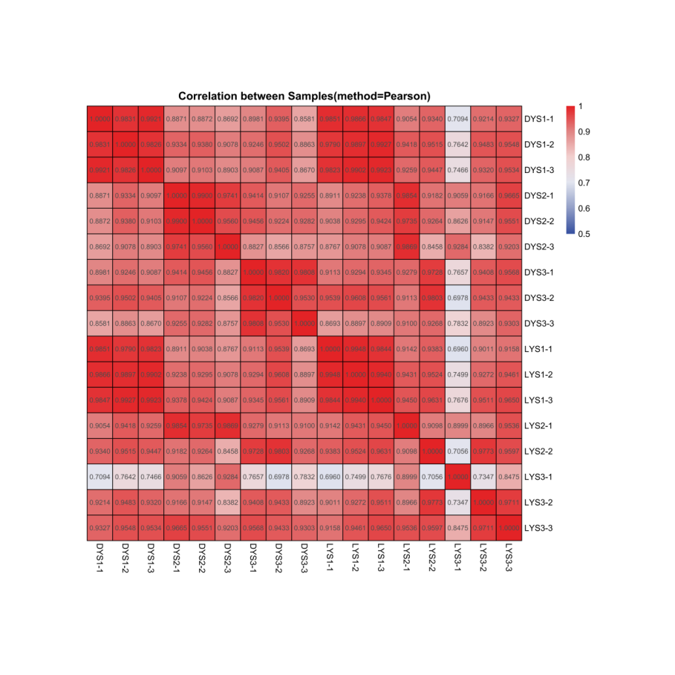
Figure S1 Heat map for correlation between RNA sequencing samples. Redder color indicates higher correlation between samples. S1 through S3 correspond to different time-points of sampling, while -1, -2, and -3 refer to three biological replicates obtained at each time-point.

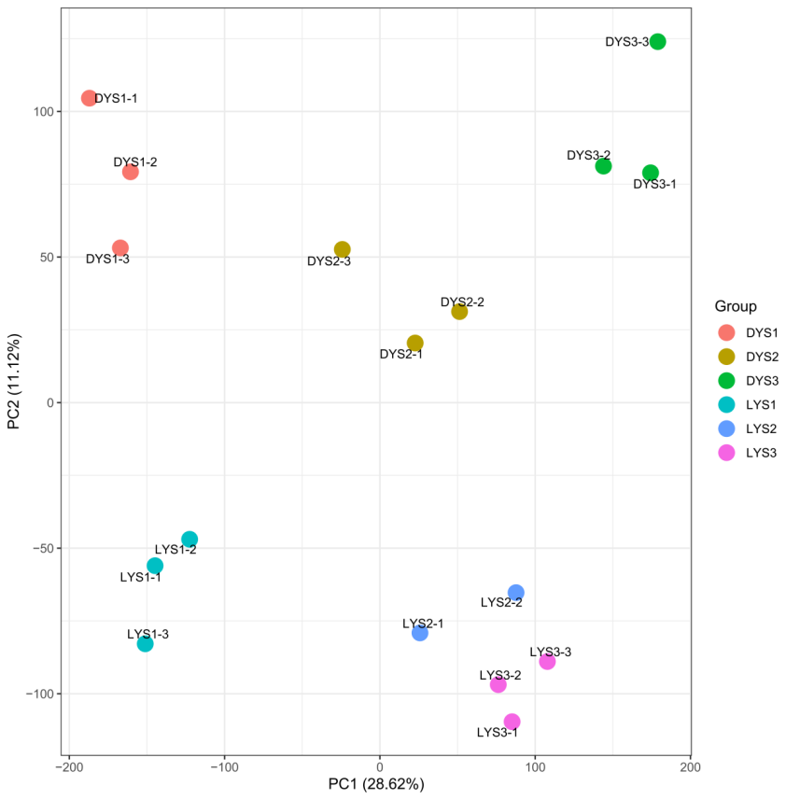
Figure S2 The principal component analysis (PCA) analysis of 17 samples
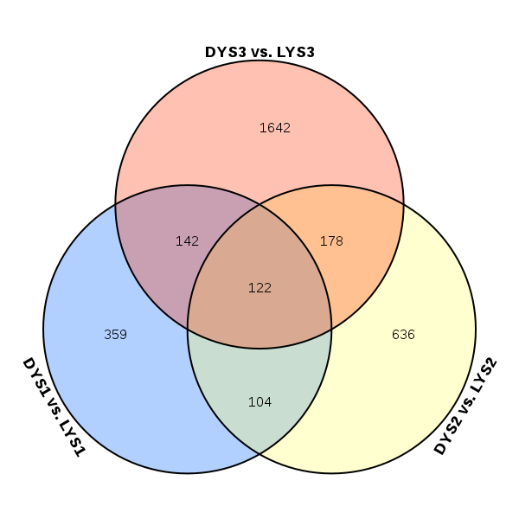
Figure S3 Venn diagrams of DEGs ibetween the DY and LY during seed development

