Table S1. Characteristics of 584,846 cases of SARS-CoV-2 infection between October 1, 2020, and August 29, 2022

 | N | (%)
Age (years)
18 – 29 | 69336 | 11.9%
30 – 39 | 128556 | 22.0%
40 – 49 | 148082 | 25.3%
50 – 59 | 124130 | 21.2%
60 – 69 | 77224 | 13.2%
≥ 70 | 37518 | 6.4%
Gender
Female | 386182 | 66.0%
Region of residence
Île-de-France | 126500 | 21.6%
Auvergne-Rhône-Alpes | 83712 | 14.3%
Occitanie | 53889 | 9.2%
Grand Est | 50890 | 8.7%
Provence-Alpes-Côte d'Azur and Corsica | 50510 | 8.6%
Nouvelle-Aquitaine | 48012 | 8.2%
Hauts-de-France | 48001 | 8.2%
Pays de la Loire | 31224 | 5.3%
Bretagne | 25751 | 4.4%
Bourgogne-Franche-Comté | 23578 | 4.0%
Normandie | 23094 | 3.9%
Centre - Val de Loire | 19685 | 3.4%
Population of place of residence
Rural or < 5,000 | 146230 | 25.0%
5,000 – 19,999 | 59244 | 10.1%
20,000 – 99,999 | 69280 | 11.8%
100,000 + | 195997 | 33.5%
Paris urban area | 114095 | 19.5%
Professional category
Intermediate profession | 97984 | 17.2%
Independent profession | 20903 | 3.7%
Senior executive | 176995 | 31.1%
Employee | 117577 | 20.6%
Worker, farmer, etc. | 29759 | 5.2%
Retired | 81718 | 14.3%
Unemployed or student | 44702 | 7.8%
Level of education
No high school diploma | 99717 | 17.1%
High school diploma | 106138 | 18.1%
Bachelor's degree | 195992 | 33.5%
Master's degree | 182999 | 31.3%
Comorbidities
Obesity | 92862 | 15.9%
Hypertension | 59645 | 10.2%
Chronic respiratory disease | 48476 | 8.3%
Immunosuppression | 22499 | 4.0%
Diabetes mellitus | 18716 | 3.2%
Coronary artery disease | 6012 | 1.0%
Symptoms of COVID-19 (current episode)
Yes | 519503 | 88.8%

Table S2. Characteristics of 584,846 cases of SARS-CoV-2 infection by period

 | Period 1  10/01/20 to 12/03/20 |  | Period 2  12/04/20 to 04/08/21 |  | Period 3  04/09/21 to 06/13/21 |  | Period 4  06/14/21 to 08/13/21 |  | Period 5  08/14/21 to 10/01/21 |  | Period 6  10/02/21 to 12/19/21 |  | Period 7  12/20/21 to 03/17/22 |  | Period 8  03/18/22 to 05/19/22 |  | Period 9  05/20/22 to 08/29/22
 | N  (45011) | % | N  (86157) | % | N  (26106) | % | N  (14501) | % | N  (9411) | % | N (56310) | % | N (179699) | % | N (81291) | % | N (84156) | %
Age (years)
18 – 29 | 6221 | 13.8% | 12747 | 14.8% | 4193 | 16.1% | 3524 | 24.3% | 1301 | 13.8% | 6926 | 12.3% | 23768 | 13.2% | 5302 | 6.5% | 4990 | 5.9%
30 – 39 | 9836 | 21.9% | 20224 | 23.5% | 6756 | 25.9% | 3884 | 26.8% | 2575 | 27.4% | 14048 | 24.9% | 43754 | 24.3% | 14113 | 17.4% | 12954 | 15.4%
40 – 49 | 11241 | 25.0% | 22250 | 25.8% | 6759 | 25.9% | 3163 | 21.8% | 2352 | 25.0% | 15358 | 27.3% | 48833 | 27.2% | 19782 | 24.3% | 17919 | 21.3%
50 – 59 | 9935 | 22.1% | 17835 | 20.7% | 5311 | 20.3% | 2196 | 15.1% | 1598 | 17.0% | 10595 | 18.8% | 34712 | 19.3% | 19643 | 24.2% | 21898 | 26.0%
60 – 69 | 5605 | 12.5% | 9470 | 11.0% | 2387 | 9.1% | 1184 | 8.2% | 1009 | 10.7% | 6952 | 12.3% | 19124 | 10.6% | 14189 | 17.5% | 16957 | 20.1%
≥ 70 | 2173 | 4.8% | 3631 | 4.2% | 700 | 2.7% | 550 | 3.8% | 576 | 6.1% | 2431 | 4.3% | 9508 | 5.3% | 8262 | 10.2% | 9438 | 11.2%
Gender
Female | 28170 | 62.6% | 53933 | 62.6% | 16645 | 63.8% | 9594 | 66.2% | 6113 | 65.0% | 35614 | 63.2% | 122742 | 68.3% | 56414 | 69.4% | 55686 | 66.2%
Region of residence
Île-de-France | 8652 | 19.2% | 21048 | 24.4% | 6838 | 26.2% | 2570 | 17.7% | 1984 | 21.1% | 12972 | 23.0% | 34407 | 19.1% | 18078 | 22.2% | 19489 | 23.2%
Auvergne-Rhône-Alpes | 10148 | 22.5% | 12666 | 14.7% | 3646 | 14.0% | 1880 | 13.0% | 1219 | 13.0% | 8962 | 15.9% | 25589 | 14.2% | 9484 | 11.7% | 9796 | 11.6%
Occitanie | 3161 | 7.0% | 6300 | 7.3% | 1926 | 7.4% | 2523 | 17.4% | 1077 | 11.4% | 5361 | 9.5% | 17259 | 9.6% | 7300 | 9.0% | 8789 | 10.4%
Grand Est | 3718 | 8.3% | 7388 | 8.6% | 1820 | 7.0% | 721 | 5.0% | 643 | 6.8% | 4410 | 7.8% | 18557 | 10.3% | 7140 | 8.8% | 6276 | 7.5%
Provence-Alpes-Côte d'Azur and Corsica | 3658 | 8.1% | 8741 | 10.1% | 1642 | 6.3% | 2382 | 16.4% | 1542 | 16.4% | 5335 | 9.5% | 14031 | 7.8% | 6169 | 7.6% | 6776 | 8.1%
Nouvelle-Aquitaine | 2625 | 5.8% | 5059 | 5.9% | 1650 | 6.3% | 1572 | 10.8% | 684 | 7.3% | 4768 | 8.5% | 17339 | 9.6% | 6177 | 7.6% | 7983 | 9.5%
Hauts-de-France | 4330 | 9.6% | 8721 | 10.1% | 2569 | 9.8% | 696 | 4.8% | 685 | 7.3% | 4234 | 7.5% | 13251 | 7.4% | 7014 | 8.6% | 6275 | 7.5%
Pays de la Loire | 2094 | 4.7% | 4044 | 4.7% | 1622 | 6.2% | 609 | 4.2% | 391 | 4.2% | 3048 | 5.4% | 10028 | 5.6% | 4524 | 5.6% | 4773 | 5.7%
Bretagne | 1160 | 2.6% | 2388 | 2.8% | 1069 | 4.1% | 552 | 3.8% | 409 | 4.3% | 2071 | 3.7% | 8898 | 5.0% | 4655 | 5.7% | 4493 | 5.3%
Bourgogne-Franche-Comté | 2200 | 4.9% | 3547 | 4.1% | 993 | 3.8% | 275 | 1.9% | 285 | 3.0% | 2046 | 3.6% | 7589 | 4.2% | 3403 | 4.2% | 3146 | 3.7%
Normandie | 1707 | 3.8% | 3446 | 4.0% | 1350 | 5.2% | 478 | 3.3% | 260 | 2.8% | 1579 | 2.8% | 6894 | 3.8% | 3983 | 4.9% | 3303 | 3.9%
Centre - Val de Loire | 1558 | 3.5% | 2809 | 3.3% | 981 | 3.8% | 243 | 1.7% | 232 | 2.5% | 1524 | 2.7% | 5857 | 3.3% | 3364 | 4.1% | 3057 | 3.6%
Population of place of residence
Rural or < 5,000 | 11483 | 25.5% | 21367 | 24.8% | 6482 | 24.8% | 3016 | 20.8% | 1946 | 20.7% | 13301 | 23.6% | 46402 | 25.8% | 20937 | 25.8% | 20786 | 24.7%
5,000 - 19,999 | 4441 | 9.9% | 8292 | 9.6% | 2486 | 9.5% | 1315 | 9.1% | 851 | 9.0% | 5301 | 9.4% | 18921 | 10.5% | 8627 | 10.6% | 8773 | 10.4%
20,000 - 99,999 | 5513 | 12.2% | 9952 | 11.6% | 2898 | 11.1% | 1671 | 11.5% | 1137 | 12.1% | 6210 | 11.0% | 21308 | 11.9% | 10214 | 12.6% | 10100 | 12.0%
100,000 + | 15767 | 35.0% | 27676 | 32.1% | 8137 | 31.2% | 6142 | 42.4% | 3649 | 38.8% | 19573 | 34.8% | 61995 | 34.5% | 25321 | 31.1% | 26964 | 32.0%
Paris urban area | 7807 | 17.3% | 18870 | 21.9% | 6103 | 23.4% | 2357 | 16.3% | 1828 | 19.4% | 11925 | 21.2% | 31073 | 17.3% | 16192 | 19.9% | 17533 | 20.8%
Professional category
Intermediate profession | 5466 | 18.2% | 15418 | 17.9% | 4495 | 17.2% | 2355 | 16.2% | 1565 | 16.6% | 9412 | 16.7% | 32544 | 18.1% | 13275 | 16.3% | 13151 | 15.6%
Independent profession | 1138 | 3.8% | 3538 | 4.1% | 1151 | 4.4% | 840 | 5.8% | 421 | 4.5% | 2454 | 4.4% | 6915 | 3.8% | 2102 | 2.6% | 2251 | 2.7%
Senior executive | 10517 | 35.1% | 24394 | 28.3% | 7423 | 28.4% | 4031 | 27.8% | 2557 | 27.2% | 20244 | 36.0% | 56213 | 31.3% | 24978 | 30.7% | 26274 | 31.2%
Employee | 5534 | 18.5% | 19861 | 23.1% | 6447 | 24.7% | 3389 | 23.4% | 2105 | 22.4% | 10743 | 19.1% | 38496 | 21.4% | 15773 | 19.4% | 14841 | 17.6%
Worker, farmer, etc. | 1852 | 6.2% | 5608 | 6.5% | 2052 | 7.9% | 911 | 6.3% | 628 | 6.7% | 2560 | 4.5% | 9320 | 5.2% | 3282 | 4.0% | 3370 | 4.0%
Retired | 4134 | 13.8% | 9148 | 10.6% | 2012 | 7.7% | 1177 | 8.1% | 1168 | 12.4% | 6579 | 11.7% | 20780 | 11.6% | 16797 | 20.7% | 19500 | 23.2%
Unemployed or student | 1353 | 4.5% | 8190 | 9.5% | 2526 | 9.7% | 1798 | 12.4% | 967 | 10.3% | 4318 | 7.7% | 15431 | 8.6% | 5084 | 6.3% | 4769 | 5.7%
Level of education
No high school diploma | 1646 | 3.7% | 18366 | 21.3% | 5660 | 21.7% | 2570 | 17.7% | 2027 | 21.5% | 9067 | 16.1% | 30727 | 17.1% | 14204 | 17.5% | 14823 | 17.6%
High school diploma | 1538 | 3.4% | 18290 | 21.2% | 5584 | 21.4% | 3098 | 21.4% | 1934 | 20.6% | 9958 | 17.7% | 34533 | 19.2% | 15407 | 19.0% | 15432 | 18.3%
Bachelor's degree | 2409 | 5.4% | 29624 | 34.4% | 8905 | 34.1% | 5087 | 35.1% | 3199 | 34.0% | 19742 | 35.1% | 65416 | 36.4% | 30117 | 37.0% | 31083 | 36.9%
Master's degree | 39418 | 87.6% | 19877 | 23.1% | 5957 | 22.8% | 3746 | 25.8% | 2251 | 23.9% | 17543 | 31.2% | 49023 | 27.3% | 21563 | 26.5% | 22818 | 27.1%
Comorbidities
Obesity | 7276 | 16.2% | 14049 | 16.3% | 4362 | 16.7% | 1740 | 12.0% | 1324 | 14.1% | 7433 | 13.2% | 27066 | 15.1% | 14214 | 17.5% | 14993 | 17.8%
Hypertension | 4323 | 9.6% | 7678 | 8.9% | 2045 | 7.8% | 920 | 6.3% | 766 | 8.1% | 4628 | 8.2% | 15692 | 8.7% | 11009 | 13.5% | 12312 | 14.6%
Chronic respiratory disease | 3787 | 8.4% | 6701 | 7.8% | 2097 | 8.0% | 1155 | 8.0% | 789 | 8.4% | 4033 | 7.2% | 14976 | 8.3% | 7232 | 8.9% | 7484 | 8.9%
Immunosuppression | 1211 | 2.7% | 2278 | 2.6% | 689 | 2.6% | 375 | 2.6% | 287 | 3.0% | 400 | 0.7% | 7015 | 3.9% | 4421 | 5.4% | 4666 | 5.5%
Diabetes mellitus | 1512 | 3.4% | 2583 | 3.0% | 690 | 2.6% | 329 | 2.3% | 281 | 3.0% | 1383 | 2.5% | 4916 | 2.7% | 3251 | 4.0% | 3620 | 4.3%
Coronary artery disease | 471 | 1.0% | 759 | 0.9% | 141 | 0.5% | 105 | 0.7% | 77 | 0.8% | 477 | 0.8% | 1593 | 0.9% | 1084 | 1.3% | 1260 | 1.5%
Symptoms of COVID-19 (current episode)ª
Yes | 30676 | 68.2% | 73757 | 85.6% | 22564 | 86.4% | 13190 | 91.0% | 8431 | 89.6% | 51858 | 92.1% | 161175 | 89.7% | 76197 | 93.7% | 80327 | 95.5%
History of SARS-CoV-2 infection^{b}
Yes | / | / | / | / | 645 | 2.5% | 554 | 3.8% | 340 | 3.6% | 1961 | 3.5% | 13233 | 7.4% | 6076 | 7.5% | 13232 | 15.7%

ª Collection of data concerning the symptomatic status of ongoing infections was introduced from period 2 onward. In period 1, participants were categorized as symptomatic only if their symptoms were the primary reason for the test.
^{b} Until February 18, 2021, participants with a history of SARS-CoV-2 infection (virological or serological test) were not included in the study.

Table S3. Characteristics of the sources of SARS-CoV-2 infection from inside and outside the household by period

 | Period 1  10/01/20 to 12/03/20 |  | Period 2  12/04/20 to 04/08/21 |  | Period 3  04/09/21 to 06/13/21 |  | Period 4  06/14/21 to 08/13/21 |  | Period 5  08/14/21 to 10/01/21 |  | Period 6  10/02/21 to 12/19/21 |  |  | Period 7  12/20/21 to 03/17/22 |  |  | Period 8  03/18/22 to 05/19/22 |  |  | Period 9  05/20/22 to 08/29/22
 | N | % | N | % | N | % | N | % | N | % | N | % | N |  | % | N |  | % | N |  | %
Source casesª
Not known | 16625 | 36.9% | 31799 | 36.9% | 9812 | 37.6% | 5330 | 36.8% | 3682 | 39.1% | 19953 | 35.5% | 46761 |  | 27.8% | 20583 |  | 25.3% | 22396 |  | 26.6%
Event suspected | 8761 | 19.5% | 14039 | 16.3% | 3891 | 14.9% | 3675 | 25.3% | 2084 | 22.1% | 13437 | 23.9% | 37564 |  | 22.4% | 21799 |  | 26.8% | 27024 |  | 32.1%
Household | 8329 | 18.5% | 17878 | 20.8% | 6011 | 23.0% | 2319 | 16.0% | 1823 | 19.4% | 10990 | 19.5% | 44678 |  | 26.6% | 18933 |  | 23.3% | 14042 |  | 16.7%
Work | 3238 | 7.2% | 6162 | 7.2% | 1754 | 6.7% | 638 | 4.4% | 328 | 3.5% | 3277 | 5.8% | 7365 |  | 4.4% | 6262 |  | 7.7% | 6537 |  | 7.8%
Extended family | 3844 | 8.5% | 8357 | 9.7% | 2301 | 8.8% | 944 | 6.5% | 742 | 7.9% | 3234 | 5.7% | 15693 |  | 9.3% | 5525 |  | 6.8% | 5356 |  | 6.4%
Friend | 2145 | 4.8% | 4686 | 5.4% | 1452 | 5.6% | 856 | 5.9% | 376 | 4.0% | 2665 | 4.7% | 8310 |  | 4.9% | 2942 |  | 3.6% | 3066 |  | 3.6%
Other | 2067 | 4.6% | 3204 | 3.7% | 884 | 3.4% | 738 | 5.1% | 373 | 4.0% | 2690 | 4.8% | 7694 |  | 4.6% | 5247 |  | 6.5% | 5735 |  | 6.8%
ª From January 2022 on, it was possible for participants to mention whether they had doubts or not about the identification of the source of infection.

Table S4. Characteristics of the source cases according to their origin between October 1, 2020, and August 29, 2022

 | Household  (n = 125 397) |  | Work  (n = 35 627) |  | Family  (n = 46 132) |  | Friend  (n = 26 580) |  | P value
Age (years) Median (IQR) | 28 (11-48) |  | 40 (30-50) |  | 40 (26-60) |  | 39 (28-55)
 | N | % | N | % | N | % | N | %
Age category |  |  |  |  |  |  |  |  | < 0.001
< 18 years | 48115 | 38.4% | 2063 | 5.8% | 6296 | 13.6% | 1277 | 4.8%
18-29 years | 16308 | 13.0% | 5085 | 14.3% | 7814 | 16.9% | 6347 | 23.8%
30-49 years | 32544 | 26.0% | 17079 | 47.9% | 13842 | 30.0% | 10028 | 37.7%
50-69 years | 24201 | 19.3% | 10417 | 29.2% | 11893 | 25.8% | 6611 | 24.8%
≥ 70 years | 4229 | 3.4% | 983 | 2.8% | 6287 | 13.6% | 2317 | 8.7%
Gender |  |  |  |  |  |  |  |  | < 0.001
Female | 51128 | 40.8% | 17787 | 49.9% | 25592 | 55.5% | 14381 | 54.1%

Table S5. Characteristics of single-encounter meetings during which SARS-CoV-2 infection took place according to the origin of the source case (household members excluded) and stratified by the symptomatic status of the source case between October 1, 2020 and August 29, 2022

 | Total |  |  |  | P value | Work |  |  |  | P value | Family |  |  |  | P value | Friends |  |  |  | P value
 | Symptomatic |  |  |  | P value | Symptomatic |  |  |  | P value | Symptomatic |  |  |  | P value | Symptomatic |  |  |  | P value
 | No |  | Yes |  | P value | No |  | Yes |  | P value | No |  | Yes |  | P value | No |  | Yes |  | P value
 | N | % | N | % |  | N | % | N | % |  | N | % | N | % |  | N | % | N | %
Location of encounter |  |  |  |  | <0.001 |  |  |  |  | < 0.001 |  |  |  |  | 0.020 |  |  |  |  | 0.316
Indoors with closed windows | 31873 | 70.4% | 17357 | 70.8% |  | 5176 | 76.1% | 4147 | 77.3% |  | 9488 | 71.4% | 5835 | 69.6% |  | 9040 | 69.0% | 3472 | 68.5%
Indoors with open windows | 9436 | 20.9% | 5251 | 21.4% |  | 1253 | 18.4% | 1006 | 18.7% |  | 3050 | 23.0% | 2031 | 24.2% |  | 3040 | 23.2% | 1171 | 23.1%
Outdoors | 3944 | 8.7% | 1919 | 7.8% |  | 369 | 5.4% | 213 | 4.0% |  | 751 | 5.7% | 513 | 6.1% |  | 1014 | 7.7% | 427 | 8.4%
Duration of encounter |  |  |  |  | <0.001 |  |  |  |  | 0.002 |  |  |  |  | < 0.001 |  |  |  |  | 0.346
Less than a minute | 3831 | 8.5% | 2519 | 10.3% |  | 826 | 12.2% | 702 | 13.1% |  | 1046 | 7.9% | 839 | 10.0% |  | 979 | 7.5% | 410 | 8.1%
Less than 5 minutes | 5441 | 12.0% | 3247 | 13.2% |  | 1103 | 16.2% | 970 | 18.1% |  | 1457 | 11.0% | 1006 | 12.0% |  | 1312 | 10.0% | 537 | 10.6%
5-15 minutes | 6238 | 13.8% | 3356 | 13.7% |  | 1187 | 17.5% | 953 | 17.8% |  | 1657 | 12.5% | 1024 | 12.2% |  | 1477 | 11.3% | 572 | 11.3%
More than 15 minutes | 23277 | 51.4% | 11929 | 48.6% |  | 2790 | 41.0% | 2019 | 37.6% |  | 6889 | 51.8% | 4089 | 48.8% |  | 7536 | 57.6% | 2894 | 57.1%
Unknown | 6467 | 14.3% | 3476 | 14.2% |  | 892 | 13.1% | 722 | 13.5% |  | 2240 | 16.9% | 1421 | 17.0% |  | 1790 | 13.7% | 657 | 13.0%
Mask-wearingª |  |  |  |  | <0.001 |  |  |  |  | < 0.001 |  |  |  |  | < 0.001 |  |  |  |  | < 0.001
Neither wore a mask | 38568 | 85.2% | 18762 | 76.5% |  | 4262 | 62.7% | 2907 | 54.2% |  | 12479 | 93.9% | 7272 | 86.8% |  | 12646 | 96.6% | 4718 | 93.1%
By suspected source of infection only | 968 | 2.1% | 1120 | 4.6% |  | 215 | 3.2% | 328 | 6.1% |  | 217 | 1.6% | 381 | 4.5% |  | 101 | 0.8% | 126 | 2.5%
By person infected only | 2223 | 4.9% | 2000 | 8.2% |  | 772 | 11.4% | 800 | 14.9% |  | 293 | 2.2% | 308 | 3.7% |  | 156 | 1.2% | 116 | 2.3%
By both source case and participant | 3494 | 7.7% | 2645 | 10.8% |  | 1549 | 22.8% | 1331 | 24.8% |  | 300 | 2.3% | 418 | 5.0% |  | 191 | 1.5% | 110 | 2.2%
Total | 45254 |  | 24527 |  |  | 6798 |  | 5366 |  |  | 13289 |  | 8379 |  |  | 13094 |  | 5070

ª Mask-wearing during the last encounter with the source when multiple encounters occurred.

Table S6. Characteristics of the suspected events (single suspicion) at the origin of the infection for participants without an identified source case between October 1, 2020, and August 29, 2022

Source of infection for suspected events (N = 132 401)ª | N | (%)
Setting of event
Work-related | 25416 | 27.2%
Friends | 18130 | 19.4%
Family | 17491 | 18.8%
Cultural/Entertainment | 5984 | 6.4%
Sports | 4757 | 5.1%
Religious | 980 | 1.1%
Other | 20506 | 22.0%
Type of event
Shared meal | 16964 | 18.2%
Meeting | 9793 | 10.5%
Party | 7312 | 7.8%
Public transportation | 6836 | 7.3%
Show, entertainment venue | 5316 | 5.7%
Visit to health care facility | 5041 | 5.4%
Ceremony (wedding, baptism, graduation etc.) | 3129 | 3.4%
Drink or coffee | 2195 | 2.4%
Sports club/wellness area | 1202 | 1.3%
Other event | 35476 | 38.0%
Reason for suspicion
No physical distancing | 45413 | 48.7%
None wore a mask | 15388 | 16.5%
Large number of people | 11558 | 12.4%
Other | 20905 | 22.4%

ª Suspicion of several events are excluded of the table n= 39137
Figure S1. Presentation of the nine study periods according to government measures, epidemic waves, and variants between October 1, 2020, and August 29, 2022 (data on the incidence rate of SARS-CoV-2 infection and the prevalence of circulating strains were obtained from public data provided by Santé publique France)

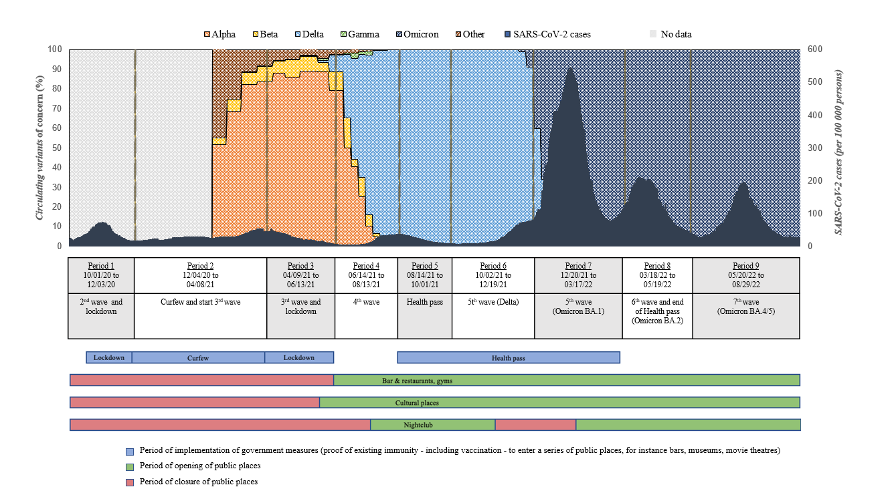
Figure S2. Proportion of encounters for which the source case was symptomatic in the single encounter that caused infection according to the setting of the meeting by period

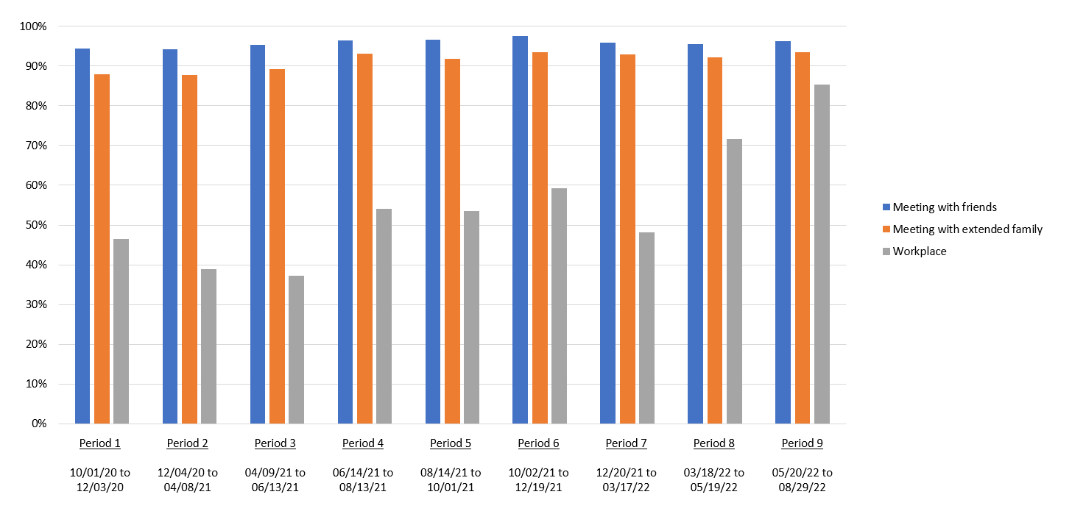

Figure S3. Proportion of encounters for which neither the source case nor the participants wore a mask during the single encounter that caused the infection according to the setting of the meeting by period

