Table1 Primer sequences for QS-related genes
Primer name | Primer sequences | Product size (bp)
psla | F:5’TTCATCCGCAAGACCAGCATCG3’ | 142
psla | R:3’TGTATTCGCTGACCGCCTCCTC5’ | 142
gaca | F:5’TGATGATCGCCAACTGCCACAAG3’ | 123
 | R:3’GTTCCACGTCGCTGGTGATCG5’ | 123
pela | F:5’AAGCCCTATCCGTTCCTCACCTC3’ | 126
 | R:3’GACCTTGTCGTCGGCGAAGATG5’ | 126
lasr | F:5’CTGACTCGTCGGGTCGGAGAG3’ | 120
 | R:3’CGCACCTGGTTCCCTTTGACAC5’ | 120
rhlr | F:5’GAGCGATACCAGATGCAGAACTACG3’ | 82
 | R:3’TCCAGACCACCATTTCCGAGGAG5’ | 82
gacs | F:5’GTTCAAGGATCTCGGCATCAAGGG3’ | 89
 | R:3’TGAAGTAACCGCCAAGCACCATC5’ | 89
16s-PA | F:5’GATTGGTGCCTTCGGGAACAGAG3’ | 120
 | R:3’CGAGGTGCTGGTAACTAAGGACAAG5’ | 120

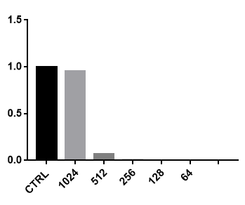

Figure 1 Erythrocyte hemolysis test. Erythrocyte hemolysis rate after the action of berberine hydrochloride at different concentrations

