Supplementary Material

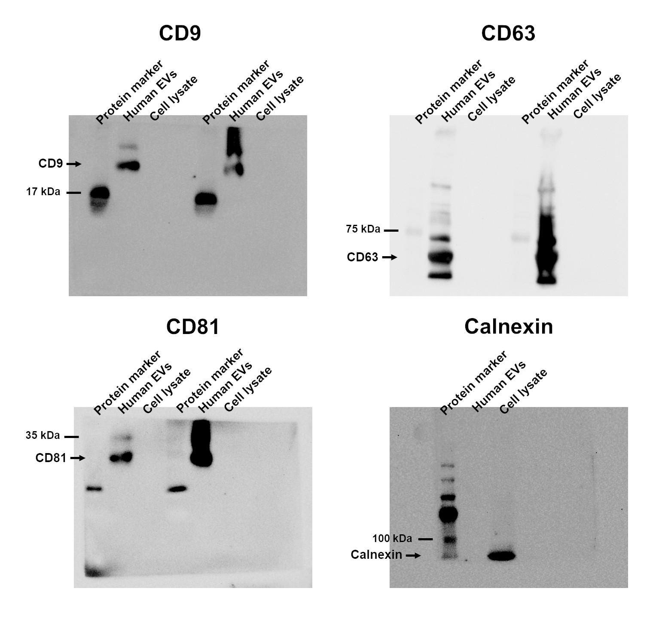
Figure S1. Whole Western blots of CD9, CD63, CD81, and calnexin are shown.

Figure S2. Bar chart representing the possible causes of a (A-E) positive or (F-J) negative LFC/LOR in the IS comparison, depending on the IF or IM comparison.

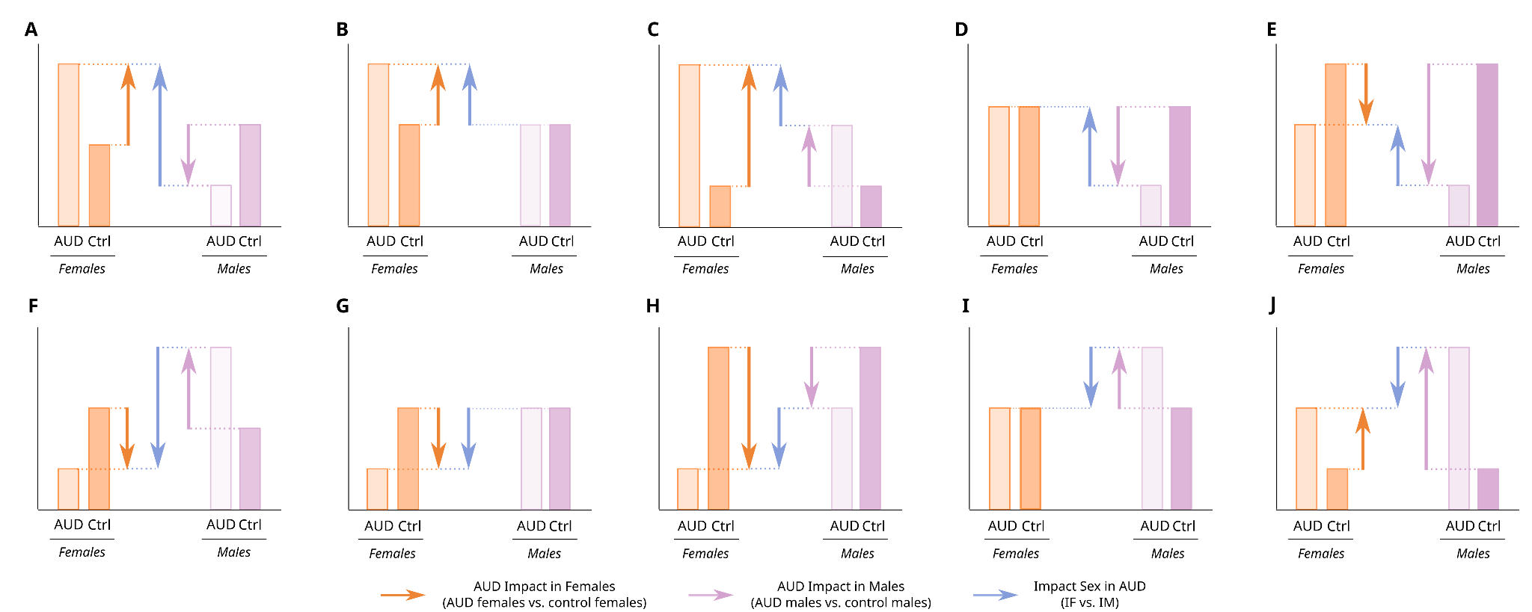
Table S1. Characteristics of study individuals displaying chronic alcohol consumption.
PARAMETER | Men (n=6) | Women (n=5) | P
Age (years) | 47.83 (9.89) | 40.00 (12.81) | 0.28
Total bilirubin (mg/dL) | 0.44 (0.17) | 0.42 (0.21) | 0.85
AST (U/L) | 33.67 (25.28) | 27.20 (9.31) | 0.58
ALT (U/L) | 27.17 (13.96) | 34.20 (24.42) | 0.72
FA (U/L) | 94.83 (32.74) | 64.60 (13.37) | 0.09
LDH (U/L) | 163.17 (22.39) | 184.00 (56.45) | 0.42
GGT (U/L) | 138.83 (178.99) | 70.00 (79.78) | 0.45
Proteins (g/dL) | 7.24 (0.37) | 6.91 (0.81) | 0.40
Albumin (g/dL) | 6.44 (1.28) | 5.21 (1.31) | 0.15
Ferritin (ng/mL) | 438.12 (389.52) | 270.82 (422.91) | 0.51
Hemoglobin (g/dL) | 14.93 (1.17) | 13.50 (1.24) | 0.08
Hematocrit (%) | 42.97 (3.13) | 32.99 (16.75) | 0.83
MCV (fL) | 99.53 (10.76) | 94.86 (5.87) | 0.41
MCH (pg) | 34.64 (4.02) | 31.90 (2.78) | 0.23
Leukocytes (x10³ cel/μL) | 7.70 (2.97) | 7.42 (1.76) | 0.86
Neutrophils (x10³ cel/μL) | 4.62 (1.87) | 4.48 (1.58) | 0.89
Lymphocytes (x10³ cel/μL) | 2.22 (0.95) | 2.03 (0.49) | 0.71
Platelets (x10³ cel/μL) | 243.33 (81.46) | 247.80 (66.60) | 0.92
Total cholesterol (mg/dL) | 196.83 (28.46) | 204.90 (36.22) | 0.69
Triglycerides (mg/dL) | 135.08 (114.40) | 127.20 (35.45) | 0.89
Prothrombin activity (%) | 96.80 (4.15) | 93.00 (4.83) | 0.24
APTT (segundos) | 35.08 (2.48) | 35.95 (2.45) | 0.61
Fibrinogen (mg/dL) | 475.40 (115.58) | 277.25 (55.05) | 0.02
D-dimer (μg/mL) | 0.36 (0.35) | 0.54 (0.46) | 0.54
Note: mean (standard deviation). AST: aspartate aminotransferase. ALT: alanine aminotransferase. AP: alkaline phosphatase. LDH: lactate dehydrogenase. GGT: gamma glutamyl transferase. MCV: mean corpuscular volume. MCH: mean corpuscular hemoglobin. APTT: activated partial thromboplastin time.

Table S2. Abbreviation of the different subclasses.

CAR | Acylcarnitine
Cer_ADS | Ceramide α-hydroxy fatty acid-dihydrosphingosine
Cer_AP | Ceramide α-hydroxy fatty acid-phytosphingosine
Cer_AS | Ceramide α-hydroxy fatty acid-sphingosine
Cer_NDS | Ceramide non-hydroxy fatty acid-dihydrosphingosine
Cer_NP | Ceramide non-hydroxy fatty acid-phytosphingosine
Cer_NS | Ceramide non-hydroxy fatty acid-sphingosine
Chol. esters | Cholesterol esters
DAG | Diacylglycerol
FA | Fatty acid
FAHFA | Fatty acid ester of hydroxyl fatty acid
HexCer_NDS | GlucosylCeramide/HexosylCeramidesnon-hydroxyfatty acid-dihydrosphingosine
HexCer_NS | GlucosylCeramide/HexosylCeramidesnon-hydroxyfatty acid-sphingosine
LPC | Lyso-phosphatidylcholine
LPE | Lyso-phosphatidylethanolamine
MGDG | Monogalactosyldiacylglycerol
OxPC | Oxidized phosphatidylcholine (OxPC)
OxPC-O | Oxidized etherphosphatidylcholine (OxEtherPC)
PA | Phosphatidic acid
PC | Phosphatidylcholine
PC-O | Etherphosphatidylcholine (EtherPC)
PE | Phosphatidylethanolamine
PE-O | Etherphosphatidylethanolamine (EtherPE)
PI | Phosphatidylinositol
SHexCer | SulfoglucosylCeramide/SulfohexosylCeramide
SM | Sphingomyelin
TAG | Triacylglycerol (TG)

Table S3. Classification by levels of all lipids in samples.

SUPER CLASS | N | MAIN CLASS | N | SUBCLASS | N
Sphingolipids | 160 | Sphingomyelins | 79 | SM | 79
Sphingolipids | 160 | Glycosphingolipids | 10 | HexCer_NDS | 5
 |  |  |  | HexCer_NS | 3
 |  |  |  | SHexCer | 2
Sphingolipids | 160 | Ceramides | 71 | Cer_ADS | 11
 |  |  |  | Cer_AP | 3
 |  |  |  | Cer_AS | 3
 |  |  |  | Cer_NDS | 27
 |  |  |  | Cer_NP | 1
 |  |  |  | Cer_NS | 26
Fatty Acyls | 64 | Fatty acids | 49 | Unsaturated FA | 49
Fatty Acyls | 64 | Fatty esters | 15 | CAR | 2
 |  |  |  | FAHFA | 13
Glycerophospholipids | 215 | Glycerophosphates | 1 | PA | 1
Glycerophospholipids | 215 | Glycerophosphocholines | 159 | PC | 102
 |  |  |  | PC-O | 27
 |  |  |  | LPC | 26
 |  |  |  | OxPC | 3
 |  |  |  | OxPC-O | 1
Glycerophospholipids | 215 | Glycerophosphoethanolamines | 44 | PE | 27
 |  |  |  | PE-O | 13
 |  |  |  | LPE | 4
Glycerophospholipids | 215 | Glycerophosphoinositols | 11 | PI | 11
Glycerolipids | 130 | Diradylglycerols | 4 | DAG | 4
Glycerolipids | 130 | Glycosyldylglycerols | 1 | MGDG | 1
Glycerolipids | 130 | Triradylglycerols | 125 | TAG | 125
Sterol Lipids | 5 | Sterol esters | 5 | Chol. esters | 5
ns | 1 | ns | 1 | ns | 1
Total | 575 |  | 575 |  | 575

Table S4. Lipids with significant differential abundance, separated by LFC.

Lipid | Ion mode | IF | IM | IS
Cer_AP t46:1 | - | UP | NS | NS
Cer_AS d35:4 | - | UP | NS | NS
Cer_NDS d18:0_18:0 RT:12.135 | - | UP | NS | UP
Cer_NDS d18:0_18:0 RT:12.203 | - | NS | DOWN | NS
Cer_NDS d34:1 | - | UP | NS | NS
Cer_NDS d39:1 | - | DOWN | DOWN | NS
Cer_NDS d40:1 | - | NS | DOWN | NS
Cer_NDS d42:1 | - | NS | DOWN | UP
Cer_NDS d42:2 RT:12.673 | - | DOWN | UP | DOWN
Cer_NDS d42:2 RT:12.747 | - | NS | DOWN | NS
Cer_NDS d46:1 | - | UP | NS | NS
Cer_NS d18:1_18:0 | - | NS | UP | NS
Cer_NS d18:1_22:0 | - | DOWN | UP | DOWN
Cer_NS d18:1_24:0 | - | NS | UP | DOWN
Cer_NS d18:1_24:1 | - | UP | DOWN | UP
Cer_NS d18:2_23:0 | - | DOWN | DOWN | NS
Cer_NS d42:3 | - | NS | DOWN | NS
EtherPC 16:0e_18:2 | - | DOWN | DOWN | NS
EtherPC 18:2e_20:4 | - | UP | NS | NS
EtherPC 38:5e | - | NS | DOWN | UP
EtherPE 16:1e_22:6 | - | NS | DOWN | UP
FA 17:0 RT:4.000 | - | NS | DOWN | NS
FA 17:0 RT:4.252 | - | NS | UP | NS
FA 18:2 | - | NS | UP | NS
FA 19:0 RT:4.868 | - | NS | DOWN | NS
FA 20:0 RT:4.411 | - | NS | UP | NS
FA 20:0 RT:4.708 | - | DOWN | NS | NS
FA 20:3 | - | NS | UP | NS
FA 22:0 RT:6.523 | - | DOWN | DOWN | NS
FAHFA 16:0_2:0 | - | NS | UP | NS
FAHFA 18:0_6:0 | - | NS | UP | NS
LPC 16:0/0:0 | + | DOWN | NS | NS
OxPC 18:1_18:3+1O | - | UP | NS | NS
PC 16:0_16:0 | - | NS | UP | NS
PC 16:0_16:1 | - | UP | NS | NS
PC 16:0_18:0 | - | UP | NS | NS
PC 16:0_22:6 | + | NS | DOWN | NS
PC 17:0_20:4 | - | DOWN | NS | NS
PC 18:2_20:4 | - | NS | DOWN | UP
PC 19:2 | + | NS | DOWN | NS
PC 32:3 RT:6.415 | + | DOWN | DOWN | NS
PC 39:4 | + | DOWN | NS | DOWN
PE 40:2 | - | DOWN | NS | NS
PI 18:0_18:2 | - | DOWN | DOWN | NS
PI 18:0_20:3 | - | NS | UP | NS
PI 34:1 | - | NS | UP | NS
SM d16:1_24:1 | - | NS | UP | NS
SM d17:1_16:0 | - | DOWN | NS | NS
SM d18:2_18:0 | - | DOWN | NS | NS
SM d18:2_24:0 | - | DOWN | DOWN | NS
SM d31:1 | + | DOWN | NS | NS
SM d33:2 | + | NS | DOWN | NS
SM d35:1 RT:9.090 | + | DOWN | NS | NS
SM d37:2 | + | NS | DOWN | UP
SM d42:4 | - | DOWN | NS | DOWN
TG 16:0_18:1_20:4 | + | NS | NS | DOWN
TG 18:1_18:1_20:1 | + | DOWN | NS | DOWN
TG 46:2 | + | NS | UP | NS
TG 48:4 RT:13.611 | + | UP | NS | NS
TG 52:5 RT:14.049 | + | NS | UP | NS
TG 53:5 | + | NS | DOWN | NS
TG 54:7 | + | DOWN | NS | DOWN

.

