Supplementary Information
Heterojunction interface engineering for stable and effective porous Fe₃O₄-ZnO nanocomposites: A highly efficient synergistic Catalyst for oxygen evolution reaction
Aniruddha Mondal^{1*}, Mohd Afzal² Sudip Mondal^{3*}
¹Department of Chemical Engineering and Biotechnology, Tatung University, No. 40, Sec. 3, Chungshan North Rd., Taipei City 104, Taiwan
²Department of Chemistry, College of Science, King Saud University, Riyadh 11451, Saudi Arabia.
³Post Graduate Department of Chemistry, Seth Kesarimal Porwal College of Arts, Science and Commerce, Kamptee 441001, Maharashtra, India
Email: aniruddhacsmcri@gmail.com , sudipmondal5555@gmail.com

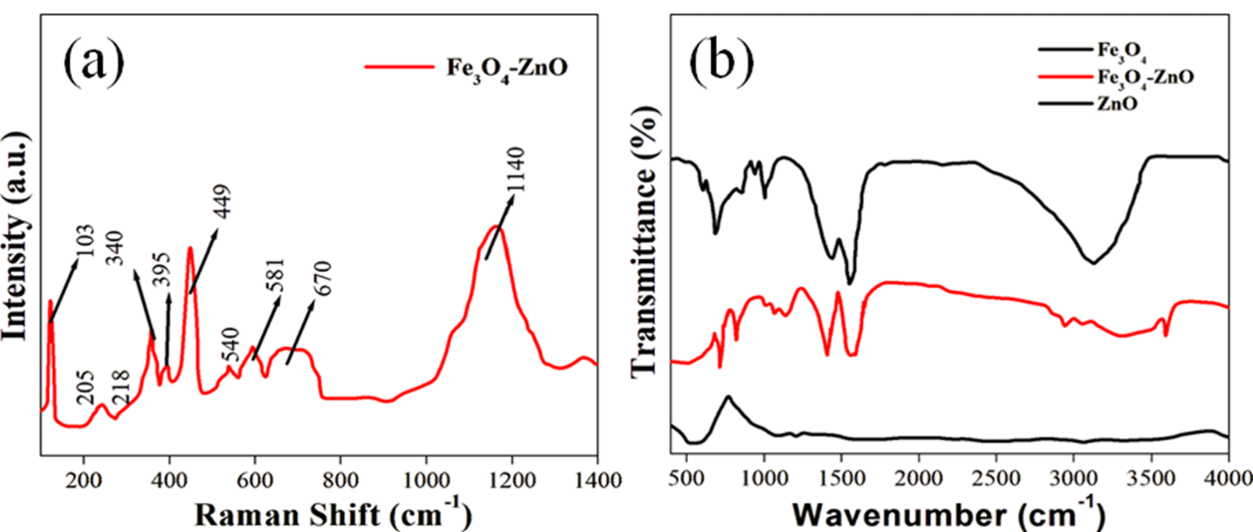
Figure S1: (a) Raman and (b) FTIR spectra of the synthesized materials

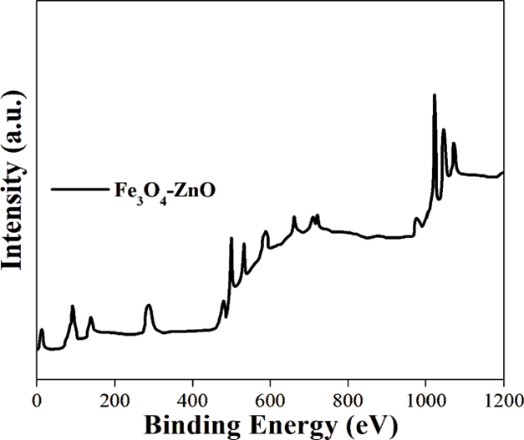
Figure S2: Survery Spectrum of the synthesized material Fe₃O₄-ZnO

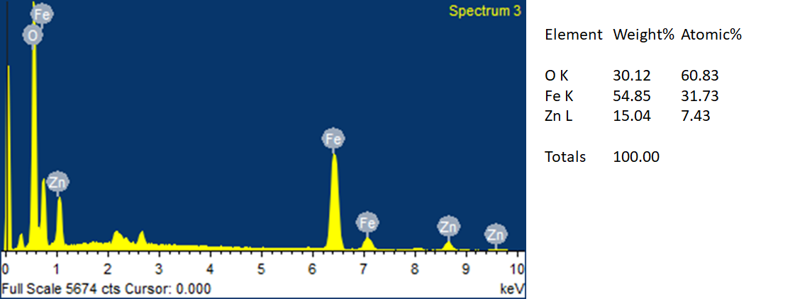
Figure S3: EDX spectra of the synthesized material

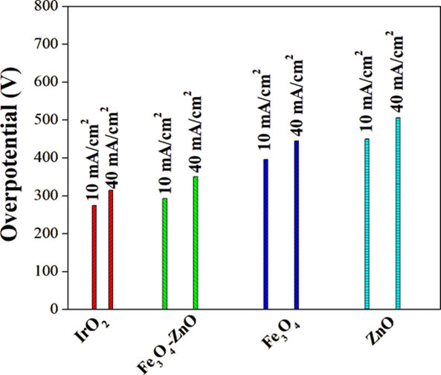
Figure S4: Overpotenital values at different current density of the synthesized materials

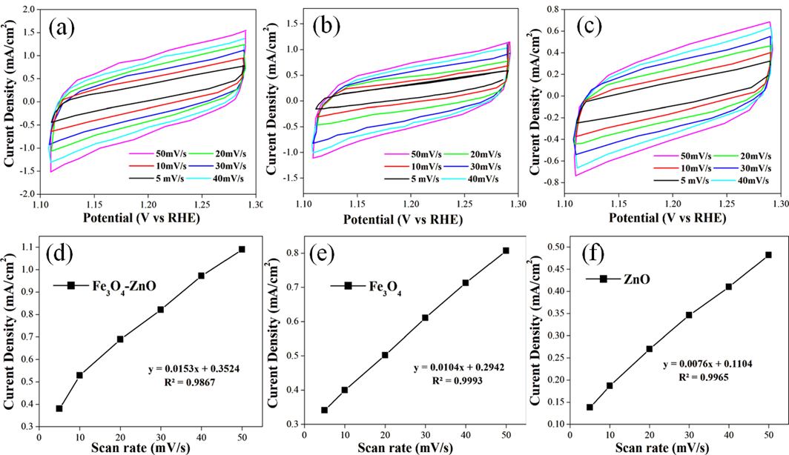
Figure S5: (a-c) Cyclic voltammetry at non faradaic zone and (d-f) capacitive properties of the synthesized materials
Electrochemically active surface areas (ECSA) is directly proportional to the electrochemical double layer capacitance (C_{dl}). Electrochemical cyclic voltammograms from 1.1V to 1.3V along with multiple scan rates (10, 20, 30, 40, 50 and 60 mV/sec) in the non-faradic regions utilized to measure the C_{dl} and formulae used to calculate the corresponding ECSA as follows:
$$A_{ECSA}=\frac{Capacitance Double layer (Cdl)}{0.040 mF/ {cm}^{2}(Cs) } per {cm}^{2}$$

Fe₃O₄-A_ECSA= 92 cm²
ZnO-A_ECSA= 45 cm²
Fe₃O₄-ZnO-A_ECSA= 115 cm²

It was assumed that the specific capacitance of flat standard surface with 1 cm² of real surface which was assume the value around 40 μF/ cm² (J. Am. Chem. Soc. 2015, 137, 4347−4357). The calculated values of the corresponding samples (Fe₃O₄, ZnO and Fe₃O₄-ZnO) are given in Table 1

Roughness factor (R_{f}) Calculation:
The following formulae has been used to calculate the Roughness factor (R_{f})

Fe₃O₄-R_{f} = 55
ZnO-R_{f} = 30
Fe₃O₄-ZnO-R_{f} = 93

