Visceral abdominal fat and muscle mass impact on patients with severe acute pancreatitis' risk for death

Supplementary files figures (1,2 and 3) and table 1.

Supplementary figure 1: The DCMtool's analysis of the various body parts' regions of interest (ROI) Hounsfield units (HU), which range from -190 to -29 for fat and from -30 to +150 for muscles, were found in the voxels of the manually designated sections.
After that, the SAT, VAT, and MM were measured in centimeters squared using the area of the conforming voxels inside the CT slice. Each picture shows the ROI (CT slice on the right) as blue, and the other portion (left) shows a histogram of the voxel count for each HU, with blue indicating the range of interest. (A) shows the analyses of the visceral and subcutaneous fat, (B) just the visceral fat compartment, and (C–E) the studies of the muscle compartments. The average heart rate (HU) of the voxels tallied in each of the three muscle sections was used to calculate the mean muscle attenuation (MMA).

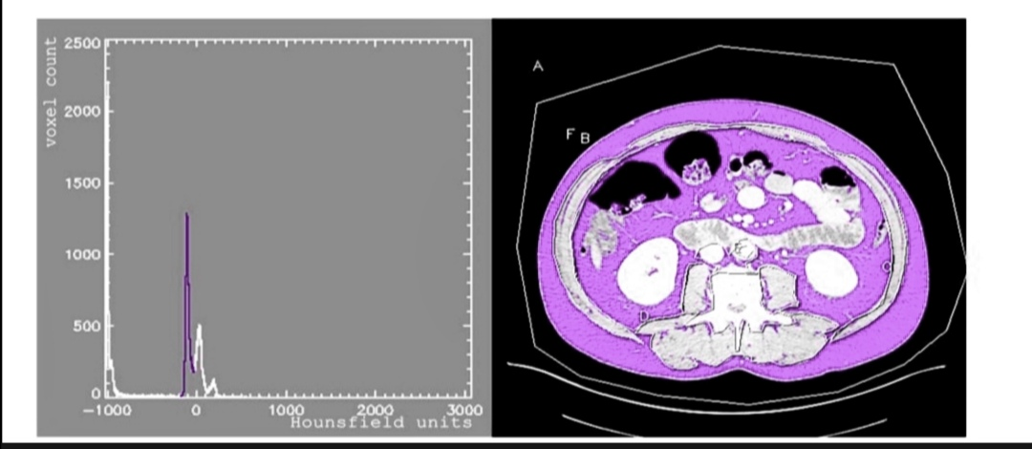

1 A
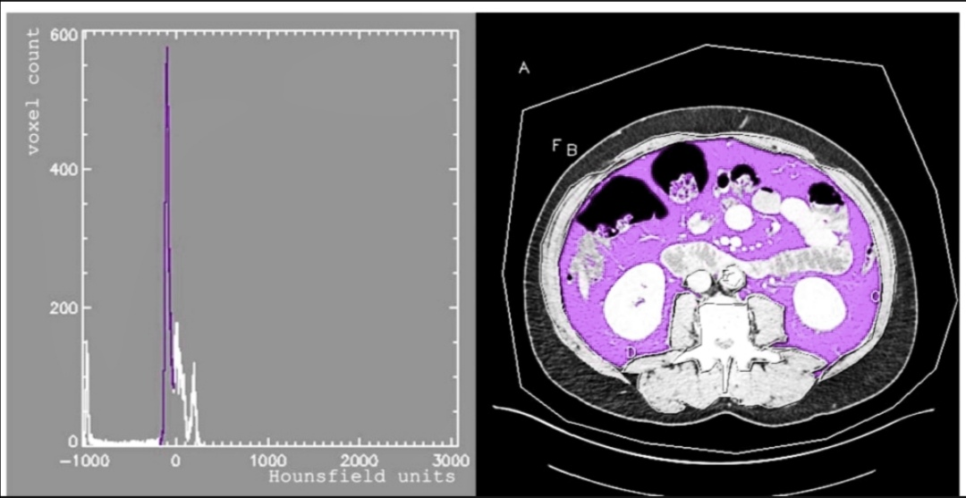
1 B
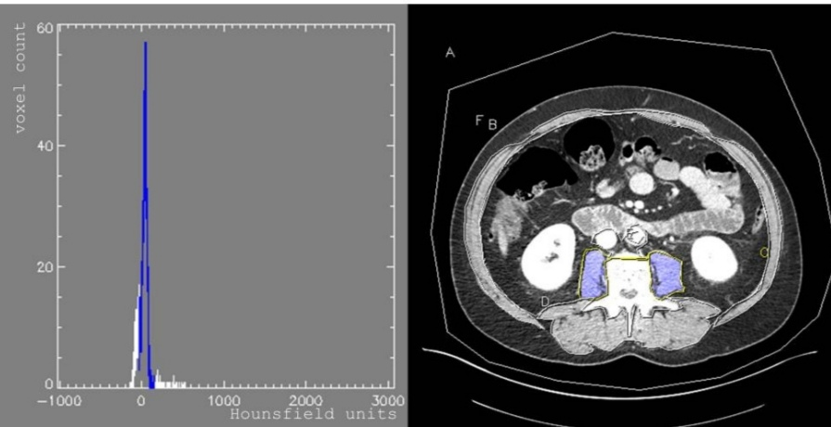

1 C

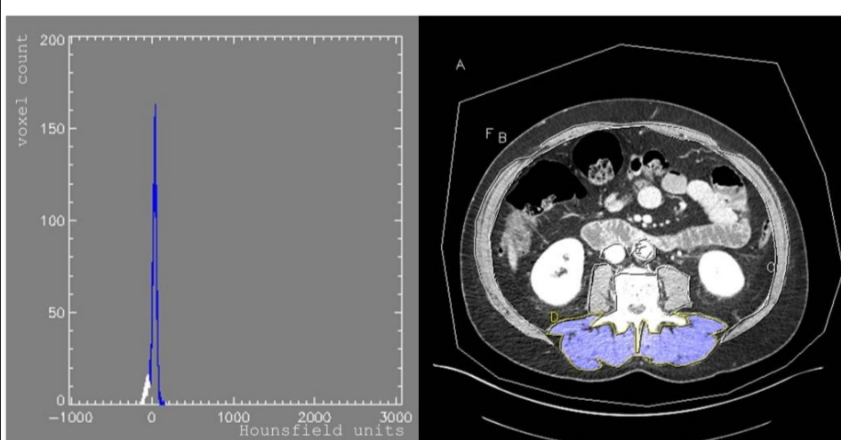

1D
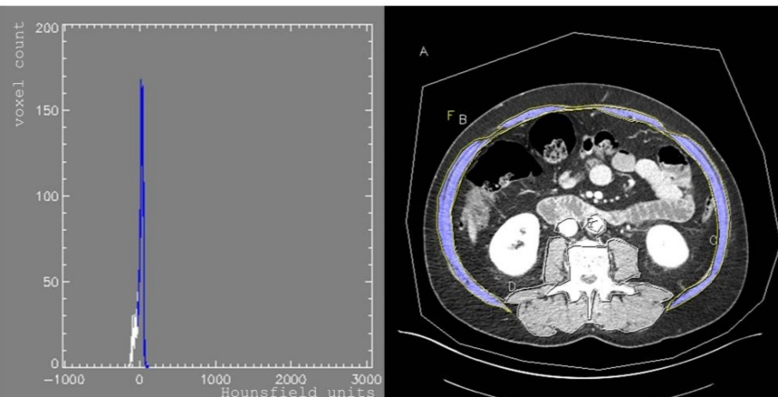

1 E

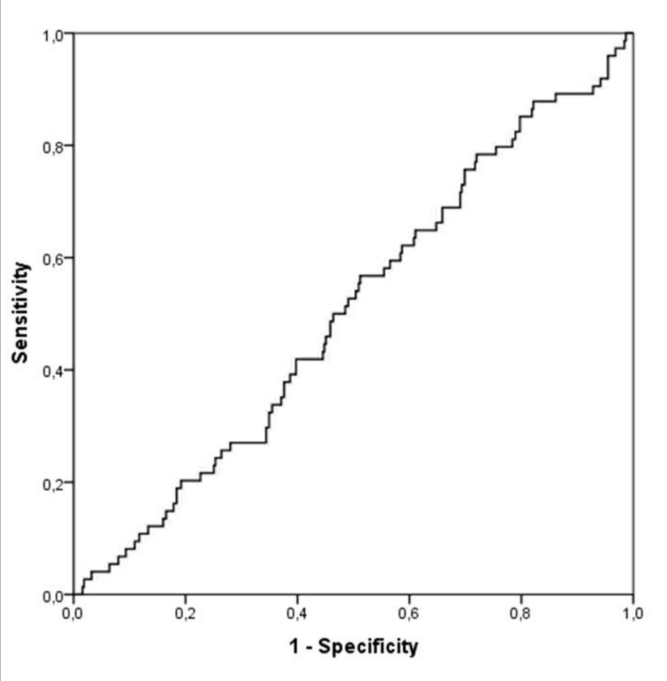
Supplementary figure 2: ROC curves (receiver operating characteristic) and the corresponding areas Under the curves to forecast the severity of AP for muscle characteristics and body composition acquired from CT. The ROC curve for VAT is represented by (A), which has an area under the curve of 0.536; the corresponding values for (B), SAT, MM, MMA, and VMR are (0.484, 0.571, 0.424, and 0.503, respectively). Every region
A p-value of < 0.05 was deemed statistically significant in all studies, yet the curves were tiny and no cut-off value for severe AP could be found.
noteworthy

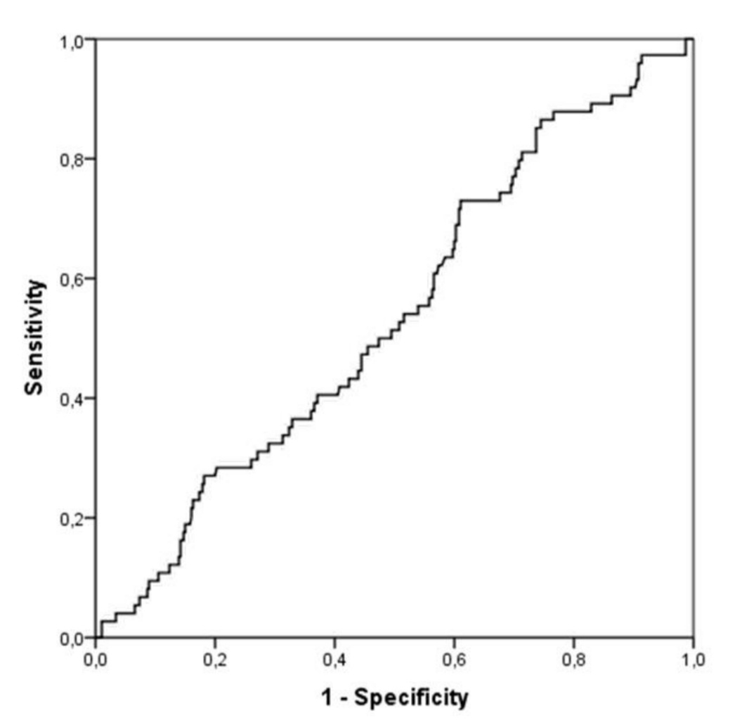
2 A
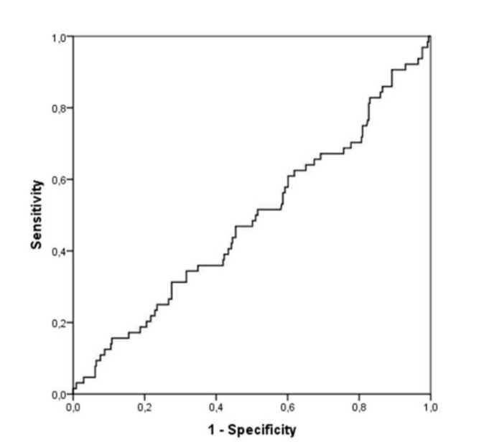

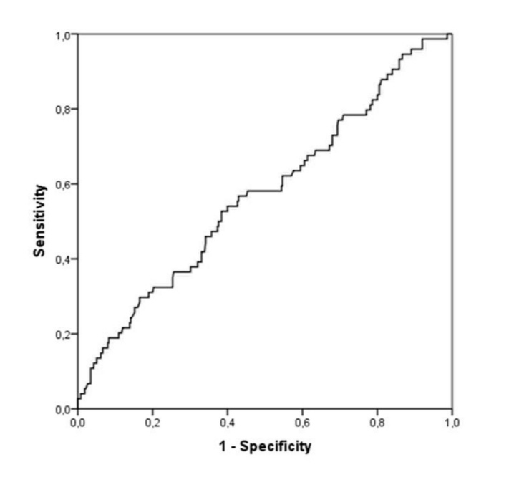
2B
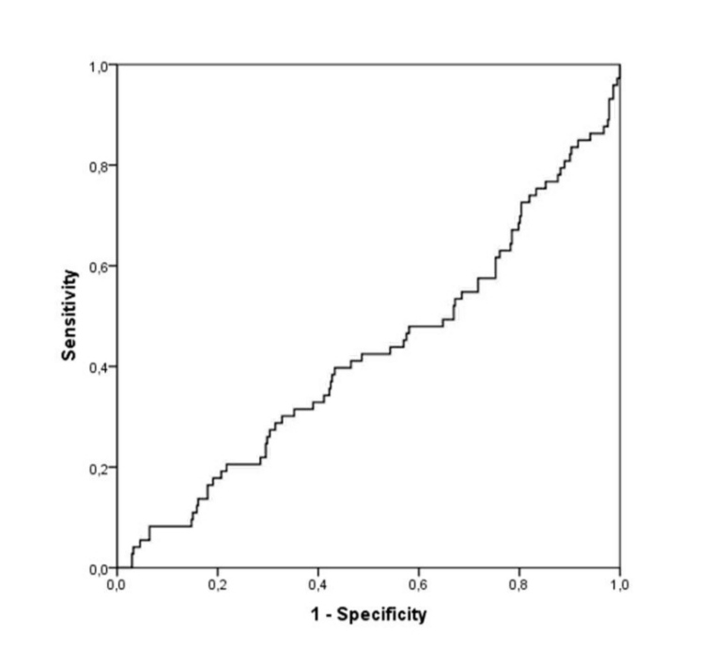
2C

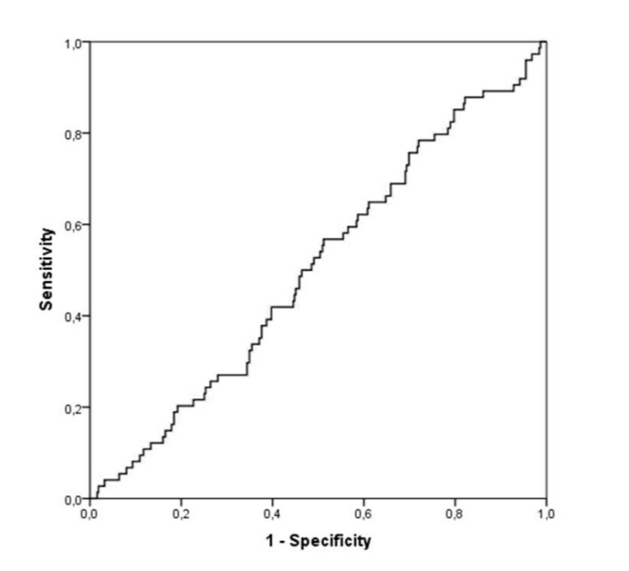
2D
2E

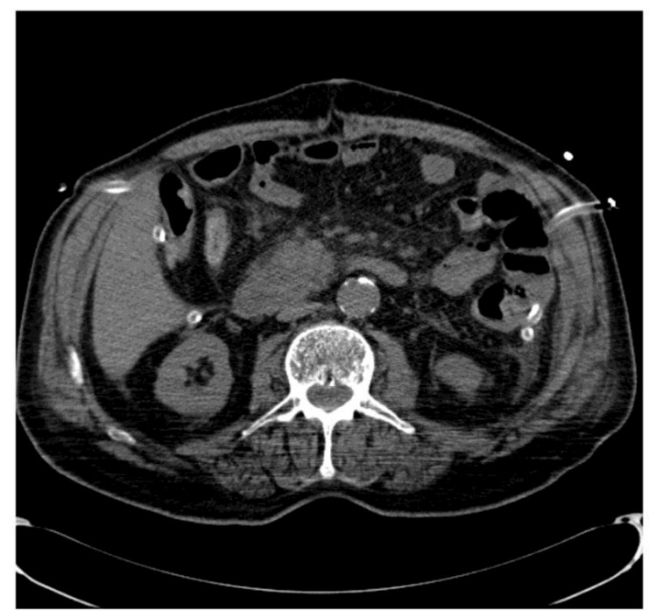
Supplementary figure 3: Two examples of sequential CT scans demonstrating the impact of the thoracic cavity's volume, bowel distension, and fluid collections—all of which are the result of AP itself—on the VAT measurement. One patient's initial CT scan is displayed in A and C, while the subsequent CT scans of the same patient are displayed in B and D. VAT in B 129.1 cm2, D 166.8 cm2, and A 190.3 cm2 and C 129.8 cm2.

3 A
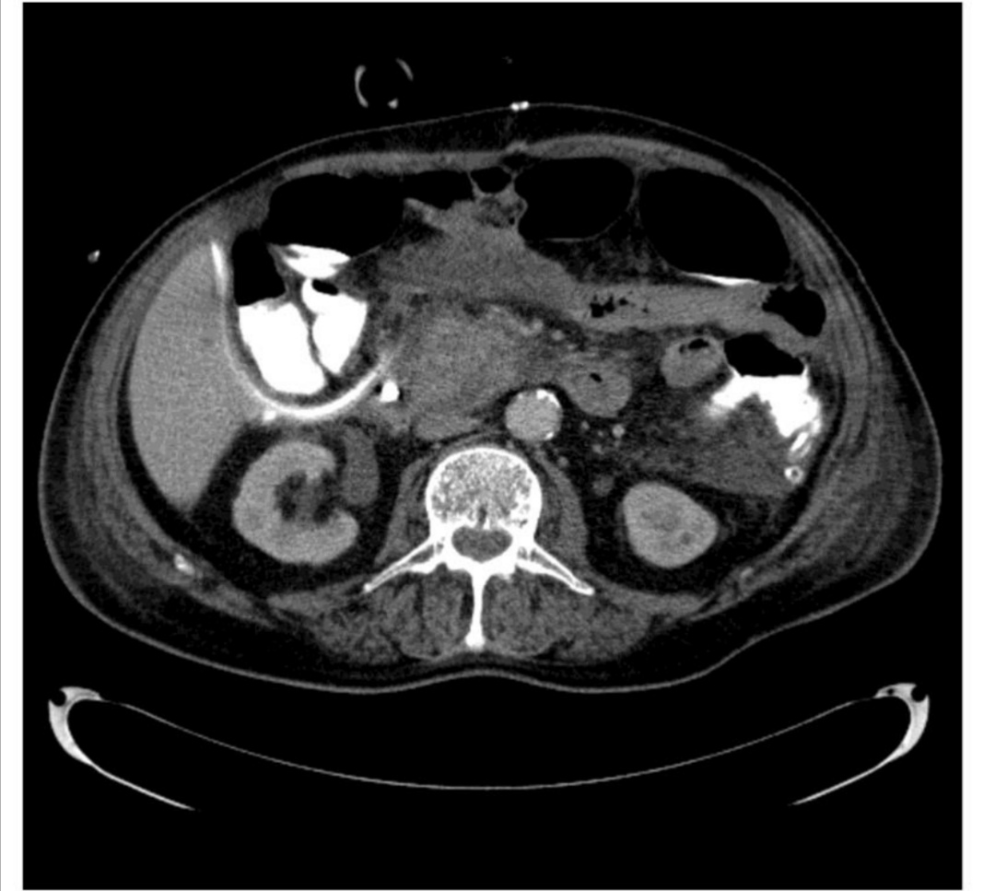

3 B
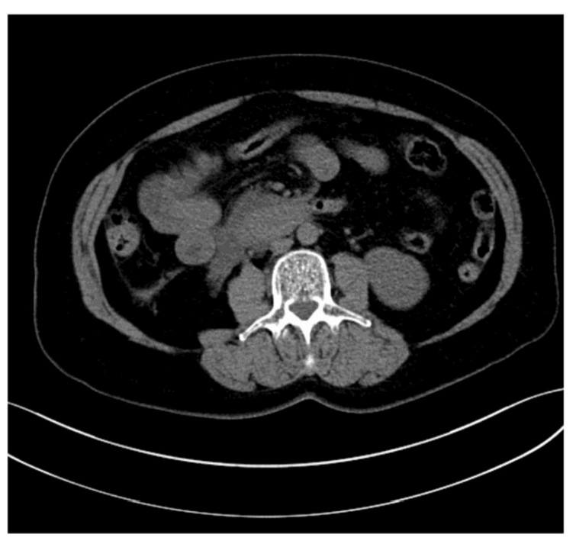

3 C
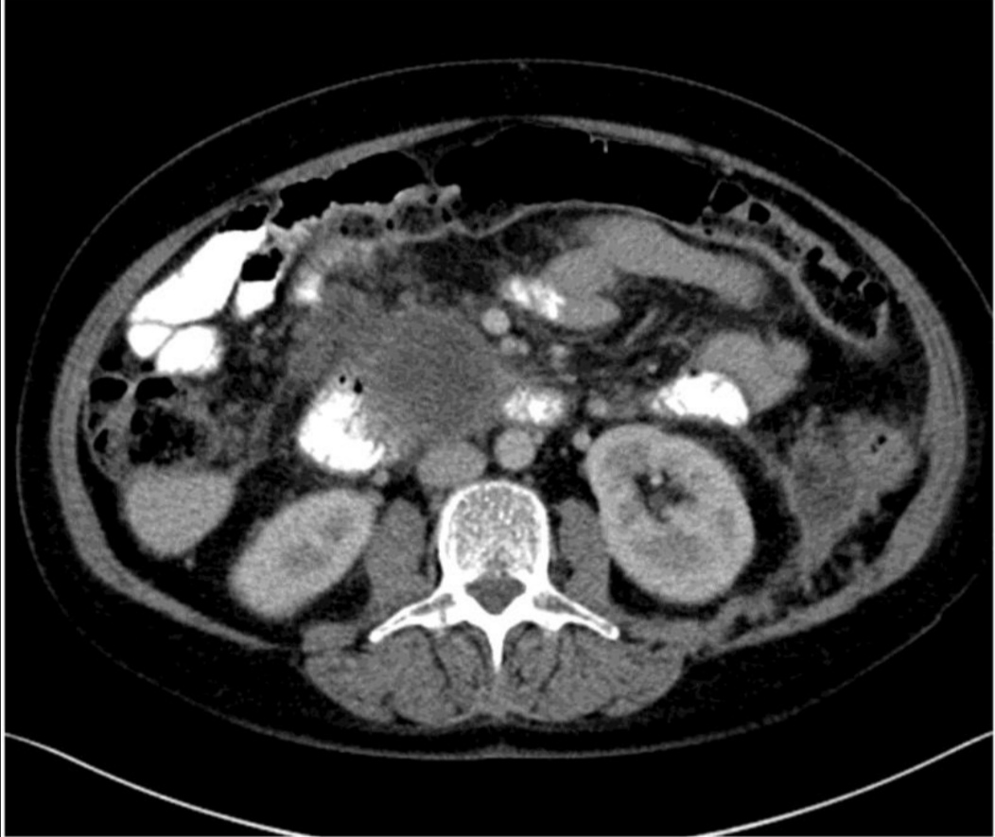

3D

Supplementary table 1:
Multivariate analysis of corporal parameter by regression; adjusted for aetiology, age, gender, and CT time (days)

.

VMR  mean  Median | MMA  Mean  Median | MM  mean  (median) | SAT mean median | VAT cm2  mean  (median) | Timing of  CTmedian  (Range) | Cases No. | Severity
2.11 (1.83)  2.33 (1.88) | 23.2 (22.2)  24.9 (24.7) | 112.6 (113.0)  103.9 (98.29 | 309.7 (318.6)  288.0 (277.5) | 223.9 (219.8)  231.6 (233.2) | 2(1-3)  12 (7-16) | 7 | Mild
1.83 (1.66)  1.76 (1.66) | 27.6 (29.6)  28.0 (28.2) | 131.2 (121.7)  123.8 (121.2) | 240.8 (226.6)  123.8 (121.2) | 240.1 (228.8)  237.9 (235.0) | 3 (1-7)  12 (8-16) | 23 | Moderately  Severe
1.58 (1.36)  1.52 (1.29) | 27.6 (25.6)  22.8 (22.0) | 157.9 (142.8)  152.1 (144.1) | 157.9 (142.8)  152.1 (144.1) | 218.4 (184.8)  215.9 (220.1) | 2 (1-6)  13 (9-17) | 11 | Severe
1.81 (1.72)  1.79 (1.66) | 26.9 (29.0)  26.3 (26.8) | 135.2 (123.6)  128.0 (121.2) | 135.2 (123.6)  128.0 (121.2) | 246.6 (204.1)  240.6 (235.0) | 2 (1-6)  12 (7-17) | 41 | Overall

To determine whether measured body parameters are altered during the
course of AP we compared consecutive CTs where available. Timing of the
CTs represents the day after admission when the CT has been performed.
For the comparison the Wilcoxon T-test was applied. Overall VAT (p=0.0083)
and MM (p=0.0003) was significantly altered by the disease course, whereas
MMA did not differ (p=0.215). For VAT and MM a significant difference was
observed for the moderately severe cases (p=0.0022; p=0.0288). SAT and
VMR differed significantly in mild cases during the disease course (p=0.018
for SAT and VMR). * Significant differences (p<0.05).

