- B.
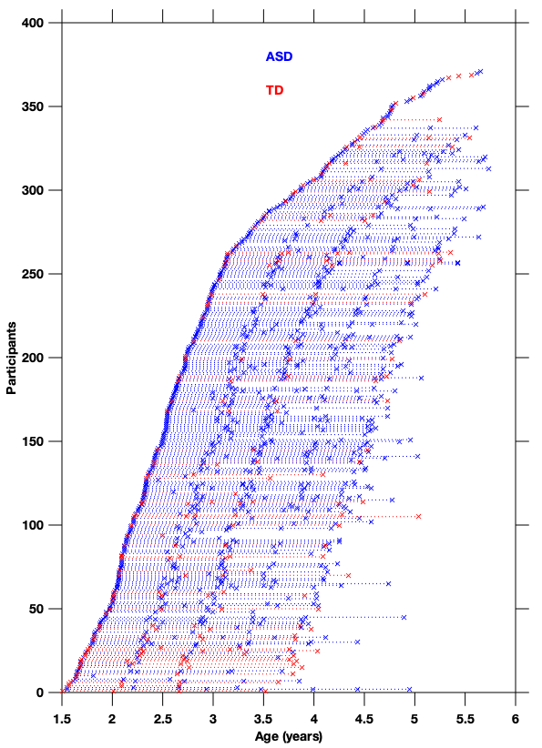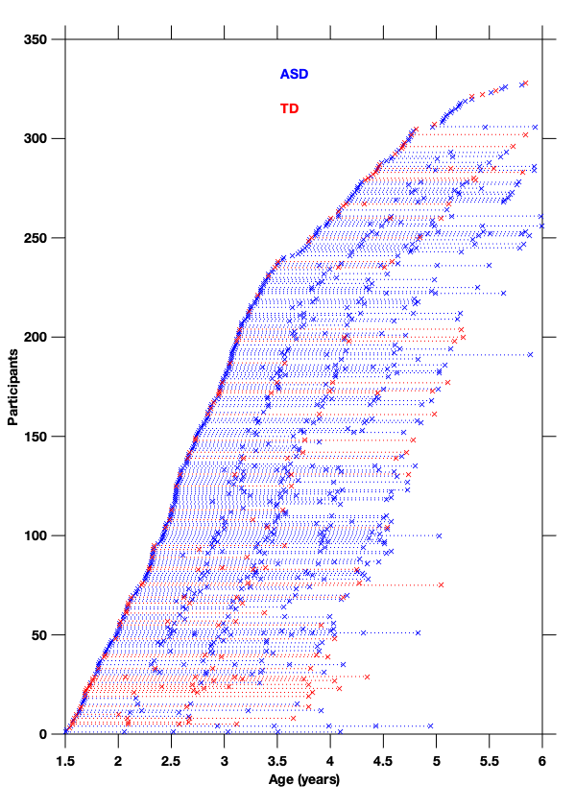
Fig. S1 Illustration of longitudinal recruitment of our sample. (A) Total sample. (B) Sub-sample of participants with a DLPF.

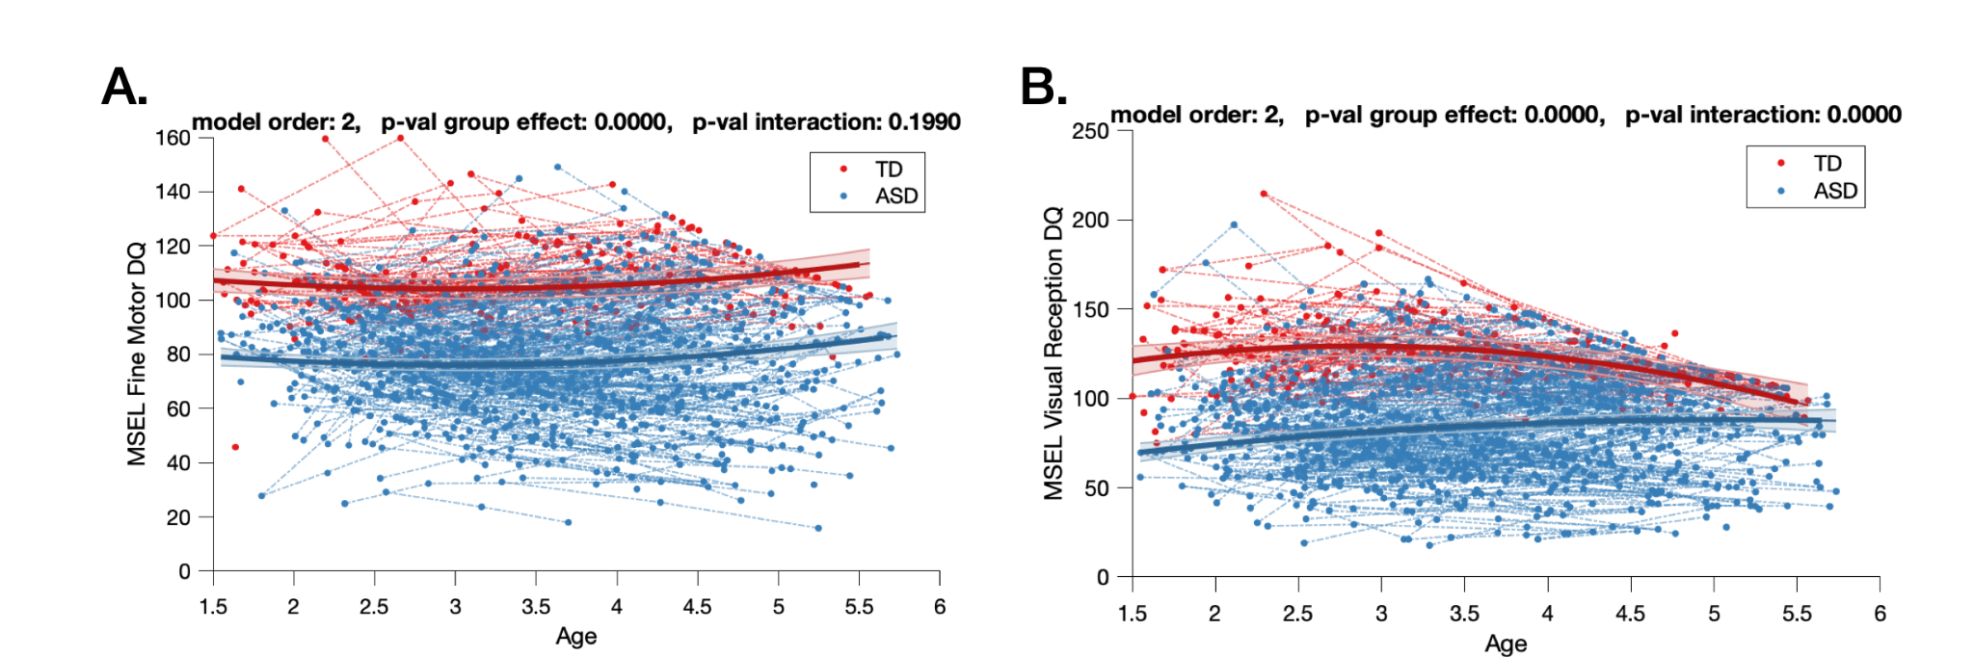
Fig. S2 Non-verbal trajectories in TD and ASD participants measured with (A) MSEL Fine Motor DQ and (B) Visual Reception DQ. DQ: Developmental Quotient ; MSEL: Mullen Scale of Early Learnings ; TD: Typical Development ; ASD: Autism Spectrum Disorder.

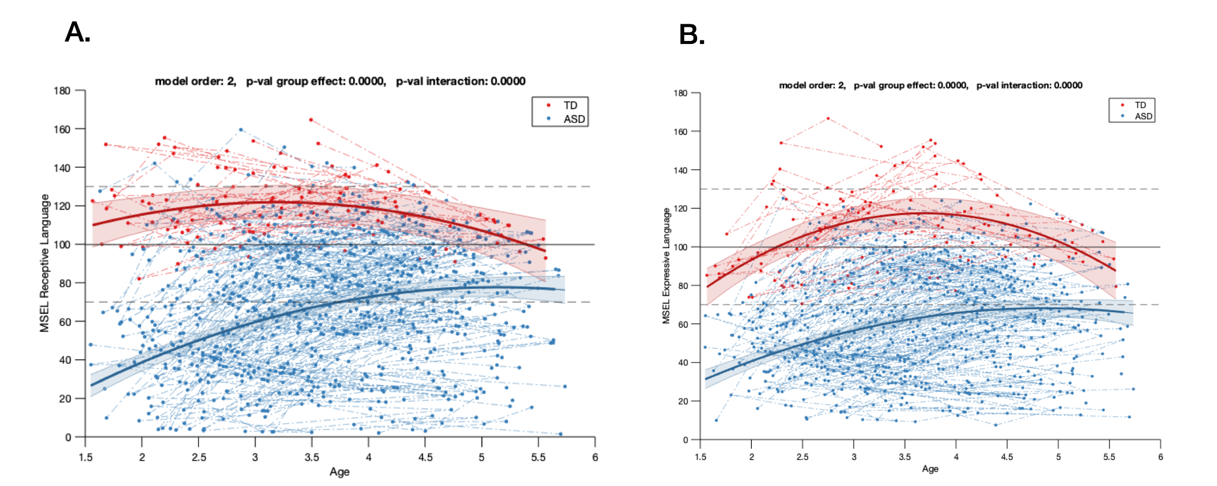
Fig. S3 Verbal trajectories in TD and ASD male participants measured with (A) MSEL Receptive DQ and (B) MSEL Receptive DQ. DQ: Developmental Quotient ; MSEL: Mullen Scale of Early Learnings ; TD: Typical Development ; ASD: Autism Spectrum Disorder.

A)
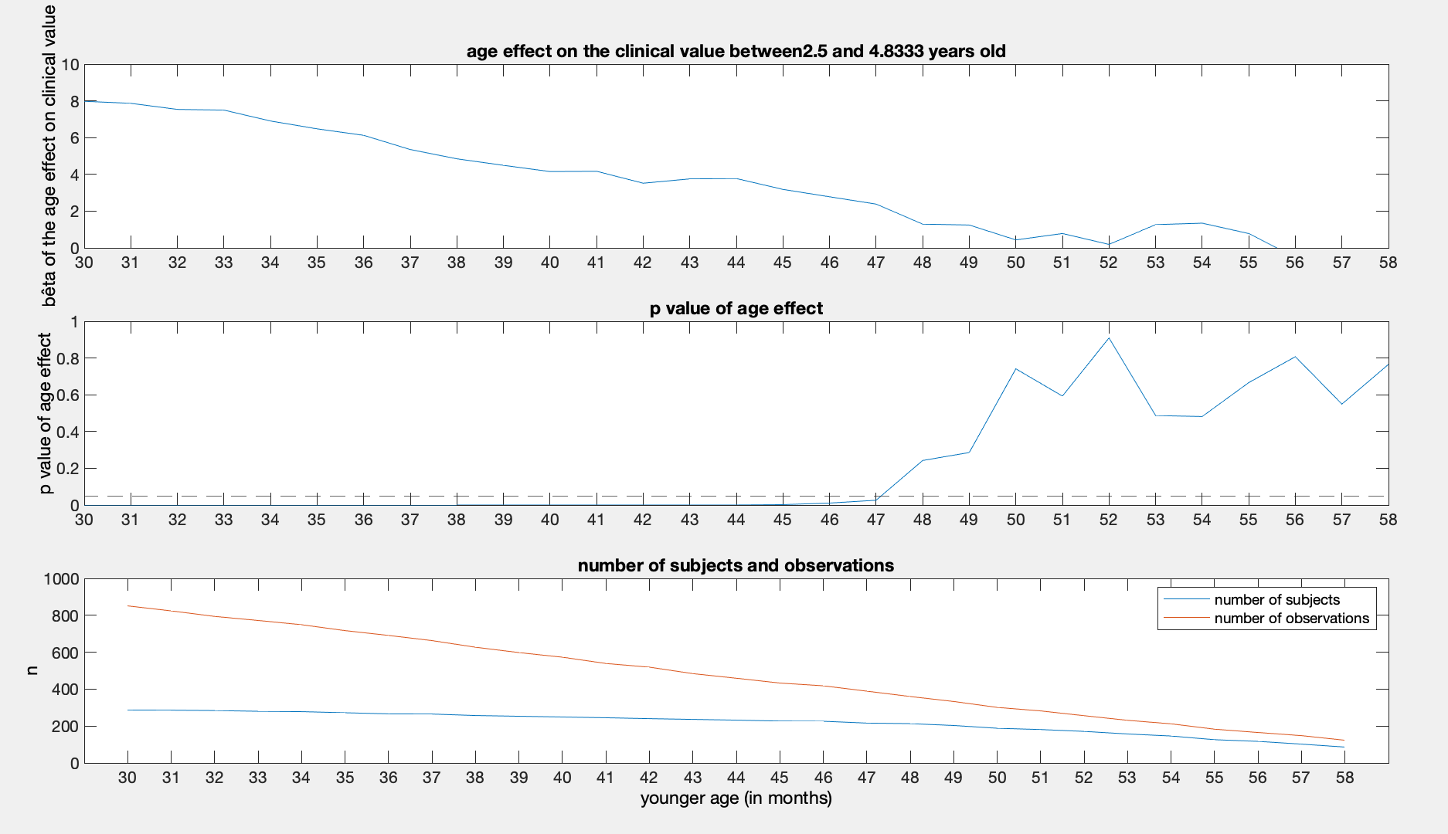
B)
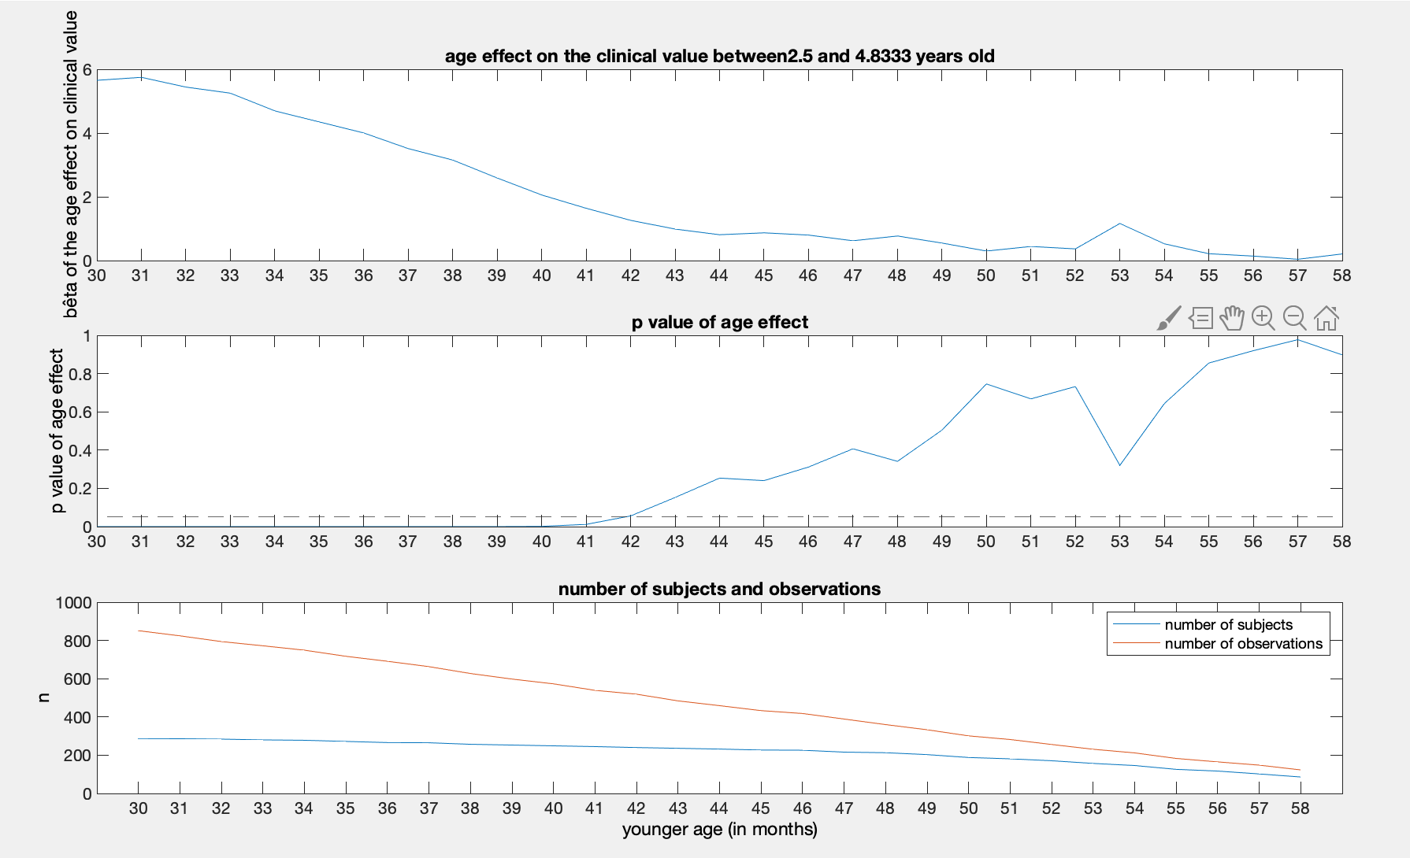
Fig. S4 Best age for clustering using a 12-month sliding window. (A) MSEL Receptive language DQ (B) MSEL Expressive language DQ

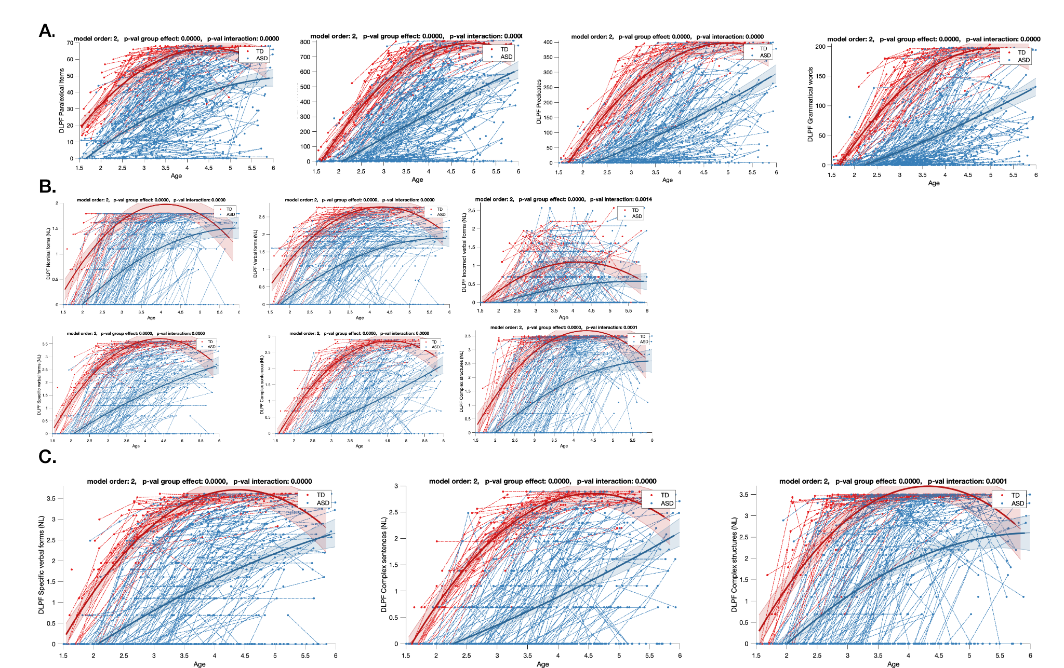
Fig S5. Linguistic trajectories in TD and ASD participants measured with the DLPF (A) DLPF Vocabulary scores (B) (A) DLPF Grammar scores (C) DLPF Pragmatic scores. DQ: Developmental Quotient ; MSEL: Mullen Scale of Early Learnings ; DLPF: Questionnaire du développement du langage productif en français ; TD: Typical Development ; ASD: Autism Spectrum Disorder.

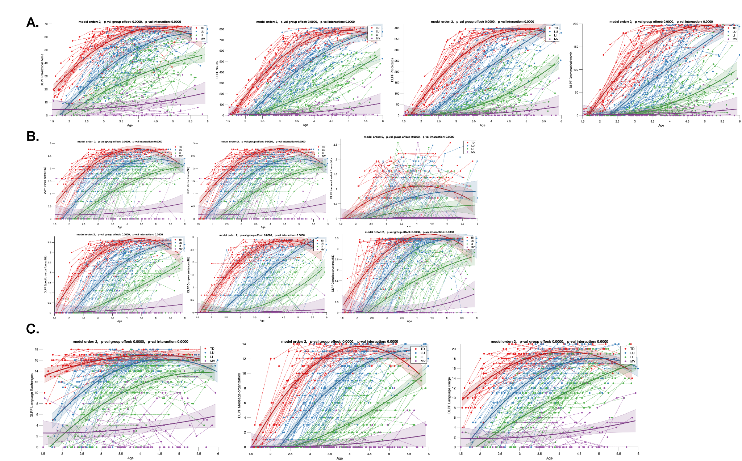
Fig. S6 Detailed Linguistic Trajectories in three autism language endophenotypes measured with DLPF in (A) Vocabulary (B) Grammar (C) Pragmatics. TD (in red) were not included in the statistical comparison and their trajectory is only displayed for illustration purposes. DQ: Developmental Quotient ; MSEL: Mullen Scale of Early Learnings ; DLPF: Questionnaire du développement du langage productif en français ; TD: Typical Development ; MV: Minimally Verbal ; LI: Language Impaired ; LU: Language Unimpaired.

Table S1. Results of the mixed model analysis comparing developmental and linguistic skills between TD and the ASD groups
 | TD vs. ASD
 | p-val group effect | p-val interaction
MSEL Total DQ | <0.001 | <0.001
MSEL VR DQ | <0.001 | <0.001
MSEL FM DQ | <0.001 | 0.600
MSEL RL DQ | <0.001 | <0.001
MSEL EL DQ | <0.001 | <0.001
DLPF Total Vocabulary Score | <0.001 | <0.001
DLPF Total  Grammar Score | <0.001 | <0.001
DLPF Total  Pragmatic Score | <0.001 | <0.001
Note: P-value group effect evaluates the difference between mean linguistic scores in the two groups whereas p-value interaction refers to the difference in the shape of the linguistic trajectory. The significance threshold was fixed at 0.05. All the p-values are corrected for Bonferroni.

Table S2. Results of the mixed model analysis comparing developmental and linguistic skills between TD and the three ASD clusters.
 | LU vs. LI vs. MV |  |  | LU vs. LI |  |  | LI vs. MV |  |  | LU vs. MV
 | p-val group effect | p-val interaction |  | p-val group effect | p-val interaction |  | p-val group effect | p-val interaction |  | p-val group effect | p-val interaction
MSEL Total DQ | <0.001 | <0.001 |  | <0.001 | <0.001 |  | <0.001 | <0.001 |  | <0.001 | <0.001
MSEL VR DQ | <0.001 | <0.001 |  | <0.001 | 0.034 |  | <0.001 | <0.001 |  | <0.001 | <0.001
MSEL FM DQ | <0.001 | <0.001 |  | <0.001 | <0.001 |  | <0.001 | <0.001 |  | <0.001 | <0.001
MSEL RL DQ | <0.001 | <0.001 |  | <0.001 | <0.001 |  | <0.001 | <0.001 |  | <0.001 | <0.001
MSEL EL DQ | <0.001 | <0.001 |  | <0.001 | <0.001 |  | <0.001 | <0.001 |  | <0.001 | <0.001
DLPF Total Vocabulary Score | <0.001 | <0.001 |  | <0.001 | <0.001 |  | <0.001 | <0.001 |  | <0.001 | <0.001
DLPF Total  Grammar Score | <0.001 | <0.001 |  | <0.001 | <0.001 |  | <0.001 | <0.001 |  | <0.001 | <0.001
DLPF Total  Pragmatic Score | <0.001 | <0.001 |  | <0.001 | <0.001 |  | <0.001 | <0.001 |  | <0.001 | <0.001
Note: P-value group effect evaluates the difference between mean linguistic scores in the two groups whereas p-value interaction refers to the difference in the shape of the linguistic trajectory. The significance threshold was fixed at 0.05. All the p-values are corrected for Bonferroni. LU = Language Unimpaired; LI = Language Impaired; MV = Minimally-Verbal

Table S3. Results of post-hoc multinomial logistic regressions performed between clusters using the early clinical characteristics. For each regression model, we used as input the early variables that showed a significant difference between the tested clusters after Bonferroni correction (Table 3). Potential input variables included ADOS CSS in Social Affect (SA) and Repetitive and Restricted Behavior (RRB), and Developmental Quotient (DQ) in Expressive Language (EL), Receptive Language (RL), Visual Reception (VR) and Fine Motor (FM).

Logistic Regressions: cluster attribution based on early characteristics | Nagelkerke R2 | LU well classified | LI well classified | MV well classified | Input Parameters | Bêta | P-Val
Language Unimpaired / Language Impaired | .624 | 83.9% | 78.0% |  | Social Affect | -.243 | .105
 |  |  |  |  | Expressive Language | .055 | .023
 |  |  |  |  | Receptive Language | .061 | .003
 |  |  |  |  | Visual Reception | .241 | .022
 |  |  |  |  | Intercept | -5.072 | .019
Language Unimpaired / Minimally Verbal | .873 | 96.4% |  | 90.9% | Social Affect | -.725 | .388
 |  |  |  |  | RRB | .626 | .506
 |  |  |  |  | Expressive Language | .165 | .054
 |  |  |  |  | Receptive Language | .233 | .011
 |  |  |  |  | Visual Reception | .114 | .030
 |  |  |  |  | Fine Motor | -.109 | .044
 |  |  |  |  | Intercept | -15.310 | .085
Lanugage Impaired / Minimally Verbal | .213 |  | 95.3% | 40.9% | Visual Reception | -0.056 | .004
 |  |  |  |  | Intercept | 2.841 | .019

