Supplementary Information
Multi-technique detection of lead iodide hybrid perovskite degradation pathways under varying electric fields
Linh Lan Nguyen^{1,a}, Qiannan Zhang^{2,b}, David. G. Bradley³, Teddy Salim¹, Patrick Li Wen Feng¹, Pritish Misha¹, Aaron D. Mueller¹, Shreyan Modal¹, Ka Shing Chong¹, Tze-Chien Sum^{2, d}, John V. Hanna^{1,3,c}*, Martial Duchamp^{1*}, Yeng Ming Lam^{1,e}*.
¹ School of Materials Science and Engineering, Nanyang Technological University, 50 Nanyang Ave, Singapore 639798
² Department of Physics and Applied Physics, School of Physical and Mathematical Sciences, Nanyang Technological University, 21 Nanyang Link, Singapore 637371
³ Department of Physics, University of Warwick, Coventry CV4 7AL, United Kingdom

AUTHOR INFORMATION
Corresponding Authors
Prof Yeng Ming Lam, School of Materials Science and Engineering, Nanyang Technological University, Singapore 639798, ymlam@ntu.edu.sg
Prof John V. Hanna, Department of Physics, University of Warwick, Coventry CV4 7AL, United Kingdom, j.v.hanna@watrwick.ac.uk

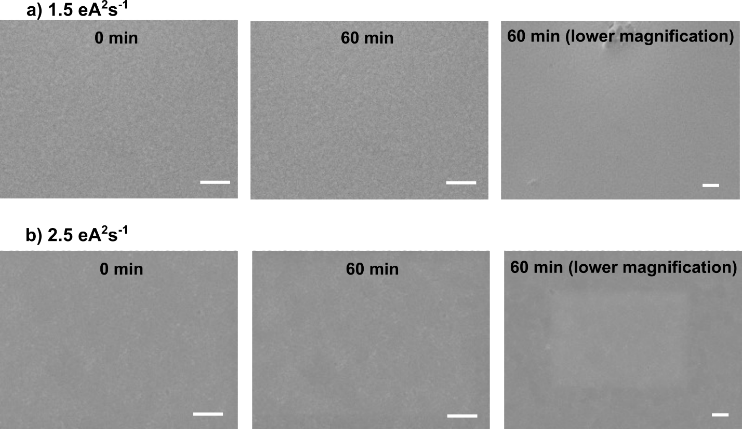
Figure S1: SEM images under various electron doses. Image sequence of unbiased films before and after 60 mins of (a) 1.5 eÅ⁻²s⁻¹, and (b) 2.5 eÅ⁻²s⁻¹ electron dosing (scale bar = 1 μm). Using 2.5 eÅ⁻²s⁻¹ electron dose results in observable discrepancies between the exposed central area and the unexposed area around the center.

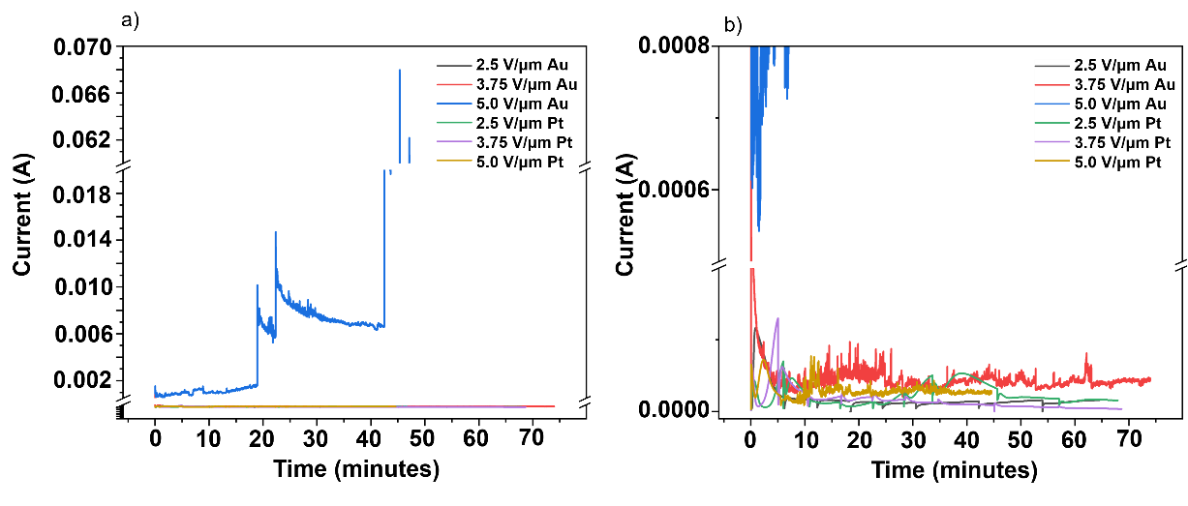
Figure S2: Measured current during biased SEM experiments. Measured current through the electrodes during biased SEM measurements (2.5-5.0 V/μm up to 70 minutes) of the MAPI-deposited Au and Pt electrodes, over a (a) full range, and (b) low current expanded range.
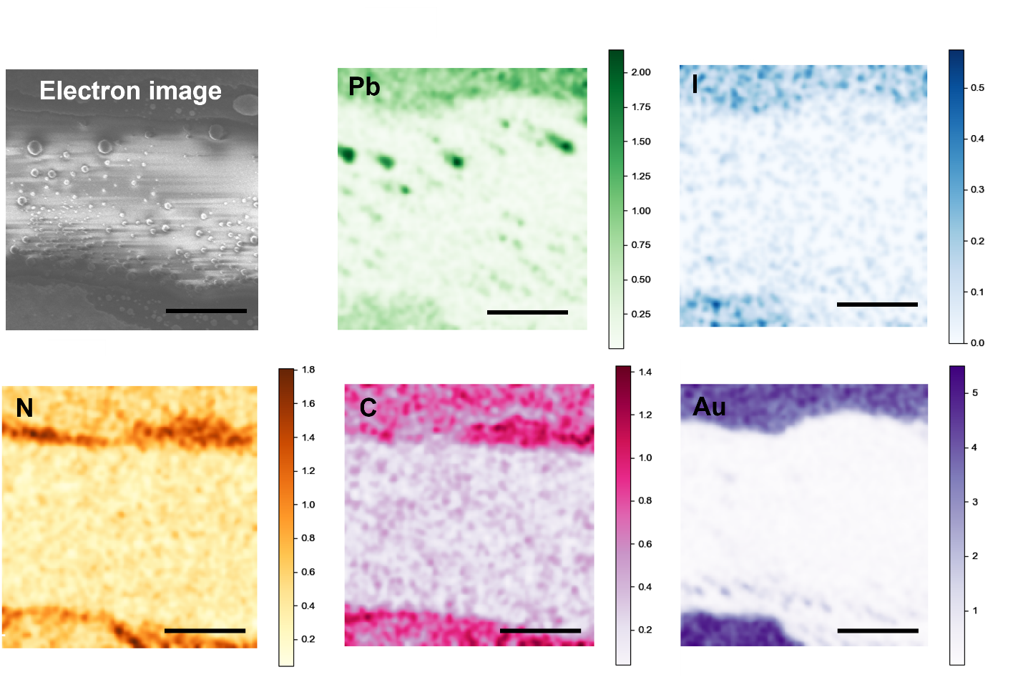
Figure S3: EDX Mapping of MAPI deposited on lateral Au chips. EDX mapping across the MAPI-deposited Au electrodes after 40 minutes of biasing at 5 V/μm with corresponding secondary electron image (top left) (scale bar = 1 μm).
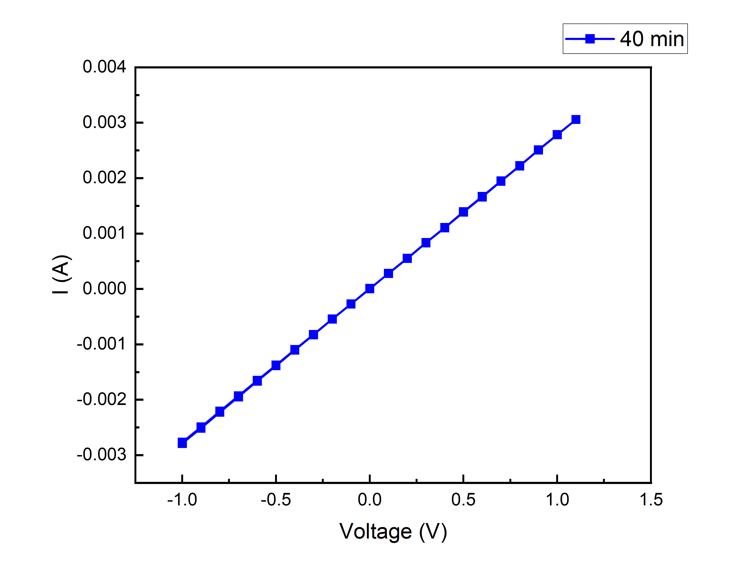
Figure S4: I-V Curve. Plotted current against voltage of the MAPI film deposited on Au electrodes after 40 mins of biasing at 5 V/μm.

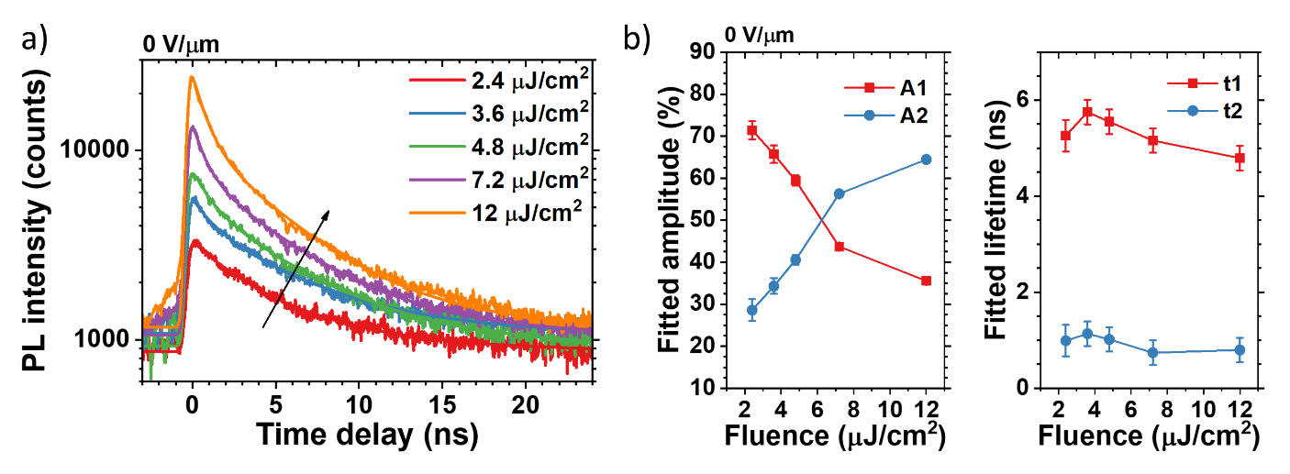
Figure S5: Fluence dependent TRPL. (a) Excitation fluence dependent TRPL measurements of the peak at 760 nm on an unbiased MAPI deposited on Au electrodes, and (b) the associated amplitudes (A₁, A₂) and carrier lifetimes (t₁, t₂) extracted from biexponentially fitting the decay curves. As excitation fluence increases, A₁ shows decreasing trend indicates that long lifetime t₁ represents trap assisted non-radiative lifetime. It means that more traps are filled by excited carriers at higher fluence. Conversely, as more traps are filled, the contribution from free carrier radiative recombination dominates. That results in an increasing A₂. Thus, short lifetime t₂ represents free carrier recombination process.

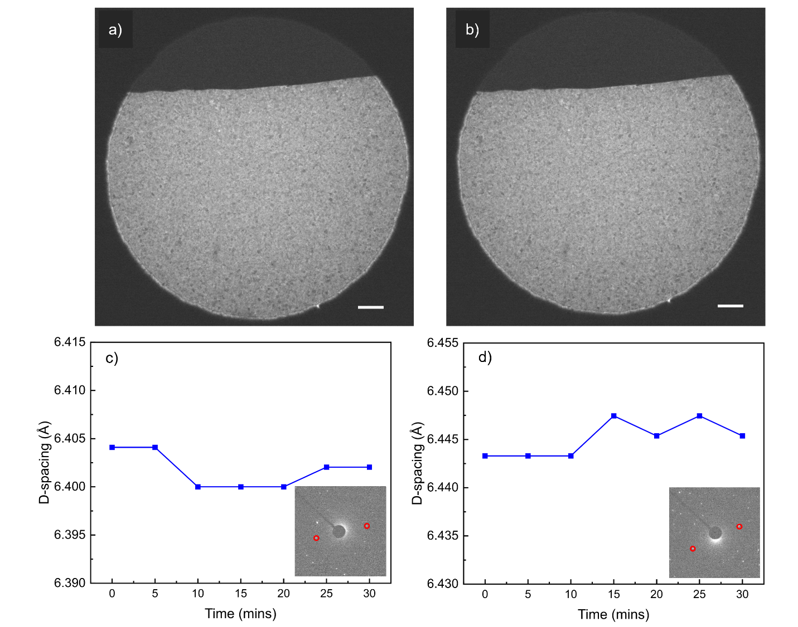
Figure S6: Effect of TEM dosing on MAPI. BF-TEM images of MAPI deposited on Pt electrodes (a) before, and (b) after 30 minutes of dosing at 0.07 eÅ⁻²s⁻¹ (scale bar = 1 μm). (c, d) The associated MAPI (002) d-spacings for diffraction spots at various locations (circled) during this dosing period.
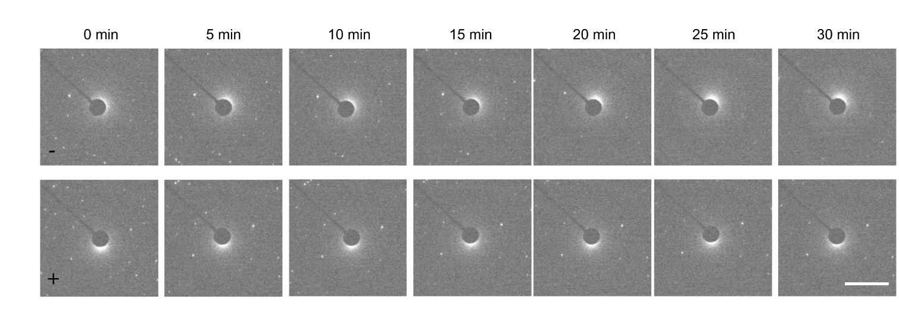
Figure S7: in-situ SAED. A timed series of SAED patterns at both the negative (-) and positive (+) electrodes of the MAPI film deposited on Pt electrodes taken at 5-min intervals for 30 mins of biasing at 2.5 V/μm (scale bar = 2 1/nm).

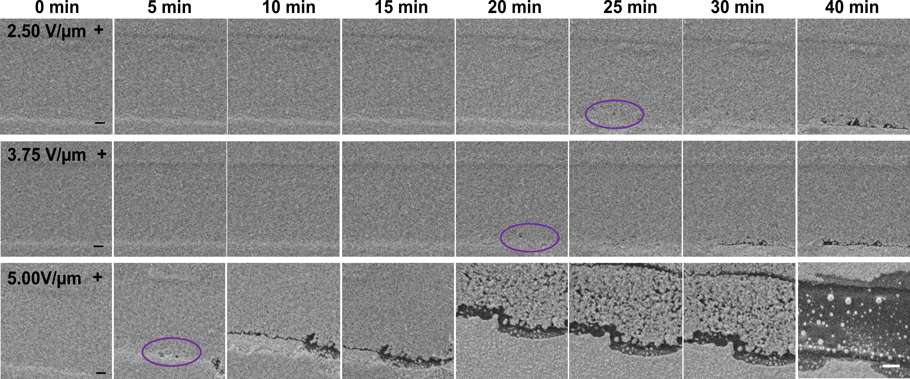
Figure S8: In-situ SEM. A timed series of in-situ SEM images of MAPI deposited on Au electrodes taken at 5-min intervals for 40 minutes of biasing at 5 V/μm (scale bar = 1 µm).
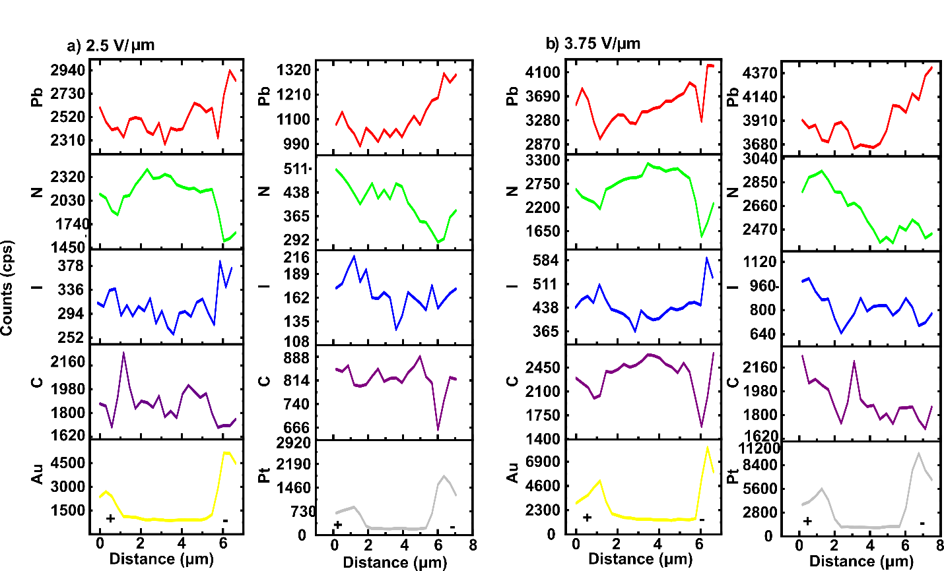
Figure S9: Comparison of EDX line scan of MAPI deposited on Au and Pt electrodes. Elemental counts across the electrode determined from the EDX mapping displayed in Figure 2a for MAPI deposited on Au and Pt electrodes after 60 mins of biasing at (a) 2.5 V/μm, and (b) 3.75 V/ μm.

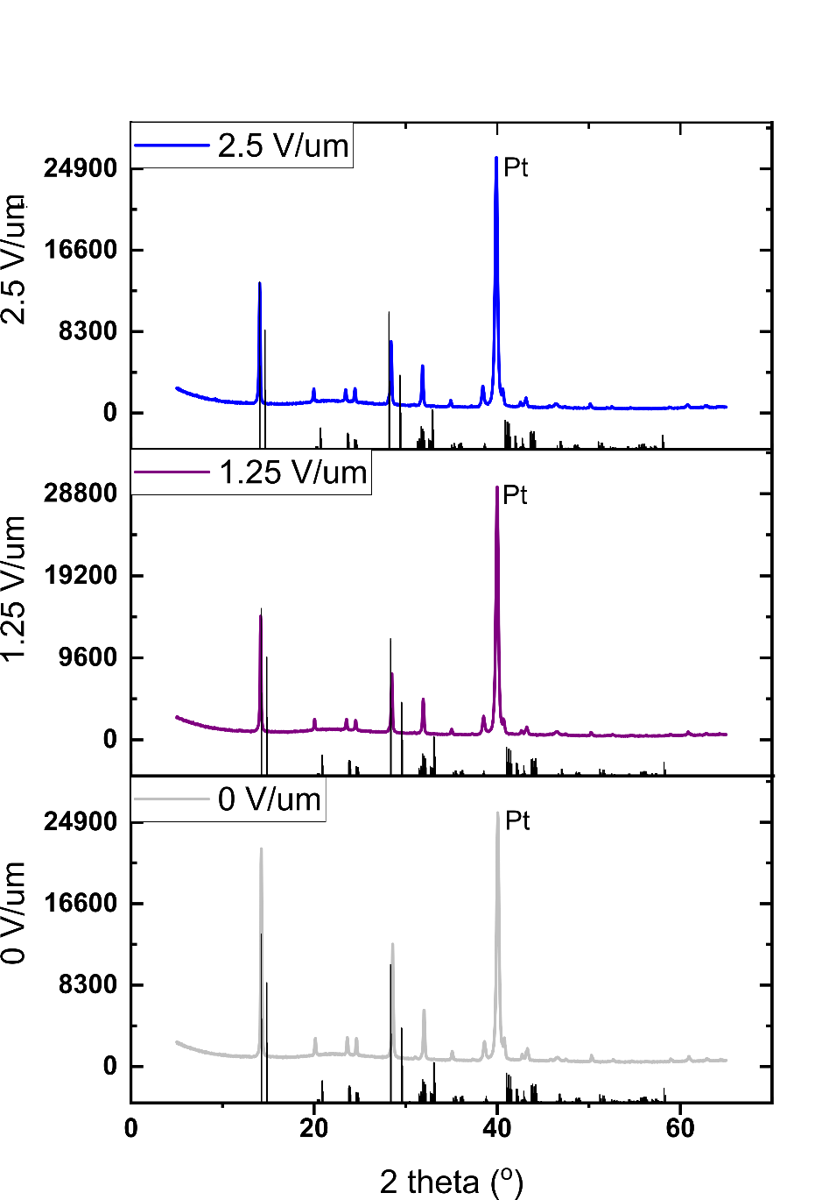
Figure S10: XRD measurements. Ex-situ thin film XRD measurements of the MAPI films deposited on Pt electrodes, prior to and after 20 mins of biasing at 1.25 and 2.5 V/μm. Plotted against an XRD patterns simulated using the structure deposited by reference ¹.
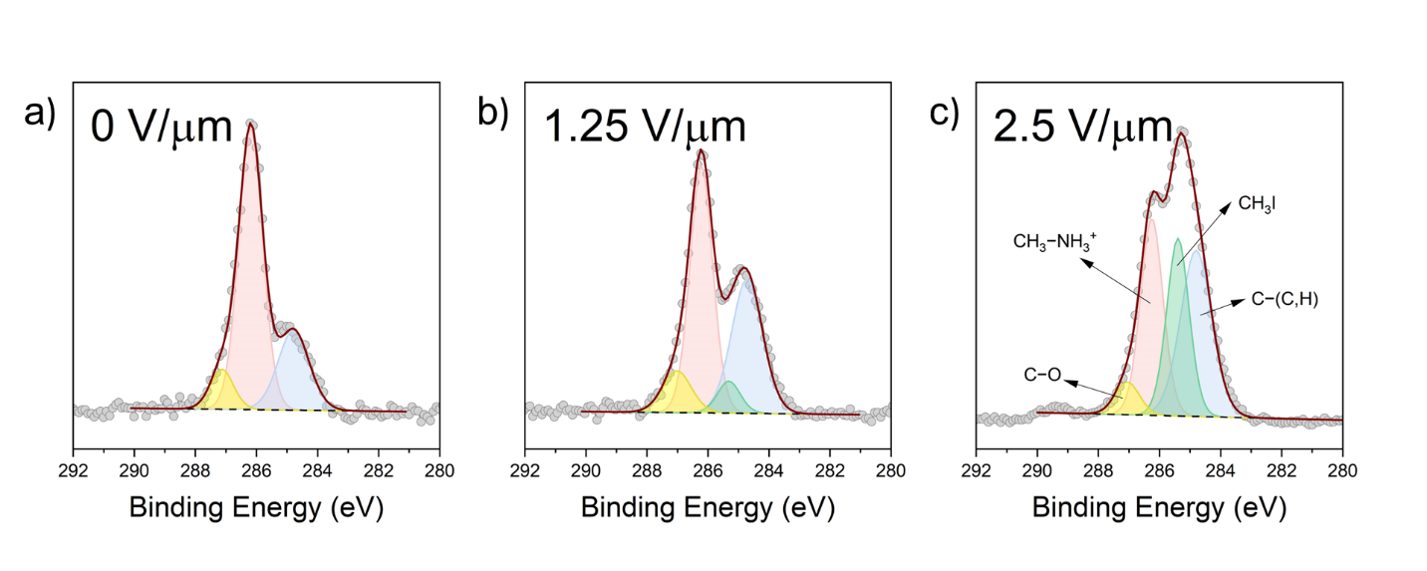Figure S11: XPS peak fitting. Peak fitting of C 1s spectra for (a) unbiased MAPI thin film, (b) 1.25 V/μm biased material deposited on Pt electrodes, and (c) 2.5 V/μm biased material deposited on Pt electrodes.

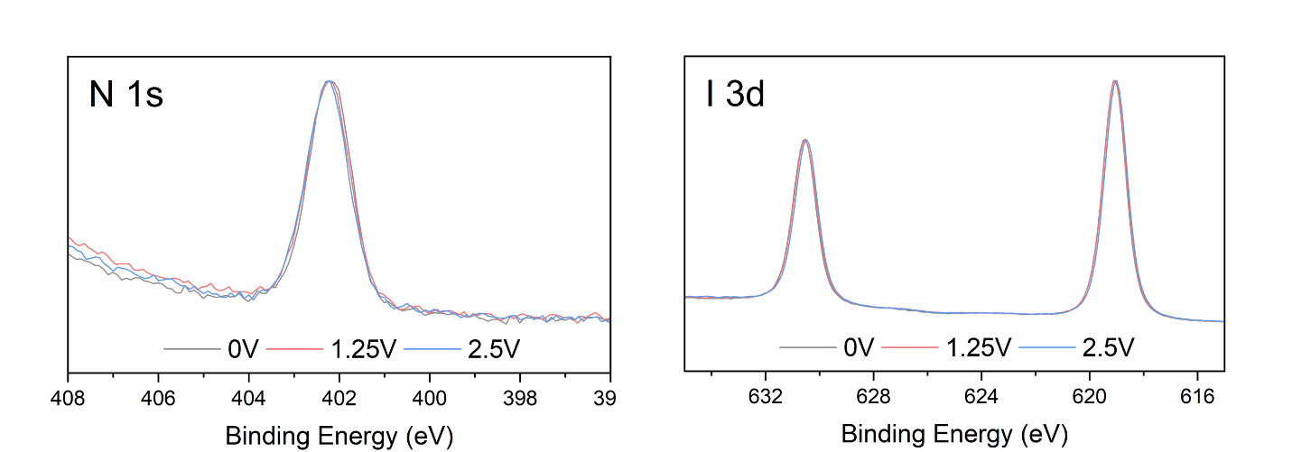
Figure S12: N 1s and I 3d XPS peaks. The N 1s and I 3d XPS spectra of as-synthesized MAPI and biased samples on Pt electrodes.

Figure S13: ¹H MAS and ¹³C CPMAS NMR of PTFE tape. Supporting MAS NMR evidence from the PTFE tape demonstrating that off-diagonal correlations are completely absent from the 2D ¹H-¹H NOESY data acquired with mixing times of (a) 10 ms, and (b) 100 ms, and (c) no ¹³C resonances are observed from measurements attempted under ¹H-¹³C CPMAS NMR conditions.

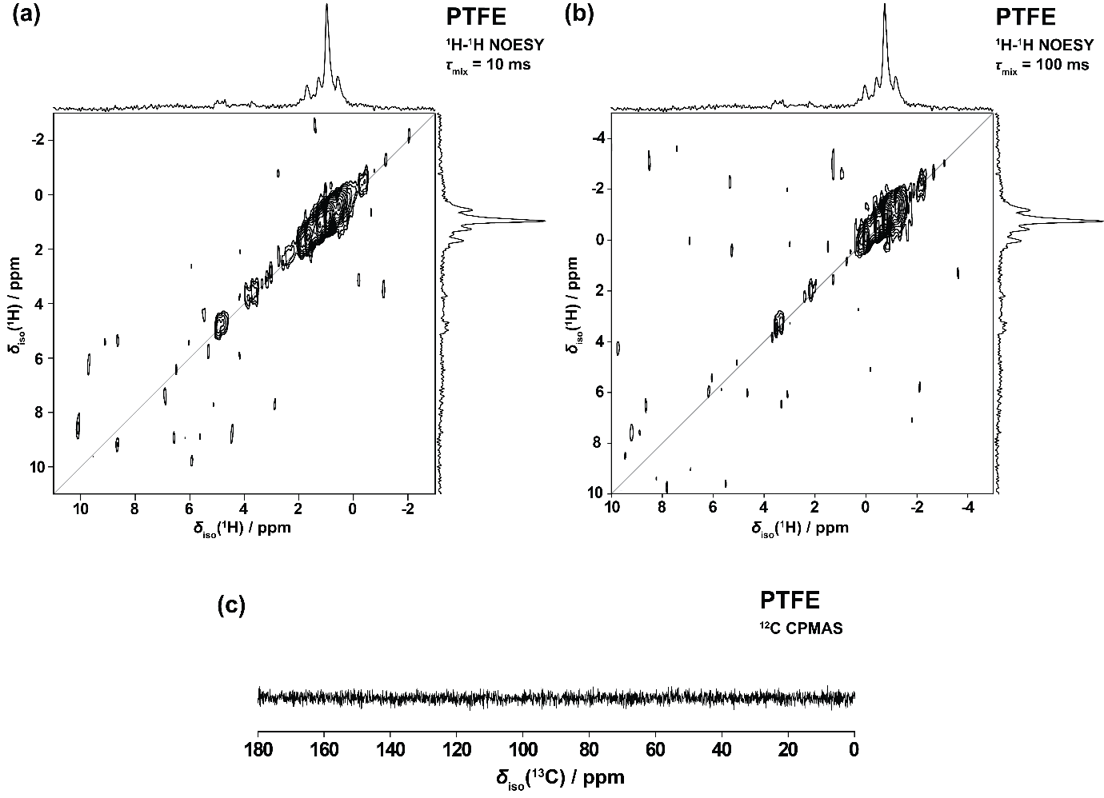

Table S1: Calculated ¹H and ¹³C isotropic shifts of a series of small iodic/amine organic molecules which could be potential products of the biasing degradation in MAPI.
Chemical Name | Molecular Formula | Calculated δ_{iso}(¹H) / ppm | Calculated δ_{iso}(¹³C) / ppm
Tetramethyllead | Pb(CH₃)₃ | 0.2 | 0.8
Methyl iodide | CH₃I | 1.8 | 1.7
Diiodomethane | CH₂I₂ | 5.0 | 42.1
Iodoform | CHI₃ | 8.9 | 90.6
Carbon Tetraiodide | CI₄ | - | 143.0
Ammonia | NH₃ | -0.6 | -
Ammonium Iodide | NH₄I | 6.2 | -
Trimethylamine | (CH₃)₃N | 2.0 | 45.8
Dimethylamine | (CH₃)₂NH | 2.2 | 38.0
Trimethylammonium iodide | (CH₃)₃NHI crystal | 3.1 | 45.3
Tetramethylammonium iodide | (CH₃)₄NI crystal | 3.3 | 53.7
Hydroiodic acid | HI | −0.5 | -

Table S2: Binding energy (BE), FWHM and area percent of the C 1s fitting components of the as synthesized and biased samples in Figure 5c.
Sample | Peak | BE (eV) | FWHM (eV) | Area (%)
0 V/μm | C–C (adC) | 284.8 | 1.20 | 24.61
 | C–N (CH₃NH₃⁺) | 286.2 | 0.92 | 66.22
 | C–O | 287.1 | 0.90 | 9.17
1.25 V/μm | C–C (adC) | 284.7 | 1.20 | 35.54
 | CH₃I | 285.3 | 0.88 | 6.21
 | C–N (CH₃NH₃⁺) | 286.2 | 0.88 | 47.98
 | C–O | 287.0 | 1.11 | 10.27
1.25 V/μm | C–C (adC) | 284.8 | 1.20 | 36.00
 | CH₃I | 285.4 | 0.86 | 27.71
 | C–N (CH₃NH₃⁺) | 286.3 | 0.87 | 30.77
 | C–O | 287.1 | 0.93 | 5.52

References:
1 Aron, W., elds22, Federico, B. & Jarvist, F. M. WMD-group/hybrid-perovskites: Collection 1 (v1.0) (Zenodo, 4/2019).

