DOM: Dual Optical Mapping Combining Sequence-specific Markers and A/T Frequency-dependent Profiles
Jaeyoung Bae^{1†}, Yunchul Kim^{2†}, Juhee Choe^{1†}, Jinhui Hong¹, Byoungsang Lee², Kaori Hashiya³, Toshikazu Bando³, Hiroshi Sugiyama³, Seonghyun Lee*⁴, Jung Heon Lee*^{2,4}, Kyubong Jo*¹

¹ Department of Chemistry, Sogang University, Seoul, Korea
² School of Advanced Materials Science and Engineering, Sungkyunkwan University (SKKU), Suwon, Korea
³ Department of Chemistry, Graduate School of Science, Kyoto University, Kyoto, Japan
⁴ Department of MetaBioHealth, Sungkyunkwan University (SKKU), Suwon, Korea

* To whom correspondence should be addressed. Tel: +82-2-705-8881;
Email: jokyubong@sogang.ac.kr;
Correspondence may also be addressed to: jhlee7@skku.edu; shlee9@skku.edu

Supporting Information (SI)

Supplementary Table and Figures

Table 1. Sequence of oligonucleotides used in FRET experiment

Figure 1. List of genes between the gaps in Figure 1A

Figure 2. Fold changes of the cc value for individual λ DNA images with reference map

Figure 3. Efficiency of DLE-1-induced sequence specific labelling

Figure 4. A complete dual optical map composed of minimal number of data

Figure 5. Space searching of simulation variables using Bayesian optimization
  - Supplementary Table and Figures
Name | Oligonucleotide Sequence
0AT | 5’-6-FAM-GGC CGC GCG CGC GCC CGG TTT TCC GGG CGC GCG CGC GGC C
1AT | 5’-6-FAM-GGC CGC GCA GCG CGC CGG TTT TCC GGC GCG CTG CGC GGC C
2AT | 5’-6-FAM-GGC CGC GCA TCG CGC CGG TTT TCC GGC GCG ATG CGC GGC C
3AT | 5’-6-FAM-GGC CGC GAT ACG CGC CGG TTT TCC GGC GCG TAT CGC GGC C
4AT | 5’-6-FAM-GGC CGC GAT ATG CGC CGG TTT TCC GGC GCA TAT CGC GGC C
5AT | 5’-6-FAM-GGC CGC GAT ATA CGC CGG TTT TCC GGC GTA TAT CGC GGC C
6AT | 5’-6-FAM-GGC CGC GAT ATA TGC CGG TTT TCC GGC ATA TAT CGC GGC C
7AT | 5’-6-FAM-GGC CGC GAT ATA TAC CGG TTT TCC GGT ATA TAT CGC GGC C
8AT | 5’-6-FAM-GGC CGC GAT ATA TAT CCG GTT TTC CGG ATA TAT ATC GCG GCC
9AT | 5’-6-FAM-GGC CGC GAT ATA TAT ACC GGT TTT CCG GTA TAT ATA TCG CGG CC
10AT | 5’-6-FAM-GGC CGC GAT ATA TAT ATC CGG TTT TCC GGA TAT ATA TAT CGC GGC C
Supplementary Table 1. Sequence of oligonucleotides used in FRET experiment

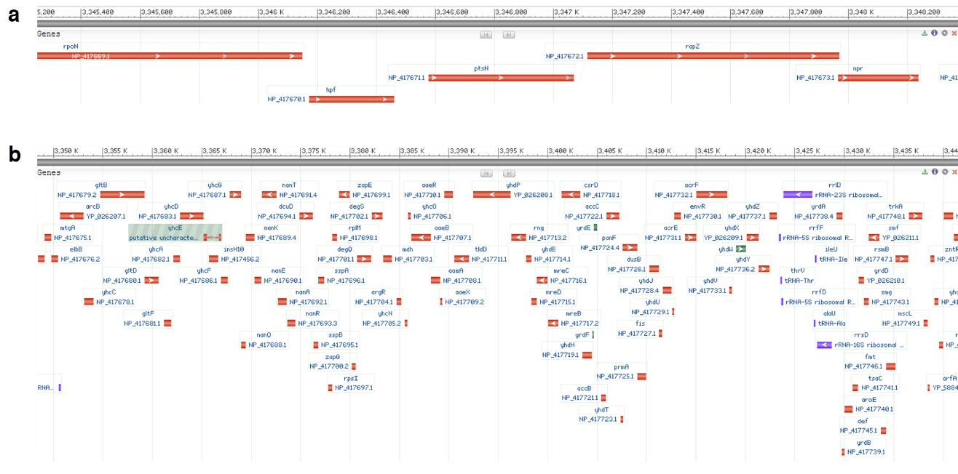

Supplementary Fig. 1. List of genes between the gaps in Figure 1A. The smallest gap (3.1 kb) contains five genes and the largest gap (93.2 kb) contains 91 genes. Detailed sequence information might be missing when solely using barcode-based optical mapping. Reference genome: NC_000913.3.

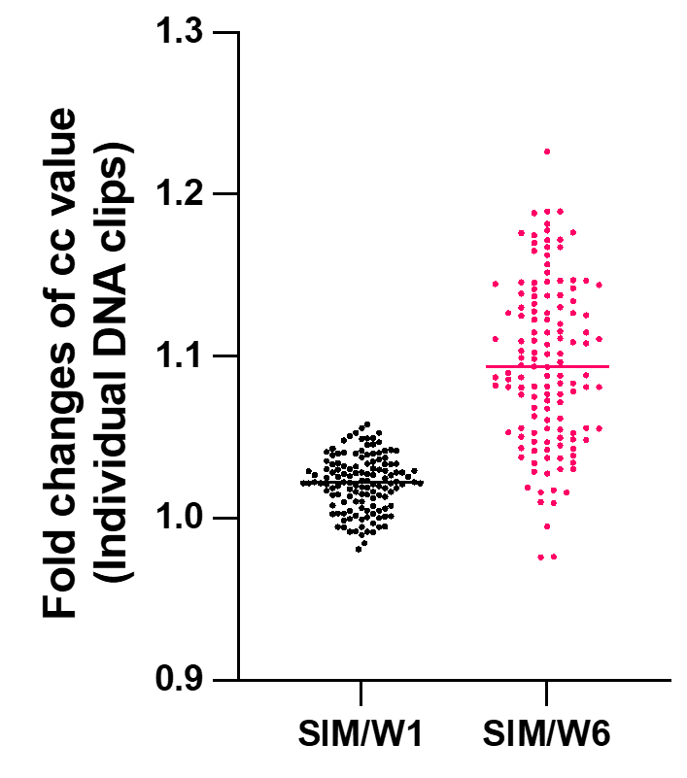

Supplementary Fig. 2. Fold changes of the cc value for individual λ DNA images with reference map. SIM is the average of ten individual simulation maps for consensus map. For most of data, cc value increased when using SIM map, implying that SIM map better describes the AP8 binding to DNA. Total 133 molecule images were used.

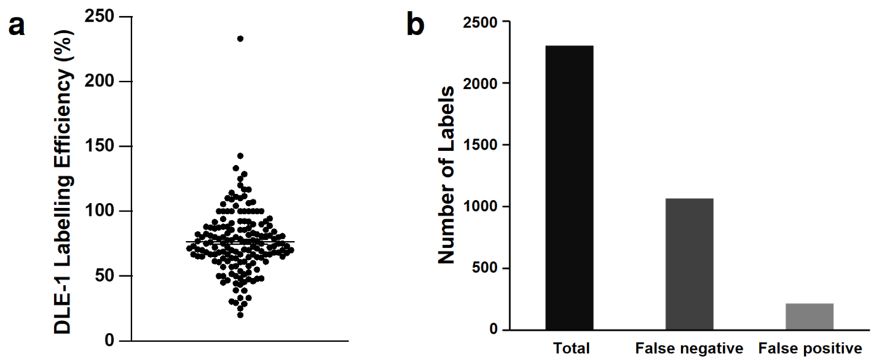

Supplementary Fig. 3. Efficiency of DLE-1-induced sequence specific labelling. (A) DLE-1 labelling efficiency for obtained E. coli DNA images. The mean DLE-1 labelling efficiency was 77 ± 1.8%. (B) The number of false negative and positive labels. There were 1066 (33.9%) false negatives and 218 (6.9%) false positives in entire dataset. (N = 178)

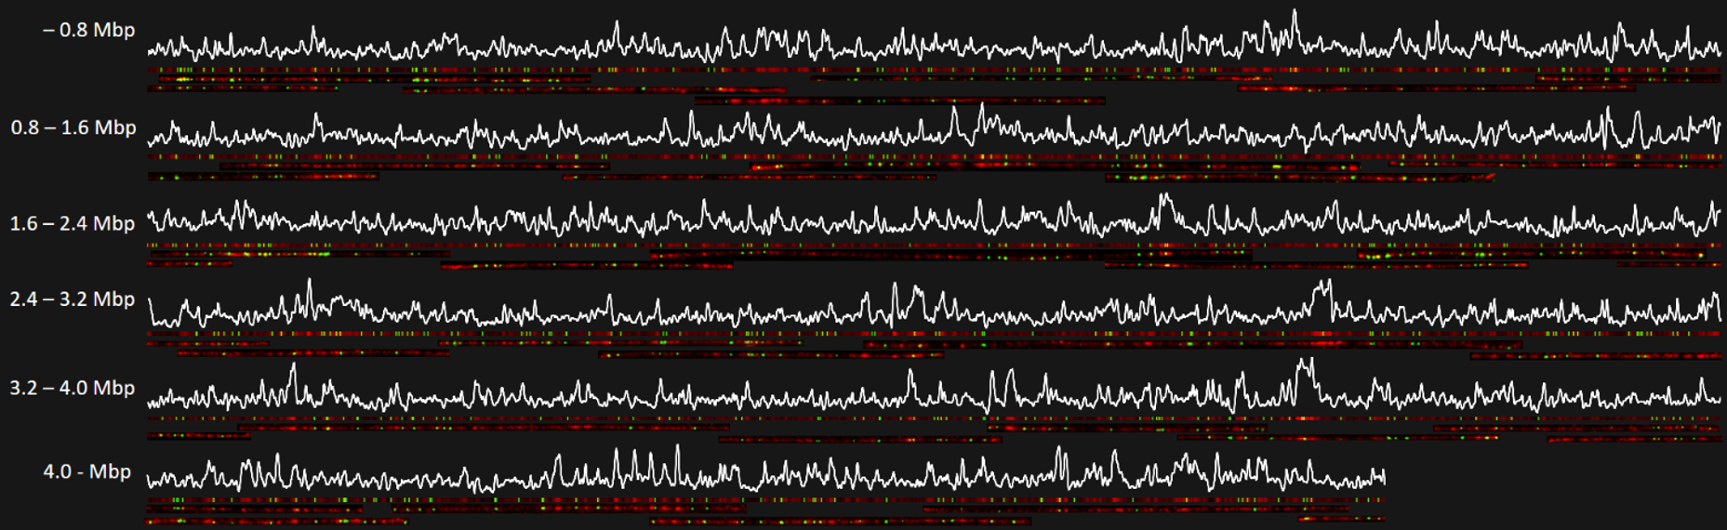

Supplementary Fig. 4. A complete dual optical map composed of minimal number of data. 34 experimental DNA fragments ranging from 116 kb to 307 kb were aligned. White graphs are in silico SIM map of AP8-stained E. coli. (N=34)

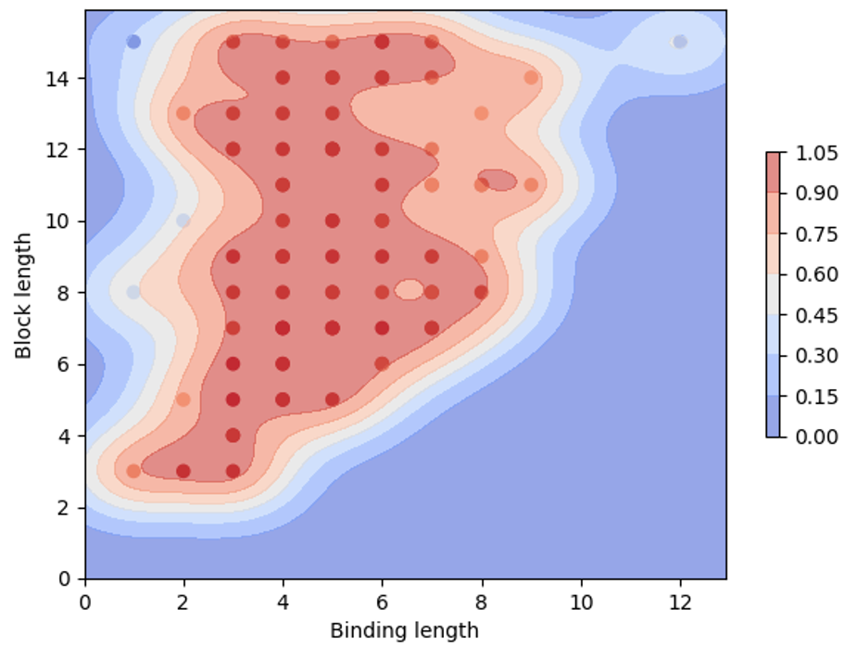

Supplementary Fig. 5. Space searching of simulation variables using Bayesian optimization. 2D representation of the predicted score map and searched points at various binding and block length. The red area indicates regions where simulation and experimental data match well

