Resting-state brain activation patterns and network topology distinguish human sign and goal trackers in humans
Martino Schettino^{1,2,*}, Marika Mauti^{1,3*}, Chiara Parrillo⁴, Ilenia Ceccarelli⁵, Federico Giove^{2,5}, Antonio Napolitano⁴, Cristina Ottaviani^{1,2}, Marialuisa Martelli¹, Cristina Orsini¹

¹ Department of Psychology, Sapienza University of Rome, Rome, Italy; ² IRCCS Santa Lucia Foundation, Rome, Italy; ³ Area of Neuroscience, SISSA, Trieste, Italy; ⁴ Bambino Gesù Children’s Hospital, Rome, Italy; ⁵ Department of Medical and Surgical Sciences, University of Bologna, Italy; ⁶ Centro di Studi e Ricerche Enrico Fermi, Rome, Italy.
*co-first authorship
Supplementary Methods
S1. Self-report questionnaires
The Barratt Impulsiveness Scale (BIS-11;[1]) is a 30-item self-report questionnaire measuring three facets of impulsiveness, namely attentional (“I concentrate easily”), motor (“I act on impulse”) and non- planning (“I say things without thinking”) impulsiveness. Participants have to report how often they experience the situations described by the different items on a 4-point Likert scale that goes from 1 (Never) to 4 (Always).
The State- Trait Anxiety Inventory (STAI; [2]) is a validated self-report assessment device usually administered in research and clinical settings to measure anxiety. It is composed of two, different scale of 20-item each: STAI-Y1 measures the general, long- lasting “trait anxiety” (“I feel like a failure”); differently, STAI-Y2 measures the more transient condition of “state anxiety” (“I feel upset”). Each item is based on a Likert scale that goes from 1 (Almost never) to 4 (Almost always).
The Temporal Experience Pleasure Scale (TEPS; [3]) is an 18-item self-report questionnaire measuring both anticipatory (“When I hear about a new movie starring my favourite actor, I can't wait to see it”) and consummatory (“I love it when people play with my hair”) pleasure. For each item, participants respond on a 6-point Likert scale rated from 1 (very false for me) to 6 (very true for me).
The Obsessive- Compulsive Inventory Revised (OCI-R, [4]) is an 18-item scale assessing obsessive-compulsive symptoms experienced over the preceding month across 6 different subscales, which are washing (“I sometimes have to wash or clean myself simply because I feel contaminated”), ordering (“I get upset if others change the way I have arranged things”), checking (“I check things more often than necessary”), obsessing (“I find it difficult to control my own thoughts”),neutralizing (“I feel compelled to count while I am doing things”) and hoarding (“I collect things I don’t need”). Each item is based on a Likert scale from 0 (Not at all) to 4 (Extremely).

S2. Pavlovian Conditioning Approach Task

The exact instructions delivered to participants are provided below.
Slide 1
Welcome. In this experiment you are not required to perform any tasks and at the end of the experiment you will receive some money. You will see some stimuli programmed to drop a coin and others not programmed to drop it. At the end of the task, you will receive the default coins for your experiment”
Slide 2:
During the experiment you will see a fixation point (white square image) in the centre of the screen. You will then see stimuli appear on the right or left side of the screen. Among the stimuli that you will see appear there are:

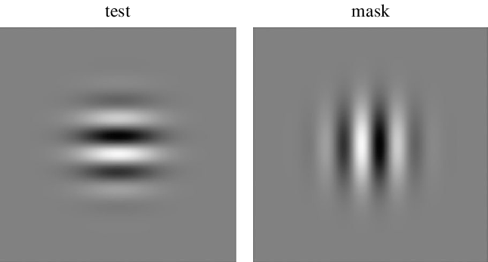

Then, coins of different values ​​or "no-coins" will appear. The presence of a coin tells you that the same coin will be released for that trial. This is one of the coins that will appear:

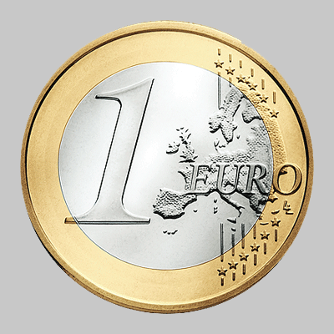

The presence of a “no-coin” will tell you that no coin will be released. This is a non-coin:



Slide 3:
Feel free to explore the screen. You are not required to perform any tasks and at the end of the experiment you will receive the total amount of coins that will appear on the screen.

As participants could fixate both the Sign and the empty Goal box during the CS periods, the PCA index has the advantage of incorporating in a single score the prevalence of the eye-gaze direction. However, changes of the specific aspects of the eye-gaze incorporated in the PCA score (duration, frequency, and probability) across the two blocks of CS+ trials were also analyzed. Statistical results are reported in Table S1 and depicted in Figure S1. Since the start of the task, subjects categorized as ST fixated the Sign more (higher dwell frequency), longer (higher dwell time), and in every CS+ trial (higher dwell probability); as the training progressed, they did not significantly change their behavior towards the Sign but decreased their probability to fixate the Goal box in presence of the Sign (thus focusing selectively on the Sign). By contrast, in participants categorized as GT, every aspect of the eye-gaze was strongly directed toward the Goal-box and across trials duration, the frequency of these fixations increased. Finally, eye-gaze specific aspects of participants categorized as Int typically fell in between the other two phenotypes.

S3. Threshold Measurement Task
The threshold Measurement task was performed to verify that phenotypical differences between STs, GTs and Ints could not be attributed to differences in stimuli perceptual processing, specifically in contrast sensitivity. In so doing, the stimuli used in the PCA (CS+, vertical Gabor patch; CS-, horizontal Gabor patch) were presented for 5 sec embedded in dynamic grey noise (rms contrast of 0.2, sampled fresh in each trial with a refresh rate of 60 Hz) that varied across 30 trials (15 CS+ and 15 CS-). After stimuli removal, participants were instructed to press N or M on the keyboard if they expected a reward (€ coins) or a no-reward (scrambled coin) based on the contingencies previously learned. Ratio of correct responses on these 30 trials set the individual signal-to-noise contrast value later analysed by ANOVA with Phenotype as independent variable. No significant differences were found (F(1,74) = 0.68, p = 0.51).

S4. MRI acquisition
The structural images T₁ and T₂-weighted were acquired on each participant using MPRAGE (Magnetization-Prepared RApid Gradient-Echo) and SPACE (Sampling Perfection with Application optimized Contrast using different flip angle Evolution) sequences respectively. Both included perspective motion correction and selective reacquisition of motion-corrupted data [44]. Further scanning parameters: MPRAGE TE/TI/TR 2.87/1090/2500 ms, Flip Angle 8°, GRAPPA 2, voxel size 0.8³ mm³. SPACE TE/TR 564/3200 ms, GRAPPA 2, voxel size 0.8³ mm³.
Functional scans were acquired with a T2* -weighted gradient-echo EPI sequence, a multiband factor of 8, and an isotropic voxel size of 2.23 mm3 (64 slices, field of view = 208 × 208 mm2). TE/TR = 32/800 ms, Flip Angle 52° and no in-plane acceleration (Moeller et al., 2010; Xu et al., 2013). Two runs were acquired with opposite phase encoding in the anterior-posterior direction. Each run included 450 measurements. Single band reference images were acquired during pre-scan. Two Spin echo scans with no multiband and the same geometrical and sampling properties were acquired with opposite phase encoding direction for field mapping (TE/TR=80/7660 ms, Flip angle 90°).

S5. List of the brain regions examined in the resting state functional connectivity analyses

- Orbitofrontal Cortex (OFC)
- Medial Prefrontal Cortex (mPFC)
- Nucleus Accumbens Core (NAcC)
- Nucleus Accumbens Shell (NAcsh)
- Caudate (Cau)
- Insula (Ins)
- Putamen (Put)
- Globus Pallidus (GP)
- Amigdala (Amy)
- Anterior ventral Thalamus (aThv)
- Posterior ventral Thalamus (pThv)
- Anterior dorsal Thalamus (aThd)
- Posterior dorsal Thalamus (pThd)

Table S1. Eye-gaze individual aspects/features (dwell time, dwell frequency and dwell probability) used to calculate the PCA score

 | Phenotype | Block | Phenotype x Block
time on Sign | F(2,102) = 49.435 p < 0.001 |  | F(2,102) = 5.605 p < 0.01
f on Sign | F(2,102) = 17.067 p < 0.001 |  | F(2,102) = 4.655 p < 0.05
p on Sign | F(2,102) = 13.608 p < 0.001 |  | F(2,102) = 3.019 p = 0.053
time on Goal | F(2,102) = 62.078 p < 0.001 |  | F(2,102) = 9.296 p < 0.001
f on Goal | F(2,102) = 51.278 p < 0.001 |  | F(2,102) = 8.432 p < 0.001
p on Goal | F(2,102) = 88.017 p < 0.001 | F(1,102) = 8.728 p < 0.01 | F(2,102) = 6.594 p < 0.01

Figure S1. Individual aspects of eye gaze (time duration, number, and probability) directed towards the CS+ and the CS- stimuli across the two blocks between the phenotypes. Bars represent standard error of the mean.
Note. STs, Sign Trackers; STs, Sign Trackers; Ints, Intermediates; GTs, Goal Trackers; * b2 vs b1

References

[1] Patton JH, Stanford MS, Barratt ES. Factor structure of the barratt impulsiveness scale. J Clin Psychol 1995; 51: 768–774.
[3] Spi2lberger, CD, Gorsuch RL, Lushene RE. Manual for the State-Trait Anxiety Inventory. Consulting Psychologists Press.: PAlo Alto, CA, 1970.

[4] Gard DE, Gard MG, Kring AM, John OP. Anticipatory and consummatory components of the experience of pleasure: A scale development study. Journal of Research in Personality 2006; 40: 1086–1102.
[5] Foa EB, Huppert JD, Leiberg S, Langner R, Kichic R, Hajcak G et al. The Obsessive-Compulsive Inventory: Development and validation of a short version. Psychological Assessment 2002; 14: 485–496.

