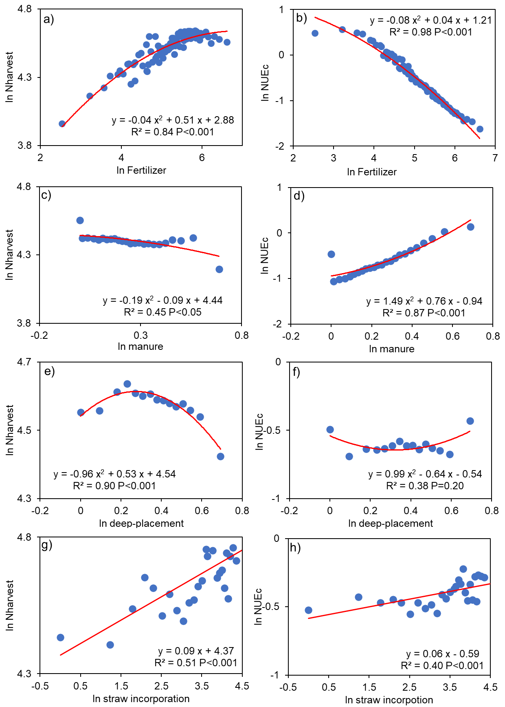
Extended data Figure 1 Relations between management practices and nitrogen use. a, c, e, g show the relations between fertilizer, manure, deep-placement, straw incorporation and N harvest, respectively. While b, d, f, h represent the relations of the four independent variables and NUEc. Fertilizer is nitrogen in fertilizer; Deep-placement is nitrogen in fertilizer and manure that is deep-placement divided by total; Manure is nitrogen in manure divided by summation of fertilizer and manure; Straw incorporation is nitrogen in straw recycle to cropland. Nharvest (kg N/ha) is nitrogen in harvest crops, NUEc (%) is nitrogen in harvest crops divided by nitrogen input in fertilizer. County-level regional effect, crop type, and year effects have been controlled in all regression equations and all the variables are log-transformed.
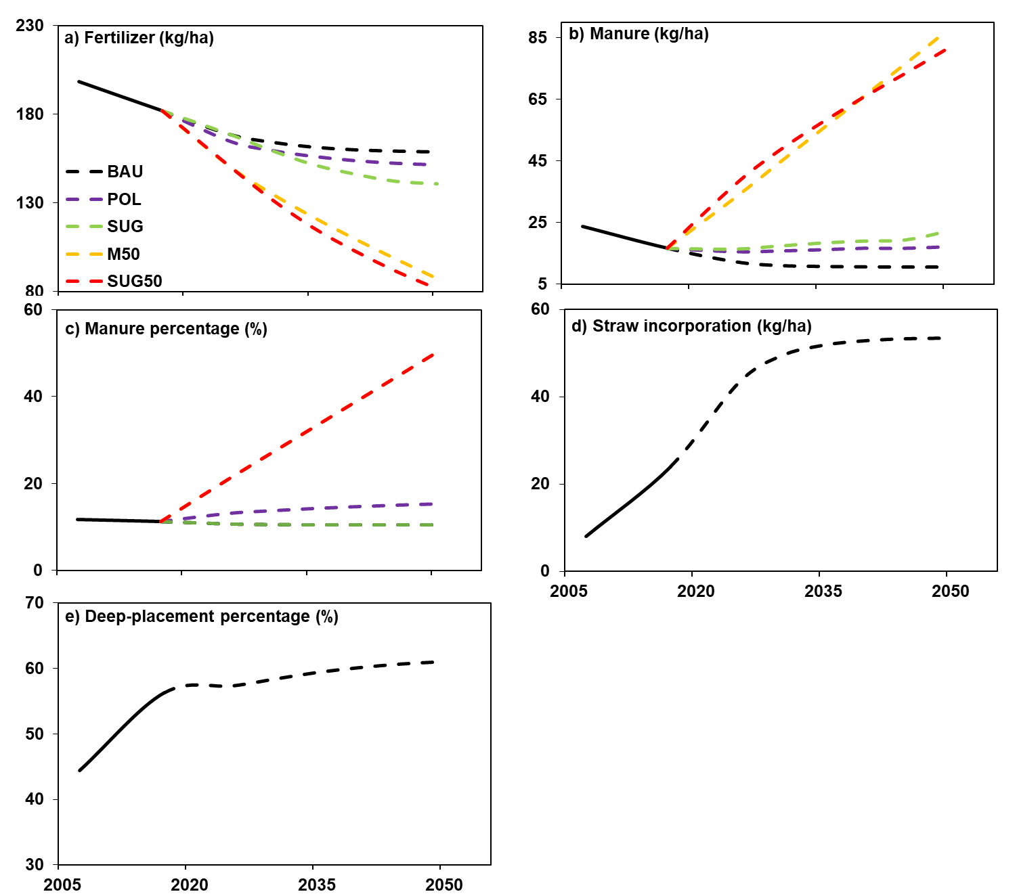
Extended data Figure 2 Fertilizer, manure, manure percentage, deep-placement percentage, straw incorporation change for different scenarios toward 2050. a, Fertilizer change. b, Manure change. c, Manure percentage change. d, Straw incorporation change. e, Deep-placement percentage change. BAU, business as usual, assumes no interventions; POL, increase organic fertilizer use at a rate of 5% every 5 years and replace inorganic amount; SUG, fertilizer and manure are jointly reduced to recommended nitrogen application rate; M50 scenarios would increase manure percent to 50% gradually; SUG50 is combined of SUG and M50. The figures show specific values for these independent variables for different scenarios that are used for scenario analysis.
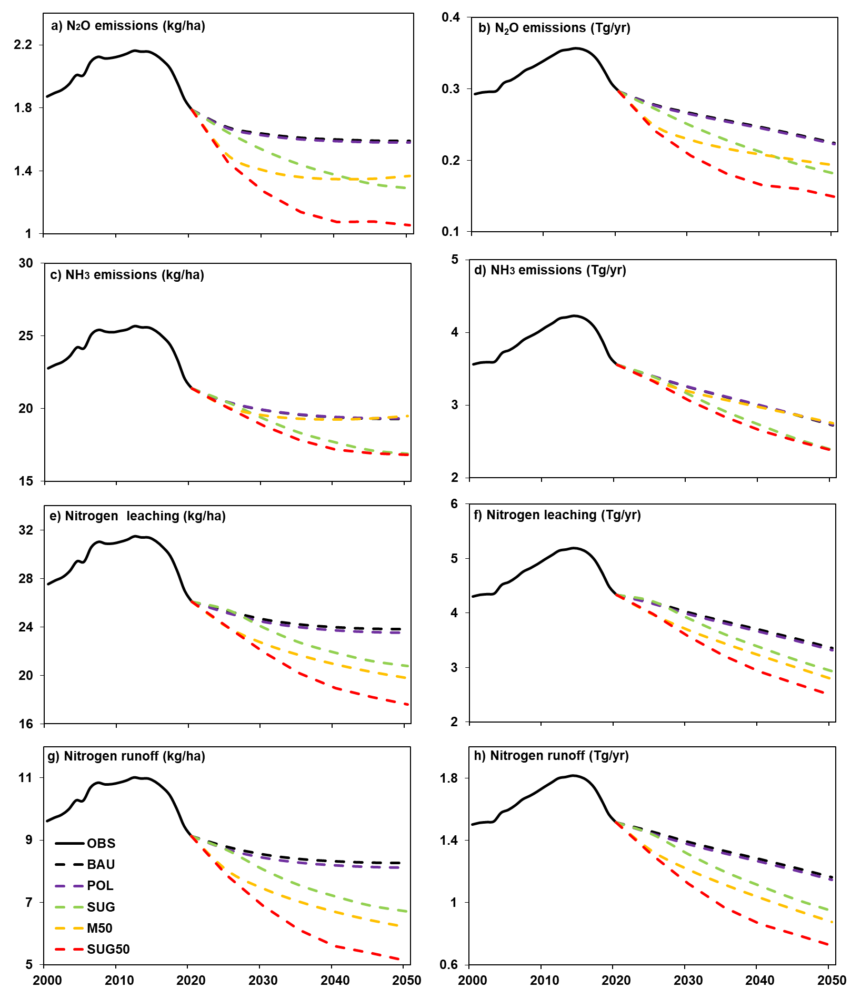
Extended data Figure 3 Nitrogen loss for per hectare and the total in under different agricultural management practices towards 2050. a, c, e, g show the per hectare value for N₂O emission, NH₃ emission, nitrogen leaching, and nitrogen runoff, respectively. While b, d, f, h represent the total value for these loss indicators. BAU, business as usual, assumes no interventions; POL, increase organic fertilizer use at a rate of 5% every 5 years and replace inorganic amount; SUG, fertilizer and manure are jointly reduced to recommended nitrogen application rate; M50 scenarios would increase manure percent to 50% gradually; SUG50 is combined of SUG and M50. As we used fertilizer and manure amount with emission factors and loss ratios, all of these curves follow a similar trend.

Extended data Table 1 Coefficients of agricultural management practice to nitrogen harvest and nitrogen use efficiency of cropland for vegetables and fruits, and cash crops. Each column represents a separate regression model. Explanatory variables include Fertilizer², Fertilizer, Deep-placement², Deep-placement, Manure², Manure, Straw return; explained variables are NUEc and Nharvest. Fertilizer is nitrogen in fertilizer; Deep-placement is nitrogen in fertilizer and manure that is deep-placement divided by total; Manure is nitrogen in manure divided by summation of fertilizer and manure; Straw incorporation is nitrogen in straw recycle to cropland. The 2-corner mark represents their quadratic. Nharvest (kg N/ha) is nitrogen in harvest crops, NUEc (%) is nitrogen in harvest crops divided by nitrogen input in fertilizer. Asterisk letters indicate the statistical significance level based on P values: ***P < 0.01; **P < 0.05; *P < 0.1. PAC on behalf of administrative district have been controlled in all regression equations. More details about the analysis can be found in the Methods. And the results for fruit and vegetables, and cash crops are in Extended data Table 1.

 | Vege&fruit |  | Cash
 | NUEc | Nharvest | NUEc | Nharvest
Fertilizer² |  | -0.041*** |  | 0.084***
Fertilizer (kg N/ha) | -0.405*** | 0.121*** | -0.323*** | 0.013*
Deep-placement percent² |  | -0.463*** |  | 0.051***
Deep-placement percent (%) | -0.080*** | 0.339*** | -0.033*** | -0.092***
Manure percent² |  | -0.075*** |  | 0.018***
Manure percent (%) | 0.106*** | 0.098*** | 0.030*** | -0.015**
Straw-recycled (kg N/ha) | 0.036*** | 0.042*** | 0.073*** | 0.072***
PAC | Yes | Yes | Yes | Yes
N | 508,862 | 565,670 | 321,709 | 320,196
Adjust R² | 0.34 | 0.27 | 0.44 | 0.47
Model | OLS | OLS | OLS | OLS

Extended data Table 2 Coefficients of agricultural management practice to nitrogen harvest and nitrogen use efficiency of cropland for all crops in 2007 and 2017. Each column represents a separate regression model. Explanatory variables include Fertilizer², Fertilizer, Deep-placement², Deep-placement, Manure², Manure, Straw return; explained variables are NUEc and Nharvest. Fertilizer is nitrogen in fertilizer; Deep-placement is nitrogen in fertilizer and manure that is deep-placement divided by total; Manure is nitrogen in manure divided by summation of fertilizer and manure; Straw incorporation is nitrogen in straw recycle to cropland. The 2-corner mark represents their quadratic. Nharvest (kg N/ha) is nitrogen in harvest crops, NUEc (%) is nitrogen in harvest crops divided by nitrogen input in fertilizer. Asterisk letters indicate the statistical significance level based on P values: ***P < 0.01; **P < 0.05; *P < 0.1. PAC on behalf of administrative district have been controlled in all regression equations. More details about the analysis can be found in the Methods.

All crops | 2007 |  | 2017
 | NUEc | Nharvest | NUEc | Nharvest
Fertilizer² |  | -0.179*** |  | -0.006
Fertilizer (kg N/ha) | -0.517*** | 0.275*** | -0.468*** | 0.129***
Deep-placement percent² |  | 0.079*** |  | -0.165***
Deep-placement percent (%) | -0.025*** | -0.197*** | -0.011*** | 0.129***
Manure percent ² |  | -0.009*** |  | -0.006
Manure percent (%) | 0.050*** | 0.006** | 0.060*** | 0.005
Straw-recycled (kg N/ha) | 0.052*** | 0.145*** | 0.103*** | 0.195***
Year | Yes | Yes | Yes | Yes
PAC | Yes | Yes | Yes | Yes
N | 2,536,607 | 2,654,297 | 359,583 | 384,702
Adjust R² | 0.39 | 0.28 | 0.35 | 0.33
Model | OLS | OLS | OLS | OLS

Extended data Table 3 Coefficients of agricultural management practice to nitrogen harvest and nitrogen use efficiency of cropland for grains in 2007 and 2017. Each column represents a separate regression model. Explanatory variables include Fertilizer², Fertilizer, Deep-placement², Deep-placement, Manure², Manure, Straw return; explained variables are NUEc and Nharvest. Fertilizer is nitrogen in fertilizer; Deep-placement is nitrogen in fertilizer and manure that is deep-placement divided by total; Manure is nitrogen in manure divided by summation of fertilizer and manure; Straw incorporation is nitrogen in straw recycle to cropland. The 2-corner mark represents their quadratic. Nharvest (kg N/ha) is nitrogen in harvest crops, NUEc (%) is nitrogen in harvest crops divided by nitrogen input in fertilizer. Asterisk letters indicate the statistical significance level based on P values: ***P < 0.01; **P < 0.05; *P < 0.1. PAC on behalf of administrative district have been controlled in all regression equations. More details about the analysis can be found in the Methods.

Grains | 2007 |  | 2017
 | NUEc | Nharvest | NUEc | Nharvest
Fertilizer² |  | -0.219*** |  | -0.118***
Fertilizer (kg N/ha) | -0.648*** | 0.405*** | -0.596*** | 0.308***
Deep-placement percent² |  | -0.094*** |  | -0.054***
Deep-placement percent (%) | 0.027*** | 0.074*** | 0.030*** | 0.098***
Manure percent ² |  | -0.075*** |  | -0.115***
Manure percent (%) | 0.068*** | 0.110*** | 0.084*** | 0.155***
Straw-recycled (kg N/ha) | 0.025*** | 0.070*** | 0.090*** | 0.223***
Year | Yes | Yes | Yes | Yes
PAC | Yes | Yes | Yes | Yes
N | 1,836,889 | 1,916,133 | 228,730 | 237,000
Adjust R² | 0.52 | 0.44 | 0.48 | 0.43
Model | OLS | OLS | OLS | OLS

Extended data Table 4 Coefficients of agricultural management practice to nitrogen harvest and nitrogen use efficiency of cropland for vegetables and fruits in 2007 and 2017. Each column represents a separate regression model. Explanatory variables include Fertilizer², Fertilizer, Deep-placement², Deep-placement, Manure², Manure, Straw return; explained variables are NUEc and Nharvest. Fertilizer is nitrogen in fertilizer; Deep-placement is nitrogen in fertilizer and manure that is deep-placement divided by total; Manure is nitrogen in manure divided by summation of fertilizer and manure; Straw incorporation is nitrogen in straw recycle to cropland. The 2-corner mark represents their quadratic. Nharvest (kg N/ha) is nitrogen in harvest crops, NUEc (%) is nitrogen in harvest crops divided by nitrogen input in fertilizer. Asterisk letters indicate the statistical significance level based on P values: ***P < 0.01; **P < 0.05; *P < 0.1. PAC on behalf of administrative district have been controlled in all regression equations. More details about the analysis can be found in the Methods.

Vege&fruit | 2007 |  | 2017
 | NUEc | Nharvest | NUEc | Nharvest
Fertilizer² |  | -0.053*** |  | 0.006
Fertilizer (kg N/ha) | -0.419*** | 0.136*** | -0.349*** | 0.113***
Deep-placement percent² |  | -0.270*** |  | -0.485***
Deep-placement percent (%) | -0.090*** | 0.122*** | -0.091*** | 0.384***
Manure percent ² |  | -0.071*** |  | -0.125***
Manure percent (%) | 0.100*** | 0.093*** | 0.154*** | 0.185***
Straw-recycled (kg N/ha) | 0.042*** | -0.050*** | - | -
Year | Yes | Yes | Yes | Yes
PAC | Yes | Yes | Yes | Yes
N | 430,129 | 472,496 | 78,733 | 93,174
Adjust R² | 0.37 | 0.28 | 0.38 | 0.37
Model | OLS | OLS | OLS | OLS

Extended data Table 5 Coefficients of agricultural management practice to nitrogen harvest and nitrogen use efficiency of cropland for cash crops in 2007 and 2017. Each column represents a separate regression model. Explanatory variables include Fertilizer², Fertilizer, Deep-placement², Deep-placement, Manure², Manure, Straw return; explained variables are NUEc and Nharvest. Fertilizer is nitrogen in fertilizer; Deep-placement is nitrogen in fertilizer and manure that is deep-placement divided by total; Manure is nitrogen in manure divided by summation of fertilizer and manure; Straw incorporation is nitrogen in straw recycle to cropland. The 2-corner mark represents their quadratic. Nharvest (kg N/ha) is nitrogen in harvest crops, NUEc (%) is nitrogen in harvest crops divided by nitrogen input in fertilizer. Asterisk letters indicate the statistical significance level based on P values: ***P < 0.01; **P < 0.05; *P < 0.1. PAC on behalf of administrative district have been controlled in all regression equations. More details about the analysis can be found in the Methods.

Cash | 2007 |  | 2017
 | NUEc | Nharvest | NUEc | Nharvest
Fertilizer² |  | 0.111*** |  | 0.036**
Fertilizer (kg N/ha) | -0.304*** | -0.016* | -0.416*** | 0.075***
Deep-placement percent² |  | 0.177*** |  | 0.047**
Deep-placement percent (%) | -0.041*** | -0.227*** | -0.016** | -0.046**
Manure percent ² |  | -0.011* |  | 0.023
Manure percent (%) | 0.030*** | 0.013* | 0.046*** | -0.015
Straw-recycled (kg N/ha) | 0.005*** | 0.003* | 0.147*** | 0.123***
Year | Yes | Yes | Yes | Yes
PAC | Yes | Yes | Yes | Yes
N | 269,589 | 265,668 | 52,120 | 54,528
Adjust R² | 0.47 | 0.45 | 0.48 | 0.69
Model | OLS | OLS | OLS | OLS

Extended data Table 6 Extreme point for Relations between nitrogen in harvest and management practice for different crops. The results of the regression analysis are presented in Table 1 and Extended data Table 1. Fertilizer is nitrogen in fertilizer; Deep-placement is nitrogen in fertilizer and manure that is deep-placement divided by total; Manure is nitrogen in manure divided by summation of fertilizer and manure; Straw incorporation is nitrogen in straw recycle to cropland; Nharvestis nitrogen in harvest crops,

 | All | Grain | Vege&fruit | Cash
Fertilizer (kg N/ha) | 507 | 518 | 1008 | -49
Deep-placement percent (%) | -34 | 48 | 38 | 94
Manure percent (%) | -11 | 66 | 62 | 37

