Extended Data Figures

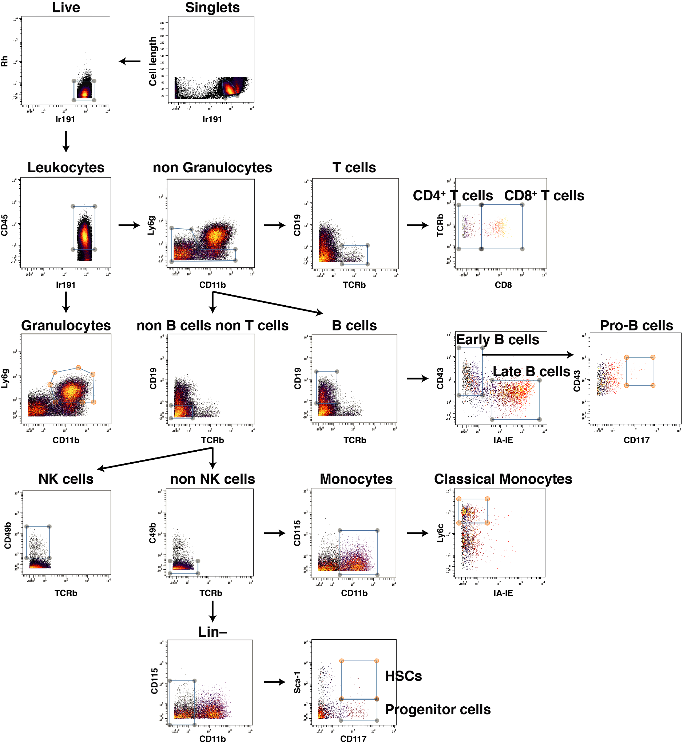

Extended Data Figure 1: Gating strategy for quantifying immune cell types in mouse bone marrow
CyTOF plots showing the gating strategy. Classical monocytes are referred to as ‘monocytes’ from hereon. ‘Stem cells’ in the text correspond to a union of ’HSCs’ and ‘Progenitor cells’ subpopulations in this figure.
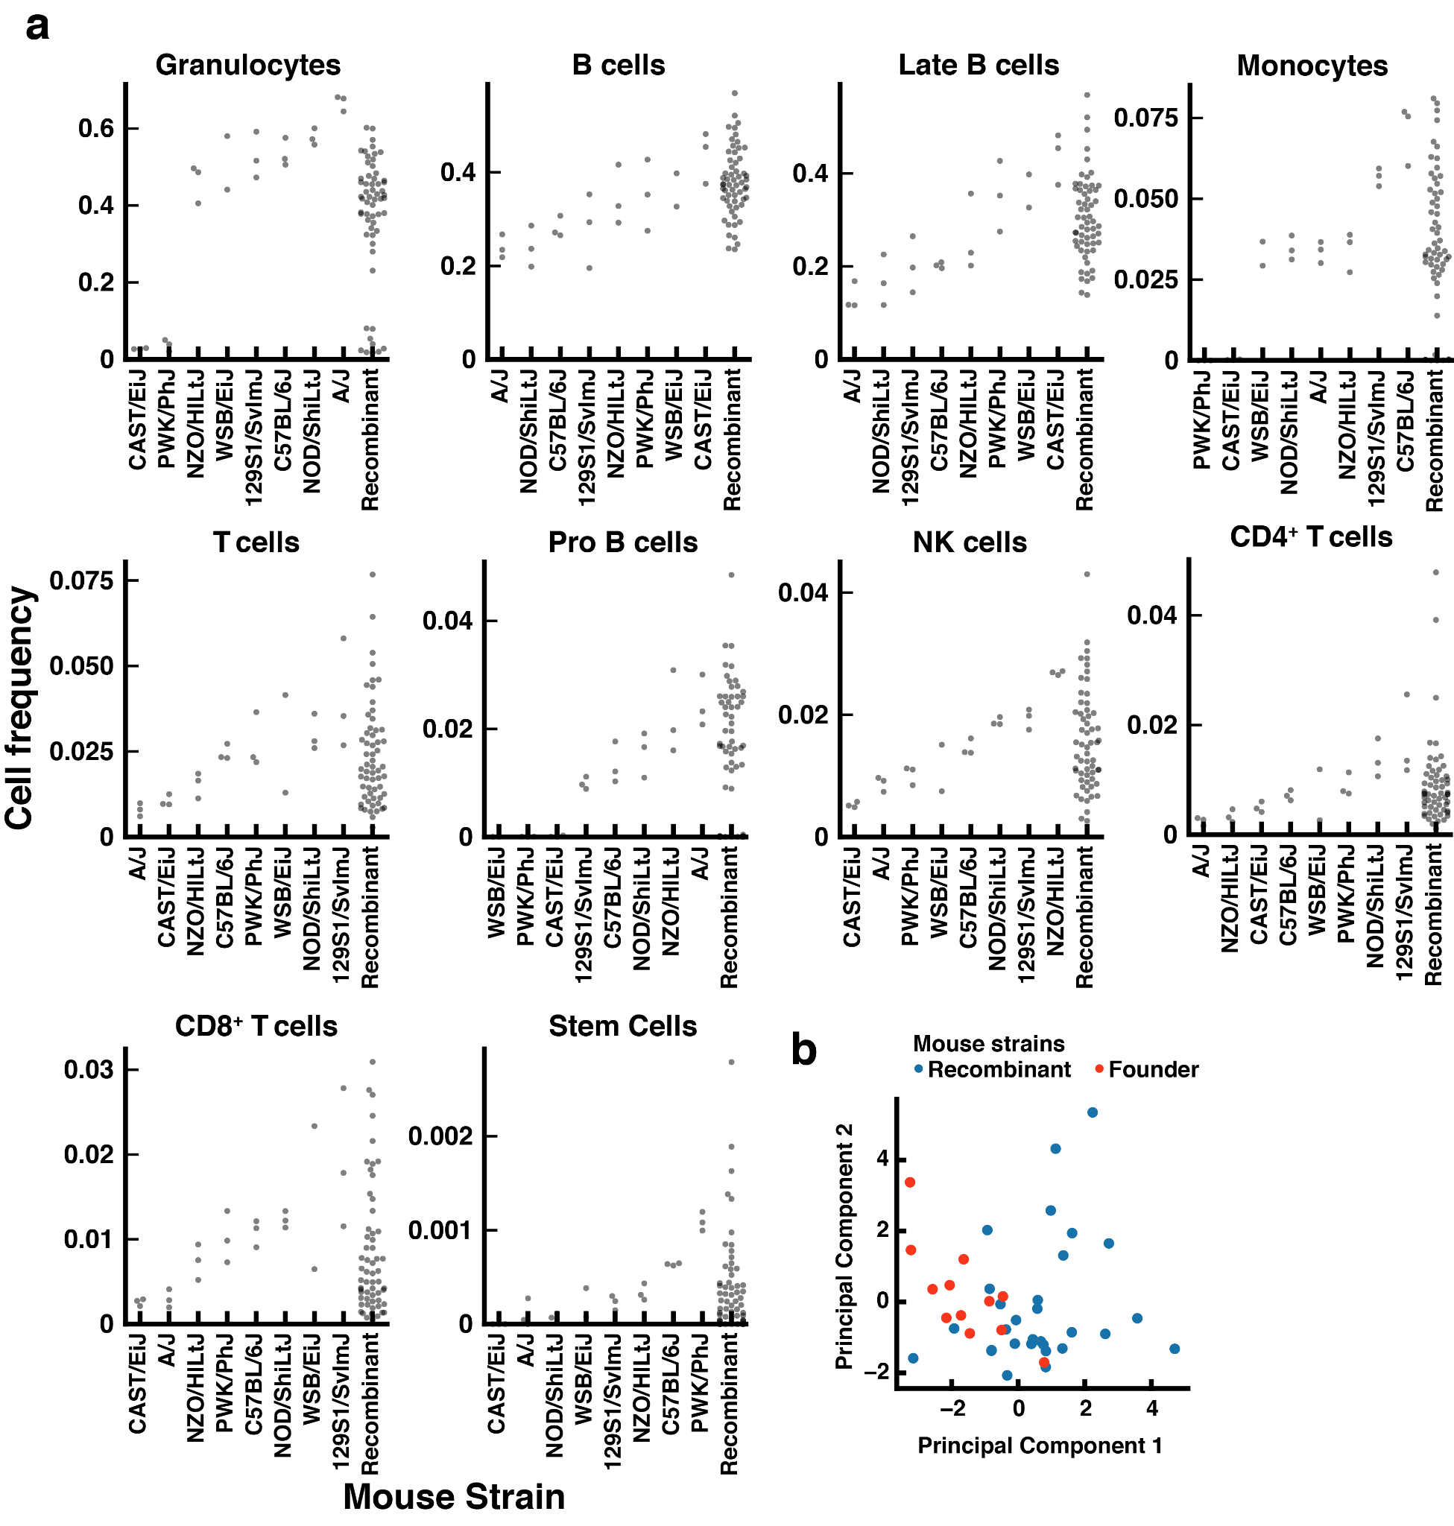

Extended Data Figure 2: Immune cell frequencies of CC parent and recombinant strains used in the exploratory part of the association study
a. Swarm plots of bone marrow immune cell frequencies, profiled using mass cytometry. Parent strains are ordered according to the median value for each of the immune cell subsets. b. Principal component analysis using immune cell frequencies of all mice measured in the first cohort, for which all target cell types could be detected. The first two principal components are shown.

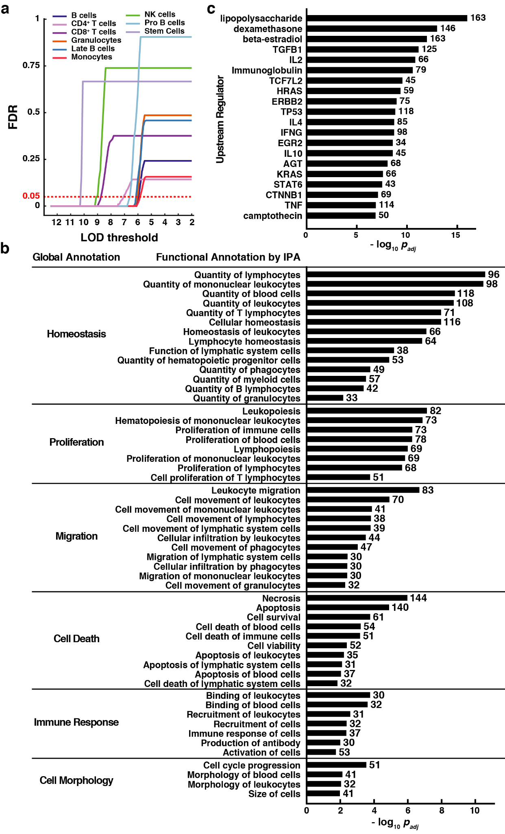

Extended Data Figure 3: Genes associated with immune cell frequencies are largely involved in quantitative homeostasis
a. False discovery rate (FDR) as a function of threshold for association as inferred from permutation analysis (Methods) for each cell type. Red dashed line indicates the FDR of 5% used to determine the cell type-specific LOD score threshold used to find associated genes in the exploratory cohort. b. Bar-plot of functionally enriched categories. Functional groups that were found enriched using Ingenuity Pathway Analysis were manually grouped into global functional groups; terms with p_{adj}<0.01 are shown. x-axis indicates -log₁₀ of adjusted p-value from Fisher’s exact test with Benjamini-Hochberg correction. Labels to the right of each bar indicate the number of genes from each pathway that were found associated. c. Bar-plot of upstream regulators the targets of which are enriched among the genes associated with immune profiles. ‘Upstream Regulator’ analysis was performed on associated genes using Ingenuity Pathway Analysis; twenty regulators with lowest p-values are shown. x-axis indicates –log₁₀ of adjusted p-value from Fisher’s exact test with Benjamini-Hochberg correction. Labels to the right of each bar indicate the number of downstream genes for each upstream regulator that were found associated with immune profiles.

Extended Data Tables

Extended Data Table 1: Mouse strains used in this study
List of mouse strains used in this study. CC mice are listed using standard CC strain identifiers; founder strains using the full strain name. The column indicates in which cohort the mouse was profiled.

Extended Data Table 2: Antibodies used in this study
List of all markers and corresponding CyTOF antibodies that were used in this study, including clone, vendor and the cell-type it was used to identify.

Extended Data Table 3: Cell type markers detected in the exploratory cohort
List of immune cell subsets for each CC strain in the first cohort of mice which could be detected in that strain using our antibody panel. 1 = detected, 0 = not detected.

Extended Data Table 4: Immune profiles of the exploratory cohort
Frequencies for each cell type identified in bone marrow of CC mice of the first cohort. Frequencies are stated as a fraction of the given cell type over the total gated live cells.

Extended Data Table 5: Cell type markers detected in the validation cohort
List of immune cell subsets for each CC strain in the second cohort of mice which could be detected in that strain using our antibody panel. 1 = detected, 0 = not detected.

Extended Data Table 6: Immune profiles of the validation cohort
Frequencies for each cell type identified in bone marrow of CC mice of the first cohort. Frequencies are stated as a fraction of the given cell type over the total gated live cells.

Extended Data Table 7: Genetic associations determined
List of gene-cell type frequency associations determined in this study. The table additionally states whether the gene is associated in cyto-cis or cyto-trans, the average PhastCons conservation score of the associated gene, the associated polymorphism and whether the gene is associated with multiple cell types.

Extended Data Table 8: Enrichment analysis of associated genes
The results of gene enrichment analysis for genes associated with immune cell frequencies in mouse bone marrow performed using Ingenuity Pathway Analysis. All significant categories after multiple hypothesis correction are shown. The specific category, disease or functional annotation, global annotation (manually curated), the actual genes included and number of genes in the category are stated.

Extended Data Table 9: Upstream regulator of associated genes
The results of upstream regulator analysis for genes associated with immune cell frequencies in mouse bone marrow performed using Ingenuity Pathway Analysis. Table shows Benjamini-Hochberg adjusted p-values for Fisher exact test of overlap between the associated genes and the genes that are regulated by a given upstream regulator, including indirect interactions. 20 upstream regulators with smallest p-values are shown. The numbers in the ‘Mechanistic network’ column indicate the total number of associated genes that are downstream of the given regulators and the number in parenthesis indicate the total number of regulators involved in that particular network.

Extended Data Table 10: Functional enrichment analysis of cyto-trans genes
Results of the gene enrichment analysis of cyto-trans genes performed by GOrilla⁶², using the ‘component’ ontology and all associated genes as a background gene set. All terms with p<0.001 are shown.

Extended Data Table 11: Mapping of Imm-Gen data to cell subtypes in this study
List of the ImmGen Consortium bone marrow samples for which the microarray gene expression data were used in this study, along with the annotation of respective cell subtypes to which these samples were assigned.

List of journals for submission in order of priority (brainstorming here):
- Nature
- Science
- Science advances
- eLife new track?
- MSB
- PNAS
- Cell Research? It is a Nature portfolio journal with IF 40, but so far mostly (but not only) China-based scientists publish there
- PLoS Biology

