Supplementary Information
Morphometric network-based abnormalities correlate with psychiatric comorbidities and gene expression in PCDH19-related developmental and epileptic encephalopathy
¹ Child Neurology Unit and Laboratories, Neuroscience Department, Meyer Children’s Hospital IRCCS, 50139 Florence, Italy
² Medical Physics Department, Bambino Gesù Children's Hospital, IRCCS, 00100 Rome, Italy
³ Neurology, Epilepsy and Movement Disorders, Bambino Gesù Children’s Hospital, IRCCS, Full Member of European Reference Network EpiCARE, 00165 Rome, Italy
⁴ Neuroradiology Unit, Meyer Children’s Hospital IRCCS, 50139 Florence, Italy
⁵ Functional and Interventional Neuroimaging Unit, Bambino Gesù Children’s Hospital, IRCCS, 00165 Rome, Italy

§ See Appendix for PCDH19 Clinical Study Group collaborators.

Correspondence to:
Prof. Renzo Guerrini MD, FRCP, FAES
Neuroscience Department, Children’s Hospital A. Meyer IRCCS - University of Florence, Viale Pieraccini 24, 50139 Firenze, Italy. Tel: +390555662573; Fax: +390555662329; E-mail: renzo.guerrini@meyer.it

Supplementary Table 1. Morphometric region-of-interest-based analysis
 |  |  | Morphometric features
 |  |  | Surface  Area [mm²] |  |  | Cortical  Thickness [mm] |  |  | Cortical  Volume [mm³]
Cortical region | Side |  | $$β_{2}$$ | p_{value} |  | $$β_{2}$$ | p_{value} |  | $$β_{2}$$ | p_{value}
Bankssts | L |  | -0.798 | 0.428 |  | 1.213 | 0.231 |  | -0.270 | 0.788
 | R |  | -1.096 | 0.278 |  | 0.017 | 0.987 |  | -0.997 | 0.324
Caudal anterior cingulate | L |  | -1.667 | 0.101 |  | -0.452 | 0.653 |  | -1.703 | 0.095
Caudal anterior cingulate | R |  | -0.909 | 0.368 |  | -1.023 | 0.311 |  | -1.797 | 0.078
Caudal middle frontal | L |  | -2.438 | 0.018 |  | -0.756 | 0.453 |  | -2.441 | 0.018
Caudal middle frontal | R |  | -1.365 | 0.178 |  | 0.638 | 0.526 |  | -1.257 | 0.214
Cuneus | L |  | -1.764 | 0.084 |  | 0.580 | 0.564 |  | -1.312 | 0.195
 | R |  | -0.684 | 0.497 |  | 0.191 | 0.849 |  | -0.811 | 0.421
Entorhinal | L |  | -3.200 | 0.002 |  | -1.480 | 0.145 |  | -3.451 | 0.001
 | R |  | -0.990 | 0.327 |  | -0.334 | 0.740 |  | -0.833 | 0.408
Fusiform | L |  | -2.994 | 0.004 |  | -0.799 | 0.428 |  | -3.141 | 0.003
 | R |  | -2.573 | 0.013 |  | -1.042 | 0.302 |  | -2.826 | 0.007
Inferior parietal | L |  | -2.911 | 0.005 |  | 1.795 | 0.078 |  | -1.611 | 0.113
 | R |  | -1.193 | 0.238 |  | 0.785 | 0.436 |  | -0.882 | 0.382
Inferior temporal | L |  | -3.250 | 0.002 |  | 1.182 | 0.243 |  | -2.367 | 0.022
 | R |  | -1.911 | 0.062 |  | 1.317 | 0.194 |  | -0.863 | 0.392
Isthmus cingulate | L |  | -0.196 | 0.846 |  | -0.341 | 0.735 |  | -0.853 | 0.398
 | R |  | -0.103 | 0.918 |  | -1.491 | 0.142 |  | -1.516 | 0.136
Lateral occipital | L |  | -2.896 | 0.006 |  | 1.719 | 0.092 |  | -1.781 | 0.081
 | R |  | -3.151 | 0.003 |  | 2.040 | 0.046 |  | -1.883 | 0.065
Lateral orbito-frontal | L |  | -0.339 | 0.736 |  | -1.392 | 0.170 |  | -1.289 | 0.203
Lateral orbito-frontal | R |  | -0.523 | 0.603 |  | 0.794 | 0.431 |  | -0.804 | 0.425
Lingual | L |  | -1.665 | 0.102 |  | 1.227 | 0.225 |  | -0.743 | 0.461
 | R |  | -0.369 | 0.713 |  | 0.925 | 0.359 |  | -0.116 | 0.908
Medial orbito-frontal | L |  | -2.179 | 0.034 |  | -1.100 | 0.276 |  | -2.349 | 0.023
Medial orbito-frontal | R |  | -1.961 | 0.055 |  | 0.117 | 0.908 |  | -1.818 | 0.075
Middle temporal | L |  | -2.584 | 0.013 |  | 0.519 | 0.606 |  | -2.091 | 0.041
 | R |  | -2.264 | 0.028 |  | 1.295 | 0.201 |  | -1.935 | 0.058
Parahippocampal | L |  | -1.214 | 0.230 |  | -2.987 | 0.004 |  | -2.294 | 0.026
 | R |  | -2.486 | 0.016 |  | -2.017 | 0.049 |  | -3.722 | <0.001
Paracentral | L |  | -0.178 | 0.860 |  | 0.290 | 0.773 |  | -0.461 | 0.646
 | R |  | 0.737 | 0.465 |  | 0.317 | 0.753 |  | 0.173 | 0.863
Pars opercularis | L |  | -1.989 | 0.052 |  | -2.260 | 0.028 |  | -3.250 | 0.002
 | R |  | -1.593 | 0.117 |  | -0.497 | 0.621 |  | -2.081 | 0.042
Pars orbitalis | L |  | -0.271 | 0.788 |  | 0.361 | 0.720 |  | -0.212 | 0.833
 | R |  | 0.626 | 0.534 |  | 1.581 | 0.120 |  | 0.698 | 0.488
Pars triangularis | L |  | 0.258 | 0.798 |  | 0.293 | 0.771 |  | 0.298 | 0.767
 | R |  | -1.571 | 0.122 |  | 0.506 | 0.615 |  | -1.270 | 0.210
Pericalcarine | L |  | -1.906 | 0.062 |  | 1.094 | 0.279 |  | -1.151 | 0.255
 | R |  | -1.209 | 0.232 |  | 0.655 | 0.515 |  | -0.842 | 0.403
Postcentral | L |  | 0.082 | 0.935 |  | 0.084 | 0.933 |  | -0.178 | 0.860
 | R |  | 0.740 | 0.463 |  | -0.547 | 0.587 |  | 0.322 | 0.749
Posterior cingulate | L |  | 0.384 | 0.703 |  | -0.848 | 0.400 |  | -0.179 | 0.859
 | R |  | 0.466 | 0.643 |  | -0.612 | 0.543 |  | -0.072 | 0.943
Precentral | L |  | -0.640 | 0.525 |  | -0.372 | 0.711 |  | -0.646 | 0.521
 | R |  | -1.345 | 0.184 |  | 0.561 | 0.577 |  | -1.055 | 0.297
Precuneus | L |  | 0.219 | 0.828 |  | -0.062 | 0.951 |  | -0.101 | 0.920
 | R |  | 0.625 | 0.535 |  | 0.721 | 0.474 |  | 0.617 | 0.540
Rostral anterior cingulate | L |  | -2.435 | 0.018 |  | -1.076 | 0.287 |  | -2.843 | 0.006
Rostral anterior cingulate | R |  | -1.857 | 0.069 |  | -1.089 | 0.281 |  | -3.297 | 0.002
Rostral middle frontal | L |  | -1.410 | 0.165 |  | 0.558 | 0.579 |  | -1.010 | 0.317
Rostral middle frontal | R |  | -1.030 | 0.308 |  | 1.425 | 0.160 |  | -0.649 | 0.519
Superior frontal | L |  | -1.163 | 0.250 |  | -0.370 | 0.713 |  | -1.278 | 0.207
 | R |  | -1.606 | 0.114 |  | 0.719 | 0.475 |  | -1.457 | 0.151
Superior parietal | L |  | -0.341 | 0.735 |  | 1.356 | 0.181 |  | 0.381 | 0.705
 | R |  | -0.377 | 0.708 |  | 1.303 | 0.198 |  | 0.129 | 0.898
Superior temporal | L |  | -2.244 | 0.029 |  | -2.271 | 0.027 |  | -2.930 | 0.005
 | R |  | -3.117 | 0.003 |  | -0.572 | 0.570 |  | -2.828 | 0.007
Supramarginal | L |  | 1.248 | 0.218 |  | -0.820 | 0.416 |  | 0.812 | 0.421
 | R |  | 0.361 | 0.720 |  | -1.074 | 0.288 |  | -0.448 | 0.656
Frontal pole | L |  | -0.586 | 0.560 |  | 1.181 | 0.243 |  | 0.845 | 0.402
 | R |  | -0.437 | 0.664 |  | 0.992 | 0.326 |  | 0.754 | 0.454
Temporal pole | L |  | -4.598 | 0.001 |  | 1.140 | 0.259 |  | -1.613 | 0.113
 | R |  | -3.019 | 0.004 |  | 1.671 | 0.101 |  | -0.920 | 0.362
Transverse temporal | L |  | -1.081 | 0.285 |  | -1.423 | 0.161 |  | -0.780 | 0.439
Transverse temporal | R |  | -1.667 | 0.101 |  | -0.895 | 0.375 |  | -1.193 | 0.238
Insula | L |  | -1.871 | 0.067 |  | -1.740 | 0.088 |  | -3.537 | 0.001
 | R |  | -2.853 | 0.006 |  | -2.717 | 0.009 |  | -4.581 | <0.001
Whole brain | L |  | -2.050 | 0.045 |  | -0.084 | 0.934 |  | -2.458 | 0.017
 | R |  | -1.760 | 0.084 |  | 0.464 | 0.645 |  | 0.663 | 0.510
Supplementary Table 1. Morphometric ROI-based analysis. Effect of the group on the cortical thickness, surface area and cortical volume of temporal structures of the cortex, located in the left (L) and right (R) hemispheres. Data were analyzed by a multivariate linear regression model ($Morph=β_{0}+β_{1}Center+ β_{2}Group+ β_{3}Age$) to explore the effect on morphometric values due to the center of acquisition ($Center$), group ($Group$) and age (Age). Significative values (p_{value}<0.05) are indicated in bold.
Supplementary Table 2. Structural network-based analysis of surface area
and cortical thickness in cortical regions
 |  |  | Structural network-based analysis
 |  |  | Surface  Area [mm²] |  |  | Cortical  Thickness [mm]
Cortical region | Side |  | r_{value} | p_{value} |  | r_{value} | p_{value}
Bankssts | L |  | -0.113 | 0.282 |  | -0.022 | 0.554
 | R |  | -0.076 | 0.216 |  | 0.077 | 0.370
Caudal anterior cingulate | L |  | 0.116 | 0.249 |  | -0.282 | 0.038
Caudal anterior cingulate | R |  | 0.065 | 0.435 |  | -0.227 | 0.037
Caudal middle frontal | L |  | -0.075 | 0.378 |  | 0.119 | 0.155
Caudal middle frontal | R |  | -0.010 | 0.378 |  | -0.002 | 0.417
Cuneus | L |  | 0.026 | 0.437 |  | 0.149 | 0.133
 | R |  | 0.006 | 0.553 |  | 0.160 | 0.189
Entorhinal | L |  | -0.282 | 0.073 |  | -0.182 | 0.164
 | R |  | -0.176 | 0.034 |  | -0.091 | 0.090
Fusiform | L |  | -0.354 | 0.025 |  | 0.128 | 0.070
 | R |  | -0.126 | 0.096 |  | 0.180 | 0.099
Inferior parietal | L |  | -0.013 | 0.593 |  | -0.061 | 0.502
 | R |  | -0.036 | 0.222 |  | 0.146 | 0.205
Inferior temporal | L |  | -0.310 | 0.014 |  | 0.070 | 0.130
 | R |  | -0.225 | 0.036 |  | 0.201 | 0.076
Isthmus cingulate | L |  | 0.198 | 0.159 |  | -0.188 | 0.150
 | R |  | 0.109 | 0.384 |  | 0.099 | 0.321
Lateral occipital | L |  | -0.336 | 0.034 |  | 0.098 | 0.151
 | R |  | -0.073 | 0.217 |  | 0.130 | 0.254
Lateral orbito-frontal | L |  | -0.132 | 0.345 |  | -0.071 | 0.466
Lateral orbito-frontal | R |  | -0.070 | 0.279 |  | -0.016 | 0.312
Lingual | L |  | -0.113 | 0.352 |  | -0.074 | 0.437
 | R |  | -0.108 | 0.228 |  | 0.146 | 0.212
Medial orbito-frontal | L |  | -0.137 | 0.307 |  | -0.013 | 0.546
Medial orbito-frontal | R |  | 0.132 | 0.306 |  | -0.107 | 0.223
Middle temporal | L |  | -0.221 | 0.119 |  | 0.101 | 0.057
 | R |  | -0.091 | 0.078 |  | 0.170 | 0.147
Parahippocampal | L |  | -0.179 | 0.201 |  | 0.001 | 0.279
 | R |  | -0.014 | 0.308 |  | 0.076 | 0.449
Paracentral | L |  | 0.471 | 0.004 |  | 0.042 | 0.397
 | R |  | 0.417 | 0.006 |  | 0.038 | 0.399
Pars opercularis | L |  | -0.030 | 0.525 |  | -0.085 | 0.374
 | R |  | 0.121 | 0.357 |  | 0.052 | 0.514
Pars orbitalis | L |  | -0.009 | 0.625 |  | -0.252 | 0.061
 | R |  | -0.090 | 0.122 |  | 0.105 | 0.349
Pars triangularis | L |  | -0.097 | 0.403 |  | -0.155 | 0.220
 | R |  | 0.039 | 0.528 |  | 0.093 | 0.364
Pericalcarine | L |  | -0.009 | 0.506 |  | 0.072 | 0.240
 | R |  | 0.015 | 0.554 |  | 0.214 | 0.098
Postcentral | L |  | 0.321 | 0.030 |  | -0.128 | 0.231
 | R |  | 0.397 | 0.009 |  | 0.011 | 0.518
Posterior cingulate | L |  | 0.262 | 0.089 |  | -0.086 | 0.336
 | R |  | 0.411 | 0.013 |  | -0.032 | 0.380
Precentral | L |  | 0.196 | 0.146 |  | -0.046 | 0.481
 | R |  | 0.237 | 0.163 |  | 0.003 | 0.575
Precuneus | L |  | 0.262 | 0.054 |  | -0.114 | 0.280
 | R |  | 0.223 | 0.158 |  | 0.005 | 0.622
Rostral anterior cingulate | L |  | 0.146 | 0.220 |  | -0.210 | 0.102
Rostral anterior cingulate | R |  | 0.101 | 0.353 |  | -0.169 | 0.087
Rostral middle frontal | L |  | -0.041 | 0.465 |  | 0.103 | 0.146
Rostral middle frontal | R |  | 0.059 | 0.477 |  | 0.128 | 0.228
Superior frontal | L |  | 0.159 | 0.256 |  | -0.153 | 0.192
 | R |  | 0.225 | 0.242 |  | -0.181 | 0.085
Superior parietal | L |  | 0.108 | 0.266 |  | 0.007 | 0.366
 | R |  | 0.114 | 0.411 |  | 0.196 | 0.148
Superior temporal | L |  | -0.045 | 0.578 |  | 0.035 | 0.167
Superior temporal | R |  | -0.064 | 0.218 |  | 0.176 | 0.113
Supramarginal | L |  | 0.016 | 0.379 |  | -0.056 | 0.495
 | R |  | 0.099 | 0.402 |  | 0.077 | 0.387
Frontal pole | L |  | -0.022 | 0.452 |  | 0.028 | 0.432
 | R |  | 0.023 | 0.477 |  | -0.012 | 0.504
Temporal pole | L |  | -0.366 | 0.018 |  | -0.202 | 0.132
 | R |  | -0.283 | 0.015 |  | -0.054 | 0.133
Transverse temporal | L |  | 0.139 | 0.098 |  | -0.276 | 0.035
Transverse temporal | R |  | -0.038 | 0.295 |  | -0.183 | 0.042
Insula | L |  | -0.110 | 0.396 |  | -0.106 | 0.434
 | R |  | -0.018 | 0.074 |  | 0.188 | 0.129
Supplementary Table 2. Structural network-based analysis of surface area (SA) and cortical thickness (CT) in cortical regions. Bold indicates significantly altered measurements (p_{value}<0.1).

Supplementary Table 3 - Structural network-based analysis
of cortical volume in subcortical regions
 |  |  | Structural network-based analysis
 |  |  | Surface  Area [mm²] |  |  | Cortical  Thickness [mm]
Cortical region | Side |  | r_{value} | p_{value} |  | r_{value} | p_{value}
Accumbens | L |  | 0.023 | 0.393 |  | -0.177 | 0.170
 | R |  | 0.002 | 0.593 |  | -0.234 | 0.012
Amygdala | L |  | -0.436 | 0.003 |  | -0.087 | 0.432
 | R |  | -0.154 | 0.033 |  | 0.157 | 0.190
Caudate | L |  | 0.018 | 0.439 |  | -0.039 | 0.562
 | R |  | 0.210 | 0.272 |  | -0.024 | 0.248
Hippocampus | L |  | -0.185 | 0.222 |  | -0.056 | 0.511
 | R |  | -0.069 | 0.204 |  | 0.087 | 0.432
Pallidum | L |  | 0.001 | 0.385 |  | -0.055 | 0.475
 | R |  | 0.029 | 0.607 |  | 0.064 | 0.490
Putamen | L |  | -0.049 | 0.660 |  | -0.117 | 0.401
 | R |  | -0.045 | 0.073 |  | 0.196 | 0.101
Thalamus | L |  | 0.106 | 0.127 |  | -0.104 | 0.358
 | R |  | 0.108 | 0.338 |  | 0.118 | 0.282
Supplementary Table 3. Structural network-based analysis in subcortical regions. Bold indicates significantly altered measurements (p_{value}<0.1).

Supplementary Table 4. Effect on grade of psychiatric comorbidities of the morphometric variables of cortical structures in PCDH19-related epilepsy patients
 |  |  | Morphometric variables
 |  |  | Surface area  (mm²) |  |  | Cortical thickness (mm) |  |  | Cortical volume (mm³)
Cortical region | Side |  | $$β_{2}$$ | p_{value} |  | $$β_{2}$$ | p_{value} |  | $$β_{2}$$ | p_{value}
Bankssts | L |  | -0.0018 | 0.320 |  | -3.2717 | 0.005 |  | -0.0008 | 0.102
 | R |  | -0.0035 | 0.198 |  | -2.7023 | 0.081 |  | -0.0014 | 0.116
Caudal anterior cingulate | L |  | -0.0033 | 0.223 |  | -1.5735 | 0.132 |  | -0.0008 | 0.199
Caudal anterior cingulate | R |  | -0.0026 | 0.159 |  | -0.6415 | 0.573 |  | -0.0009 | 0.095
Caudal middle frontal | L |  | -0.0007 | 0.539 |  | -1.5586 | 0.286 |  | -0.0004 | 0.249
Caudal middle frontal | R |  | 0.0001 | 0.990 |  | -0.1354 | 0.934 |  | -0.0001 | 0.685
Cuneus | L |  | -0.0016 | 0.359 |  | 0.2752 | 0.863 |  | -0.0001 | 0.801
 | R |  | -0.0003 | 0.850 |  | 0.0701 | 0.971 |  | 0.0001 | 0.971
Entorhinal | L |  | -0.0093 | 0.013 |  | 0.0211 | 0.969 |  | -0.0012 | 0.095
 | R |  | -0.0007 | 0.852 |  | 0.4295 | 0.501 |  | 0.0001 | 0.988
Fusiform | L |  | -0.0018 | 0.046 |  | -2.7051 | 0.089 |  | -0.0005 | 0.013
 | R |  | -0.0005 | 0.547 |  | -2.7521 | 0.160 |  | -0.0001 | 0.551
Inferior parietal | L |  | -0.0015 | 0.003 |  | -1.6350 | 0.250 |  | -0.0004 | 0.004
 | R |  | -0.0008 | 0.066 |  | -0.7566 | 0.660 |  | -0.0002 | 0.136
Inferior temporal | L |  | -0.0011 | 0.048 |  | -1.6802 | 0.217 |  | -0.0002 | 0.092
 | R |  | -0.0010 | 0.053 |  | -1.2071 | 0.425 |  | -0.0002 | 0.089
Isthmus cingulate | L |  | -0.0031 | 0.187 |  | -1.6411 | 0.351 |  | -0.0014 | 0.072
 | R |  | -0.0041 | 0.088 |  | -1.9312 | 0.134 |  | -0.0016 | 0.021
Lateral occipital | L |  | -0.0006 | 0.214 |  | 0.5972 | 0.763 |  | -0.0001 | 0.529
 | R |  | -0.0003 | 0.660 |  | -2.0604 | 0.276 |  | -0.0001 | 0.403
Lateral orbito-frontal | L |  | -0.0009 | 0.252 |  | -1.4775 | 0.254 |  | -0.0005 | 0.099
Lateral orbito-frontal | R |  | -0.0012 | 0.110 |  | 1.0872 | 0.553 |  | -0.0005 | 0.112
Lingual | L |  | -0.0003 | 0.647 |  | 0.3748 | 0.819 |  | 0.0001 | 0.961
 | R |  | -0.0001 | 0.865 |  | -2.4632 | 0.297 |  | -0.0001 | 0.819
Medial orbito-frontal | L |  | -0.0019 | 0.156 |  | -0.6011 | 0.713 |  | -0.0006 | 0.185
Medial orbito-frontal | R |  | -0.0027 | 0.013 |  | -1.8884 | 0.229 |  | -0.0009 | 0.004
Middle temporal | L |  | -0.0009 | 0.186 |  | -1.7803 | 0.189 |  | -0.0003 | 0.102
 | R |  | -0.0012 | 0.082 |  | -1.2101 | 0.385 |  | -0.0002 | 0.164
Parahippocampal | L |  | -0.0067 | 0.065 |  | -0.2452 | 0.792 |  | -0.0010 | 0.252
 | R |  | -0.0050 | 0.365 |  | -1.3755 | 0.144 |  | -0.0024 | 0.051
Paracentral | L |  | -0.0018 | 0.445 |  | 0.3785 | 0.792 |  | -0.0003 | 0.619
 | R |  | -0.0011 | 0.472 |  | -0.6470 | 0.676 |  | -0.0003 | 0.491
Pars opercularis | L |  | -0.0008 | 0.538 |  | -2.8646 | 0.057 |  | -0.0004 | 0.307
 | R |  | -0.0010 | 0.663 |  | -2.8527 | 0.065 |  | -0.0005 | 0.447
Pars orbitalis | L |  | -0.0042 | 0.127 |  | -0.8569 | 0.335 |  | -0.0007 | 0.145
 | R |  | -0.0066 | 0.060 |  | -1.1918 | 0.425 |  | -0.0011 | 0.101
Pars triangularis | L |  | -0.0040 | 0.005 |  | -1.9856 | 0.247 |  | -0.0010 | 0.017
 | R |  | -0.0017 | 0.337 |  | 0.0607 | 0.976 |  | -0.0001 | 0.751
Pericalcarine | L |  | -0.0003 | 0.777 |  | 0.2673 | 0.887 |  | 0.0001 | 0.782
 | R |  | -0.0001 | 0.891 |  | -1.0452 | 0.530 |  | -0.0001 | 0.821
Postcentral | L |  | -0.0015 | 0.128 |  | -2.1044 | 0.321 |  | -0.0004 | 0.183
 | R |  | -0.0016 | 0.073 |  | -2.1344 | 0.466 |  | -0.0004 | 0.109
Posterior cingulate | L |  | -0.0035 | 0.138 |  | -1.2976 | 0.361 |  | -0.0006 | 0.264
 | R |  | -0.0010 | 0.619 |  | -0.3800 | 0.854 |  | -0.0002 | 0.775
Precentral | L |  | -0.0008 | 0.289 |  | -2.1918 | 0.151 |  | -0.0003 | 0.113
 | R |  | -0.0007 | 0.502 |  | -1.1320 | 0.417 |  | -0.0003 | 0.262
Precuneus | L |  | -0.0012 | 0.054 |  | -1.5397 | 0.388 |  | -0.0003 | 0.062
 | R |  | -0.0009 | 0.161 |  | -1.4463 | 0.433 |  | -0.0003 | 0.132
Rostral anterior cingulate | L |  | -0.0033 | 0.025 |  | -2.1594 | 0.034 |  | -0.0010 | 0.005
Rostral anterior cingulate | R |  | -0.0042 | 0.117 |  | -1.5573 | 0.068 |  | -0.0023 | 0.001
Rostral middle frontal | L |  | -0.0009 | 0.022 |  | -0.7664 | 0.643 |  | -0.0003 | 0.041
Rostral middle frontal | R |  | -0.0004 | 0.241 |  | 1.0403 | 0.581 |  | -0.0001 | 0.304
Superior frontal | L |  | -0.0001 | 0.789 |  | -1.6028 | 0.357 |  | -0.0001 | 0.657
 | R |  | 0.0001 | 0.917 |  | -1.0031 | 0.501 |  | 0.0001 | 0.791
Superior parietal | L |  | -0.0007 | 0.031 |  | -0.9358 | 0.582 |  | -0.0002 | 0.051
 | R |  | -0.0007 | 0.083 |  | 0.6290 | 0.747 |  | -0.0001 | 0.250
Superior temporal | L |  | -0.0005 | 0.655 |  | -3.9567 | 0.007 |  | -0.0003 | 0.191
 | R |  | -0.0008 | 0.567 |  | -3.8243 | 0.009 |  | -0.0005 | 0.083
Supramarginal | L |  | -0.0012 | 0.026 |  | -1.1173 | 0.455 |  | -0.0003 | 0.061
 | R |  | -0.0012 | 0.057 |  | -2.8847 | 0.159 |  | -0.0003 | 0.048
Frontal pole | L |  | -0.0138 | 0.148 |  | -0.0497 | 0.952 |  | -0.0009 | 0.516
 | R |  | -0.0070 | 0.328 |  | 0.7525 | 0.338 |  | 0.0007 | 0.444
Temporal pole | L |  | -0.0053 | 0.274 |  | -0.0646 | 0.944 |  | -0.0007 | 0.338
 | R |  | -0.0043 | 0.359 |  | -0.7581 | 0.286 |  | -0.0008 | 0.224
Transverse temporal | L |  | 0.0025 | 0.633 |  | -1.9566 | 0.014 |  | -0.0014 | 0.228
Transverse temporal | R |  | 0.0134 | 0.102 |  | -2.4586 | 0.001 |  | -0.0026 | 0.152
Insula | L |  | -0.0018 | 0.144 |  | -1.0201 | 0.312 |  | -0.0007 | 0.033
 | R |  | -0.0022 | 0.141 |  | -1.2550 | 0.329 |  | -0.0006 | 0.091
Supplementary Table 4. Effect on grade of psychiatric comorbidities of the cortical thickness, surface area and cortical volume of structures in PCDH19-related epilepsy patients. Data were analyzed by a multivariate linear regression model ($Grade=β_{0}+β_{1}Center+ β_{2}Morph+ β_{3}Age$) to explore the effect on the clinical variables of patients due to the center of acquisition ($Center$), group ($Group$) and age (Age). Bold indicates significantly altered measures (p<0.05).
Supplementary Table 5 – Volumetric analysis of hippocampal subfields - Effect of the group on the volume of hippocampal subfields in PCDH19 and controls
 |  |  | Controls |  |  |  |  | PCDH19
Region | Side |  | $$Mean$$ | STD |  |  |  | $$Mean$$ |  | STD |  |  | $${ β}_{2}$$ |  | p_{value}
Hippocampal tail | L |  | 578.29 |  | 80.73 |  |  |  | 543.10 |  | 82.23 |  |  | -1.486 |  | 0.143
 | R |  | 583.09 |  | 76.97 |  |  |  | 538.78 |  | 74.02 |  |  | -2.021 |  | 0.048
Subiculum body | L |  | 237.96 |  | 33.16 |  |  |  | 226.71 |  | 44.80 |  |  | -0.995 |  | 0.324
 | R |  | 226.95 |  | 30.34 |  |  |  | 211.58 |  | 35.51 |  |  | -1.658 |  | 0.103
CA1 body | L |  | 122.01 |  | 19.90 |  |  |  | 112.15 |  | 21.91 |  |  | -1.656 |  | 0.103
 | R |  | 134.35 |  | 22.07 |  |  |  | 124.06 |  | 16.95 |  |  | -1.726 |  | 0.089
CA1 head | L |  | 503.41 |  | 64.89 |  |  |  | 502.35 |  | 57.96 |  |  | -0.007 |  | 0.995
 | R |  | 534.12 |  | 71.88 |  |  |  | 531.68 |  | 65.73 |  |  | -0.061 |  | 0.951
Pre-subiculum head | L |  | 135.48 |  | 17.08 |  |  |  | 134.50 |  | 13.06 |  |  | -0.243 |  | 0.809
 | R |  | 134.58 |  | 16.78 |  |  |  | 133.50 |  | 14.44 |  |  | -0.201 |  | 0.841
Pre-subiculum body | L |  | 170.26 |  | 24.92 |  |  |  | 166.34 |  | 32.26 |  |  | -0.427 |  | 0.671
 | R |  | 156.40 |  | 22.18 |  |  |  | 148.50 |  | 23.38 |  |  | -1.177 |  | 0.244
Parasubiculum | L |  | 63.90 |  | 8.79 |  |  |  | 63.86 |  | 7.62 |  |  | -0.050 |  | 0.961
 | R |  | 64.78 |  | 7.89 |  |  |  | 62.77 |  | 9.76 |  |  | -0.793 |  | 0.431
Hippocampal fissure | L |  | 132.59 |  | 21.63 |  |  |  | 114.09 |  | 20.26 |  |  | -3.087 |  | 0.003
 | R |  | 134.22 |  | 21.10 |  |  |  | 118.68 |  | 22.43 |  |  | -2.530 |  | 0.014
Molecular layer head | L |  | 322.68 |  | 38.22 |  |  |  | 316.87 |  | 36.04 |  |  | -0.495 |  | 0.623
 | R |  | 336.60 |  | 45.01 |  |  |  | 332.73 |  | 41.38 |  |  | -0.252 |  | 0.801
Molecular layer body | L |  | 225.81 |  | 29.79 |  |  |  | 209.30 |  | 30.07 |  |  | -1.938 |  | 0.058
 | R |  | 232.22 |  | 30.05 |  |  |  | 212.81 |  | 21.58 |  |  | -2.472 |  | 0.016
GC ML DG head | L |  | 150.04 |  | 19.84 |  |  |  | 143.51 |  | 20.07 |  |  | -1.104 |  | 0.274
 | R |  | 160.23 |  | 25.07 |  |  |  | 151.20 |  | 20.98 |  |  | -1.288 |  | 0.203
GC ML DG body | L |  | 132.31 |  | 18.24 |  |  |  | 125.06 |  | 20.80 |  |  | -1.283 |  | 0.205
 | R |  | 134.83 |  | 17.12 |  |  |  | 122.17 |  | 13.09 |  |  | -2.802 |  | 0.007
Fimbria | L |  | 74.88 |  | 19.00 |  |  |  | 88.61 |  | 23.42 |  |  | 2.325 |  | 0.024
 | R |  | 73.29 |  | 16.67 |  |  |  | 73.67 |  | 12.11 |  |  | 0.018 |  | 0.985
HATA | L |  | 57.21 |  | 9.09 |  |  |  | 60.02 |  | 12.48 |  |  | 0.940 |  | 0.352
 | R |  | 61.34 |  | 9.85 |  |  |  | 56.53 |  | 12.12 |  |  | -1.664 |  | 0.101
CA3 head | L |  | 85.62 |  | 16.98 |  |  |  | 71.51 |  | 11.72 |  |  | -3.230 |  | 0.002
 | R |  | 130.14 |  | 25.13 |  |  |  | 118.12 |  | 20.15 |  |  | -1.7552 |  | 0.084
CA3 body | L |  | 119.08 |  | 17.04 |  |  |  | 110.21 |  | 17.11 |  |  | -1.794 |  | 0.078
 | R |  | 95.62 |  | 17.13 |  |  |  | 82.76 |  | 10.92 |  |  | -2.936 |  | 0.004
CA4 head | L |  | 126.13 |  | 15.91 |  |  |  | 118.53 |  | 17.04 |  |  | -1.604 |  | 0.115
 | R |  | 134.25 |  | 20.28 |  |  |  | 125.19 |  | 18.35 |  |  | -1.580 |  | 0.119
CA4 body | L |  | 117.32 |  | 17.50 |  |  |  | 108.56 |  | 16.38 |  |  | -1.764 |  | 0.083
 | R |  | 120.22 |  | 16.67 |  |  |  | 108.79 |  | 12.12 |  |  | -2.618 |  | 0.011
Whole hippocampal head | L |  | 1166.16 |  | 148.28 |  |  |  | 1108.24 |  | 161.28 |  |  | -1.286 |  | 0.204
head  WholWe hippocampal body | R |  | 1737.66 |  | 221.18 |  |  |  | 1700.33 |  | 213.94 |  |  | -0.548 |  | 0.585
head  WholWe hippocampal body | L |  | 1660.82 |  | 193.90 |  |  |  | 1638.00 |  | 188.18 |  |  | -0.375 |  | 0.709
Whole hippocampal body | R |  | 1173.87 |  | 145.27 |  |  |  | 1084.33 |  | 118.57 |  |  | -2.285 |  | 0.026
Whole hippocampal body | L |  | 3405.28 |  | 392.63 |  |  |  | 3289.33 |  | 393.35 |  |  | -0.984 |  | 0.330
Whole hippocampus | R |  | 3494.62 |  | 407.85 |  |  |  | 3323.44 |  | 373.46 |  |  | -1.474 |  | 0.146
Supplementary Table 5. Volumetric analysis of hippocampal subfields. Effect of the group due to the volume (mm³) calculated in the regions of the hippocampal subfields, located in the left (L) and right (R) hemispheres. Data were analyzed by a multivariate linear regression model (${Volume}_{}=β_{0}+β_{1}Center+ β_{2}Group+ β_{3} Age+ β_{4} eICV$) to explore the effect on the volume of the hippocampal subfields of the ($Group$), with the center of acquisition ($Center$) and age ($Age$) considered as covariates. Bold indicates significantly altered measures (p<0.05).

Supplementary Table 6 – Volumetric analysis of amygdala subfields - Effect of the group on the volume of amygdala subfields in PCDH19 and controls
 |  |  | Controls |  |  | PCDH19
Region | Side |  | $$Mean$$ | STD |  | $$Mean$$ | STD |  |  |  | $${ β}_{2}$$ | p_{value}
Lateral nucleus | L |  | 603.08 | 70.59 |  | 595.60 |  | 65.96 |  | -0.359 |  |  | 0.721
 | R |  | 618.98 | 77.02 |  | 611.83 |  | 64.61 |  | -0.330 |  |  | 0.743
Basal nucleus | L |  | 417.49 | 45.21 |  | 415.91 |  | 46.89 |  | -0.097 |  |  | 0.923
 | R |  | 437.74 | 51.47 |  | 426.45 |  | 51.69 |  | -0.744 |  |  | 0.460
Accessory Basal nucleus | L |  | 252.12 | 30.18 |  | 246.61 |  | 33.56 |  | -0.595 |  |  | 0.554
 | R |  | 266.62 | 33.68 |  | 261.53 |  | 37.55 |  | -0.467 |  |  | 0.642
Anterior amygdaloid area | L |  | 52.22 | 6.03 |  | 50.50 |  | 4.54 |  | -1.098 |  |  | 0.277
Anterior amygdaloid area | R |  | 54.74 | 7.08 |  | 54.21 |  | 7.31 |  | -0.215 |  |  | 0.830
Central nucleus | L |  | 42.65 | 8.88 |  | 38.65 |  | 6.64 |  | -1.675 |  |  | 0.100
 | R |  | 45.96 | 9.37 |  | 44.45 |  | 8.70 |  | -0.540 |  |  | 0.591
Medial nucleus | L |  | 19.66 | 6.81 |  | 16.70 |  | 4.65 |  | -1.671 |  |  | 0.100
 | R |  | 21.66 | 6.71 |  | 20.84 |  | 6.36 |  | -0.330 |  |  | 0.742
Cortical nucleus | L |  | 24.68 | 3.80 |  | 22.65 |  | 4.21 |  | -1.773 |  |  | 0.082
 | R |  | 26.85 | 4.13 |  | 26.89 |  | 4.03 |  | 0.163 |  |  | 0.871
Cortico-amygdaloid transitio | L |  | 172.37 | 19.34 |  | 181.60 |  | 27.73 |  | 1.431 |  |  | 0.158
Cortico-amygdaloid transitio | R |  | 181.13 | 21.22 |  | 184.41 |  | 27.19 |  | 0.484 |  |  | 0.631
Paralaminar nucleus | L |  | 46.86 | 4.73 |  | 47.99 |  | 4.92 |  | 0.828 |  |  | 0.412
Paralaminar nucleus | R |  | 48.52 | 5.29 |  | 48.11 |  | 5.25 |  | -0.255 |  |  | 0.800
Whole amygdala | L |  | 1631.13 | 179.18 |  | 1616.21 |  | 176.13 |  | -0.268 |  |  | 0.790
 | R |  | 1702.20 | 197.00 |  | 1678.72 |  | 192.38 |  | -0.393 |  |  | 0.696
Supplementary Table 6. Effect of the group due to the volume (mm³) calculated in the regions of the amygdala subfields, located in the left (L) and right (R) hemispheres. Data were analyzed by a multivariate linear regression model (${Volume}_{}=β_{0}+β_{1}Center+ β_{2}Group+ β_{3} Age+ β_{4} eICV$) to explore the effect on the volume of the hippocampal subfields of the ($Group$), with the center of acquisition ($Center$) and age ($Age$) considered as covariates. Bold indicates significantly altered measures (p<0.05).

Supplementary Table 7 – Effect on clinical variables of the volume of hippocampal sub-structures in PCDH19 patients
 |  |  |  | Clinical variables
 |  |  |  | Age at  seizure onset |  |  | Cognitive  level |  |  | Psychiatric disorder
ROI |  | Side |  | $$β_{2}$$ | p_{value} |  | $$β_{2}$$ | p_{value} |  | $$β_{2}$$ | p_{value}
Hippocampal tail |  | L |  | 0.0190 | 0.369 |  | -0.0033 | 0.313 |  | -0.0045 | 0.148
 |  | R |  | 0.0303 | 0.207 |  | -0.0030 | 0.432 |  | -0.0038 | 0.293
Subiculum body |  | L |  | -0.0117 | 0.770 |  | -0.0060 | 0.358 |  | -0.0150 | 0.005
 |  | R |  | 0.0029 | 0.957 |  | -0.0090 | 0.269 |  | -0.0145 | 0.057
Subiculum head |  | L |  | -0.0703 | 0.309 |  | 0.0104 | 0.328 |  | -0.0112 | 0.281
 |  | R |  | -0.1055 | 0.074 |  | 0.0153 | 0.094 |  | -0.0072 | 0.435
CA1 body |  | L |  | 0.0226 | 0.789 |  | -0.0018 | 0.916 |  | 0.0032 | 0.803
 |  | R |  | 0.0930 | 0.364 |  | 0.0026 | 0.870 |  | -0.0178 | 0.247
CA1 head |  | L |  | -0.0168 | 0.570 |  | -0.0001 | 0.980 |  | -0.0087 | 0.038
 |  | R |  | -0.0315 | 0.217 |  | 0.0022 | 0.575 |  | -0.0067 | 0.072
Pre-subiculum head |  | L |  | -0.0604 | 0.651 |  | 0.0140 | 0.497 |  | -0.0152 | 0.448
 |  | R |  | -0.2220 | 0.048 |  | 0.0318 | 0.068 |  | -0.0092 | 0.609
Pre-subiculum body |  | L |  | -0.0296 | 0.597 |  | -0.005 | 0.552 |  | -0.0135 | 0.096
 |  | R |  | -0.0864 | 0.269 |  | -0.0040 | 0.747 |  | -0.0156 | 0.181
Parasubiculum |  | L |  | -0.3288 | 0.131 |  | 0.0028 | 0.937 |  | -0.0289 | 0.390
 |  | R |  | -0.2662 | 0.133 |  | 0.0203 | 0.469 |  | 0.0008 | 0.976
Hippocampal fissure |  | L |  | 0.2436 | 0.003 |  | -0.0206 | 0.137 |  | -0.0127 | 0.358
 |  | R |  | 0.0426 | 0.611 |  | 0.0146 | 0.250 |  | 0.0056 | 0.655
Molecular layer HP head |  | L |  | -0.0273 | 0.567 |  | -0.0001 | 0.995 |  | -0.0137 | 0.044
 |  | R |  | -0.0557 | 0.170 |  | 0.0045 | 0.477 |  | -0.0093 | 0.125
Molecular layer HP body |  | L |  | -0.0031 | 0.960 |  | -0.0092 | 0.326 |  | -0.0171 | 0.049
 |  | R |  | 0.0018 | 0.983 |  | -0.0066 | 0.610 |  | -0.0272 | 0.021
GC ML DG head |  | L |  | -0.0543 | 0.531 |  | -0.0019 | 0.888 |  | -0.0237 | 0.056
 |  | R |  | -0.1023 | 0.226 |  | 0.0018 | 0.894 |  | -0.0209 | 0.094
GC ML DG body |  | L |  | -0.0389 | 0.650 |  | -0.0059 | 0.657 |  | -0.0245 | 0.044
 |  | R |  | -0.0281 | 0.845 |  | -0.0059 | 0.790 |  | -0.0330 | 0.112
Fimbria |  | L |  | -0.0986 | 0.168 |  | 0.0194 | 0.077 |  | 0.0057 | 0.608
 |  | R |  | -0.2491 | 0.064 |  | 0.0245 | 0.253 |  | 0.0017 | 0.936
HATA |  | L |  | -0.1473 | 0.282 |  | 0.0116 | 0.587 |  | -0.0158 | 0.447
 |  | R |  | -0.1016 | 0.473 |  | -0.0021 | 0.923 |  | -0.0391 | 0.054
CA3 head |  | L |  | -0.1035 | 0.307 |  | -0.0025 | 0.876 |  | -0.0214 | 0.154
 |  | R |  | -0.1209 | 0.215 |  | -0.0084 | 0.583 |  | -0.0278 | 0.049
CA3 body |  | L |  | 0.0586 | 0.691 |  | -0.0116 | 0.609 |  | -0.0034 | 0.877
 |  | R |  | 0.1732 | 0.288 |  | -0.0235 | 0.353 |  | -0.0360 | 0.107
CA4 head |  | L |  | -0.0484 | 0.638 |  | -0.0073 | 0.645 |  | -0.0302 | 0.038
 |  | R |  | -0.1060 | 0.287 |  | 0.0023 | 0.884 |  | -0.0220 | 0.136
CA4 body |  | L |  | -0.0343 | 0.750 |  | -0.0124 | 0.452 |  | -0.0330 | 0.028
Whole hippocampal head |  | R |  | -0.0090 | 0.954 |  | -0.0097 | 0.684 |  | -0.0360 | 0.107
Whole hippocampal head |  | L |  | -0.0070 | 0.438 |  | -0.0008 | 0.630 |  | -0.0024 | 0.071
Whole hippocampal body |  | R |  | -0.0112 | 0.154 |  | 0.0008 | 0.517 |  | -0.0018 | 0.127
 |  | L |  | -0.0048 | 0.669 |  | 0.0002 | 0.895 |  | -0.0029 | 0.072
 |  | R |  | -0.0029 | 0.854 |  | -0.0012 | 0.624 |  | -0.0045 | 0.048
Whole hippocampus |  | L |  | -0.0016 | 0.718 |  | -0.0002 | 0.739 |  | -0.0012 | 0.055
 |  | R |  | -0.0030 | 0.525 |  | 0.0001 | 0.935 |  | -0.0012 | 0.087
Supplementary Table 7. Effect on the clinical variables of the PCDH19 group due to the volume calculated in the subfields of the left (L) and right (R) hippocampus. Data were analyzed by a multivariate linear regression model (${Clinics}_{}=β_{0}+β_{1}Center+ β_{2}Volume+ β_{3} Age$) to explore the effect on the age at seizure onset or the cognitive status or the psychiatric disorder ($Clinics$, categorized clinical variables indicated in Supplementary Table 1) of the Volume, with the center of acquisition ($Center$) and age ($Age$) considered as covariates. $β_{2}$ indicates the regression parameters of the model and represents the slope of the regression lines. Bold indicates significantly altered measures (p<0.05).

Supplementary Table 8 - PCDH19 expression in limbic system structures during mouse embryogenesis
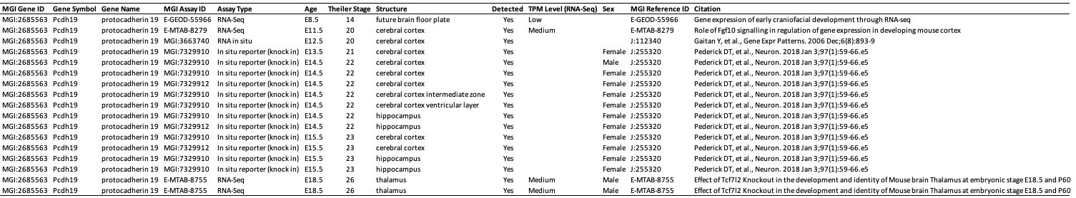
Supplementary Table 8. PCDH19 expression in limbic system structures during mouse embryogenesis. Data retrieved from the Mouse Genome Informatics (MGI) database (https://www.informatics.jax.org/) on September 13, 2023. PCDH19 expression is present in the developing brain from embryonic day (E) 8.5 and has been detected in cerebral cortex (from E11.5 to E15.5), hippocampus (from E14.5 to E15.5), and thalamus (E18.5)
Supplementary Figures

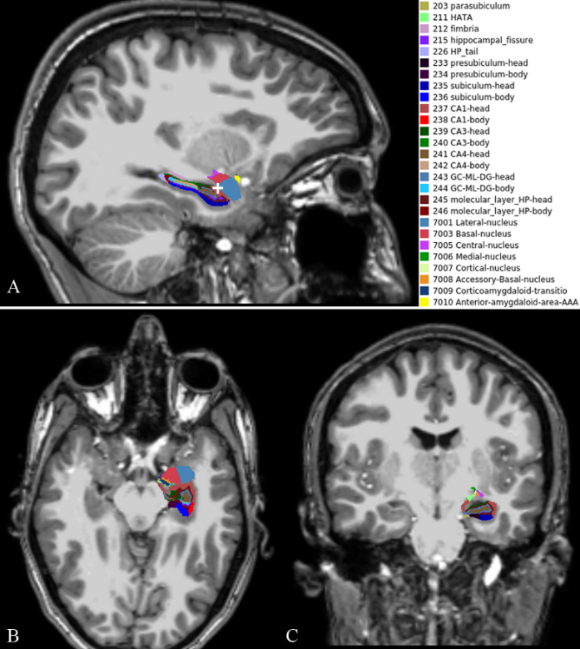
Supplementary Figure 1. Hippocampal subfields segmentation. Sagittal (A) plane with the white cross indicating the axial (B) and coronal (C) views of the segmentation of the left hippocampal subfield in patient no. 1.

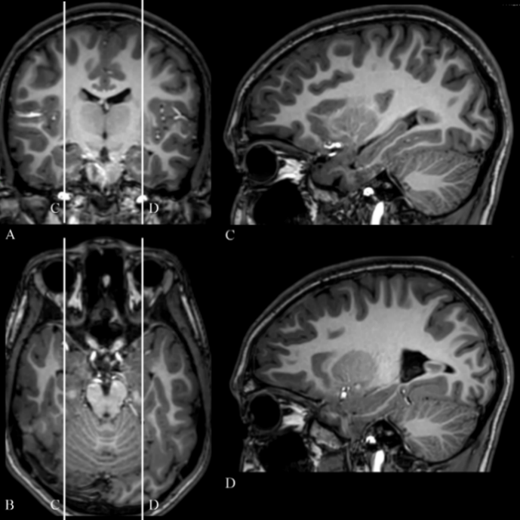
Supplementary Figure 2. MRI T1-weighted exam of patient no. 10 with incomplete inversion of left hippocampus (D). White lines in coronal (A) and axial (B) MRI views indicates sagittal sections without (C, right hippocampus) and with (D, left hippocampus) incomplete inversion.

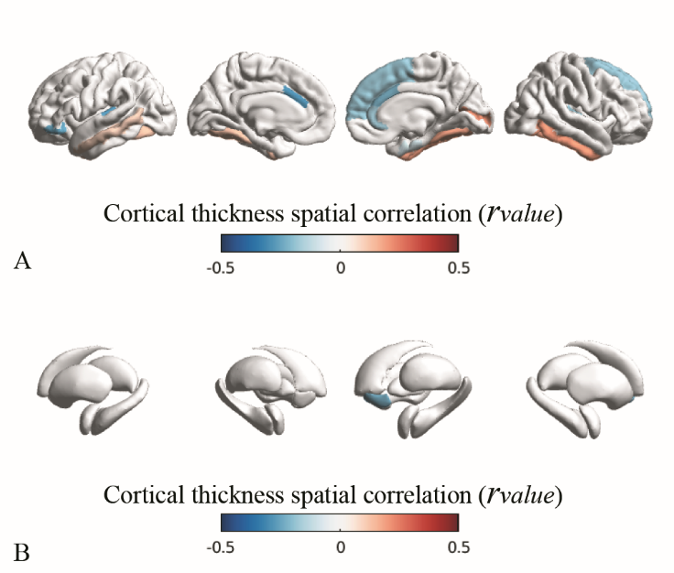
Supplementary Figure 3. Network-based structural analysis of cortical thickness (CT). Spatial correlations (r_{value}, blue-red colormap) between CT patterns ($β_{2}$) and seed-based cortico-cortical (panel A) and subcortico-cortical (panel B) connectivity profiles. In this example, we used as seed the left entorhinal gyrus. Correlation scores (r_{value}) are detailed in Supplementary Tables 2 and 3. CT changes ($β_{2}$) are indicated in Supplementary Table 1.

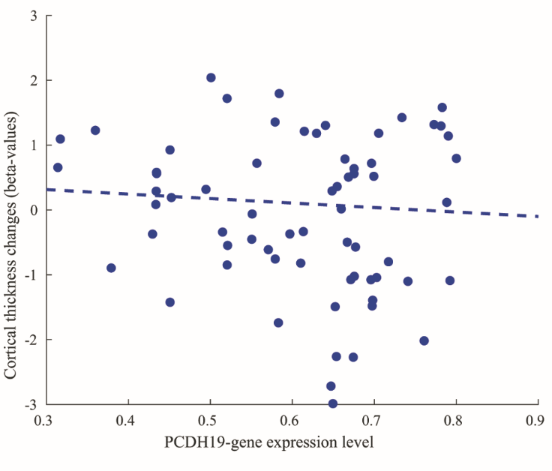
Supplementary Figure 4. Correlation between levels of PCDH19 expression and cortical thickness changes ($β_{2}$ in Supplementary Table 1) observed in cortical and subcortical regions.

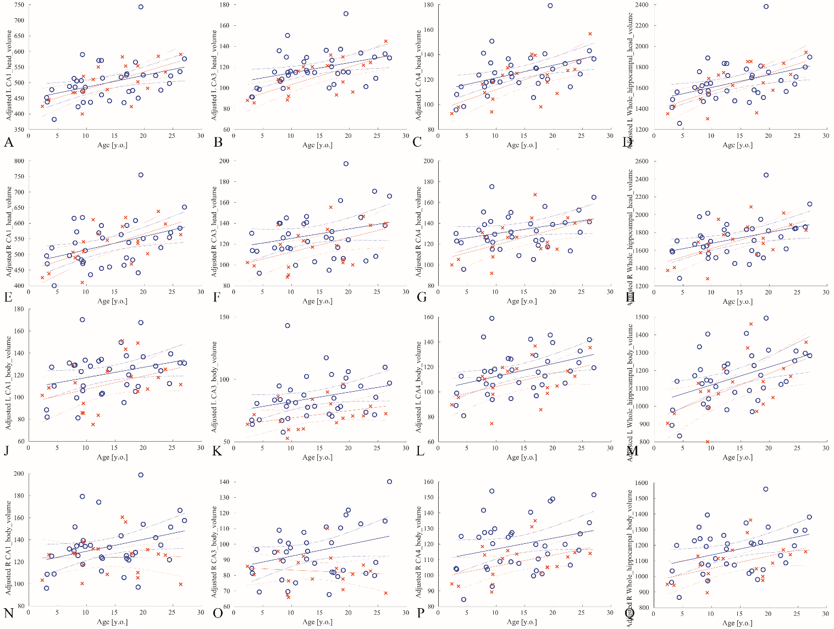
Supplementary Figure 5. Age-related cortical patterns of volumes of selected hippocampal subfields, in controls (blue circle) and PCDH19 mutated patients (red crosses), assessed in the left (L) and right (R) hemispheres. The comparison between the age-related volumetric patterns obtained in the body of CA3 revealed a statistically significantly lower mean value ($β_{2}$=-2.936, p-value=0.004) and a trend of reduction with age. The body of the whole hippocampus was significantly reduced with age in the right side ($β_{0}$=-2.285, p-value=0.026). The continuous line represents the fitting line, the dotted line indicated the 95% confidence bounds.
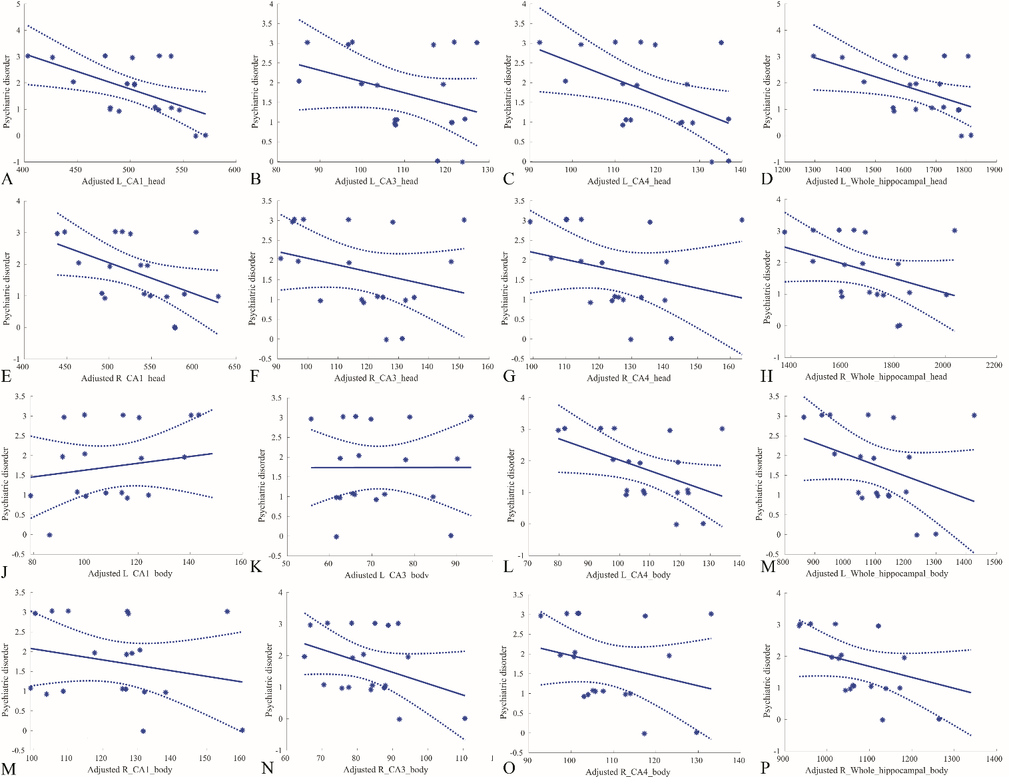
Supplementary Figure 6. Significant correlation patterns between the categorized psychiatric disorder and values of volumetric segmentations assessed in a representative subset of the selected regions of interest reported in Table 2. The values, indicated by asterisks, are adjusted according to the linear regression model applied in the statistical analysis. The continuous line represents the fitting line, the dotted line indicated the 95% confidence bounds.

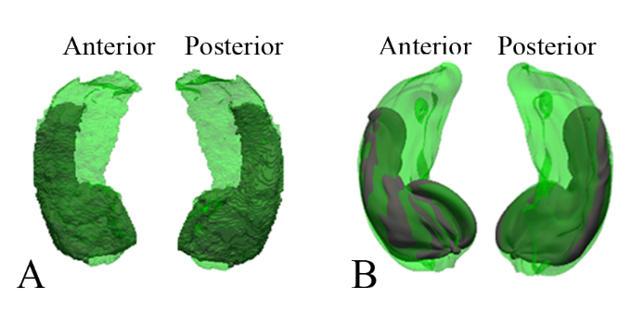
Supplementary Figure 7. Surface of the left hippocampus of a patient (A, green) after the registration with the surface of the Cornu Ammonis (in A, grey). In B, the final shape of the surface of hippocampus (green) and Cornu Ammonis (grey) after resampling on the high-resolution mesh (level 6 icosahendreal mesh with 40962 vertices and 81920 faces).

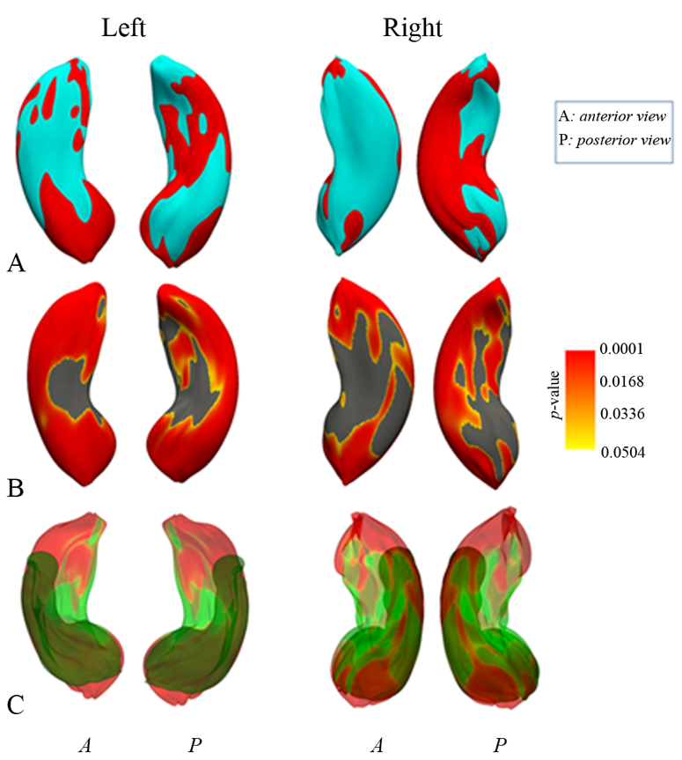
Supplementary Figure 8. Hippocampal shape analysis. In A, the mean shape of the left and right hippocampi of PCDH19 -mutated patients (red) with in overlay the mean shape of the left and right hippocampi of controls (light blue). In B, the FDRP p_{value} maps obtained with p_{value}≤0.05 (yellow-red colormap, with gray for regions not statistically significant, p_{value}>0.05). In C, the projection of FDRP p_{value} on mean hippocampus (green) overlaid on the Cornus Ammonis (grey).
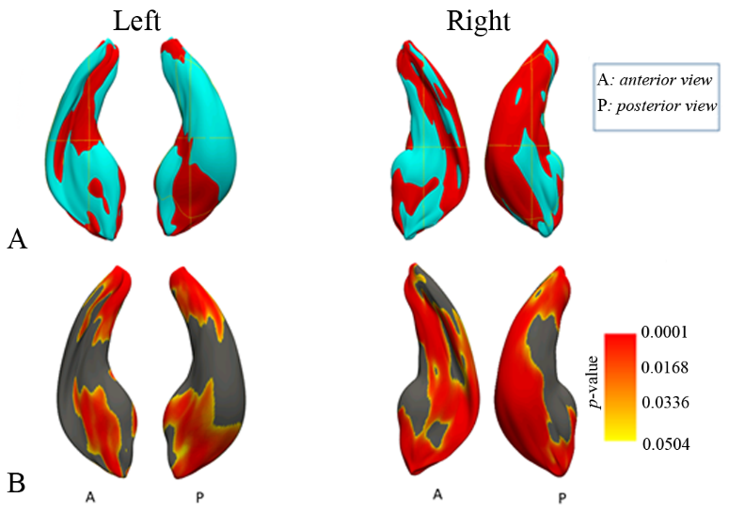
Supplementary Figure 9. Cornu Ammonis (CA) shape analysis. In A, the mean shape of the left and right CA of PCDH19 patients (red) with in overlay the mean shape of the left and right CA of controls (light blue). In B, the p-value maps obtained with p≤0.05 (yellow-red colormap, with gray for regions not statistically significant, p>0.05).

