Table. S1 Hardware list

Hardware Module
Item(model) | Image | Parameter | Link
Computer | 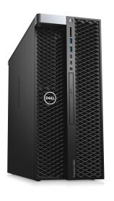 | Precision 5820 Tower  Inter(R) Xeon(R) W-2155 CPU  NVIDIA GeForce RTX 2080Ti | https://www.dell.com/zh-cn/shop/
Stm32 | 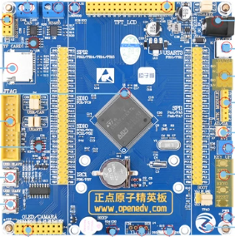 | STM32F103ZET6  72 MHz clock | https://item.taobao.com/item.htm?spm=a1z0k.7386009.1997985097.d4918993.46cf37de6uNgrP&id=523092580242&_u=t2dmg8j26111
Camera | 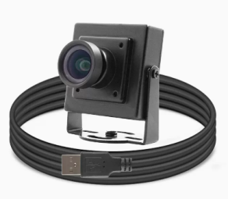 | HF868SS  Pixel Size 3um*3um  480P:120 fps | https://detail.tmall.com/item.htm?_u=t2dmg8j26111&id=627225947424&spm=a1z0k.7386009.1997985097.d4918993.46cf37de6uNgrP
Servo Motor Driver | 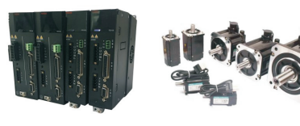 | 0.1kw-5.5kw  SVPWM  220VAC+10%  ~-15%  RS-485 | www.fereme.cn
Slide rail | 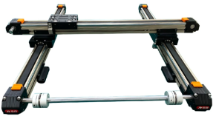 | Length: 1000 mm  Width: 1000 mm | https://item.taobao.com/item.htm?spm=a1z0k.7386009.1997985097.d4918993.46cf37de6uNgrP&id=629115224689&_u=t2dmg8j26111
Square Magnetic Block | 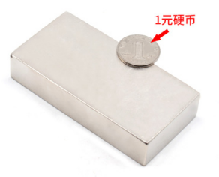 | Length: 100 mm  Width: 50 mm  Thickness: 20 mm | https://item.taobao.com/item.htm?spm=a1z0k.7386009.1997985097.d4918993.46cf37de6uNgrP&id=584042996591&_u=t2dmg8j26111
Round magnetic block | 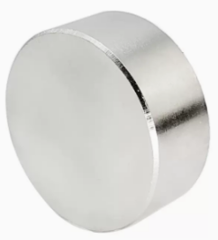 | Diameter 40 mm  thickness 10 mm | https://detail.tmall.com/item.htm?id=619864317122
Regulated power supply | 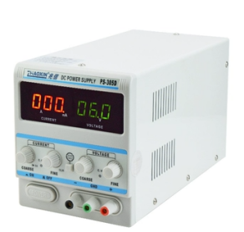 | Output voltage: 0-30 V  Output current:  0-3 A | https://item.taobao.com/item.htm?spm=a1z0k.7386009.1997985097.d4918993.46cf37de6uNgrP&id=610465415897&_u=t2dmg8j26111
circuit board | 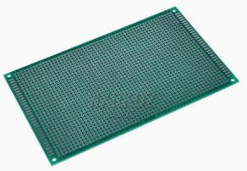 | Length: 60 mm  Width: 40 mm  Hole spacing:  2.54 mm | https://detail.tmall.com/item.htm?abbucket=0&id=619035415749&ns=1&skuId=4368959501684&spm=a21n57.1.0.0.7237523chCxvsC
Square acrylic plate | 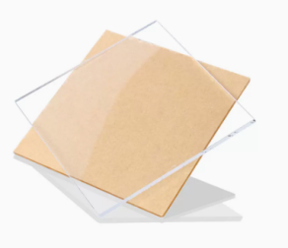 | Length: 800 mm  Width: 800 mm  Thickness：10 mm | https://detail.tmall.com/item.htm?_u=t2dmg8j26111&id=45653259177&spm=a1z0k.7386009.1997985097.d4918993.46cf37de6uNgrP
Acrylic cylinder | 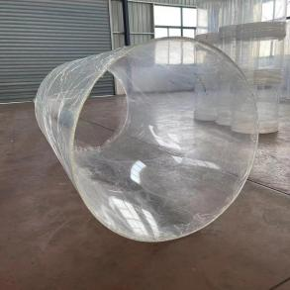 | Diameter 800 mm, height 300 mm, thickness 8 mm | https://item.taobao.com/item.htm?spm=a1z0k.7386009.0.0.46cf37de6uNgrP&id=668894324208&_u=t2dmg8j26111
Anti-vibration table | 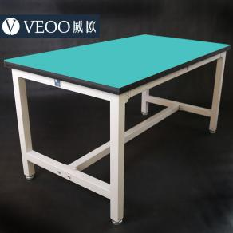 | Length 1500 mm  Width 1500 mm  Height 750 mm | https://item.taobao.com/item.htm?spm=a1z0k.7386009.1997985097.d4918993.46cf37de6uNgrP&id=19140891812&_u=t2dmg8j26111
Platform support frame | 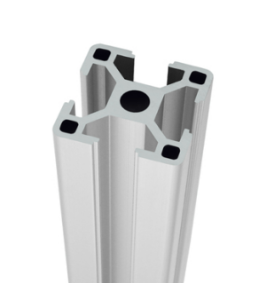 | OB3030  Length 1600 mm  height 900 mm  width 800 mm | https://item.taobao.com/item.htm?spm=a1z0k.7386009.1997985097.d4918993.46cf37de6uNgrP&id=598799357725&_u=t2dmg8j26111
Camera support frame | 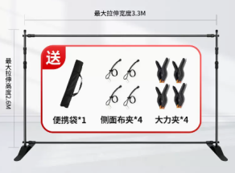 | Maximum width 3300 mm, maximum height 2600 mm | https://detail.tmall.com/item.htm?_u=t2dmg8j26111&id=653440514110&spm=a1z0k.7386009.1997985097.d4918993.46cf37de6uNgrP&skuId=4710466984766
Circuit Components
DuPont Line | 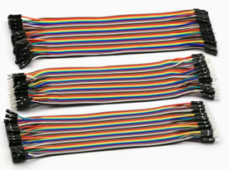 | / | https://detail.tmall.com/item.htm?abbucket=0&id=41254478179&ns=1&spm=a21n57.1.0.0.cfe4523cn15qaS&sku_properties=122216547:20213
2N2222A | 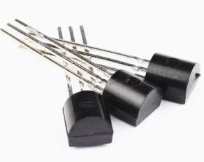 | NPN | https://detail.tmall.com/item.htm?_u=t2dmg8j26111&id=602012446142&spm=a1z0k.7385961.0.0.3dd337deMz7y0R&skuId=4209941168719

Figure. S4 Signal adaptation circuit
Ports PE6 and PE7 in the STM32 give direction and speed signal, respectively, which are passed through an amplifier circuit to ports 43 and 39 of the servo motor controller.

