Supplementary Information
Low hormetic dose of curcumin-PDA nanoparticles improves viability and proliferation in cell culture
Lucia Vázquez Alberdi^{1,2*}(L.V.A), Marcela Martínez-Busi³(M.M.B), Carolina Echeverry⁴(C.E.), Miguel Calero⁵(M.C) and Alejandra Kun^{1,6*}(A.K.).

Table S1. Curcumin concentration in controls. Standard curcumin and unloaded PDA, both at 1mg/ml in methanol, were evaluated to obtain the curcumin concentration from the area of integration.
Controls | Area | Concentration (mg/ml)
PDA | 450 ± 94 | 0.002 ±0,001
Curcumin | 213,599 ± 18,597 | 1.03 ± 0.03

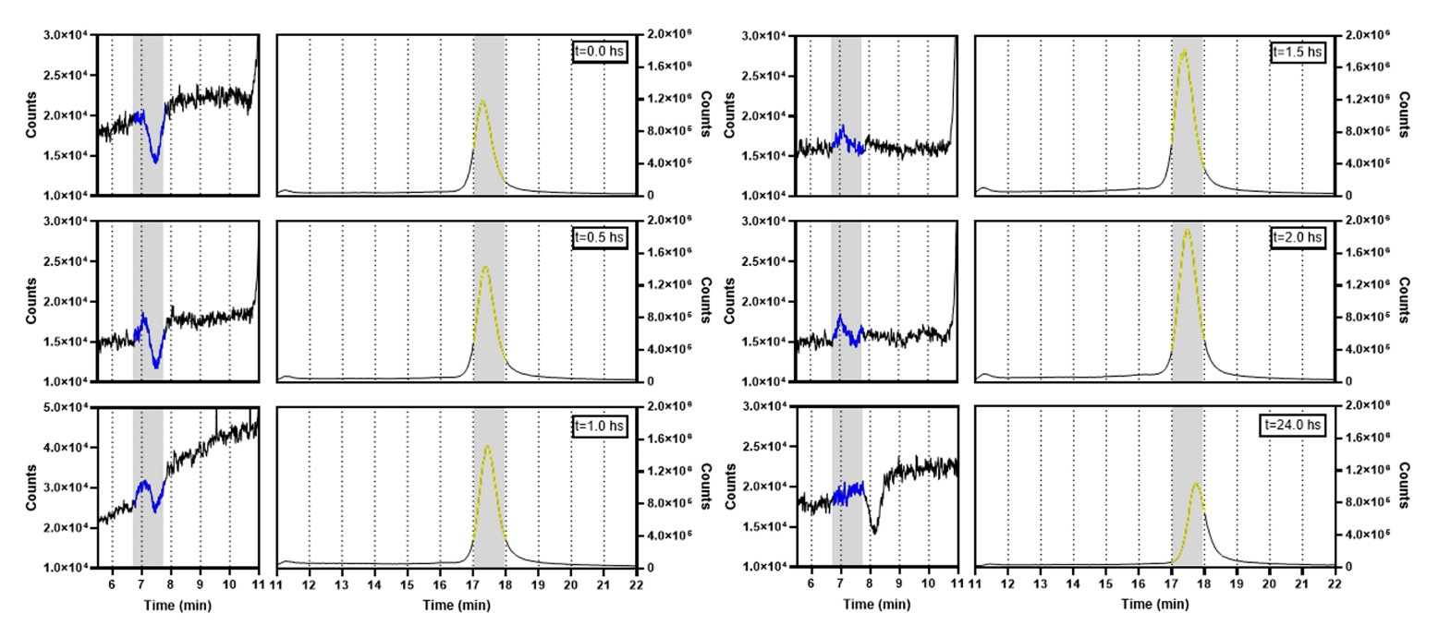

Figure S1. Curcumin retention in Curc-PDA. Curcumin-loaded NPs were placed in a culture medium, and the presence of curcumin retained in PDA was evaluated after 0.5, 1.0, 1.5, 2.0, and 24 hs. A. Spectra obtained by UHPLC-MS, m/z=369, for retained curcumin. Yellow indicates the characteristic peak of curcumin. In blue indicates the area where Neo-curcumin is found.
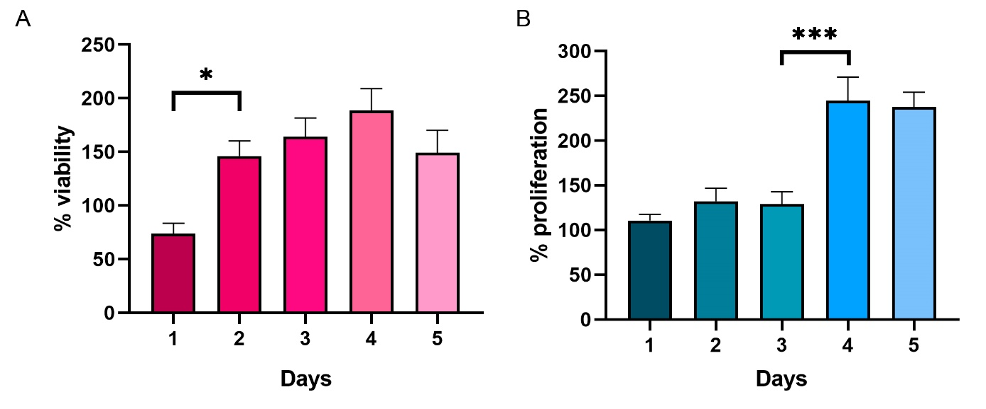
Figure S2. Change in viability and proliferation of cultures treated with Curc-PDA. For endoneurial fibroblast cultures treated with Curc-PDA (0.05µM curcumin) for 5 days, we assessed during which day the change in A. Viability (by MTT assay) and B. Proliferation (by CyQUANT assay). The median ± SEM is represented.

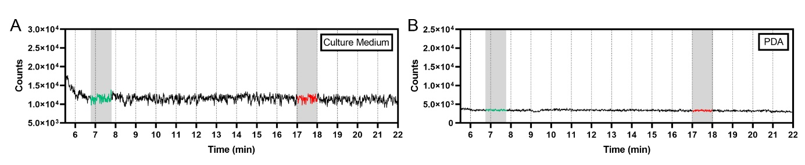
Figure S3. Controls used for UHPLC. We performed controls with A. culture medium and B. unloaded PDA (1mg/ml) at ion m/z=369 to rule out that the peaks resulting from our analysis could be due to these compounds.
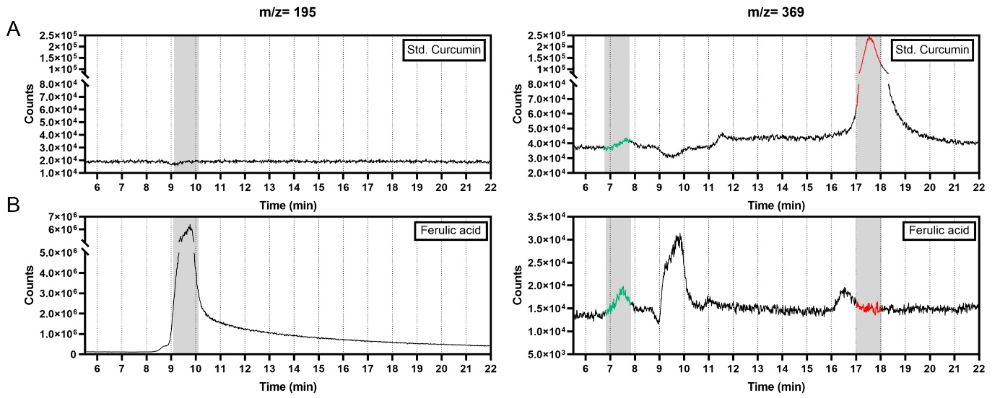Figure S4. Standard evaluated by UHPLC-MS. The standard of A. curcumin and B. ferulic acid were evaluated at two ion m/z: 195 and 369. For this purpose, 1 mg/ml solutions in methanol were made. m/z=369 ion, the characteristic peak of curcumin is indicated in red. Green indicates the presence of Neo-curcumin.

