Appendix A.

Additional file 1: Interaction plots for the external and personal domain of the food environment and dietary outcomes
Figure 1. Interaction effect of SES on the perceived availability of FV in the neighborhood for FV consumption frequency per day.
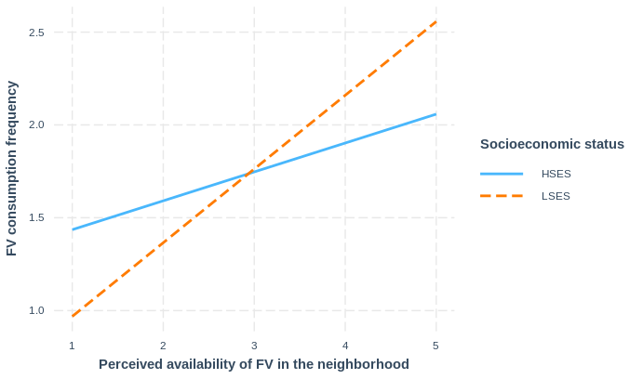
Figure 2. Interaction effect of SES on the density of healthy food outlets in the 1000m buffer for SSN consumption frequency per day.
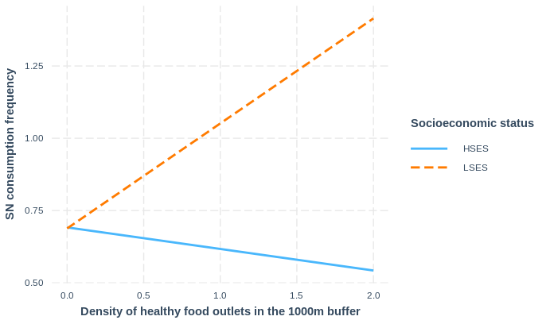

Figure 3. Interaction effect of SES on the density of unhealthy food outlets in the 1000m buffer for SSBs consumption frequency

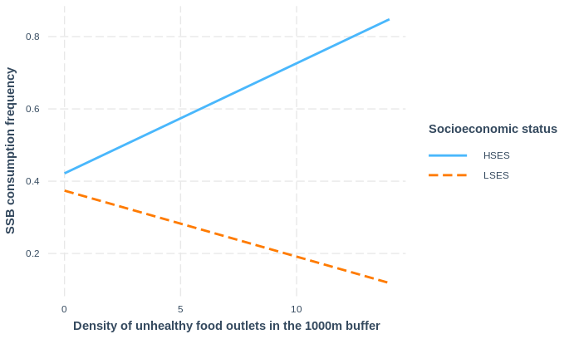

Additional file 2: Recalculation of consumption frequency values of fruit-and vegetables, fast-food, snacks and sugar-sweetened beverages
Table S2: transformation of food consumption frequency values from categorical to numerical in times per day.
Original values (categories) |  | Calculation steps | Converted values (times per day)
1 | Never | 0 | 0
2 | Less than once per month | < 1/30 times per day → 0 - 0.033 times per day→ average 0.033/2 = 0.017 per day | 0.017
3 | 1-3 times per month | 1/30 – 3/30 times per day → 0.033 – 0.1 times per day → on average (0.033+0.1)/2 = 0.067 times per day | 0.067
4 | once per week | 1/7 times per day = 0.14 times per day | 0.14
5 | 2-4 times per week | 2/7 – 4/7 times per day → 0.29 – 0.57  times per day → on average (0.29 + 0.57)/2 = 0.43 times per day | 0.43
6 | 5-6 times per week | 5/7 – 6/7 times per day → 0.71 -0.86 times per day → on average (0.71 +  0.86)/2 = 0.79 per day | 0.79
7 | once per day | 1 time per day | 1
8 | 2-3 times per day | on average (2+3)/2 = 2.5 times per day | 2.5
9 | more than 3 times per day | 3 times per day | 3
-1 | missing | NA | NA

Additional file 3: Reclassification of the Locatus food retail outlet categories
Table S3: The original food retail categories from the Locatus database and their reclassification for the purposes of this study
Reclassification | Locatus classification | Locatus definition
Fastfood /takeaway/delivery outlets | 59.210.171-Fastfood | Meal provider where service is not at the table, without fixed cutlery and where the usually fried products are ready for consumption within minutes of ordering (excludes sandwich stores)
 | 59.210.215-Grillroom/ Shoarma | Sales of grill products, shoarma, kebab and alike.
 | 59.210.180-Takeaway/ delivery | Provision of (hot) meals, which are not consumed on site but are collected or delivered
Full service restaurants | 59.210.235-Hotel-Restaurant | Hotel combined with ‘a la carte’ restaurant
 | 59.210.333-Lunchroom | Meal provider, with table service, particularly including breakfasts, lunches and desserts, opposed to restaurants mostly closed in the evening
 | 59.210.430-Café-Restaurant | Provision of both beverages and meals
 | 59.210.434-Restaurant | Provision of meals, beverages are provided only in conjunction with the food
 | 59.210.392-Pancakes | Restaurants specializing in pancakes
Supermarkets | 11.010.519-Supermarket | Stores with a wide and varied range of food products often supplemented by a narrow and shallow range of non-food products. Floor space is greater than 149m²
Greengrocers | 11.010.012-Vegetables/ fruit | Almost exclusively sales of potatoes, vegetables and fruit that have not been cultivated by the company itself
Shops selling animal products | 11.010.471-Butcher | Sales of meat and meat products
 | 11.010.399-Poulterer | Sales of game and poultry
 | 11.010.588-Fish | Sales of fish, crustaceans and molluscs
Bakeries | 11.010.111-Baker | Sales of bread and pastries, with possible lunchroom but that is not be the main activity
 | 11.010.112-Flans | Sales of pastries, with an emphasis on flans
Other shops | 11.010.132-Chocolate | Sales of Chocolate
 | 11.010.261-Cheese | Sales of Cheese
 | 11.010.310-Farm store | Farm sales of own products, primarily food products, supplemented by an assortment of purchased products
 | 11.010.378-Nuts | Sales of nuts, dates and dried fruits
 | 11.010.423-Reform | Biodynamic, ecological and macrobiotically grown products supplemented with dietary supplements, homeopathic remedies, herbs
Convenience stores | 11.010.309-Minisuper | See definition of supermarket, but store is up to 149m²
 | 11.010.350-Nightshop | Mini supermarket with (late) evening and night opening
Confectionary stores | 11.010.657-Sweets | Sales of sweets and confectionery, also sugars
 | 59.210.246-Ice cream parlor | Sales of ice cream
Excluded from the study | 11.010.137-Coffee/Tea | Store selling mainly coffee and tea, possibly supplemented by items intended for drinking coffee/tea
 | 11.010.424-Food Supplements | Sales of supplements intended to supplement or replace a normal diet. Also vitamins, sports supplements
 | 11.010.141-Delicacies | Store that sells specialty, usually more luxurious foods, and often convenience products
 | 11.010.477-Liquor | Sales of alcoholic and non-alcoholic beverages
 | 59.210.123-Bar | Provision of almost exclusively beverages (not meals)
 | 59.210.127-Coffee house | Provision of only non-alcoholic beverages (in the regulation Turkish or Moroccan beverages)
 | 59.210.334-Coffee bar | Provision of predominantly (hot, non-alcoholic) beverages prepared by a barista, limited offering of breakfasts, lunches and desserts. Predominantly ordering at the counter.
 | 59.210.950-Horeca other | Hospitality industry not further classifiable into one of the other categories
 | 11.010.123-Toko | Store selling mainly oriental foods

Additional file 4 – Health scores based on expert opinion
Table 4: Health scores of the food outlets in the Locatus database based on the expert opinion of 15 Flemish experts
Locatus Category | Explanation | Likert Scale Score | Healthy/unhealthy
Primary food retailers
59.210.171-Fastfood | Meal provider where service is not at the table, without fixed cutlery and where the usually fried products are ready for consumption within minutes of ordering (excludes sandwich stores). | 1 | Unhealthy
59.210.215-Grillroom/Shoarma | Sales of grill products, shoarma, kebab and alike. | 1 | Unhealthy
59.210.180-Delivery | Provision of (hot) meals, which are not consumed on site but are collected or delivered. | 2 | Unhealthy
59.210.235-Hotel-Restaurant | Hotel combined with ‘a la carte’ restaurant. | 3 | Neutral
59.210.333-Lunchroom | Meal provider, with table service, particularly including breakfasts, lunches and desserts, opposed to restaurants mostly closed in the evening. | 3 | Neutral
59.210.430-Café-Restaurant | Provision of both beverages and meals. | 2 | Unhealthy
59.210.434-Restaurant | Provision of meals, beverages are provided only in conjunction with the food. | 3 | Neutral
59.210.392-Pancakes | Restaurants specializing in pancakes. | 2 | Unhealthy
11.010.519-Supermarkt | Stores with a wide and varied range of food products often supplemented by a narrow and shallow range of non-food products. Floor space is greater than 149m². | 3 | Neutral
11.010.309-Minisuper | See definition of supermarket, but store is up to 149m². | 3 | Neutral
11.010.012-Greengrocer | Almost exclusively sales of potatoes, vegetables and fruit that have not been cultivated by the company itself. | 5 | Healthy
11.010.471-Butcher | Sales of meat and meat products. | 2 | Unhealthy
11.010.399-Poulterer | Sales of game and poultry. | 3 | Neutral
11.010.588-Fish | Sales of fish, crustaceans and molluscs. | 4 | Healthy
11.010.261-Cheese | Sales of Cheese. | 3 | Neutral
11.010.111-Bakery | Sales of bread and pastries, with possible lunchroom but that is not be the main activity. | 3 | Neutral
11.010.112-Flans | Sales of pastries, with an emphasis on flans. | 2 | Unhealthy
11.010.310-On Farm Store | Farm sales of own products, primarily food products, supplemented by an assortment of purchased products. | 4 | Healthy
11.010.378-Nuts | Sales of nuts, dates and dried fruits. | 4 | Healthy
11.010.423-Bio Store | Biodynamic, ecological and macrobiotically grown products supplemented with dietary supplements, homeopathic remedies, herbs. | 4 | Healthy
11.010.132-Chocolate | Sales of Chocolate. | 1 | Unhealthy
11.010.657-Candystore | Sales of sweets and confectionery, also sugars. | 1 | Unhealthy
59.210.246-Icecream Parlor | Sales of ice cream. | 1 | Unhealthy
11.010.350-Nightshop | Mini supermarket with (late) evening and night opening. | 2 | Unhealthy
Secondary food retailers |  |  | Unhealthy
11.010.522-Tobacco | Sale of tobacco products and smoking accessories, in conjunction with magazines, confectionery and soft drinks. | 1 | Unhealthy
11.020.156-Drugstore | Sells personal care products, self-help medications, health care products, nursing and cleaning supplies. | 2 | Unhealthy
22.030.618-Warehouse | Store with a broad assortment of alimentary and non-alimentary products in which the fashion segment is often predominant. | 2 | Unhealthy
45.205.528-Gas station | Sale of automotive fuels, with or without a store. | 2 | Unhealthy
59.210.150-Disco | Opportunity for evening-night catering with a central dance floor and loud music. | 1 | Unhealthy
59.210.155 Sex/partyclubs | Opportunity for sex, erotic massages, shows, couples clubs etc. | 1 | Unhealthy
59.210.465-Partycenter | Rental of rooms for parties and celebrations, including the provision of food and beverages for these parties. | 2 | Unhealthy
59.230.018-Amusement hall | Is an age-independent, freely accessible place with gambling and gaming machines. | 1 | Unhealthy
59.230.020-Theme park | Terrain on which one or more attractions are assembled. | 2 | Unhealthy
59.230.028-Casino | An adult-only venue where you can play slot machines and various gambling games such as roulette and blackjack at a table in luxurious surroundings. | 1 | Unhealthy
59.230.078-Biljart/Pool | Space primarily designed for billiards/pool and / or snooker (any catering service here is additional and not the main purpose). | 2 | Unhealthy
59.230.080-Indoor playground | Indoor play area for children. | 2 | Unhealthy
59.230.102-Bowling | Bowling center (catering service is complementary here and not the main purpose). | 2 | Unhealthy
59.230.150-Zoo | Grounds where animals can be viewed for a fee. | 2 | Unhealthy
59.230.950-Amusement Other | All other forms of entertainment, not previously mentioned. | 2 | Unhealthy
65.250.033-Video Store | Rental of image and sound carriers with or without computer games. | 1 | Unhealthy
59.220.081-Cinema | Screening of films. | 1 | Unhealthy
59.220.549-Theater | Room for the screening of live shows. | 2 | Unhealthy
59.230.265-Go Cart Track | Place where karts can be rented and driven . | 2 | Unhealthy
59.230.295-Ice Skating Track | Permanently established indoor ice rink where artificial ice can be skated for a fee. | 2 | Unhealthy
59.230.290-Climbing Hall | Indoor facility for the practice of climbing . | 2 | Unhealthy
59.230.310-Laser Game | Center where laser games can be played. | 2 | Unhealthy
59.230.590-Ski Track | Indoor place where skiing can be done. | 2 | Unhealthy
59.230.700-Swimming Pool | Indoor public pool. | 2 | Unhealthy
59.230.570-Sauna | Sauna complex accessible to everyone. | 2 | Unhealthy

