Supplementary materials for
A novel enrofloxacin-degrading fungus, Humicola sp. KC0924g, isolated from the rhizosphere sediment of the submerged macrophyte Vallisneria spiralis L.

Xueting Chen*, Yuping Zhang, Jinghua Liu
Shanghai Fisheries Research Institute, Shanghai Fisheries Technical Extension Station, No.265 Jiamusi Road, Yangpu District, Shanghai 200433, China
*Correspondence: cxtsnow@126.com; Tel.:+86-21-65483215-774

Table S1. Primer pairs used in the study
Primer pairs | Sequence (5’-3’) | Purpose and Reference
ITS5 | GGAAGTAAAAGTCGTAACAAGG | to amplify the ITS and LSU region | (White et al., 1990; O'Donnell, 1993)
NL4 | GGTCCGTGTTTCAAGACGG | to amplify the ITS and LSU region | (White et al., 1990; O'Donnell, 1993)
rpb2-5F2 | GGGGWGAYCAGAAGAAGGC | to amplify the partial rpb2 gene region | (Miller & Huhndorf, 2005; Sung et al., 2007)
rpb2AM-7R | GAATRTTGGCCATGGTRTCCAT | to amplify the partial rpb2 gene region | (Miller & Huhndorf, 2005; Sung et al., 2007)
T1 | AACATGCGTGAGATTGTAAGT | to amplify the partial tub2 gene region | (O'Donnell & Cigelnik, 1997; Groenewald et al., 2013)
TUB4Rd | CCRGAYTGRCCRAARACRAAGTTGTC | to amplify the partial tub2 gene region | (O'Donnell & Cigelnik, 1997; Groenewald et al., 2013)

Table S2. Accession numbers of each strain used for phylogenetic analyses
Species | Culture accession number | Origin | ENA accession numbers
Species | Culture accession number | Origin | ITS & LSU | rpb2 | tub2
Humicola
H. ampulliella | CBS 116735^{T} | Discarded sock, China | LT993568 | LT993487 | LT993649
H. atrobrunnea | HSAUPII05-1004^{T} | Soil, China, Guizhou | LT993570 | LT993489 | LT993651
H. christensenii | CBS 127760^{T} | Soil, USA, Minnesota | LT993571 | LT993490 | LT993652
H. cuyabenoensis | CBS 398.97^{T} | Rain forest, Ecuador | LT993573 | LT993492 | LT993654
H. degenerans | CBS 232.65^{T} | Soil under mixed forest, Canada, Ontario | LT993574 | LT993493 | LT993655
H. distorta | CBS 417.66^{T} | Populus tremuloides dead leaf, USA, Iowa | LT993577 | LT993496 | LT993658
H. floriformis | CBS 815.97^{T} | Fallen leaves, Thailand, Sukhothai | LT993578 | LT993497 | LT993659
H. fuscoatra | CBS 118.14^{T} | Soil, Norway | LT993579 | LT993498 | LT993660
H. fuscogrisea | CGMCC 3.13790^{T} | Soil, China, Shennongjia | LT993581 | LT993500 | LT993662
H. homopilata | CBS 157.55^{T} | Filter paper in soil, Norway | LT993582 | LT993501 | LT993663
H. leptodermospora | CBS 120095^{T} | Forestal soil, Brazil | LT993584 | LT993503 | LT993665
H. mutabilis | CBS 779.71^{T} | Soil, Israel | LT993588 | LT993507 | LT993669
H. olivacea | CBS 142031^{T} | Dust, USA | LT993589 | LT993508 | LT993670
H. pinnata | CBS 467.66^{T} | Dead wood, USA, Coronado National Forest | LT993590 | LT993509 | LT993671
H. pulvericola | CBS 144165^{T} | Dust, Mexico | LT993591 | LT993510 | LT993672
H. pulvericola | CBS 144166 | Dust, South Africa | LT993592 | LT993511 | LT993673
H. quadrangulata | CBS 111771^{T} | Soil, Brazil | LT993593 | LT993512 | LT993674
H. seminuda | CBS 368.84^{T} | Soil, Canada, Ontario | LT993594 | LT993513 | LT993675
H. semispiralis | CBS 723.97^{T} | Paper, Canada, Toronto | LT993597 | LT993516 | LT993678
H. sphaeralis | CBS 985.87^{T} | Soil, France | LT993598 | LT993517 | LT993679
H. udagawae | CBS 337.68^{T} | Unknown substrate, unknown country | LT993601 | LT993520 | LT993682
H. wallefii | CBS 147.67^{T} | Soil, Zaire | LT993602 | LT993521 | LT993683
Mycothermus
M. thermophiloides | CBS 183.81^{T} | Soil, USA, Indiana | LT993603 | LT993522 | LT993684
M. thermophilum | CBS 625.91^{T} | Chicken nest straw, USA, Nevada | LT993604 | LT993523 | LT993685
Remersonia
R. tenuis | CBS 784.85^{T} | Dung of horse, India | LT993609 | LT993528 | LT993690
Staphylotrichum
S. acaciicola | CBS 281.65^{T} | Acacia karroo leaf litter, South Africa | LT993613 | LT993532 | LT993694
S. brevistipitatum | CBS 408.67^{T} | Eucalyptus leaf litter, South Africa | LT993619 | LT993538 | LT993700
S. coccosporum | CBS 364.58^{T} | Soil, Zaire | LT993620 | LT993539 | LT993701
S. microascosporum | CBS 184.79^{T} | Soil from Mangifera orchard, Sudan | LT993624 | LT993543 | LT993705
Trichocladium
T. acropullum | CBS 114580^{T} | Soil, China | LT993626 | LT993545 | LT993707
Microascus
M. trigonosporus | CBS 218.31^{T} | USA | LM652443  HG380436 | DQ470908 | LM652655
Species | Culture accession number | Origin | GenBank accession numbers
Species | Culture accession number | Origin | ITS & LSU | rpb2 | tub2
Chaetomium
C. citrinum | CBS 693.82^{T} | Rice field soil, Japan | KT214587 KT214617 | KT214691 | KT214764
C. globosum | CBS 160.62^{T} | Compost, Germany | KT214565 KT214596 | KT214742 | KT214666
C. grande | CBS 126780^{T} | Leaf, Iran | HM365253 | HM365273 | KT214657
C. interruptum | CBS 126660^{T} | Seed, Iran | HM365246 | KT214665 | KT214741
C. madrasense | CBS 315.74^{T} | Rhizosphere, India | KC109751 | KF001831 | KC109769
C. rectangulare | CBS 126778^{T} | Leaf, Iran | HM365239 | KT214688 | HM365285
C. subaffine | CBS 637.91^{T} | USSR Cereal | JN209929 | KF001817 | JN256199
C. undulatulum | CBS 126775^{T} | Leaf, Iran | HM365251 | KT214682 | HM365279

Table S3 Summary of the sequencing.
Sample | Total raw reads | Total clean reads (%) | Clean bases | Error (%) | Q20 | Q30 | GC (%) | Mapped-rate
CK-1 | 53895930 | 48149374  (89.34%) | 7.18G | 0.0276 | 97.55 | 95.18 | 54.5 | 96.5%
CK-2 | 74320176 | 65827546  (88.57%) | 9.81G | 0.028 | 97.46 | 94.98 | 53.7 | 94.4%
CK-3 | 53000402 | 46650198  (88.02%) | 6.95G | 0.0286 | 97.25 | 94.66 | 56.46 | 95.2%
CU-1 | 53717604 | 45903962  (85.45%) | 6.84G | 0.0278 | 97.48 | 95.06 | 57.09 | 91.4%
CU-2 | 57681696 | 48426194  (83.95%) | 7.22G | 0.0271 | 97.72 | 95.5 | 56.43 | 92.9%
CU-3 | 51724610 | 45676216  (88.31%) | 6.79G | 0.0302 | 96.79 | 93.82 | 58.96 | 96%
CK-1, CK-2 and CK-3: controlled sample (three independent biological replicates)
CU-1, CU-2 and CU-3: Cu²⁺-treated sample (three independent biological replicates)
Q20: The percentage of bases with a Phred value＞20
Q30: The percentage of bases with a Phred value＞30

Table S4 BLAST analysis of non-redundant unigenes against public databases.
 | Number of unigenes | Percentage (%)
Annotated in NR | 21516 | 87.71
Annotated in GO | 10662 | 43.46
Annotated in COG | 14200 | 57.89
Annotated in KEGG | 6793 | 27.69
Annotated in SWISS | 14592 | 59.48
Annotated in all database | 4785 | 19.51
Annotated in at least one database | 21527 | 87.75
Total unigenes | 24531 | 100

Table S5 GO enrichment of top three up-regulated or down-regulated DEGs in each category (q-value<0.05).
Category |  | GO accession | Description | Number of genes | Percentage (%)
Biological Process | Up-regulated DEGs | GO:0009987 | cellular process | 52 | 96.3
Biological Process | Up-regulated DEGs | GO:0008152 | metabolic process | 38 | 70. 4
Biological Process | Up-regulated DEGs | GO:0065007 | biological regulation | 36 | 66. 7
Biological Process | Down-regulated DEGs | GO:0009987 | cellular process | 4908 | 70.2
Biological Process | Down-regulated DEGs | GO:0008152 | metabolic process | 3597 | 51. 5
Biological Process | Down-regulated DEGs | GO:0050896 | response to stimulus | 2889 | 41.3
Cellular Component | Up-regulated DEGs | GO:0110165 | cellular anatomical entity | 51 | 94.4
Cellular Component | Up-regulated DEGs | GO:0005622 | intracellular | 48 | 88. 9
Cellular Component | Up-regulated DEGs | GO:0032991 | protein-containing complex | 20 | 37.0
Cellular Component | Down-regulated DEGs | GO:0110165 | cellular anatomical entity | 51 | 94.4
Cellular Component | Down-regulated DEGs | GO:0005622 | intracellular | 48 | 88. 9
Cellular Component | Down-regulated DEGs | GO:0032991 | protein-containing complex | 20 | 37.0
Molecular Function | Up-regulated DEGs | GO:0005488 | binding | 32 | 59. 3
Molecular Function | Up-regulated DEGs | GO:0003824 | catalytic activity | 30 | 55. 6
Molecular Function | Up-regulated DEGs | GO:0005215 | transporter activity | 5 | 9. 3
Molecular Function | Down-regulated DEGs | GO:0003824 | catalytic activity | 2947 | 42.2
Molecular Function | Down-regulated DEGs | GO:0005488 | binding | 2435 | 34.8
Molecular Function | Down-regulated DEGs | GO:0140110 | transcription regulator activity | 615 | 8.8

Table S6 KEGG pathway enrichment of Cu²⁺-responsive DEGs.
Category |  | KEGG pathway | ID | DEGs numbers
 |  | KEGG pathway | ID | Up-regulated | Down-regulated | Total
Metabolism | Carbohydrate metabolism | Glycolysis / Gluconeogenesis | ko00010 | - | 94 | 94
Metabolism | Carbohydrate metabolism | Citrate cycle (TCA cycle) | ko00020 | 1 | 56 | 57
Metabolism | Metabolism of other amino acids | Glutathione metabolism | ko00480 | - | 52 | 52
Metabolism | Global and overview maps | Carbon metabolism | ko01200 | 3 | 186 | 189
Metabolism | Lipid metabolism | Arachidonic acid metabolism | ko00590 | - | 15 | 15
Genetic Information Processing | Folding, sorting and degradation | Protein processing in endoplasmic reticulum | ko04141 | 2 | 137 | 139
Genetic Information Processing | Transcription | Spliceosome | ko03040 | - | 138 | 138
Genetic Information Processing | Translation | Ribosome | ko03010 | 5 | 192 | 197
Environmental Information Processing | Signal transduction | TGF-beta signaling pathway | ko04350 | - | 21 | 21
Environmental Information Processing | Signal transduction | ErbB signaling pathway | ko04012 | - | 22 | 22
Environmental Information Processing | Signal transduction | HIF-1 signaling pathway | ko04066 | - | 49 | 49
Environmental Information Processing | Signal transduction | Rap1 signaling pathway | ko04015 | 1 | 39 | 40
Environmental Information Processing | Signal transduction | FoxO signaling pathway | ko04068 | 1 | 38 | 39
Environmental Information Processing | Signal transduction | PI3K-Akt signaling pathway | ko04151 | 1 | 72 | 73
Environmental Information Processing | Signal transduction | Apelin signaling pathway | ko04371 | - | 48 | 48
Environmental Information Processing | Signal transduction | Calcium signaling pathway | ko04020 | - | 52 | 52
Environmental Information Processing | Signal transduction | cAMP signaling pathway | ko04024 | - | 62 | 62
Environmental Information Processing | Signal transduction | cGMP-PKG signaling pathway | ko04022 | - | 53 | 53
Cellular Processes | Transport and catabolism | Peroxisome | ko04146 | - | 84 | 84
Cellular Processes | Cellular community - eukaryotes | Focal adhesion | ko04510 | 2 | 39 | 41
Cellular Processes | Cell growth and death | Cellular senescence | ko04218 | - | 62 | 62
Cellular Processes | Cell motility | Regulation of actin cytoskeleton | ko04810 | 2 | 59 | 61
Organismal Systems | Immune system | T cell receptor signaling pathway | ko04660 | 2 | 26 | 28
Organismal Systems | Immune system | Fc gamma R-mediated phagocytosis | ko04666 | 1 | 43 | 44
Organismal Systems | Immune system | Th1 and Th2 cell differentiation | ko04658 | - | 15 | 15
Organismal Systems | Immune system | C-type lectin receptor signaling pathway | ko04625 | - | 36 | 36
Organismal Systems | Immune system | B cell receptor signaling pathway | ko04662 | - | 25 | 25
Organismal Systems | Immune system | Th17 cell differentiation | ko04659 | - | 24 | 24
Organismal Systems | Immune system | IL-17 signaling pathway | ko04657 | - | 30 | 30
Organismal Systems | Immune system | NOD-like receptor signaling pathway | ko04621 | 1 | 64 | 65
Organismal Systems | Endocrine system | Aldosterone synthesis and secretion | ko04925 | - | 33 | 33
Organismal Systems | Endocrine system | PPAR signaling pathway | ko03320 | 3 | 38 | 41
Organismal Systems | Environmental adaptation | Circadian entrainment | ko04713 | - | 34 | 34
Organismal Systems | Environmental adaptation | Plant-pathogen interaction | ko04626 | - | 30 | 30
Organismal Systems | Development and regeneration | Axon guidance | ko04360 | 1 | 46 | 47
Organismal Systems | Sensory system | Phototransduction | ko04744 | - | 20 | 20
Organismal Systems | Nervous system | Long-term potentiation | ko04720 | - | 51 | 51
P≤0.05

Table S7 Up-regulated differently expressed genes (DEGs) related to xenobiotics biodegradation and metabolism.
Gene ID | p-value | q-value | Log₂Foldchange | Putative protein product | similarity
TRINITY_DN2180_c0_g1 | 1.03E-10 | 8.94E-10 | 10.0566 | FAD-dependent monooxygenase OpS4 | 53.2%
TRINITY_DN13314_c0_g1 | 0.004418 | 0.009767 | 1.6569

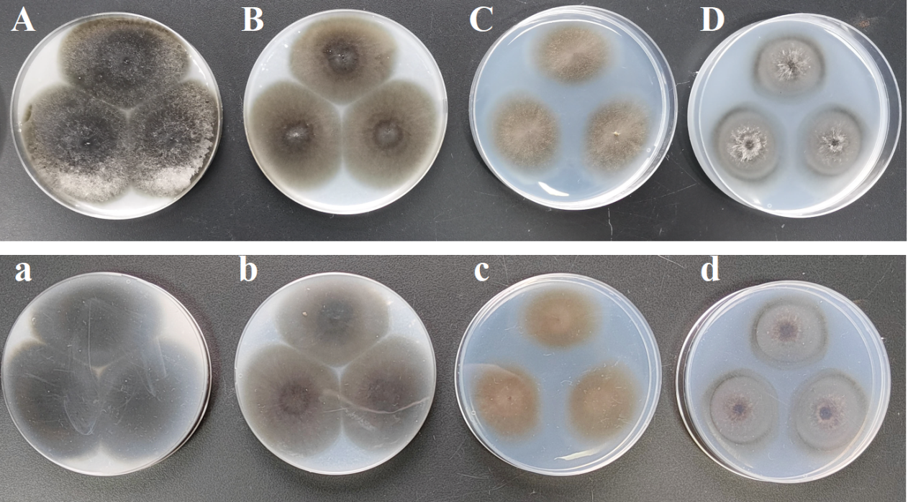
Fig S1. Photographs of strain KC0924g. A-D, front view of colonies after 7 days of incubation on OA, CMA, MEA, and PCA, respectively; a-d, reverse view of colonies after 7 days of incubation on PDA, OA, CMA, MEA, and PCA, respectively. The colonies on OA, after 7 days at 25℃, were 52 to 53 mm in diameter and had entire edges. The aerial mycelium was white (Fig. S1A) and olivaceous black in reverse (Fig. S1a). The colonies on CMA, under the same conditions, were 45 to 50 mm in diam and had entire edges. The aerial mycelium had varying shades, from white to dark brick (Fig. S1B) and dark brick in reverse (Fig. S1b). After 7 days at 25℃, colonies grown on MEA had diameters of 39 to 40 mm with entirely smooth edges. The aerial mycelium was either white or salmon in color (Fig. S1C), and had a reverse color of salmon or pale luteous (Fig. S1c). Colonies grown on PCA had diameters of 44 to 46 mm after 7 days at 25℃ and had entire edges. The aerial mycelium was white in color (Fig. S1D) whilst the color was slightly pale luteous (Fig. S1d).

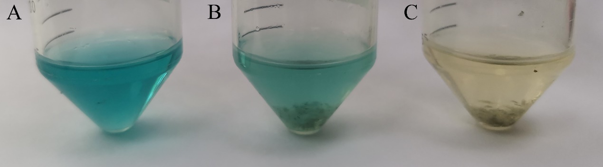
Fig S2. Color change of MG after degradation by strain KC0924g. A, MG without inoculation; B.MG treated with heat-killed cells of strain KC0924g for 48h; C. MG treated with strain KC0924g for 48h.
References
Groenewald JZ, Nakashima C, Nishikawa J, Shin HD, Park JH, Jama AN, Groenewald M, Braun U & Crous PW (2013) Species concepts in Cercospora: spotting the weeds among the roses. Studies in Mycology 75: 115-170.
Miller AN & Huhndorf SM (2005) Multi-gene phylogenies indicate ascomal wall morphology is a better predictor of phylogenetic relationships than ascospore morphology in the Sordariales (Ascomycota, Fungi). Molecular Phylogenetics and Evolution 35: 60-75.
O'Donnell K (1993) Fusarium and its near relatives. Fungal Holomorph Mitotic Motic & Pleomorphic Speciation in Fungal Systematics.
O'Donnell K & Cigelnik E (1997) Two Divergent Intragenomic rDNA ITS2 Types within a Monophyletic Lineage of the FungusFusariumAre Nonorthologous. Molecular Phylogenetics and Evolution 7: 103-116.
Sung G-H, Sung J-M, Hywel-Jones NL & Spatafora JW (2007) A multi-gene phylogeny of Clavicipitaceae (Ascomycota, Fungi): Identification of localized incongruence using a combinational bootstrap approach. Molecular Phylogenetics and Evolution 44: 1204-1223.
White TJ, Bruns T, Lee S & Taylor J (1990) 38 - AMPLIFICATION AND DIRECT SEQUENCING OF FUNGAL RIBOSOMAL RNA GENES FOR PHYLOGENETICS. PCR Protocols,(Innis MA, Gelfand DH, Sninsky JJ & White TJ, eds.), p.^pp. 315-322. Academic Press, San Diego.

